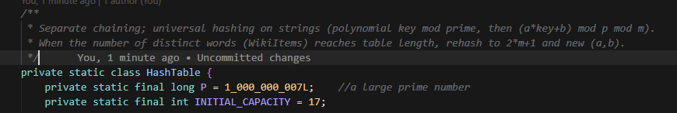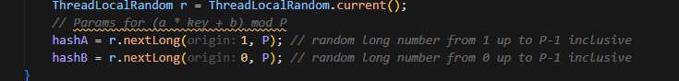
s.charAt(i) is the i-th character of the string s, converted to a long value (ex. 'A' → 65, 'a' → 97).
For each character c (in order, left to right), update:
h = (h * 257 + c) % P

