Criterion E: Evaluation

Success criterion | Result | Justification
Details of customers should get stored in Microsoft Office Access. | Met | The connection of Microsoft Office Access using the JDBC ODBC bridge made this possible. Each customer’s personal details are stored as records in the flat file database.
Add or search for certain customer records in the database. | Met | Records can be easily added, searched and deleted in the flat file database of Microsoft Office Access.
Ensure that there are presence checks on the cover page. | Met | Algorithms were made in order to implement presence checks. These were implemented in the Netbeans sofware.
Guarantee that the correct table number is entered. | Met | With the help of the combo box, the client can ensure that a valid table number is entered.
Develop an attractive, user-friendly interface so that customers can easily place an order. | Met | This was done by creating various JFrame’s as well as with the help of the buttons.
Ensure that the ingredients are present for every dish a customer chooses. | Met | Ingredients of each field were present in the text field of the JFrame containing a dish.
Ensure a picture is alongside every dish to certify maximum customer knowledge. | Met | Media was integrated as images in each JFrame of the dish by using label icons.
Develop a bill after an order is placed which shows the total amount to pay. | Met | This was done by creating a connection to an external database, which then populates the Jtable in the bill Jframe.
(247 words)
Recommendations for further development

- Database consisting of customer details: An alert should be added for my client, if a customer’s birthday is there on the present day. This will set as a reminder to allow my client to send an email to the customer.
- Birthday: The customer’s birthday should also be calculated based on the present day. This will give a more personalized touch to the customer.
- Order placed: The user should be allowed to add more quantities of a particular dish. This total amount and quantity should then be transferred to the bill Jframe.
- Bill: The level of tax should also be added to ensure a more detailed total amount.
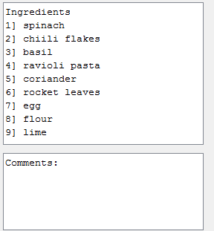
- JFrames of dish: User should also be allowed to add comments, and this information should be sent to the chef. These comments should be based upon the ingredients in the dish. For example in the image on the left, the customer can demand for it to be extra spicy, so the chef would add more chili flakes.
- Connection between two databases: A connection should be made between the customer’s order and the table number between both the databases. This would allow multiple customers on a single table to order at the same time.
- Printout of order: Instead of an order being printed and given to the chef, a direct link should be produced electronically between the customer and the chef. When a customer places an order, this information should be transferred to the chef’s tablet.

(249 words)

