<NeYesek>

<Muhammet Şeramet - 150115069>

<Mahmut Aktaş - 150115010>

<Ali Beytullah Özkan - 150114043>

**1. Introduction**

**1.1 Purpose**

The purpose of this document to present a detailed description of open source project **NeYesek,** its parameters and goals. This document describes the projects target audience, functionality, performance, attributes and the design constraints of the system which is going to be developed. This document is intended for users of the app and also developers.

**1.2 Scope**

This project is an application that people can use to find a place to eat. Users can choose randomly or one of their favorite restaurant. They can taste different food cultures around their location by choosing random. Alternatively, they can find restaurant among their favorites.

Currently, there are lots of food applications that deliver food to customer. They are both open-source and commercial, in the market. However, there are two simple but substantial problem with today’s application. First they do not encourage the customer to eat outside and be more social person. Second is they provide so much junk features to the user and it makes difficult to use.

**1.3 Definitions, Acronyms and Abbreviations**

**1.4 References**

SRS example:

<http://user.ceng.metu.edu.tr/~e1679216/documents/SRS.pdf>

IEEE Template for System Requirement Specification Documents:

<https://goo.gl/nsUFwy>

**General Constraints**

* Time - time is a main constraint for our project. We have to finish before deadline.
* Scope – This app will suggest only restaurants.
* Resource Constraints – We will use Google map place service. Information about restaurants will return from this service. Some places may not have too much information.
* Limit of database – The size of the database where we keep users' information have a limit.
* Software Platform – “Neyesek?” is an Android Project, so we can do what this platform allows.

**Assumptions**

* All group members will do their responsibility.
* Technology – This is an android project. Users have an Android device.
* Users login with their gmail accounts and they allow location info.
* Service – The Google map place API return result enough.
* Some restaurant accept our discount offers.

**Dependencies**

* We will make UI first before all of the other things.
* We will start using database after connect to Google service. At the beginning app run at local.
* At the same time we will code the back-end side of the project

**Functional Requirements**

**Create An Account:**

The user can create an account if user’s email does not inside the Users database.

**Login:**

If user has an account, the user can login in the system.

**Randomized Restaurants:**

If the system is logged in, user can press the button to get a near random restaurant from the near restaurants.

**Adding Favorite Restaurants:**

Each user can have own favorite restaurants by adding a restaurant as a favorite.

**Randomized Favorite Restaurants:**

The user can also get a random restaurant from their own favorite list.

**Rejecting a Restaurant:**

If the user doesn’t like the random restaurant before she/he meals in, she/he can reject that restaurant and get a new random restaurant.

**Getting Points By Going The Random Restaurant:**

If the user goes first or the second random restaurant, the user earn some points.

**Level System:**

If user collect some amount of points, the user levels up. At each level, the user wins discounts for admin selected restaurants.

**Non-Functional Requirements**

**Access Security:**

* The access permissions for system data may only be changed by the system’s data administrator.
* Passwords shall never be viewable at the point of entry or at any other time.

**Accessibility:**

* The system shall be accessible for only users in Turkey.

**Confidentiality:**

* The system shall protect the privacy of all users. Protected information contains; users name-surname, users email, users favorite restaurants, users discounts.

**Efficiency:**

* System shall be able to random process less than a 10 seconds.

**Integrity:**

* All points must be integers multiplied by 10.

**Usability:**

* Both random restaurant and random favorite restaurant button shall be in the first page after login in a considerably visible width and length.
* Users can reach the favorite restaurants list from the drawable menu on the left.
* People with no high skills in English shall easily understand the interface.
* The system shall easy to understand that make tutorial phase unnecessary.

**Interoperability:**

* The application must be available to Android 4.0.3 or higher devices

**Use Case Diagrams**

Diagram 1

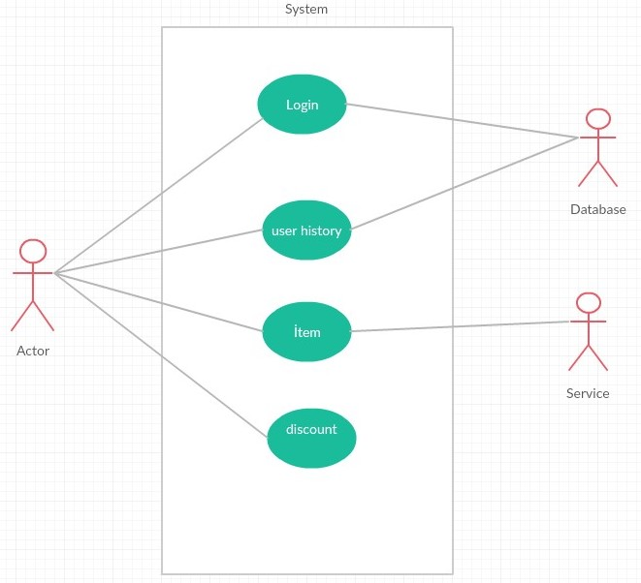

Diagram 2

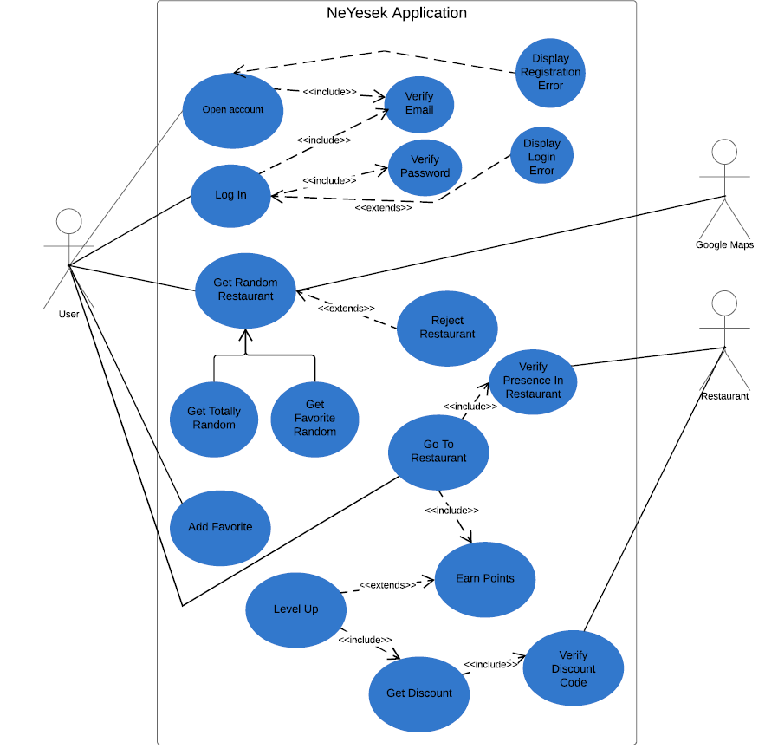

Diagram 3

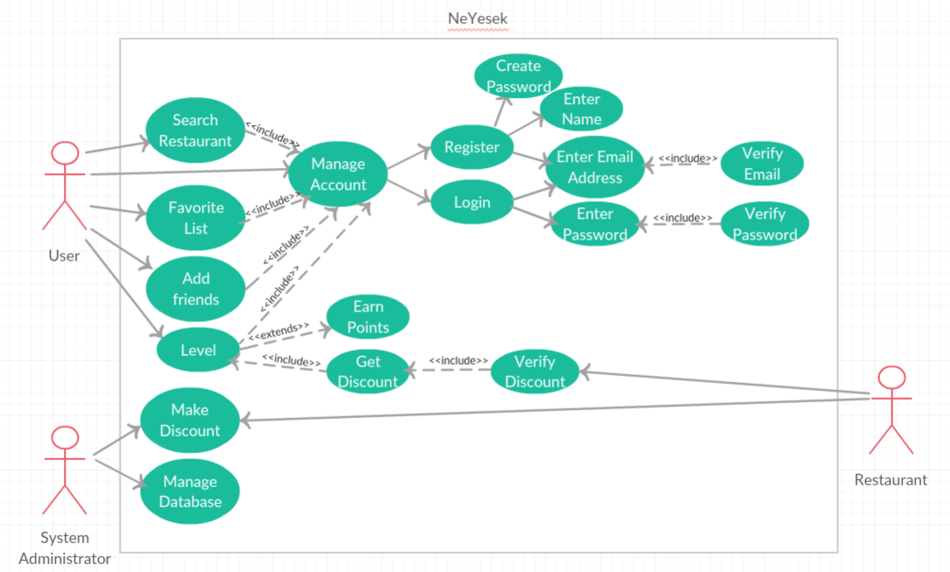

**Participation to the document**

