1. You have to implement code to get the BREEM data. (the Energe data isn’t correct. So we used the local data.)

You open the Command window to implement the code. Write “npm install” to install node modules and then write “npm start”.(Please wait till finish the orders)

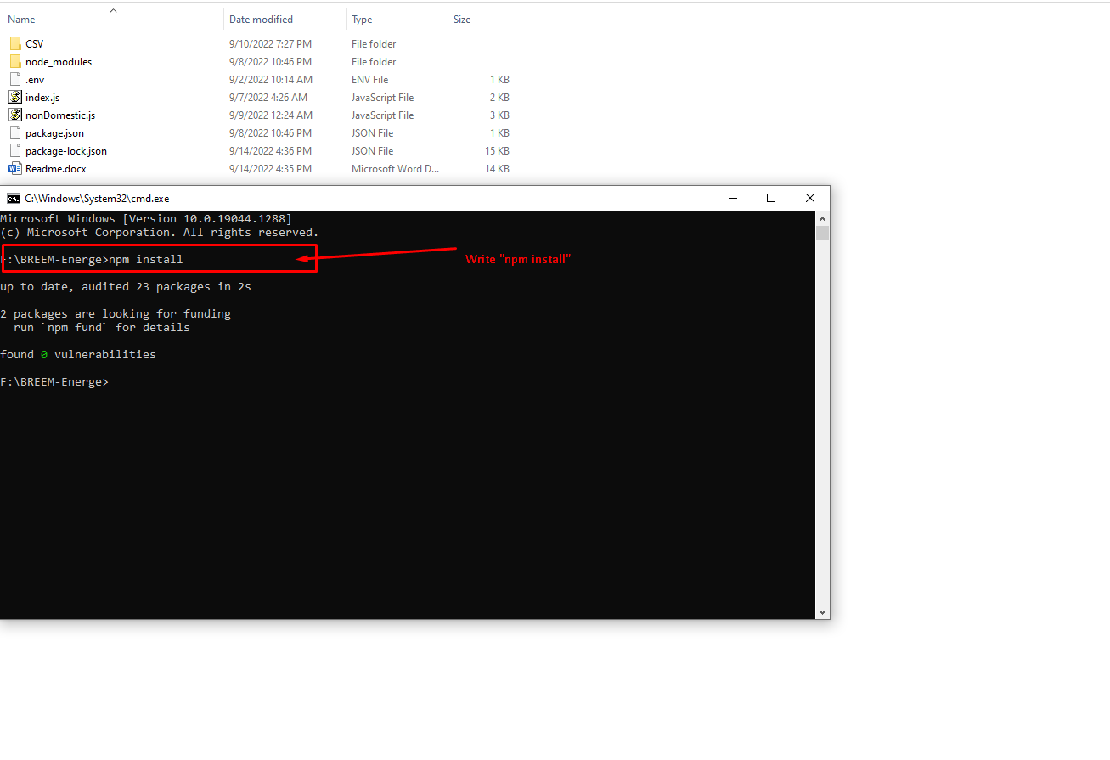

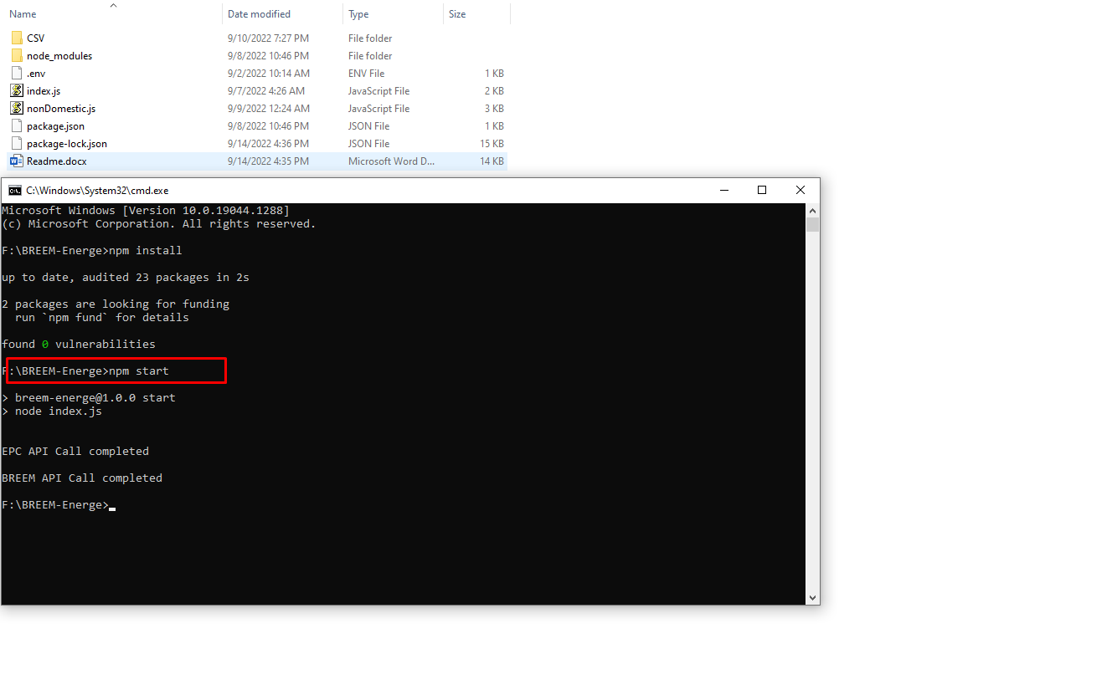

1. Upload the BREEM data to Tableau public.

Your BREEMdata.csv(./BREEM-Energe/CSV/BREEMdata.csv) data will be updated.

Open your public.tableau.com and click the “Edit” button.

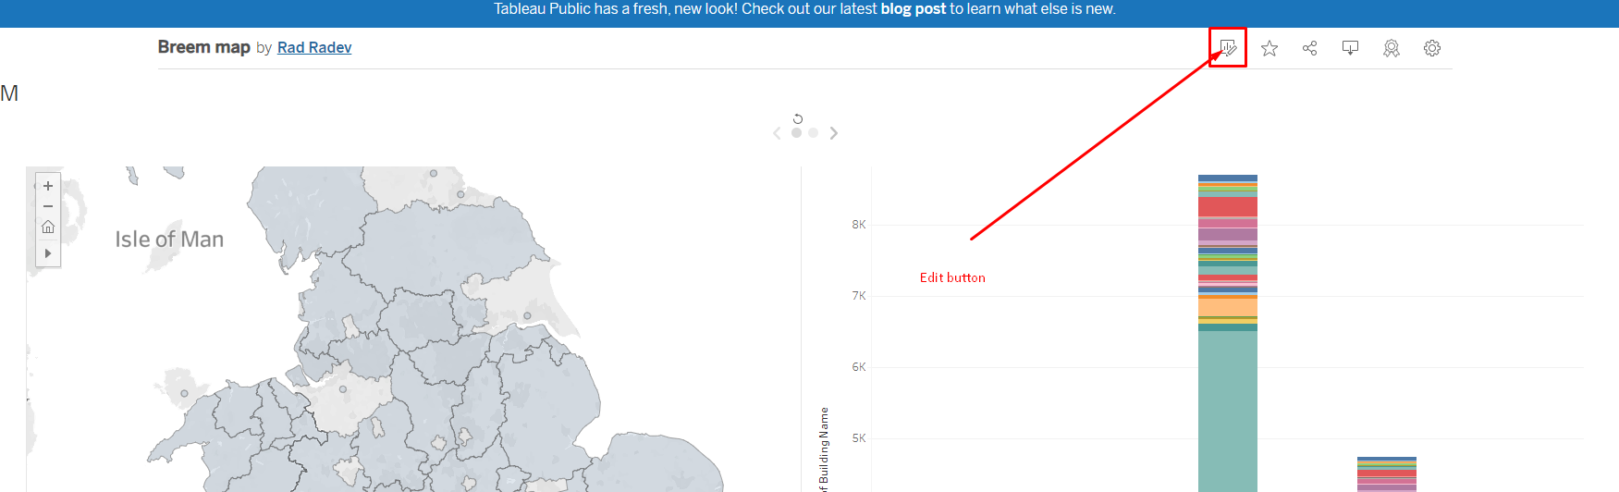

Click the “Data Source”.

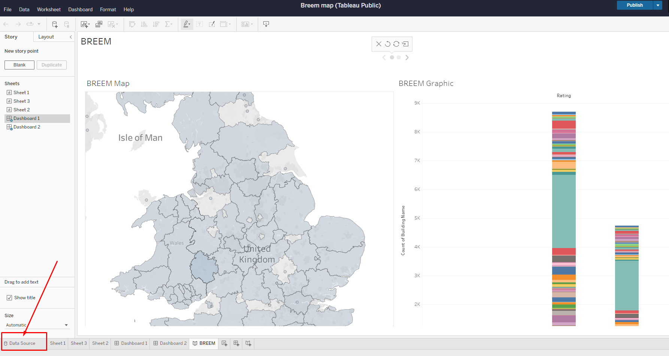

Replace BREEM data connection from BREEMdata.csv file.

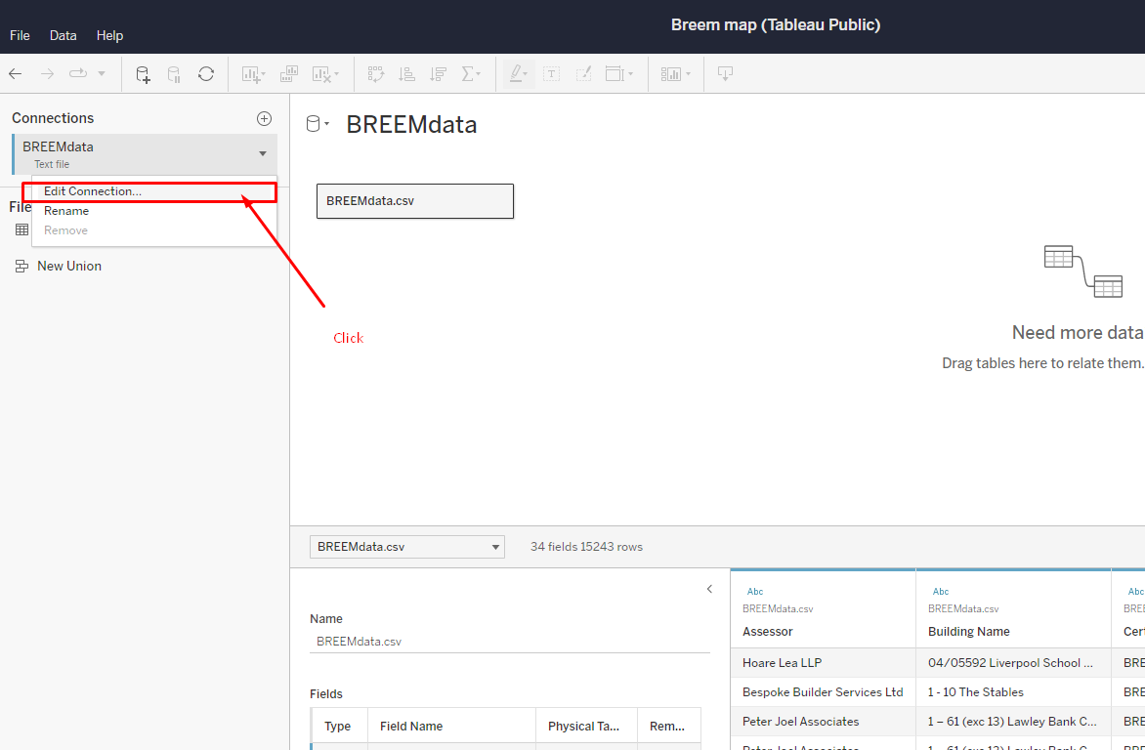

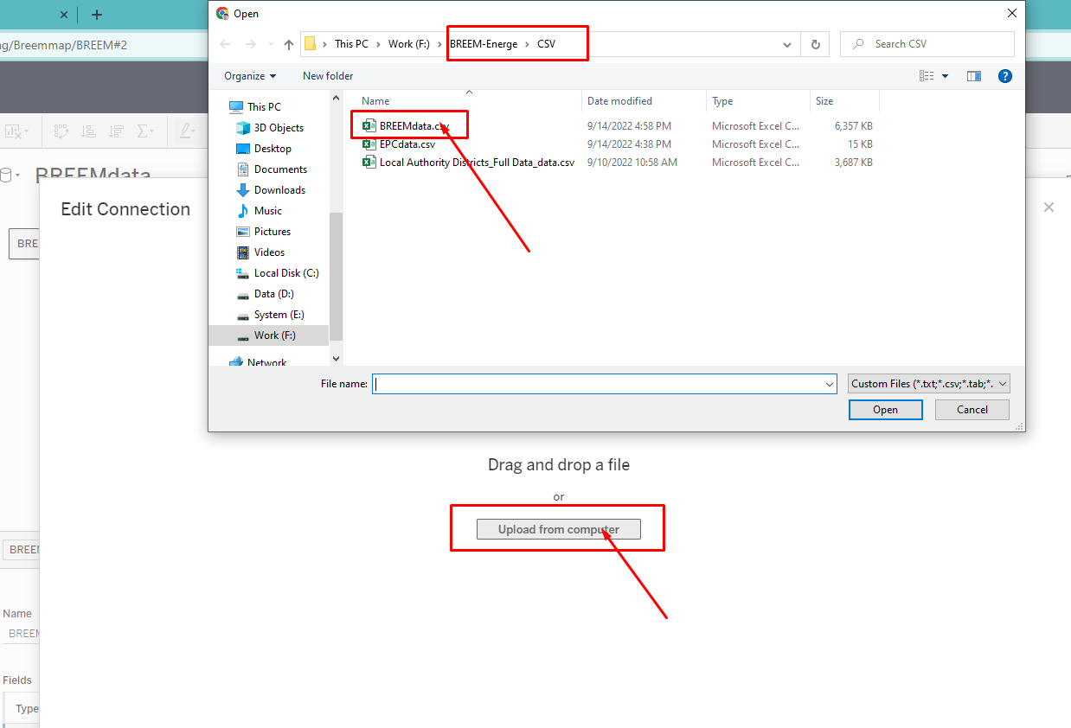

1. Make sure BREEM Map and Graph, and then publish it.

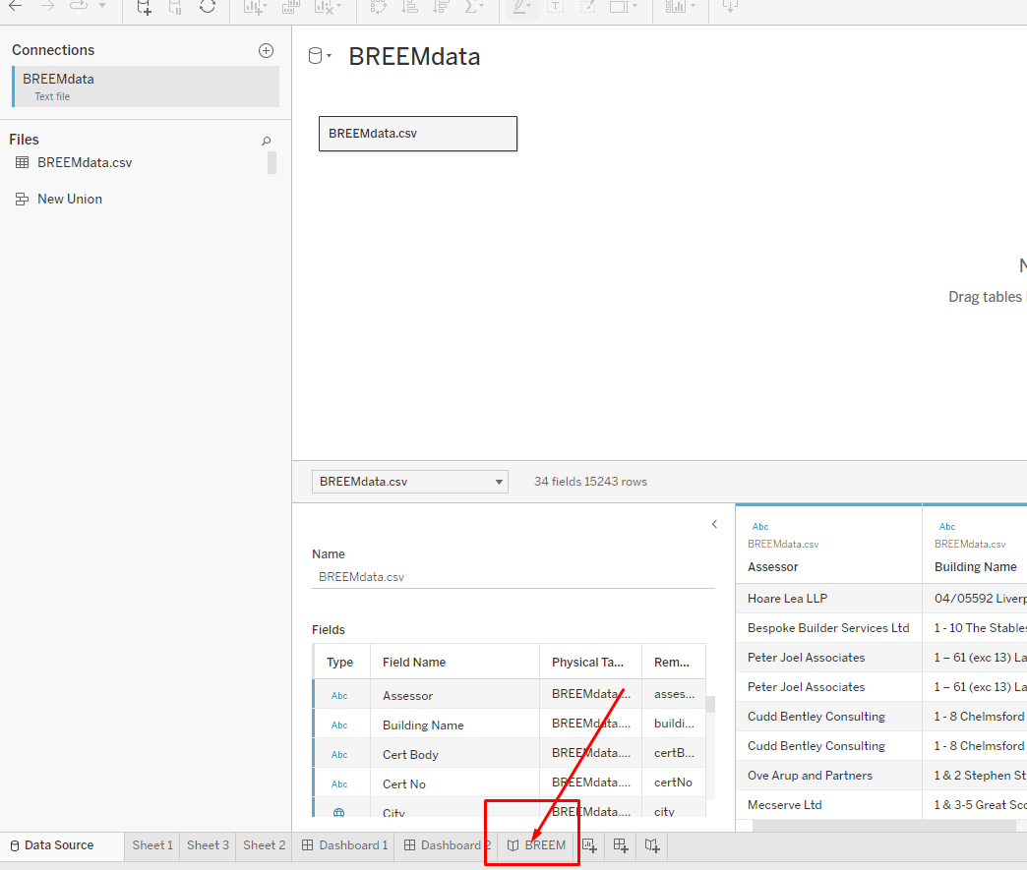

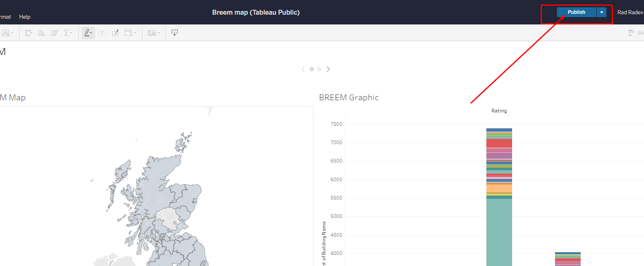

The Breem data is uploaded.