**课前预习软件及环境安装笔记-（更新前+更新后）**

**1.预习地址：**

Ai-预习资料v.1（林）

https://note.youdao.com/s/FZgyUjPM

**2.软件具体安装**

**2.1 Anaconda安装（Miniconda的安装）**

我的电脑信息为：



**①Miniconda安装包的安装**

**下载链接：【Mac M芯片】：**[**https://mirrors.tuna.tsinghua.edu.cn/anaconda/miniconda/Miniconda3-py312_24.9.2-0-MacOSX-arm64.pkg**](https://mirrors.tuna.tsinghua.edu.cn/anaconda/miniconda/Miniconda3-py312_24.9.2-0-MacOSX-arm64.pkg)

遇到的问题：（已自行解决）

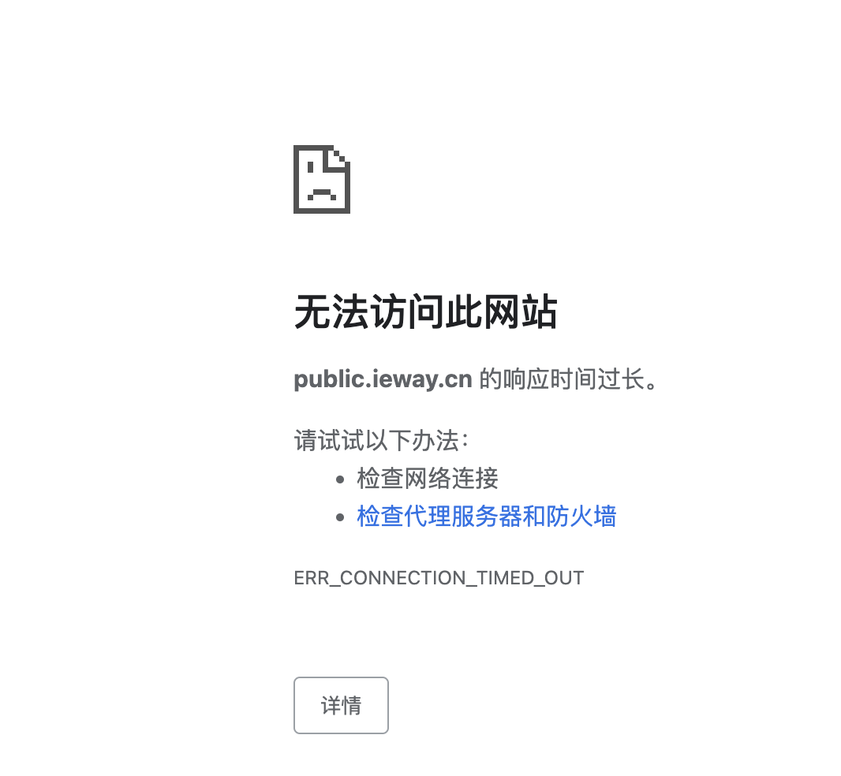

解决问题过程：

|  |
| --- |
| 从图中能看到几个关键提示：一是“由于意外错误，无法打开编辑器” ，二是“安装‘Python’扩展时出错” 。以下是可能的排查方向：  **网络问题**  VS Code 安装扩展需要联网下载相关文件，如果网络不稳定、延迟高，或者被防火墙、代理限制，可能导致下载中断、失败。可以试试切换网络（比如手机热点），或者检查防火墙、代理设置，暂时关闭不必要的网络限制，重新安装扩展。  **VS Code 自身问题**   1. **缓存或损坏**：VS Code 长时间使用，本地缓存、配置可能出问题。可尝试重启 VS Code ，或者用 Code --disable-extensions 命令（在终端执行，不同系统启动方式有差异，Windows 可在开始菜单找到 “VS Code 命令提示符” 之类入口）以无扩展模式启动，再安装 Python 扩展，看是否正常。 2. **版本兼容**：如果 VS Code 版本较旧，和新版 Python 扩展可能存在兼容问题。可尝试更新 VS Code 到最新稳定版，再重新安装扩展 。   **系统环境问题**   1. **权限不足**：安装扩展时，VS Code 需要读写相关目录（比如扩展安装路径、日志目录等 ），如果系统权限不足（比如非管理员账户，且系统限制了用户对程序目录的操作 ），可能导致安装失败。在 Windows 上，可尝试以管理员身份运行 VS Code （右键 VS Code 快捷方式，选 “以管理员身份运行” ）；Linux 或 macOS 下，检查用户对 VS Code 安装目录、扩展目录的读写权限，必要时用 sudo （需谨慎，避免权限过大风险 ）辅助安装操作。 2. **依赖缺失**：Python 扩展可能依赖系统某些基础组件（比如特定版本的 Python 运行时环境，虽然扩展本身不一定要你本地装 Python ，但底层可能有依赖 ）。确保你本地有符合要求的 Python 环境（建议从 [Python 官网](https://www.python.org/) 下载安装官方版，配置好环境变量 ），或者检查系统是否缺少相关依赖库（Linux 下可能需要 glibc 等基础库，可通过系统包管理器安装；macOS 可能依赖 Xcode Command Line Tools ，执行 xcode-select --install 尝试安装 ）。   另外，图里提示 “有关详细信息，请参阅日志” ，可以通过 VS Code 的 “帮助” - “切换开发人员工具” ，在控制台或者 “输出” 面板（按 Ctrl+Shift+U 调出 ）里找更具体的报错日志，根据日志里的错误代码、堆栈信息，能更精准定位问题，比如是下载链接 404 、文件校验失败，还是其他底层错误 ，针对性解决会更高效。要是试了上述方法还没解决，把详细日志内容补充出来，能进一步分析~ |

通过以上分析，发现是开了代理，把代理关掉就解决了问题，后续安装比较顺利，没有出现问题。

**②MAC配置Miniconda环境变量**

老师的笔记里给出了window的环境变量配置，里面没有mac的，于是自行检索信息，如下：

|  |
| --- |
| 在 macOS M 系列芯片上配置 Miniconda 环境变量，可以按照以下步骤进行操作：  **步骤一：安装 Miniconda**  首先，前往 [Miniconda 官方下载页面](https://docs.conda.io/en/latest/miniconda.html)，找到适用于 macOS Apple M1 或 M2 芯片的安装包（通常是 Miniconda3-MacOSX-arm64.sh 这类文件名），下载完成后，在终端中执行以下命令进行安装：  按照安装向导的提示进行操作，例如按回车键查看许可协议，输入 yes 同意许可协议，选择安装路径（一般默认即可，若要自定义安装路径，请记住该路径，后续配置环境变量时会用到）等。  **步骤二：配置环境变量**  安装完成后，需要将 Miniconda 的相关路径添加到系统的环境变量中，这样系统才能找到 conda 等命令。  打开终端，使用文本编辑器（如 nano 或 vim ）编辑用户的 bash 配置文件。如果使用的是 zsh 终端（默认情况下，macOS 从 Catalina 开始使用 zsh 作为默认 shell），则编辑 ~/.zshrc 文件；如果使用的是 bash 终端，则编辑 ~/.bash_profile 文件。以 zsh 为例，执行以下命令：  （如果使用 vim ，命令则是 vim ~/.zshrc ，进入 vim 编辑模式后，按 i 键进入插入模式，编辑完成后按 Esc 键退出插入模式，再输入 :wq 保存并退出）  在打开的文件末尾添加以下内容，其中 /Users/your_username/miniconda3 是 Miniconda 的默认安装路径，如果安装时选择了其他路径，请替换为实际的安装路径：  添加完成后，按下 Ctrl + X （在 nano 编辑器中），然后输入 Y 确认保存，最后按回车键确认保存的文件名。  **步骤三：使环境变量生效**  执行以下命令，让刚刚添加的环境变量立即生效：  （如果编辑的是 ~/.bash_profile ，则执行 source ~/.bash_profile ）  **步骤四：验证配置**  在终端中输入以下命令，查看 conda 的版本信息，如果能正常显示版本号，则说明 Miniconda 环境变量配置成功：    通过以上步骤，就可以在 macOS M 系列芯片的电脑上成功配置 Miniconda 的环境变量了。 |

经过查看，从终端窗口标题 liufengxiang --zsh --80x24 以及命令提示符里的 zsh 环境标识（(base) liufengxiang@liufengangdeMBP ~ % ，% 是 zsh 典型的命令提示符结尾符号 ），可以判断这是 zsh 终端，不是 bash 终端（bash 终端默认提示符结尾一般是 $ ） 。

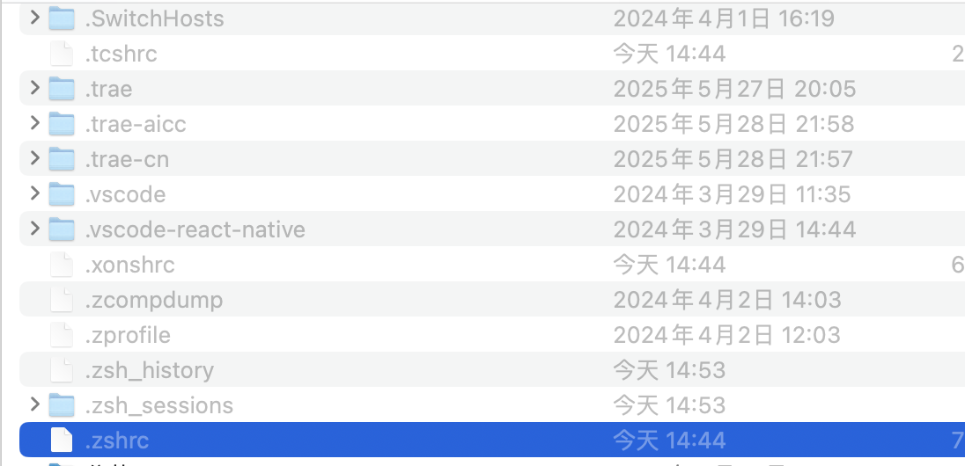

发现，在mac M系统上安装包自行配置了环境变量，不需要手动配置了

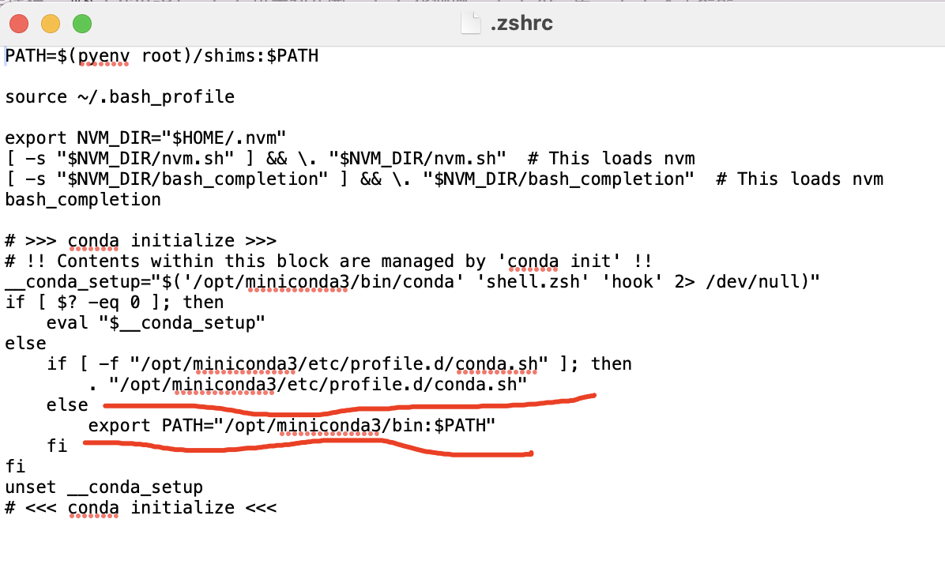

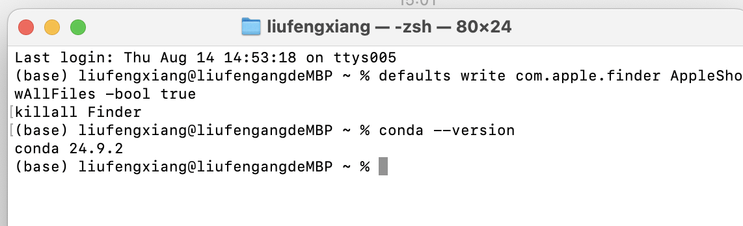

在这个过程中还用到了mac显示隐藏的系统文件知识点：

|  |
| --- |
| 在mac上显示隐藏的系统文件，有以下几种常用方法：  **使用终端命令**  打开“终端”应用程序（可以通过在“聚焦搜索”中输入“终端”快速找到 ），然后执行以下命令来显示隐藏文件：  上述命令中，defaults write com.apple.finder AppleShowAllFiles -bool true 这行代码的作用是修改 Finder 的设置，让它显示所有文件，包括隐藏文件；killall Finder 这行代码则是重启 Finder 应用程序，使设置立即生效。  如果想要再次隐藏这些文件，在“终端”中输入以下命令：  **使用快捷键临时显示隐藏文件**  在访达（Finder）窗口处于活动状态时，按下 Command + Shift +.（Command键、Shift键和英文句号键）组合键，即可临时显示隐藏文件。再次按下该组合键，则会隐藏这些文件。  **通过第三方工具显示隐藏文件**  比如使用Path Finder等第三方文件管理工具。安装并打开这类工具后，一般在其设置选项中会有显示隐藏文件的相关功能开关，开启后就能在该工具的界面中看到隐藏的系统文件 。    通过上述方法，你可以根据实际需求，方便地在mac上显示或隐藏系统文件。 |

**③mac电脑M系统验证Miniconda环境变量是否设置成功**

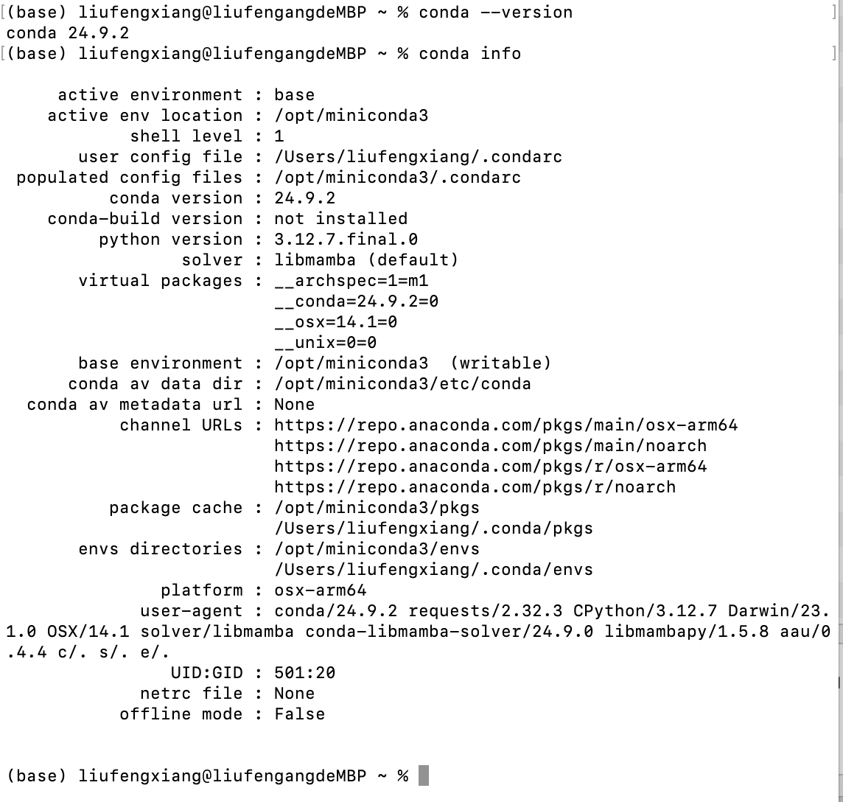

**2.1 VsCode安装：** [**vscode安装配置**](https://note.youdao.com/s/RNEVsPwo)

已完成，并安装chinese和python如下：

|  |  |
| --- | --- |
|  |  |

**3.深度学习环境配置**

**3.1 anaconda创建py环境：** [**env-conda创建管理py环境**](https://note.youdao.com/s/Tf6yJQGL)

|  |
| --- |
| conda create -n py312 python=3.12  conda activate py312  conda deactivate |

|  |
| --- |
| Bash Last login: Thu Aug 14 14:53:18 on ttys005 (base) liufengxiang@liufengangdeMBP ~ % defaults write com.apple.finder AppleShowAllFiles -bool true killall Finder (base) liufengxiang@liufengangdeMBP ~ % conda --version conda 24.9.2 (base) liufengxiang@liufengangdeMBP ~ % conda info    active environment : base  active env location : /opt/miniconda3  shell level : 1  user config file : /Users/liufengxiang/.condarc  populated config files : /opt/miniconda3/.condarc  conda version : 24.9.2  conda-build version : not installed  python version : 3.12.7.final.0  solver : libmamba (default)  virtual packages : __archspec=1=m1  __conda=24.9.2=0  __osx=14.1=0  __unix=0=0  base environment : /opt/miniconda3 (writable)  conda av data dir : /opt/miniconda3/etc/conda  conda av metadata url : None  channel URLs : https://repo.anaconda.com/pkgs/main/osx-arm64  https://repo.anaconda.com/pkgs/main/noarch  https://repo.anaconda.com/pkgs/r/osx-arm64  https://repo.anaconda.com/pkgs/r/noarch  package cache : /opt/miniconda3/pkgs  /Users/liufengxiang/.conda/pkgs  envs directories : /opt/miniconda3/envs  /Users/liufengxiang/.conda/envs  platform : osx-arm64  user-agent : conda/24.9.2 requests/2.32.3 CPython/3.12.7 Darwin/23.1.0 OSX/14.1 solver/libmamba conda-libmamba-solver/24.9.0 libmambapy/1.5.8 aau/0.4.4 c/. s/. e/.  UID:GID : 501:20  netrc file : None  offline mode : False   (base) liufengxiang@liufengangdeMBP ~ % python --version Python 3.12.7 (base) liufengxiang@liufengangdeMBP ~ % python3 -V Python 3.12.7 (base) liufengxiang@liufengangdeMBP ~ % conda create -n py312 python=3.12 Channels:  - defaults Platform: osx-arm64 Collecting package metadata (repodata.json): done Solving environment: done  ## Package Plan ##   environment location: /opt/miniconda3/envs/py312   added / updated specs:  - python=3.12   The following packages will be downloaded:   package | build  ---------------------------|-----------------  ca-certificates-2025.7.15 | hca03da5_0 127 KB  expat-2.7.1 | h313beb8_0 156 KB  libcxx-19.1.7 | hb09ecce_3 315 KB  ncurses-6.5 | hee39554_0 886 KB  openssl-3.0.17 | h4ee41c1_0 4.3 MB  pip-25.1 | pyhc872135_2 1.3 MB  python-3.12.11 | h421de30_0 13.8 MB  readline-8.3 | h0b18652_0 464 KB  setuptools-78.1.1 | py312hca03da5_0 2.2 MB  sqlite-3.50.2 | h79febb2_1 1.0 MB  tk-8.6.14 | h6ba3021_1 3.3 MB  tzdata-2025b | h04d1e81_0 116 KB  wheel-0.45.1 | py312hca03da5_0 148 KB  xz-5.6.4 | h80987f9_1 289 KB  ------------------------------------------------------------  Total: 28.3 MB  The following NEW packages will be INSTALLED:   bzip2 pkgs/main/osx-arm64::bzip2-1.0.8-h80987f9_6   ca-certificates pkgs/main/osx-arm64::ca-certificates-2025.7.15-hca03da5_0   expat pkgs/main/osx-arm64::expat-2.7.1-h313beb8_0   libcxx pkgs/main/osx-arm64::libcxx-19.1.7-hb09ecce_3   libffi pkgs/main/osx-arm64::libffi-3.4.4-hca03da5_1   ncurses pkgs/main/osx-arm64::ncurses-6.5-hee39554_0   openssl pkgs/main/osx-arm64::openssl-3.0.17-h4ee41c1_0   pip pkgs/main/noarch::pip-25.1-pyhc872135_2   python pkgs/main/osx-arm64::python-3.12.11-h421de30_0   readline pkgs/main/osx-arm64::readline-8.3-h0b18652_0   setuptools pkgs/main/osx-arm64::setuptools-78.1.1-py312hca03da5_0   sqlite pkgs/main/osx-arm64::sqlite-3.50.2-h79febb2_1   tk pkgs/main/osx-arm64::tk-8.6.14-h6ba3021_1   tzdata pkgs/main/noarch::tzdata-2025b-h04d1e81_0   wheel pkgs/main/osx-arm64::wheel-0.45.1-py312hca03da5_0   xz pkgs/main/osx-arm64::xz-5.6.4-h80987f9_1   zlib pkgs/main/osx-arm64::zlib-1.2.13-h18a0788_1    Proceed ([y]/n)? y   Downloading and Extracting Packages:   Preparing transaction: done  Verifying transaction: done  Executing transaction: done  #  # To activate this environment, use  #  # $ conda activate py312  #  # To deactivate an active environment, use  #  # $ conda deactivate    (base) liufengxiang@liufengangdeMBP ~ % conda activate py312  (py312) liufengxiang@liufengangdeMBP ~ % |

**3.2 Numpy安装**

**用于科学计算，提供了高性能的多维数组对象和丰富的数学函数**

|  |
| --- |
| pip install numpy==1.26.4 -i https://pypi.tuna.tsinghua.edu.cn/simple |

|  |
| --- |
| Java (base) liufengxiang@liufengangdeMBP ~ % conda activate py312  (py312) liufengxiang@liufengangdeMBP ~ % pip install numpy==1.26.4 -i https://pypi.tuna.tsinghua.edu.cn/simple Looking in indexes: https://pypi.tuna.tsinghua.edu.cn/simple Collecting numpy==1.26.4  Downloading https://pypi.tuna.tsinghua.edu.cn/packages/75/5b/ca6c8bd14007e5ca171c7c03102d17b4f4e0ceb53957e8c44343a9546dcc/numpy-1.26.4-cp312-cp312-macosx_11_0_arm64.whl (13.7 MB)  ━━━━━━━━━━━━━━━━━━━━━━━━━━━━━━━━━━━━━━━ 13.7/13.7 MB 431.3 kB/s eta 0:00:00 Installing collected packages: numpy Successfully installed numpy-1.26.4 (py312) liufengxiang@liufengangdeMBP ~ % |

**3.3 Pandas安装**

用于数据分析，提供了灵活的数据结构（如DataFrame），使数据清洗和分析变得简单高效

|  |
| --- |
| pip install pandas==2.2.2 -i https://pypi.tuna.tsinghua.edu.cn/simple |

|  |
| --- |
| Bash (py312) liufengxiang@liufengangdeMBP ~ % pip install pandas==2.2.2 -i https://pypi.tuna.tsinghua.edu.cn/simple Looking in indexes: https://pypi.tuna.tsinghua.edu.cn/simple Collecting pandas==2.2.2  Downloading https://pypi.tuna.tsinghua.edu.cn/packages/db/7c/9a60add21b96140e22465d9adf09832feade45235cd22f4cb1668a25e443/pandas-2.2.2-cp312-cp312-macosx_11_0_arm64.whl (11.3 MB)  ━━━━━━━━━━━━━━━━━━━━━━━━━━━━━━━━━━━━━━━ 11.3/11.3 MB 542.7 kB/s eta 0:00:00 Requirement already satisfied: numpy>=1.26.0 in /opt/miniconda3/envs/py312/lib/python3.12/site-packages (from pandas==2.2.2) (1.26.4) Collecting python-dateutil>=2.8.2 (from pandas==2.2.2)  Downloading https://pypi.tuna.tsinghua.edu.cn/packages/ec/57/56b9bcc3c9c6a792fcbaf139543cee77261f3651ca9da0c93f5c1221264b/python_dateutil-2.9.0.post0-py2.py3-none-any.whl (229 kB) Collecting pytz>=2020.1 (from pandas==2.2.2)  Downloading https://pypi.tuna.tsinghua.edu.cn/packages/81/c4/34e93fe5f5429d7570ec1fa436f1986fb1f00c3e0f43a589fe2bbcd22c3f/pytz-2025.2-py2.py3-none-any.whl (509 kB) Collecting tzdata>=2022.7 (from pandas==2.2.2)  Downloading https://pypi.tuna.tsinghua.edu.cn/packages/5c/23/c7abc0ca0a1526a0774eca151daeb8de62ec457e77262b66b359c3c7679e/tzdata-2025.2-py2.py3-none-any.whl (347 kB) Collecting six>=1.5 (from python-dateutil>=2.8.2->pandas==2.2.2)  Downloading https://pypi.tuna.tsinghua.edu.cn/packages/b7/ce/149a00dd41f10bc29e5921b496af8b574d8413afcd5e30dfa0ed46c2cc5e/six-1.17.0-py2.py3-none-any.whl (11 kB) Installing collected packages: pytz, tzdata, six, python-dateutil, pandas Successfully installed pandas-2.2.2 python-dateutil-2.9.0.post0 pytz-2025.2 six-1.17.0 tzdata-2025.2 (py312) liufengxiang@liufengangdeMBP ~ % |

**3.4 Matplotlib安装**

用于数据可视化，能够创建静态、动态和交互式图表

|  |
| --- |
| pip install matplotlib==3.9.2 -i https://pypi.tuna.tsinghua.edu.cn/simple Looking in indexes: https://pypi.tuna.tsinghua.edu.cn/simple |

|  |
| --- |
| Bash (py312) liufengxiang@liufengangdeMBP ~ % pip install matplotlib==3.9.2 -i https://pypi.tuna.tsinghua.edu.cn/simple Looking in indexes: https://pypi.tuna.tsinghua.edu.cn/simple Collecting matplotlib==3.9.2  Downloading https://pypi.tuna.tsinghua.edu.cn/packages/35/3e/5713b84a02b24b2a4bd4d6673bfc03017e6654e1d8793ece783b7ed4d484/matplotlib-3.9.2-cp312-cp312-macosx_11_0_arm64.whl (7.8 MB)  ━━━━━━━━━━━━━━━━━━━━━━━━━━━━━━━━━━━━━━━━ 7.8/7.8 MB 634.0 kB/s eta 0:00:00 Collecting contourpy>=1.0.1 (from matplotlib==3.9.2)  Downloading https://pypi.tuna.tsinghua.edu.cn/packages/53/3e/405b59cfa13021a56bba395a6b3aca8cec012b45bf177b0eaf7a202cde2c/contourpy-1.3.3-cp312-cp312-macosx_11_0_arm64.whl (273 kB) Collecting cycler>=0.10 (from matplotlib==3.9.2)  Downloading https://pypi.tuna.tsinghua.edu.cn/packages/e7/05/c19819d5e3d95294a6f5947fb9b9629efb316b96de511b418c53d245aae6/cycler-0.12.1-py3-none-any.whl (8.3 kB) Collecting fonttools>=4.22.0 (from matplotlib==3.9.2)  Downloading https://pypi.tuna.tsinghua.edu.cn/packages/e2/77/b1c8af22f4265e951cd2e5535dbef8859efcef4fb8dee742d368c967cddb/fonttools-4.59.0-cp312-cp312-macosx_10_13_universal2.whl (2.8 MB)  ━━━━━━━━━━━━━━━━━━━━━━━━━━━━━━━━━━━━━━━━ 2.8/2.8 MB 298.9 kB/s eta 0:00:00 Collecting kiwisolver>=1.3.1 (from matplotlib==3.9.2)  Downloading https://pypi.tuna.tsinghua.edu.cn/packages/5b/5a/51f5464373ce2aeb5194508298a508b6f21d3867f499556263c64c621914/kiwisolver-1.4.9-cp312-cp312-macosx_11_0_arm64.whl (64 kB) Requirement already satisfied: numpy>=1.23 in /opt/miniconda3/envs/py312/lib/python3.12/site-packages (from matplotlib==3.9.2) (1.26.4) Collecting packaging>=20.0 (from matplotlib==3.9.2)  Downloading https://pypi.tuna.tsinghua.edu.cn/packages/20/12/38679034af332785aac8774540895e234f4d07f7545804097de4b666afd8/packaging-25.0-py3-none-any.whl (66 kB) Collecting pillow>=8 (from matplotlib==3.9.2)  Downloading https://pypi.tuna.tsinghua.edu.cn/packages/2c/32/7e2ac19b5713657384cec55f89065fb306b06af008cfd87e572035b27119/pillow-11.3.0-cp312-cp312-macosx_11_0_arm64.whl (4.7 MB)  ━━━━━━━━━━━━━━━━━━━━━━━━━━━━━━━━━━━━━━━━ 4.7/4.7 MB 331.2 kB/s eta 0:00:00 Collecting pyparsing>=2.3.1 (from matplotlib==3.9.2)  Downloading https://pypi.tuna.tsinghua.edu.cn/packages/05/e7/df2285f3d08fee213f2d041540fa4fc9ca6c2d44cf36d3a035bf2a8d2bcc/pyparsing-3.2.3-py3-none-any.whl (111 kB) Requirement already satisfied: python-dateutil>=2.7 in /opt/miniconda3/envs/py312/lib/python3.12/site-packages (from matplotlib==3.9.2) (2.9.0.post0) Requirement already satisfied: six>=1.5 in /opt/miniconda3/envs/py312/lib/python3.12/site-packages (from python-dateutil>=2.7->matplotlib==3.9.2) (1.17.0) Installing collected packages: pyparsing, pillow, packaging, kiwisolver, fon |

**3.5 Pytorch安装**

深度学习领域的顶级框架，提供了构建和训练神经网络的工具

**安装torch**

**安装文档：** [env-pytorch安装](https://note.youdao.com/s/ClPF5oUU)

1. python版本：python 3.12【注意：安装torch，python必须为64位】
2. CPU Only方式安装：

* 打开cmd/终端，进入到对应的虚拟环境中：conda activate py312
* 命令：pip install torch==2.4.1 -i https://pypi.tuna.tsinghua.edu.cn/simple/

**注意：**

* **有些Mac电脑最高只能安装2.2.2版本的torch，所以提示版本问题时，将2.4.1改为2.2.2**
* **安装其他版本的torch，只需要将版本号2.4.1更改为其他版本号，同时注意库之间的依赖关系**

太棒了，我的电脑2.4.1版本安装成功了~~~~~如下：

|  |
| --- |
| Bash (py312) liufengxiang@liufengangdeMBP ~ % pip install torch==2.4.1 -i https://pypi.tuna.tsinghua.edu.cn/simple/ Looking in indexes: https://pypi.tuna.tsinghua.edu.cn/simple/ Collecting torch==2.4.1  Downloading https://pypi.tuna.tsinghua.edu.cn/packages/ac/30/8b6f77ea4ce84f015ee024b8dfef0dac289396254e8bfd493906d4cbb848/torch-2.4.1-cp312-none-macosx_11_0_arm64.whl (62.1 MB)  ━━━━━━━━━━━━━━━━━━━━━━━━━━━━━━━━━━━━━━━ 62.1/62.1 MB 491.1 kB/s eta 0:00:00 Collecting filelock (from torch==2.4.1)  Downloading https://pypi.tuna.tsinghua.edu.cn/packages/4d/36/2a115987e2d8c300a974597416d9de88f2444426de9571f4b59b2cca3acc/filelock-3.18.0-py3-none-any.whl (16 kB) Collecting typing-extensions>=4.8.0 (from torch==2.4.1)  Downloading https://pypi.tuna.tsinghua.edu.cn/packages/b5/00/d631e67a838026495268c2f6884f3711a15a9a2a96cd244fdaea53b823fb/typing_extensions-4.14.1-py3-none-any.whl (43 kB) Collecting sympy (from torch==2.4.1)  Downloading https://pypi.tuna.tsinghua.edu.cn/packages/a2/09/77d55d46fd61b4a135c444fc97158ef34a095e5681d0a6c10b75bf356191/sympy-1.14.0-py3-none-any.whl (6.3 MB)  ━━━━━━━━━━━━━━━━━━━━━━━━━━━━━━━━━━━━━━━━ 6.3/6.3 MB 476.6 kB/s eta 0:00:00 Collecting networkx (from torch==2.4.1)  Downloading https://pypi.tuna.tsinghua.edu.cn/packages/eb/8d/776adee7bbf76365fdd7f2552710282c79a4ead5d2a46408c9043a2b70ba/networkx-3.5-py3-none-any.whl (2.0 MB)  ━━━━━━━━━━━━━━━━━━━━━━━━━━━━━━━━━━━━━━━━ 2.0/2.0 MB 658.4 kB/s eta 0:00:00 Collecting jinja2 (from torch==2.4.1)  Downloading https://pypi.tuna.tsinghua.edu.cn/packages/62/a1/3d680cbfd5f4b8f15abc1d571870c5fc3e594bb582bc3b64ea099db13e56/jinja2-3.1.6-py3-none-any.whl (134 kB) Collecting fsspec (from torch==2.4.1)  Downloading https://pypi.tuna.tsinghua.edu.cn/packages/2f/e0/014d5d9d7a4564cf1c40b5039bc882db69fd881111e03ab3657ac0b218e2/fsspec-2025.7.0-py3-none-any.whl (199 kB) Requirement already satisfied: setuptools in /opt/miniconda3/envs/py312/lib/python3.12/site-packages (from torch==2.4.1) (78.1.1) Collecting MarkupSafe>=2.0 (from jinja2->torch==2.4.1)  Downloading https://pypi.tuna.tsinghua.edu.cn/packages/6b/b0/18f76bba336fa5aecf79d45dcd6c806c280ec44538b3c13671d49099fdd0/MarkupSafe-3.0.2-cp312-cp312-macosx_11_0_arm64.whl (12 kB) Collecting mpmath<1.4,>=1.1.0 (from sympy->torch==2.4.1)  Downloading https://pypi.tuna.tsinghua.edu.cn/packages/43/e3/7d92a15f894aa0c9c4b49b8ee9ac9850d6e63b03c9c32c0367a13ae62209/mpmath-1.3.0-py3-none-any.whl (536 kB)  ━━━━━━━━━━━━━━━━━━━━━━━━━━━━━━━━━━━━━ 536.2/536.2 kB 224.0 kB/s eta 0:00:00 Installing collected packages: mpmath, typing-extensions, sympy, networkx, MarkupSafe, fsspec, filelock, jinja2, torch Successfully installed MarkupSafe-3.0.2 filelock-3.18.0 fsspec-2025.7.0 jinja2-3.1.6 mpmath-1.3.0 networkx-3.5 sympy-1.14.0 torch-2.4.1 typing-extensions-4.14.1 (py312) liufengxiang@liufengangdeMBP ~ % |

3.测试是否成功

输入python，回车，进入到python的shell中：

输入以下代码：

|  |
| --- |
| import torch # __version__：左右各两个"_" print(torch.__version__) # 如果返回：2.4.1+cpu代表安装成功，Mac电脑只显示2.4.1，是正常的 |

|  |
| --- |
| Python (py312) liufengxiang@liufengangdeMBP ~ % python Python 3.12.11 | packaged by Anaconda, Inc. | (main, Jun 5 2025, 08:03:38) [Clang 14.0.6 ] on darwin Type "help", "copyright", "credits" or "license" for more information. >>> import torch >>> print(torch.__version__) 2.4.1 >>> |

至此，pytorch安装成功，测试完成之后，输入：exit()，回车，退出python的交互窗口

|  |
| --- |
| Plain Text >>> exit() (py312) liufengxiang@liufengangdeMBP ~ % |

**3.6 Fasttext安装**

进行文本分类和训练词向量

* **安装文档：** [env-fasttext](https://note.youdao.com/s/FCIBFV4d)
* **Mac系统**

**1、打开终端**

**2、激活对应的环境，以py312为例：**

conda activate py312

**3、执行安装命令：**

pip install fasttext -i https://pypi.tuna.tsinghua.edu.cn/simple

|  |
| --- |
| pip install fasttext -i https://pypi.tuna.tsinghua.edu.cn/simple |

|  |
| --- |
| Bash (py312) liufengxiang@liufengangdeMBP ~ % pip install fasttext -i https://pypi.tuna.tsinghua.edu.cn/simple Looking in indexes: https://pypi.tuna.tsinghua.edu.cn/simple Collecting fasttext  Downloading https://pypi.tuna.tsinghua.edu.cn/packages/9f/3b/9a10b95eaf565358339162848863197c3f0a29b540ca22b2951df2d66a48/fasttext-0.9.3.tar.gz (73 kB)  Installing build dependencies ... done  Getting requirements to build wheel ... done  Preparing metadata (pyproject.toml) ... done Collecting pybind11>=2.2 (from fasttext)  Using cached https://pypi.tuna.tsinghua.edu.cn/packages/41/9c/85f50a5476832c3efc67b6d7997808388236ae4754bf53e1749b3bc27577/pybind11-3.0.0-py3-none-any.whl (292 kB) Requirement already satisfied: setuptools>=0.7.0 in /opt/miniconda3/envs/py312/lib/python3.12/site-packages (from fasttext) (78.1.1) Requirement already satisfied: numpy in /opt/miniconda3/envs/py312/lib/python3.12/site-packages (from fasttext) (1.26.4) Building wheels for collected packages: fasttext  Building wheel for fasttext (pyproject.toml) ... done  Created wheel for fasttext: filename=fasttext-0.9.3-cp312-cp312-macosx_14_0_arm64.whl size=304463 sha256=dfa2cf4776fffef04ebae0dc5a38038fc14df7954ca6d54590f15e73fc63029b  Stored in directory: /Users/liufengxiang/Library/Caches/pip/wheels/94/e1/64/ff65bf3c706d196ba164fd67554a9ecbb96e467fbfa6728d17 Successfully built fasttext Installing collected packages: pybind11, fasttext Successfully installed fasttext-0.9.3 pybind11-3.0.0 (py312) liufengxiang@liufengangdeMBP ~ % |

**3.7 Scikit-learn安装**

提供了简单高效的数据挖掘和数据分析工具，支持多种机器学习算法

|  |
| --- |
| pip install Scikit-learn==1.4.2 -i https://pypi.tuna.tsinghua.edu.cn/simple |

|  |
| --- |
| Bash (py312) liufengxiang@liufengangdeMBP ~ % pip install Scikit-learn==1.4.2 -i https://pypi.tuna.tsinghua.edu.cn/simple Looking in indexes: https://pypi.tuna.tsinghua.edu.cn/simple Collecting Scikit-learn==1.4.2  Downloading https://pypi.tuna.tsinghua.edu.cn/packages/fc/f1/7028da970a41c542a0f3a2234f78040c820dae87ed7e949cec9f585f2b1a/scikit_learn-1.4.2-cp312-cp312-macosx_12_0_arm64.whl (10.5 MB)  ━━━━━━━━━━━━━━━━━━━━━━━━━━━━━━━━━━━━━━━━ 10.5/10.5 MB 2.6 MB/s eta 0:00:00 Requirement already satisfied: numpy>=1.19.5 in /opt/miniconda3/envs/py312/lib/python3.12/site-packages (from Scikit-learn==1.4.2) (1.26.4) Collecting scipy>=1.6.0 (from Scikit-learn==1.4.2)  Downloading https://pypi.tuna.tsinghua.edu.cn/packages/0e/37/9f65178edfcc629377ce9a64fc09baebea18c80a9e57ae09a52edf84880b/scipy-1.16.1-cp312-cp312-macosx_14_0_arm64.whl (20.9 MB)  ━━━━━━━━━━━━━━━━━━━━━━━━━━━━━━━━━━━━━━━ 20.9/20.9 MB 776.7 kB/s eta 0:00:00 Collecting joblib>=1.2.0 (from Scikit-learn==1.4.2)  Downloading https://pypi.tuna.tsinghua.edu.cn/packages/7d/4f/1195bbac8e0c2acc5f740661631d8d750dc38d4a32b23ee5df3cde6f4e0d/joblib-1.5.1-py3-none-any.whl (307 kB) Collecting threadpoolctl>=2.0.0 (from Scikit-learn==1.4.2)  Downloading https://pypi.tuna.tsinghua.edu.cn/packages/32/d5/f9a850d79b0851d1d4ef6456097579a9005b31fea68726a4ae5f2d82ddd9/threadpoolctl-3.6.0-py3-none-any.whl (18 kB) Installing collected packages: threadpoolctl, scipy, joblib, Scikit-learn Successfully installed Scikit-learn-1.4.2 joblib-1.5.1 scipy-1.16.1 threadpoolctl-3.6.0 (py312) liufengxiang@liufengangdeMBP ~ % |

**3.8 Tensorboard安装**

Google开发的一个机器学习可视化工具。其主要用于记录机器学习过程,例如: 记录损失变化、准确率变化等 记录图片变化、语音变化、文本变化等

|  |
| --- |
| pip install tensorboard -i https://pypi.tuna.tsinghua.edu.cn/simple |

|  |
| --- |
| Bash (py312) liufengxiang@liufengangdeMBP ~ % pip install tensorboard -i https://pypi.tuna.tsinghua.edu.cn/simple Looking in indexes: https://pypi.tuna.tsinghua.edu.cn/simple Collecting tensorboard  Downloading https://pypi.tuna.tsinghua.edu.cn/packages/9c/d9/a5db55f88f258ac669a92858b70a714bbbd5acd993820b41ec4a96a4d77f/tensorboard-2.20.0-py3-none-any.whl (5.5 MB)  ━━━━━━━━━━━━━━━━━━━━━━━━━━━━━━━━━━━━━━━━ 5.5/5.5 MB 1.2 MB/s eta 0:00:00 Collecting absl-py>=0.4 (from tensorboard)  Downloading https://pypi.tuna.tsinghua.edu.cn/packages/8f/aa/ba0014cc4659328dc818a28827be78e6d97312ab0cb98105a770924dc11e/absl_py-2.3.1-py3-none-any.whl (135 kB) Collecting grpcio>=1.48.2 (from tensorboard)  Downloading https://pypi.tuna.tsinghua.edu.cn/packages/43/01/730e37056f96f2f6ce9f17999af1556df62ee8dab7fa48bceeaab5fd3008/grpcio-1.74.0-cp312-cp312-macosx_11_0_universal2.whl (11.0 MB)  ━━━━━━━━━━━━━━━━━━━━━━━━━━━━━━━━━━━━━━━ 11.0/11.0 MB 456.2 kB/s eta 0:00:00 Collecting markdown>=2.6.8 (from tensorboard)  Downloading https://pypi.tuna.tsinghua.edu.cn/packages/96/2b/34cc11786bc00d0f04d0f5fdc3a2b1ae0b6239eef72d3d345805f9ad92a1/markdown-3.8.2-py3-none-any.whl (106 kB) Requirement already satisfied: numpy>=1.12.0 in /opt/miniconda3/envs/py312/lib/python3.12/site-packages (from tensorboard) (1.26.4) Requirement already satisfied: packaging in /opt/miniconda3/envs/py312/lib/python3.12/site-packages (from tensorboard) (25.0) Requirement already satisfied: pillow in /opt/miniconda3/envs/py312/lib/python3.12/site-packages (from tensorboard) (11.3.0) Collecting protobuf!=4.24.0,>=3.19.6 (from tensorboard)  Downloading https://pypi.tuna.tsinghua.edu.cn/packages/6a/c9/b9689a2a250264a84e66c46d8862ba788ee7a641cdca39bccf64f59284b7/protobuf-6.31.1-cp39-abi3-macosx_10_9_universal2.whl (425 kB) Requirement already satisfied: setuptools>=41.0.0 in /opt/miniconda3/envs/py312/lib/python3.12/site-packages (from tensorboard) (78.1.1) Collecting tensorboard-data-server<0.8.0,>=0.7.0 (from tensorboard)  Downloading https://pypi.tuna.tsinghua.edu.cn/packages/7a/13/e503968fefabd4c6b2650af21e110aa8466fe21432cd7c43a84577a89438/tensorboard_data_server-0.7.2-py3-none-any.whl (2.4 kB) Collecting werkzeug>=1.0.1 (from tensorboard)  Downloading https://pypi.tuna.tsinghua.edu.cn/packages/52/24/ab44c871b0f07f491e5d2ad12c9bd7358e527510618cb1b803a88e986db1/werkzeug-3.1.3-py3-none-any.whl (224 kB) Requirement already satisfied: MarkupSafe>=2.1.1 in /opt/miniconda3/envs/py312/lib/python3.12/site-packages (from werkzeug>=1.0.1->tensorboard) (3.0.2) Installing collected packages: werkzeug, tensorboard-data-server, protobuf, markdown, grpcio, absl-py, tensorboard Successfully installed absl-py-2.3.1 grpcio-1.74.0 markdown-3.8.2 protobuf-6.31.1 tensorboard-2.20.0 tensorboard-data-server-0.7.2 werkzeug-3.1.3 (py312) liufengxiang@liufengangdeMBP ~ % |

**3.9 Torchmetrics安装**

torchmetrics是一个用于 PyTorch的开源库,提供了一组方便且高效的评估指标计算工具

|  |
| --- |
| pip install torchvision==0.19.1 -i https://pypi.tuna.tsinghua.edu.cn/simple |

|  |
| --- |
| Bash (py312) liufengxiang@liufengangdeMBP ~ % pip install torchvision==0.19.1 -i https://pypi.tuna.tsinghua.edu.cn/simple Looking in indexes: https://pypi.tuna.tsinghua.edu.cn/simple Collecting torchvision==0.19.1  Downloading https://pypi.tuna.tsinghua.edu.cn/packages/a4/d0/b1029ab95d9219cac2dfc0d835e9ab4cebb01f5cb6b48e736778020fb995/torchvision-0.19.1-cp312-cp312-macosx_11_0_arm64.whl (1.7 MB)  ━━━━━━━━━━━━━━━━━━━━━━━━━━━━━━━━━━━━━━━━ 1.7/1.7 MB 1.4 MB/s eta 0:00:00 Requirement already satisfied: numpy in /opt/miniconda3/envs/py312/lib/python3.12/site-packages (from torchvision==0.19.1) (1.26.4) Requirement already satisfied: torch==2.4.1 in /opt/miniconda3/envs/py312/lib/python3.12/site-packages (from torchvision==0.19.1) (2.4.1) Requirement already satisfied: pillow!=8.3.*,>=5.3.0 in /opt/miniconda3/envs/py312/lib/python3.12/site-packages (from torchvision==0.19.1) (11.3.0) Requirement already satisfied: filelock in /opt/miniconda3/envs/py312/lib/python3.12/site-packages (from torch==2.4.1->torchvision==0.19.1) (3.18.0) Requirement already satisfied: typing-extensions>=4.8.0 in /opt/miniconda3/envs/py312/lib/python3.12/site-packages (from torch==2.4.1->torchvision==0.19.1) (4.14.1) Requirement already satisfied: sympy in /opt/miniconda3/envs/py312/lib/python3.12/site-packages (from torch==2.4.1->torchvision==0.19.1) (1.14.0) Requirement already satisfied: networkx in /opt/miniconda3/envs/py312/lib/python3.12/site-packages (from torch==2.4.1->torchvision==0.19.1) (3.5) Requirement already satisfied: jinja2 in /opt/miniconda3/envs/py312/lib/python3.12/site-packages (from torch==2.4.1->torchvision==0.19.1) (3.1.6) Requirement already satisfied: fsspec in /opt/miniconda3/envs/py312/lib/python3.12/site-packages (from torch==2.4.1->torchvision==0.19.1) (2025.7.0) Requirement already satisfied: setuptools in /opt/miniconda3/envs/py312/lib/python3.12/site-packages (from torch==2.4.1->torchvision==0.19.1) (78.1.1) Requirement already satisfied: MarkupSafe>=2.0 in /opt/miniconda3/envs/py312/lib/python3.12/site-packages (from jinja2->torch==2.4.1->torchvision==0.19.1) (3.0.2) Requirement already satisfied: mpmath<1.4,>=1.1.0 in /opt/miniconda3/envs/py312/lib/python3.12/site-packages (from sympy->torch==2.4.1->torchvision==0.19.1) (1.3.0) Installing collected packages: torchvision Successfully installed torchvision-0.19.1 (py312) liufengxiang@liufengangdeMBP ~ % |

**3.10 Tqdm安装**

是一个快速、可扩展的Python进度条库，主要用于在长时间运行的循环中添加进度提示信息，帮助用户监控程序的执行进度

|  |
| --- |
| pip install tqdm -i https://pypi.tuna.tsinghua.edu.cn/simple |

|  |
| --- |
| Plain Text (py312) liufengxiang@liufengangdeMBP ~ % pip install tqdm -i https://pypi.tuna.tsinghua.edu.cn/simple Looking in indexes: https://pypi.tuna.tsinghua.edu.cn/simple Collecting tqdm  Downloading https://pypi.tuna.tsinghua.edu.cn/packages/d0/30/dc54f88dd4a2b5dc8a0279bdd7270e735851848b762aeb1c1184ed1f6b14/tqdm-4.67.1-py3-none-any.whl (78 kB) Installing collected packages: tqdm Successfully installed tqdm-4.67.1 (py312) liufengxiang@liufengangdeMBP ~ % |

**3.11 VsCode中配置conda环境**

* **安装文档：**[env-VsCode中配置conda环境](https://note.youdao.com/s/MW7aoO8Y)

**配置conda环境**

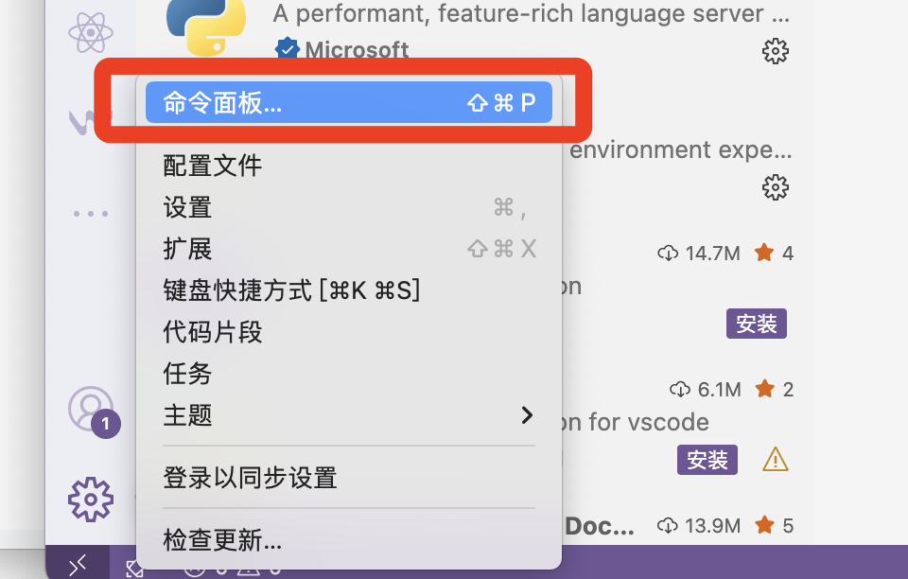

|  |
| --- |
| python:select interpreter |

|  |  |
| --- | --- |
|  |  |

**激活命令：**

conda activate py312

**退出命令：**

conda deactivate

**更新之后的**

Ai-预习资料v2.1（毛）

https://share.note.youdao.com/s/HwEpfoA8

**1.软件安装**

* **Pycharm安装：** [env-pycharm安装](https://note.youdao.com/s/Pd6zCswy)
* **作用：** 用于编写python代码，运行课程中的代码

1. **pycharm使用中文说明：**[**https://pycharm.net.cn/**](https://pycharm.net.cn/)
2. **Mac M芯片：**<https://download.jetbrains.com/python/pycharm-community-2024.1.3-aarch64.dmg>

**[pycharm-community-2024.1.3-aarch64.dmg]**

**2.深度学习环境配置**

**2.1 Jieba安装**

jieba 是一个专门用于中文文本分词的 Python 库,可以将连续的中文字符切分为有意义的词语

|  |
| --- |
| **pip install jieba -i https://pypi.tuna.tsinghua.edu.cn/simple** |

|  |
| --- |
| Bash (base) liufengxiang@liufengangdeMBP ~ % conda activate py312 (py312) liufengxiang@liufengangdeMBP ~ % pip install jieba -i https://pypi.tuna.tsinghua.edu.cn/simple Looking in indexes: https://pypi.tuna.tsinghua.edu.cn/simple Collecting jieba  Downloading https://pypi.tuna.tsinghua.edu.cn/packages/c6/cb/18eeb235f833b726522d7ebed54f2278ce28ba9438e3135ab0278d9792a2/jieba-0.42.1.tar.gz (19.2 MB)  ━━━━━━━━━━━━━━━━━━━━━━━━━━━━━━━━━━━━━━━━ 19.2/19.2 MB 3.7 MB/s eta 0:00:00  Preparing metadata (setup.py) ... done Building wheels for collected packages: jieba  DEPRECATION: Building 'jieba' using the legacy setup.py bdist_wheel mechanism, which will be removed in a future version. pip 25.3 will enforce this behaviour change. A possible replacement is to use the standardized build interface by setting the `--use-pep517` option, (possibly combined with `--no-build-isolation`), or adding a `pyproject.toml` file to the source tree of 'jieba'. Discussion can be found at https://github.com/pypa/pip/issues/6334  Building wheel for jieba (setup.py) ... done  Created wheel for jieba: filename=jieba-0.42.1-py3-none-any.whl size=19314509 sha256=2b3fb776a4430cba83521f79fc01193e0c179e16b189a814dcf72b6657e99699  Stored in directory: /Users/liufengxiang/Library/Caches/pip/wheels/7b/3a/3e/1bf625b8dd63d53265aad527b244647c679dff9b60588a324f Successfully built jieba Installing collected packages: jieba Successfully installed jieba-0.42.1 (py312) liufengxiang@liufengangdeMBP ~ % |

**2.2 Gensim安装**

用于主题建模和文本相似性计算

|  |
| --- |
| conda activate py312  pip install gensim -i https://pypi.tuna.tsinghua.edu.cn/simple |

**在线安装gensim【推荐】**

1. 打开cmd，进入到对应的py环境：conda activate env_name

* 比如要使用的环境为：py312：conda activate py312

1. 安装命令：pip install gensim -i https://pypi.tuna.tsinghua.edu.cn/simple
2. 返回：Successfully installed gensim-x.x.x, 代表安装成功。

|  |
| --- |
| Bash (py312) liufengxiang@liufengangdeMBP ~ % pip install gensim -i https://pypi.tuna.tsinghua.edu.cn/simple Looking in indexes: https://pypi.tuna.tsinghua.edu.cn/simple Collecting gensim  Downloading https://pypi.tuna.tsinghua.edu.cn/packages/1f/76/616bc781bc19ee76b387a101211f73e00cf59368fcc221e77f88ea907d04/gensim-4.3.3-cp312-cp312-macosx_11_0_arm64.whl (24.0 MB)  ━━━━━━━━━━━━━━━━━━━━━━━━━━━━━━━━━━━━━━━━ 24.0/24.0 MB 5.6 MB/s eta 0:00:00 Requirement already satisfied: numpy<2.0,>=1.18.5 in /opt/miniconda3/envs/py312/lib/python3.12/site-packages (from gensim) (1.26.4) Collecting scipy<1.14.0,>=1.7.0 (from gensim)  Downloading https://pypi.tuna.tsinghua.edu.cn/packages/dc/5a/2043a3bde1443d94014aaa41e0b50c39d046dda8360abd3b2a1d3f79907d/scipy-1.13.1-cp312-cp312-macosx_12_0_arm64.whl (30.4 MB)  ━━━━━━━━━━━━━━━━━━━━━━━━━━━━━━━━━━━━━━━━ 30.4/30.4 MB 5.4 MB/s eta 0:00:00 Collecting smart-open>=1.8.1 (from gensim)  Downloading https://pypi.tuna.tsinghua.edu.cn/packages/08/5b/a2a3d4514c64818925f4e886d39981f1926eeb5288a4549c6b3c17ed66bb/smart_open-7.3.0.post1-py3-none-any.whl (61 kB) Collecting wrapt (from smart-open>=1.8.1->gensim)  Downloading https://pypi.tuna.tsinghua.edu.cn/packages/33/df/bdf864b8997aab4febb96a9ae5c124f700a5abd9b5e13d2a3214ec4be705/wrapt-1.17.3-cp312-cp312-macosx_11_0_arm64.whl (39 kB) Installing collected packages: wrapt, scipy, smart-open, gensim  Attempting uninstall: scipy  Found existing installation: scipy 1.16.1  Uninstalling scipy-1.16.1:  Successfully uninstalled scipy-1.16.1 Successfully installed gensim-4.3.3 scipy-1.13.1 smart-open-7.3.0.post1 wrapt-1.17.3 (py312) liufengxiang@liufengangdeMBP ~ % |

**2.3 Peft安装**

模型微调

|  |
| --- |
| pip install peft==0.15.0 -i https://pypi.tuna.tsinghua.edu.cn/simple |

|  |
| --- |
| Bash (py312) liufengxiang@liufengangdeMBP ~ % pip install peft==0.15.0 -i https://pypi.tuna.tsinghua.edu.cn/simple Looking in indexes: https://pypi.tuna.tsinghua.edu.cn/simple Collecting peft==0.15.0  Downloading https://pypi.tuna.tsinghua.edu.cn/packages/c3/0a/01efce80e60ce8b11adc90ac9077e4fe3b0fa2f4b03aa459206588e8f7bc/peft-0.15.0-py3-none-any.whl (410 kB) Requirement already satisfied: numpy>=1.17 in /opt/miniconda3/envs/py312/lib/python3.12/site-packages (from peft==0.15.0) (1.26.4) Requirement already satisfied: packaging>=20.0 in /opt/miniconda3/envs/py312/lib/python3.12/site-packages (from peft==0.15.0) (25.0) Collecting psutil (from peft==0.15.0)  Downloading https://pypi.tuna.tsinghua.edu.cn/packages/04/8b/30f930733afe425e3cbfc0e1468a30a18942350c1a8816acfade80c005c4/psutil-7.0.0-cp36-abi3-macosx_11_0_arm64.whl (239 kB) Collecting pyyaml (from peft==0.15.0)  Downloading https://pypi.tuna.tsinghua.edu.cn/packages/a8/0c/38374f5bb272c051e2a69281d71cba6fdb983413e6758b84482905e29a5d/PyYAML-6.0.2-cp312-cp312-macosx_11_0_arm64.whl (173 kB) Requirement already satisfied: torch>=1.13.0 in /opt/miniconda3/envs/py312/lib/python3.12/site-packages (from peft==0.15.0) (2.4.1) Collecting transformers (from peft==0.15.0)  Downloading https://pypi.tuna.tsinghua.edu.cn/packages/db/5a/022ac010bedfb5119734cf9d743cf1d830cb4c604f53bb1552216f4344dc/transformers-4.55.2-py3-none-any.whl (11.3 MB)  ━━━━━━━━━━━━━━━━━━━━━━━━━━━━━━━━━━━━━━━━ 11.3/11.3 MB 3.1 MB/s eta 0:00:00 Requirement already satisfied: tqdm in /opt/miniconda3/envs/py312/lib/python3.12/site-packages (from peft==0.15.0) (4.67.1) Collecting accelerate>=0.21.0 (from peft==0.15.0)  Downloading https://pypi.tuna.tsinghua.edu.cn/packages/30/dd/0107f0aa179869ee9f47ef5a2686abd5e022fdc82af901d535e52fe91ce1/accelerate-1.10.0-py3-none-any.whl (374 kB) Collecting safetensors (from peft==0.15.0)  Downloading https://pypi.tuna.tsinghua.edu.cn/packages/8c/c9/bb114c158540ee17907ec470d01980957fdaf87b4aa07914c24eba87b9c6/safetensors-0.6.2-cp38-abi3-macosx_11_0_arm64.whl (432 kB) Collecting huggingface_hub>=0.25.0 (from peft==0.15.0)  Downloading https://pypi.tuna.tsinghua.edu.cn/packages/39/7b/bb06b061991107cd8783f300adff3e7b7f284e330fd82f507f2a1417b11d/huggingface_hub-0.34.4-py3-none-any.whl (561 kB)  ━━━━━━━━━━━━━━━━━━━━━━━━━━━━━━━━━━━━━━━━ 561.5/561.5 kB 2.2 MB/s eta 0:00:00 Requirement already satisfied: filelock in /opt/miniconda3/envs/py312/lib/python3.12/site-packages (from huggingface_hub>=0.25.0->peft==0.15.0) (3.18.0) Requirement already satisfied: fsspec>=2023.5.0 in /opt/miniconda3/envs/py312/lib/python3.12/site-packages (from huggingface_hub>=0.25.0->peft==0.15.0) (2025.7.0) Collecting requests (from huggingface_hub>=0.25.0->peft==0.15.0)  Downloading https://pypi.tuna.tsinghua.edu.cn/packages/7c/e4/56027c4a6b4ae70ca9de302488c5ca95ad4a39e190093d6c1a8ace08341b/requests-2.32.4-py3-none-any.whl (64 kB) Requirement already satisfied: typing-extensions>=3.7.4.3 in /opt/miniconda3/envs/py312/lib/python3.12/site-packages (from huggingface_hub>=0.25.0->peft==0.15.0) (4.14.1) Collecting hf-xet<2.0.0,>=1.1.3 (from huggingface_hub>=0.25.0->peft==0.15.0)  Downloading https://pypi.tuna.tsinghua.edu.cn/packages/51/a3/fa5897099454aa287022a34a30e68dbff0e617760f774f8bd1db17f06bd4/hf_xet-1.1.7-cp37-abi3-macosx_11_0_arm64.whl (2.6 MB)  ━━━━━━━━━━━━━━━━━━━━━━━━━━━━━━━━━━━━━━━━ 2.6/2.6 MB 2.5 MB/s eta 0:00:00 Requirement already satisfied: sympy in /opt/miniconda3/envs/py312/lib/python3.12/site-packages (from torch>=1.13.0->peft==0.15.0) (1.14.0) Requirement already satisfied: networkx in /opt/miniconda3/envs/py312/lib/python3.12/site-packages (from torch>=1.13.0->peft==0.15.0) (3.5) Requirement already satisfied: jinja2 in /opt/miniconda3/envs/py312/lib/python3.12/site-packages (from torch>=1.13.0->peft==0.15.0) (3.1.6) Requirement already satisfied: setuptools in /opt/miniconda3/envs/py312/lib/python3.12/site-packages (from torch>=1.13.0->peft==0.15.0) (78.1.1) Requirement already satisfied: MarkupSafe>=2.0 in /opt/miniconda3/envs/py312/lib/python3.12/site-packages (from jinja2->torch>=1.13.0->peft==0.15.0) (3.0.2) Collecting charset_normalizer<4,>=2 (from requests->huggingface_hub>=0.25.0->peft==0.15.0)  Downloading https://pypi.tuna.tsinghua.edu.cn/packages/e9/5e/14c94999e418d9b87682734589404a25854d5f5d0408df68bc15b6ff54bb/charset_normalizer-3.4.3-cp312-cp312-macosx_10_13_universal2.whl (205 kB) Collecting idna<4,>=2.5 (from requests->huggingface_hub>=0.25.0->peft==0.15.0)  Downloading https://pypi.tuna.tsinghua.edu.cn/packages/76/c6/c88e154df9c4e1a2a66ccf0005a88dfb2650c1dffb6f5ce603dfbd452ce3/idna-3.10-py3-none-any.whl (70 kB) Collecting urllib3<3,>=1.21.1 (from requests->huggingface_hub>=0.25.0->peft==0.15.0)  Downloading https://pypi.tuna.tsinghua.edu.cn/packages/a7/c2/fe1e52489ae3122415c51f387e221dd0773709bad6c6cdaa599e8a2c5185/urllib3-2.5.0-py3-none-any.whl (129 kB) Collecting certifi>=2017.4.17 (from requests->huggingface_hub>=0.25.0->peft==0.15.0)  Downloading https://pypi.tuna.tsinghua.edu.cn/packages/e5/48/1549795ba7742c948d2ad169c1c8cdbae65bc450d6cd753d124b17c8cd32/certifi-2025.8.3-py3-none-any.whl (161 kB) Requirement already satisfied: mpmath<1.4,>=1.1.0 in /opt/miniconda3/envs/py312/lib/python3.12/site-packages (from sympy->torch>=1.13.0->peft==0.15.0) (1.3.0) Collecting regex!=2019.12.17 (from transformers->peft==0.15.0)  Downloading https://pypi.tuna.tsinghua.edu.cn/packages/cd/70/69506d53397b4bd6954061bae75677ad34deb7f6ca3ba199660d6f728ff5/regex-2025.7.34-cp312-cp312-macosx_11_0_arm64.whl (286 kB) Collecting tokenizers<0.22,>=0.21 (from transformers->peft==0.15.0)  Downloading https://pypi.tuna.tsinghua.edu.cn/packages/8d/a6/28975479e35ddc751dc1ddc97b9b69bf7fcf074db31548aab37f8116674c/tokenizers-0.21.4-cp39-abi3-macosx_11_0_arm64.whl (2.7 MB)  ━━━━━━━━━━━━━━━━━━━━━━━━━━━━━━━━━━━━━━━━ 2.7/2.7 MB 2.1 MB/s eta 0:00:00 Installing collected packages: urllib3, safetensors, regex, pyyaml, psutil, idna, hf-xet, charset_normalizer, certifi, requests, huggingface_hub, tokenizers, accelerate, transformers, peft Successfully installed accelerate-1.10.0 certifi-2025.8.3 charset_normalizer-3.4.3 hf-xet-1.1.7 huggingface_hub-0.34.4 idna-3.10 peft-0.15.0 psutil-7.0.0 pyyaml-6.0.2 regex-2025.7.34 requests-2.32.4 safetensors-0.6.2 tokenizers-0.21.4 transformers-4.55.2 urllib3-2.5.0 (py312) liufengxiang@liufengangdeMBP ~ % |

**2.4 transformers安装**

通过自注意力机制和位置编码，实现对序列数据的高效处理

|  |
| --- |
| pip install transformers==4.49.0 -i https://pypi.tuna.tsinghua.edu.cn/simple |

|  |
| --- |
| Bash (py312) liufengxiang@liufengangdeMBP ~ % pip install transformers==4.49.0 -i https://pypi.tuna.tsinghua.edu.cn/simple Looking in indexes: https://pypi.tuna.tsinghua.edu.cn/simple Collecting transformers==4.49.0  Downloading https://pypi.tuna.tsinghua.edu.cn/packages/20/37/1f29af63e9c30156a3ed6ebc2754077016577c094f31de7b2631e5d379eb/transformers-4.49.0-py3-none-any.whl (10.0 MB)  ━━━━━━━━━━━━━━━━━━━━━━━━━━━━━━━━━━━━━━━━ 10.0/10.0 MB 8.4 MB/s eta 0:00:00 Requirement already satisfied: filelock in /opt/miniconda3/envs/py312/lib/python3.12/site-packages (from transformers==4.49.0) (3.18.0) Requirement already satisfied: huggingface-hub<1.0,>=0.26.0 in /opt/miniconda3/envs/py312/lib/python3.12/site-packages (from transformers==4.49.0) (0.34.4) Requirement already satisfied: numpy>=1.17 in /opt/miniconda3/envs/py312/lib/python3.12/site-packages (from transformers==4.49.0) (1.26.4) Requirement already satisfied: packaging>=20.0 in /opt/miniconda3/envs/py312/lib/python3.12/site-packages (from transformers==4.49.0) (25.0) Requirement already satisfied: pyyaml>=5.1 in /opt/miniconda3/envs/py312/lib/python3.12/site-packages (from transformers==4.49.0) (6.0.2) Requirement already satisfied: regex!=2019.12.17 in /opt/miniconda3/envs/py312/lib/python3.12/site-packages (from transformers==4.49.0) (2025.7.34) Requirement already satisfied: requests in /opt/miniconda3/envs/py312/lib/python3.12/site-packages (from transformers==4.49.0) (2.32.4) Requirement already satisfied: tokenizers<0.22,>=0.21 in /opt/miniconda3/envs/py312/lib/python3.12/site-packages (from transformers==4.49.0) (0.21.4) Requirement already satisfied: safetensors>=0.4.1 in /opt/miniconda3/envs/py312/lib/python3.12/site-packages (from transformers==4.49.0) (0.6.2) Requirement already satisfied: tqdm>=4.27 in /opt/miniconda3/envs/py312/lib/python3.12/site-packages (from transformers==4.49.0) (4.67.1) Requirement already satisfied: fsspec>=2023.5.0 in /opt/miniconda3/envs/py312/lib/python3.12/site-packages (from huggingface-hub<1.0,>=0.26.0->transformers==4.49.0) (2025.7.0) Requirement already satisfied: typing-extensions>=3.7.4.3 in /opt/miniconda3/envs/py312/lib/python3.12/site-packages (from huggingface-hub<1.0,>=0.26.0->transformers==4.49.0) (4.14.1) Requirement already satisfied: hf-xet<2.0.0,>=1.1.3 in /opt/miniconda3/envs/py312/lib/python3.12/site-packages (from huggingface-hub<1.0,>=0.26.0->transformers==4.49.0) (1.1.7) Requirement already satisfied: charset_normalizer<4,>=2 in /opt/miniconda3/envs/py312/lib/python3.12/site-packages (from requests->transformers==4.49.0) (3.4.3) Requirement already satisfied: idna<4,>=2.5 in /opt/miniconda3/envs/py312/lib/python3.12/site-packages (from requests->transformers==4.49.0) (3.10) Requirement already satisfied: urllib3<3,>=1.21.1 in /opt/miniconda3/envs/py312/lib/python3.12/site-packages (from requests->transformers==4.49.0) (2.5.0) Requirement already satisfied: certifi>=2017.4.17 in /opt/miniconda3/envs/py312/lib/python3.12/site-packages (from requests->transformers==4.49.0) (2025.8.3) Installing collected packages: transformers  Attempting uninstall: transformers  Found existing installation: transformers 4.55.2  Uninstalling transformers-4.55.2:  Successfully uninstalled transformers-4.55.2 Successfully installed transformers-4.49.0 (py312) liufengxiang@liufengangdeMBP ~ % |

**2.5 fastapi[standard]**

现代、快速（高性能）的 Python Web 框架，用于构建API

|  |
| --- |
| * **Mac命令**：pip install fastapi -i https://pypi.tuna.tsinghua.edu.cn/simple |

|  |
| --- |
| Bash (py312) liufengxiang@liufengangdeMBP ~ % pip install fastapi -i https://pypi.tuna.tsinghua.edu.cn/simple Looking in indexes: https://pypi.tuna.tsinghua.edu.cn/simple Collecting fastapi  Downloading https://pypi.tuna.tsinghua.edu.cn/packages/e5/47/d63c60f59a59467fda0f93f46335c9d18526d7071f025cb5b89d5353ea42/fastapi-0.116.1-py3-none-any.whl (95 kB) Collecting starlette<0.48.0,>=0.40.0 (from fastapi)  Downloading https://pypi.tuna.tsinghua.edu.cn/packages/f7/1f/b876b1f83aef204198a42dc101613fefccb32258e5428b5f9259677864b4/starlette-0.47.2-py3-none-any.whl (72 kB) Collecting pydantic!=1.8,!=1.8.1,!=2.0.0,!=2.0.1,!=2.1.0,<3.0.0,>=1.7.4 (from fastapi)  Downloading https://pypi.tuna.tsinghua.edu.cn/packages/6a/c0/ec2b1c8712ca690e5d61979dee872603e92b8a32f94cc1b72d53beab008a/pydantic-2.11.7-py3-none-any.whl (444 kB) Requirement already satisfied: typing-extensions>=4.8.0 in /opt/miniconda3/envs/py312/lib/python3.12/site-packages (from fastapi) (4.14.1) Collecting annotated-types>=0.6.0 (from pydantic!=1.8,!=1.8.1,!=2.0.0,!=2.0.1,!=2.1.0,<3.0.0,>=1.7.4->fastapi)  Downloading https://pypi.tuna.tsinghua.edu.cn/packages/78/b6/6307fbef88d9b5ee7421e68d78a9f162e0da4900bc5f5793f6d3d0e34fb8/annotated_types-0.7.0-py3-none-any.whl (13 kB) Collecting pydantic-core==2.33.2 (from pydantic!=1.8,!=1.8.1,!=2.0.0,!=2.0.1,!=2.1.0,<3.0.0,>=1.7.4->fastapi)  Downloading https://pypi.tuna.tsinghua.edu.cn/packages/a1/02/6224312aacb3c8ecbaa959897af57181fb6cf3a3d7917fd44d0f2917e6f2/pydantic_core-2.33.2-cp312-cp312-macosx_11_0_arm64.whl (1.8 MB)  ━━━━━━━━━━━━━━━━━━━━━━━━━━━━━━━━━━━━━━━━ 1.8/1.8 MB 3.2 MB/s eta 0:00:00 Collecting typing-inspection>=0.4.0 (from pydantic!=1.8,!=1.8.1,!=2.0.0,!=2.0.1,!=2.1.0,<3.0.0,>=1.7.4->fastapi)  Downloading https://pypi.tuna.tsinghua.edu.cn/packages/17/69/cd203477f944c353c31bade965f880aa1061fd6bf05ded0726ca845b6ff7/typing_inspection-0.4.1-py3-none-any.whl (14 kB) Collecting anyio<5,>=3.6.2 (from starlette<0.48.0,>=0.40.0->fastapi)  Downloading https://pypi.tuna.tsinghua.edu.cn/packages/6f/12/e5e0282d673bb9746bacfb6e2dba8719989d3660cdb2ea79aee9a9651afb/anyio-4.10.0-py3-none-any.whl (107 kB) Requirement already satisfied: idna>=2.8 in /opt/miniconda3/envs/py312/lib/python3.12/site-packages (from anyio<5,>=3.6.2->starlette<0.48.0,>=0.40.0->fastapi) (3.10) Collecting sniffio>=1.1 (from anyio<5,>=3.6.2->starlette<0.48.0,>=0.40.0->fastapi)  Downloading https://pypi.tuna.tsinghua.edu.cn/packages/e9/44/75a9c9421471a6c4805dbf2356f7c181a29c1879239abab1ea2cc8f38b40/sniffio-1.3.1-py3-none-any.whl (10 kB) Installing collected packages: typing-inspection, sniffio, pydantic-core, annotated-types, pydantic, anyio, starlette, fastapi Successfully installed annotated-types-0.7.0 anyio-4.10.0 fastapi-0.116.1 pydantic-2.11.7 pydantic-core-2.33.2 sniffio-1.3.1 starlette-0.47.2 typing-inspection-0.4.1 (py312) liufengxiang@liufengangdeMBP ~ % |

**2.6 mypy**

静态类型检查工具，它使用 Python 的类型提示（Type Hints）来检查代码中的类型错误。

|  |
| --- |
| pip install fastapi -i https://pypi.tuna.tsinghua.edu.cn/simple |

|  |
| --- |
| Bash (py312) liufengxiang@liufengangdeMBP ~ % pip install fastapi -i https://pypi.tuna.tsinghua.edu.cn/simple Looking in indexes: https://pypi.tuna.tsinghua.edu.cn/simple Collecting fastapi  Downloading https://pypi.tuna.tsinghua.edu.cn/packages/e5/47/d63c60f59a59467fda0f93f46335c9d18526d7071f025cb5b89d5353ea42/fastapi-0.116.1-py3-none-any.whl (95 kB) Collecting starlette<0.48.0,>=0.40.0 (from fastapi)  Downloading https://pypi.tuna.tsinghua.edu.cn/packages/f7/1f/b876b1f83aef204198a42dc101613fefccb32258e5428b5f9259677864b4/starlette-0.47.2-py3-none-any.whl (72 kB) Collecting pydantic!=1.8,!=1.8.1,!=2.0.0,!=2.0.1,!=2.1.0,<3.0.0,>=1.7.4 (from fastapi)  Downloading https://pypi.tuna.tsinghua.edu.cn/packages/6a/c0/ec2b1c8712ca690e5d61979dee872603e92b8a32f94cc1b72d53beab008a/pydantic-2.11.7-py3-none-any.whl (444 kB) Requirement already satisfied: typing-extensions>=4.8.0 in /opt/miniconda3/envs/py312/lib/python3.12/site-packages (from fastapi) (4.14.1) Collecting annotated-types>=0.6.0 (from pydantic!=1.8,!=1.8.1,!=2.0.0,!=2.0.1,!=2.1.0,<3.0.0,>=1.7.4->fastapi)  Downloading https://pypi.tuna.tsinghua.edu.cn/packages/78/b6/6307fbef88d9b5ee7421e68d78a9f162e0da4900bc5f5793f6d3d0e34fb8/annotated_types-0.7.0-py3-none-any.whl (13 kB) Collecting pydantic-core==2.33.2 (from pydantic!=1.8,!=1.8.1,!=2.0.0,!=2.0.1,!=2.1.0,<3.0.0,>=1.7.4->fastapi)  Downloading https://pypi.tuna.tsinghua.edu.cn/packages/a1/02/6224312aacb3c8ecbaa959897af57181fb6cf3a3d7917fd44d0f2917e6f2/pydantic_core-2.33.2-cp312-cp312-macosx_11_0_arm64.whl (1.8 MB)  ━━━━━━━━━━━━━━━━━━━━━━━━━━━━━━━━━━━━━━━━ 1.8/1.8 MB 3.2 MB/s eta 0:00:00 Collecting typing-inspection>=0.4.0 (from pydantic!=1.8,!=1.8.1,!=2.0.0,!=2.0.1,!=2.1.0,<3.0.0,>=1.7.4->fastapi)  Downloading https://pypi.tuna.tsinghua.edu.cn/packages/17/69/cd203477f944c353c31bade965f880aa1061fd6bf05ded0726ca845b6ff7/typing_inspection-0.4.1-py3-none-any.whl (14 kB) Collecting anyio<5,>=3.6.2 (from starlette<0.48.0,>=0.40.0->fastapi)  Downloading https://pypi.tuna.tsinghua.edu.cn/packages/6f/12/e5e0282d673bb9746bacfb6e2dba8719989d3660cdb2ea79aee9a9651afb/anyio-4.10.0-py3-none-any.whl (107 kB) Requirement already satisfied: idna>=2.8 in /opt/miniconda3/envs/py312/lib/python3.12/site-packages (from anyio<5,>=3.6.2->starlette<0.48.0,>=0.40.0->fastapi) (3.10) Collecting sniffio>=1.1 (from anyio<5,>=3.6.2->starlette<0.48.0,>=0.40.0->fastapi)  Downloading https://pypi.tuna.tsinghua.edu.cn/packages/e9/44/75a9c9421471a6c4805dbf2356f7c181a29c1879239abab1ea2cc8f38b40/sniffio-1.3.1-py3-none-any.whl (10 kB) Installing collected packages: typing-inspection, sniffio, pydantic-core, annotated-types, pydantic, anyio, starlette, fastapi Successfully installed annotated-types-0.7.0 anyio-4.10.0 fastapi-0.116.1 pydantic-2.11.7 pydantic-core-2.33.2 sniffio-1.3.1 starlette-0.47.2 typing-inspection-0.4.1 (py312) liufengxiang@liufengangdeMBP ~ % pip install mypy -i https://pypi.tuna.tsinghua.edu.cn/simple Looking in indexes: https://pypi.tuna.tsinghua.edu.cn/simple Collecting mypy  Downloading https://pypi.tuna.tsinghua.edu.cn/packages/14/1f/19e7e44b594d4b12f6ba8064dbe136505cec813549ca3e5191e40b1d3cc2/mypy-1.17.1-cp312-cp312-macosx_11_0_arm64.whl (10.1 MB)  ━━━━━━━━━━━━━━━━━━━━━━━━━━━━━━━━━━━━━━━━ 10.1/10.1 MB 3.5 MB/s eta 0:00:00 Requirement already satisfied: typing_extensions>=4.6.0 in /opt/miniconda3/envs/py312/lib/python3.12/site-packages (from mypy) (4.14.1) Collecting mypy_extensions>=1.0.0 (from mypy)  Downloading https://pypi.tuna.tsinghua.edu.cn/packages/79/7b/2c79738432f5c924bef5071f933bcc9efd0473bac3b4aa584a6f7c1c8df8/mypy_extensions-1.1.0-py3-none-any.whl (5.0 kB) Collecting pathspec>=0.9.0 (from mypy)  Downloading https://pypi.tuna.tsinghua.edu.cn/packages/cc/20/ff623b09d963f88bfde16306a54e12ee5ea43e9b597108672ff3a408aad6/pathspec-0.12.1-py3-none-any.whl (31 kB) Installing collected packages: pathspec, mypy_extensions, mypy Successfully installed mypy-1.17.1 mypy_extensions-1.1.0 pathspec-0.12.1 (py312) liufengxiang@liufengangdeMBP ~ % |

**2.7 Pycharm中配置conda环境**

**安装文档：**[**env-pycharm中配置conda环境**](https://note.youdao.com/s/HMaU5s5b)

