In this lab, I discovered networks through the ipconfig command, tested connectivity between local and outside sources with the ping command, and traced the paths with tracert.

tracert is a command that traces the route and reports each router encountered between your workstation and another.

nslookup is a network administration command that queries the DNS to obtain mapping between domain name and IP address.

Link to tech journal: <https://github.com/seraphimgerber/NET-150>

Fill in the following information for your Ethernet Adapter:

IPv4 Address: 192.168.3.118

Subnet Mask: 255.255.255.0

Default Gateway: 192.168.3.250

Run the command ipconfig /all. Fill in the following information:

Physical Address(of your active port): 48-21-0b-33-5E-87

DNS Servers: 192.168.4.4

192.168.4.5

192.168.4.3

To test connectivity, we often use the ping Ping the IPv4 address of your default gateway i.e. ping 192.168.0.1 where 192.168.0.1 is the address you wrote down in 8-3.

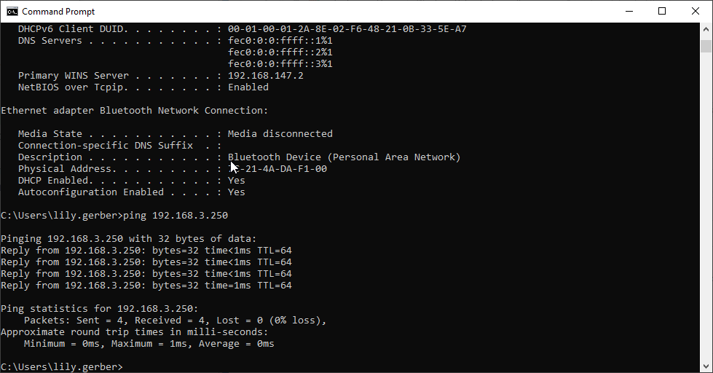

Now test connectivity to an outside source. Run the command ping [www.google.com](http://www.google.com).

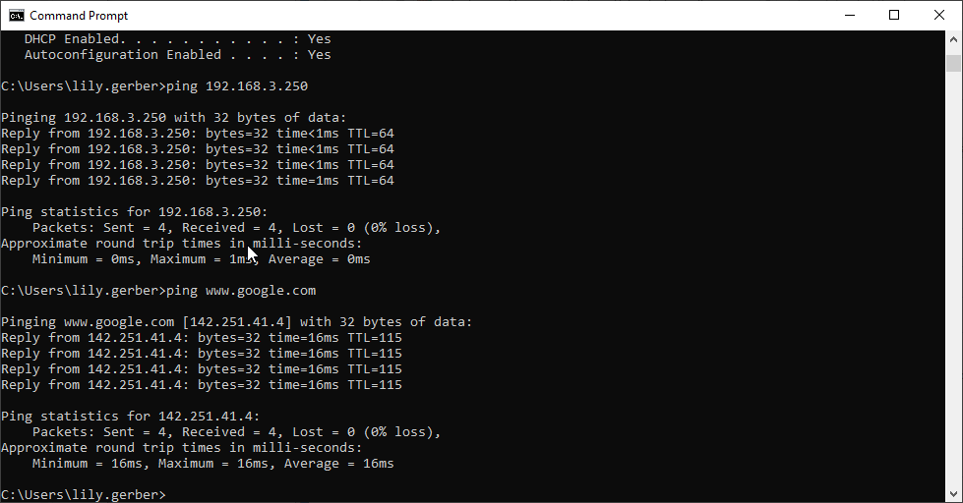

Ping the IP address of the person to your right or left. How are the results different from pinging Google?

The results are different as pinging Google takes slightly more time.

How many hops were there between you and google? What are the names of the routers? Add screen capture.

There were 14 hops and the names of the routers are champlain.edu, static.burlingtontelecom.net, equinix.com.

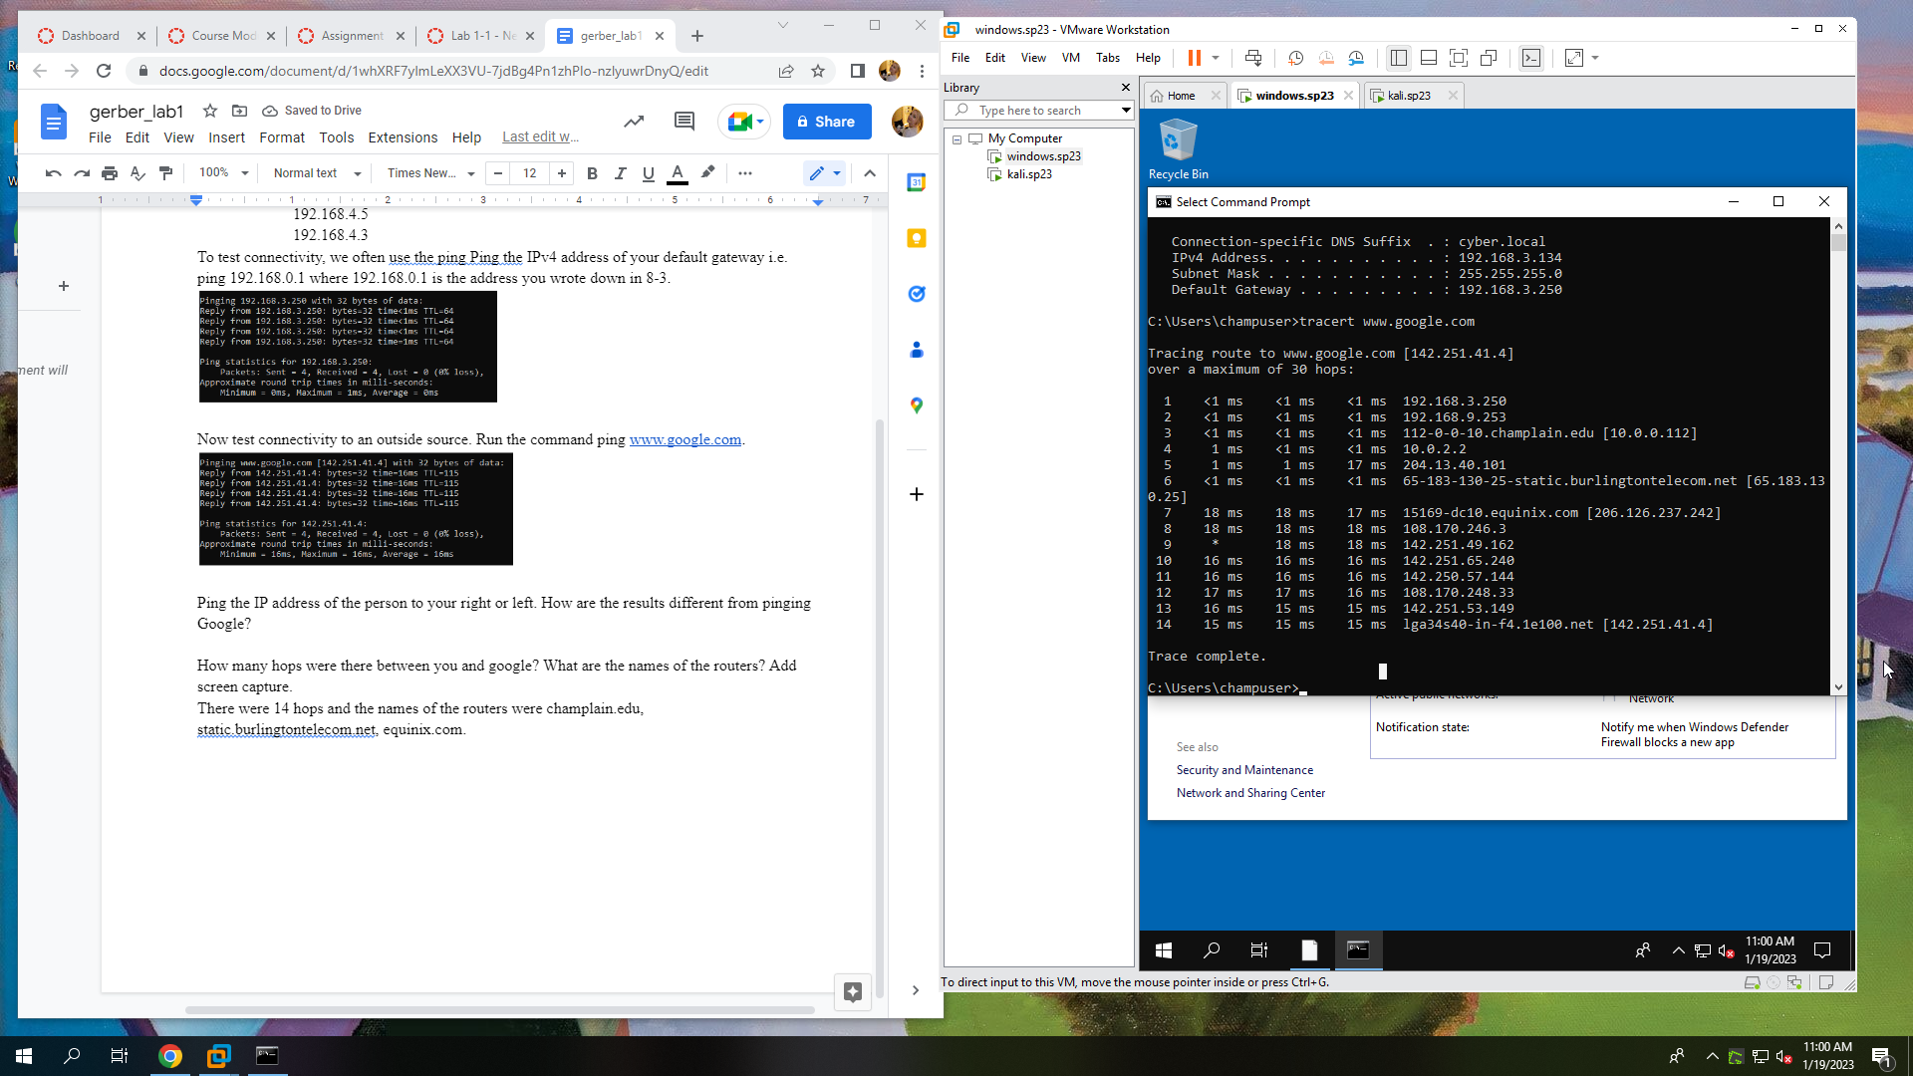

Answer the following:

Type bing.com

How many IP addresses are assigned to bing.com?: 2

Take a screenshot of the cmd window and submit.

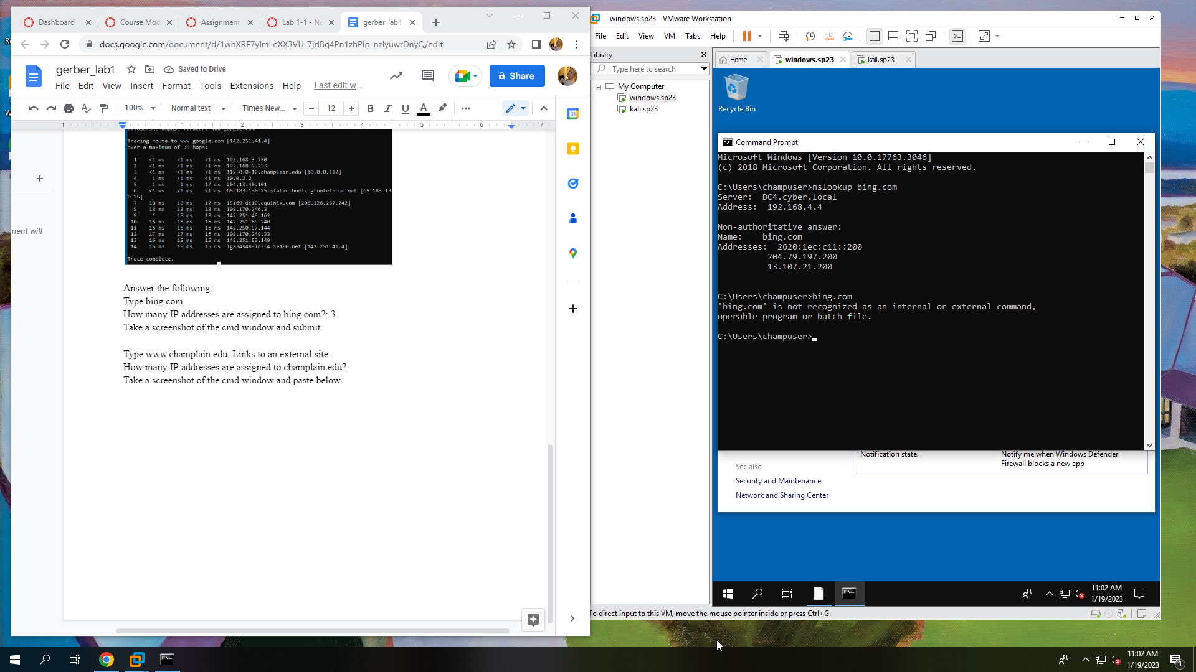

Type www.champlain.edu. Links to an external site.

How many IP addresses are assigned to champlain.edu?: 1

Take a screenshot of the cmd window and paste below.

