In this lab, I observed LAN activity through Wireshark.

ping [destination] -4 to show only IPv4 addresses.

Link to tech journal: <https://github.com/seraphimgerber/NET-150>

**What is the IP address of your default gateway?**

The IP address of the default gateway is 192.168.3.250

**Record: What are the source and destination MAC addresses (Not IP Addresses) SCREEN CAPTURE:**

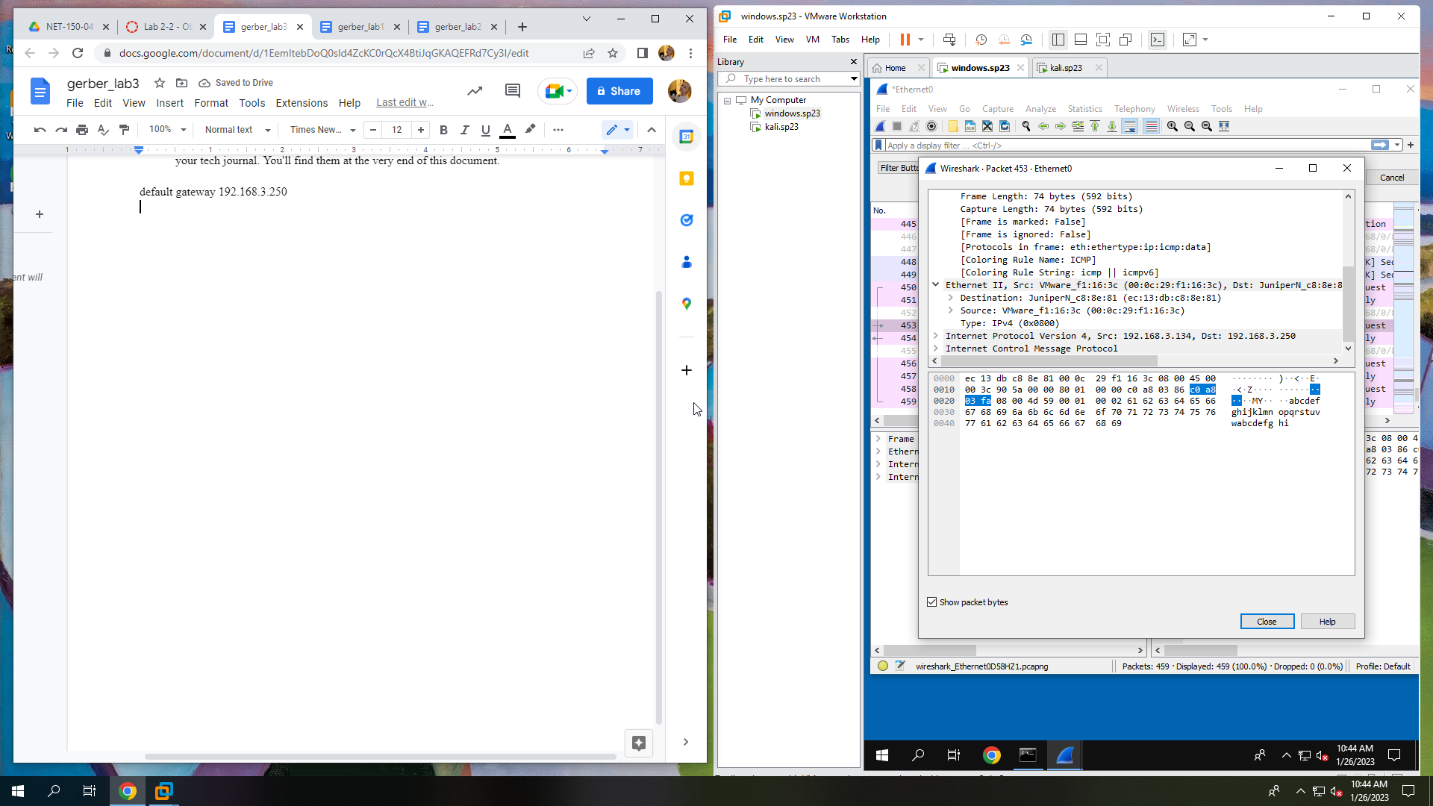

**Record: What are the source and destination MAC addresses SCREEN CAPTURE:**

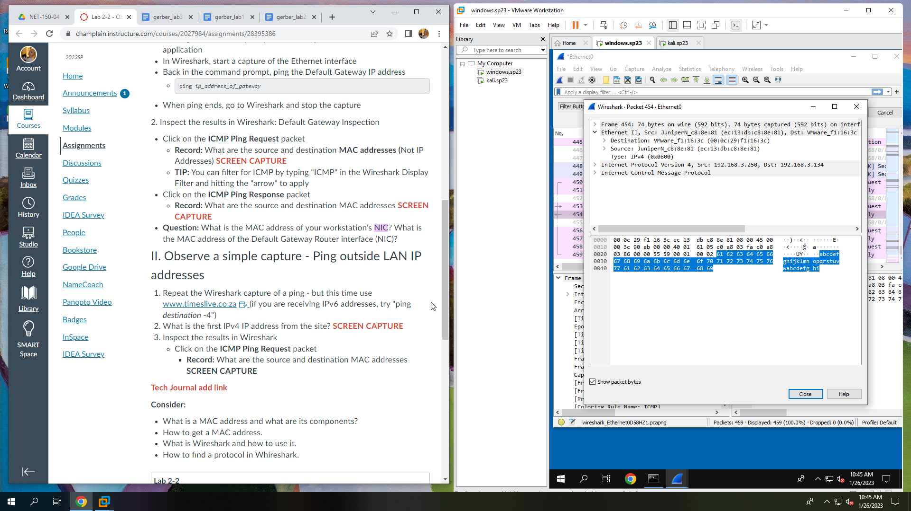

**What is the MAC address of your workstation's NIC? What is the MAC address of the Default Gateway Router interface (NIC)?**

Workstation’s MAC address is 00:0c:29:f1:16:3c

Default Gateway Router’s MAC address is ec:13:db:c8:8e:81

**What is the first IPv4 IP address from the site? SCREEN CAPTURE:**

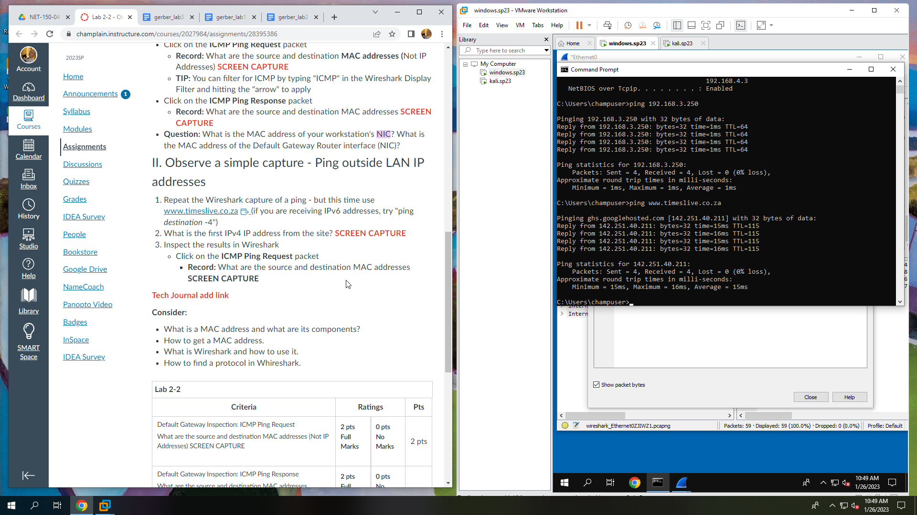

**Record: What are the source and destination MAC addresses SCREEN CAPTURE:**

