In this lab, I will locate, deploy, and cable multiple types of devices using Packet Tracer.

Link to tech journal: <https://github.com/seraphimgerber/NET-150>

SUBMIT: Screenshot of the completed lab in Packet Tracer with your name visible on Workspace:

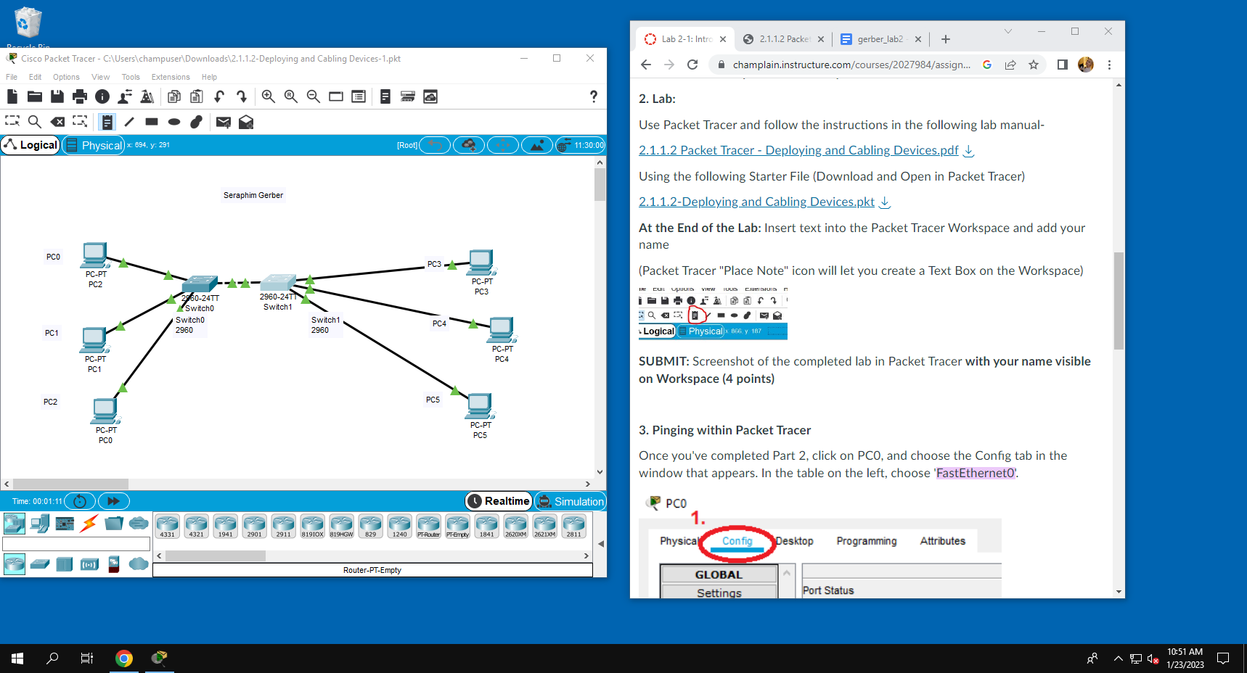

SUBMIT: A screenshot of the PC0 terminal window showing a successful ping of PC1:

