In this lab, I used Packet Tracer to simulate a small network and used that to observe ARP.

enable moves you to admin mode and exit returns you to basic mode for admin.

show mac-address-table shows you the table of MAC addresses.

Link to tech journal: <https://github.com/seraphimgerber/NET-150>

**What is the MAC address of PC0?**

000A.F3B9.E829

**Is there an IP address?**

Not assigned yet.

**Hold the mouse over the switch to see the configuration.**

**Are there IP addresses assigned?**

Not assigned yet.

**What does it mean for PCs to be "on the same network"?**

It means that they are connected to the same network and the first number of their IP address is the same.

**SUBMIT (2 Points) Screenshot showing successful ping between PC0 and PC3.**

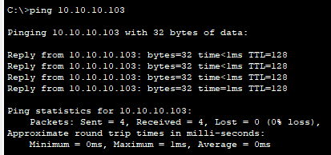

**SUBMIT (3 Points): Complete the following table**

MAC Address Port

0001.430b.1646 Fa0/3

000a.f3b9.e829 Fa0/1

0040.0b74 Fa0/4

0040.0b76.4160 Fa0/2

**SUBMIT: Screenshot of Packet Tracer showing all 4 PC's connected to switch (1 Points)**

