In this lab, I configured and observed a simple routed network using Cisco Packet Tracer.

Link to tech journal: <https://github.com/seraphimgerber/NET-150>

**What is a subnet mask?**

A subnet mask is an address that defines the range of IP addresses that can be added and used within a network. By adjusting the subnet mask, you can designate how many IP addresses are available in a network. The most common one is 255.255.255.0.

**Define default gateway?**

A default gateway is the forwarding route that gets used by a packet when no IP address is specified. **Q1: SUBMIT screenshots of a successful ping between PC0 and PC1 (2 points) and a successful ping between PC0 and PC2 (2 points)**

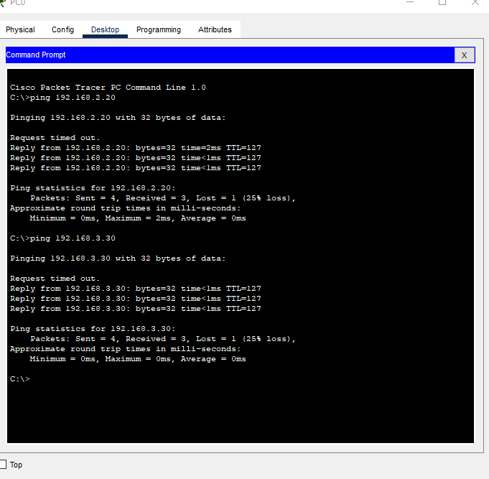

**What is the Source and Destination MAC address of the packet as it arrives at the switch? (1 point) SCREEN CAPTURE**

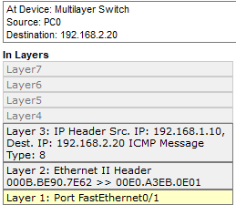

**What is the Source and Destination MAC address of the packet as it leaves the switch? (1 point) SCREEN CAPTURE**

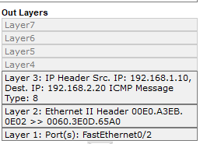

**Why does the Destination MAC of the packet arriving at the switch match the Source MAC of the packet leaving the switch? (3 point)**

Because it is moving from PC0 to the switch to PC1, so the destination becomes the source.