In this lab, I built and observed simple networks using two networks in Cisco Packet Tracer.

Link to tech journal: <https://github.com/seraphimgerber/NET-150>

**Submit: screenshot of successful ping (2 Points)**

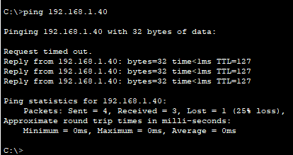

**SUBMIT: Screenshot of Details (Inbound or Outbound PDU) of a HTTP packet that includes the Source/Destination MAC, Source/Destination IP Address (2 Points)**

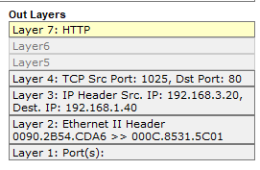

**Submit Screenshot of CNCS Router showing IP address on an Interface (2 Points)**

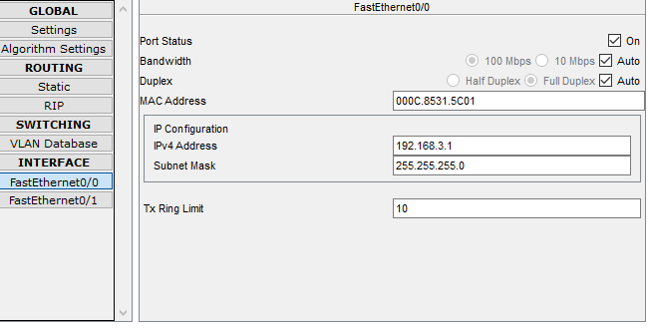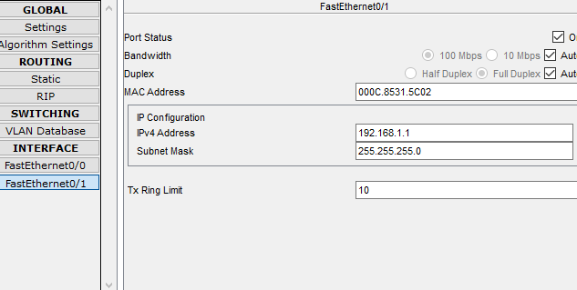

**Enter useful Packet Tracer Tips/Tricks:**

You can select the “delete” key on your keyboard to delete objects and wires. When you’re done, you can select the “Esc” tool.