In this lab,

Link to tech journal: <https://github.com/seraphimgerber/NET-150>

**Deliverable 1: Build the below network in Packet Tracer. Screen Capture of networks:**

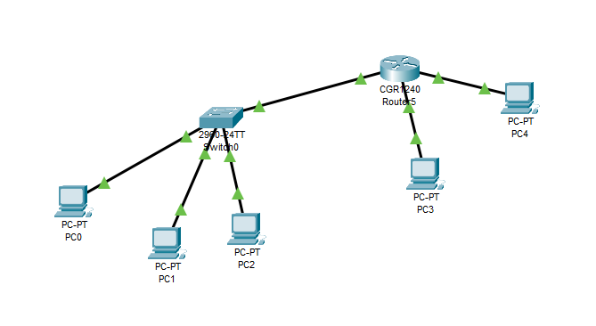**Deliverable 2: Screen capture of router IP settings.**

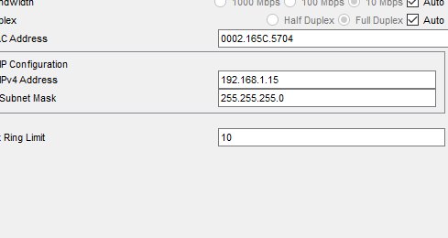

**Deliverable 3: Screen capture of HELLO! pinging Ping Me. 1 points**

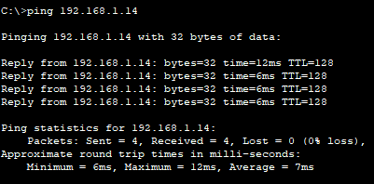

**Deliverable 4: SCREEN CAPTURE of sniffer GUI info. 2 points  
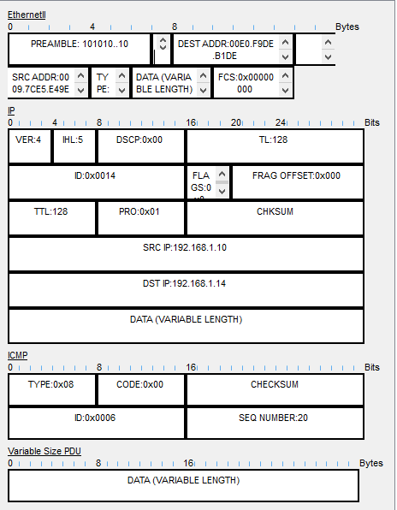  
Deliverable 5: What was different about the sniffer information when it was connected to a hub? 3 points**

There was no notable difference in information.

