In this lab, I configured a network in Packet Tracer.

Link to tech journal: <https://github.com/seraphimgerber/NET-150>

Deliverable 1. Show the successful transmission of a PDU from Joyce1 to Skiff1 and SkiffLast to JoyceLast. Make sure to Capture the PDU List showing these successes in a screenshot that captures your entire PT window to include the PDU list (make sure to label your diagram with your name)

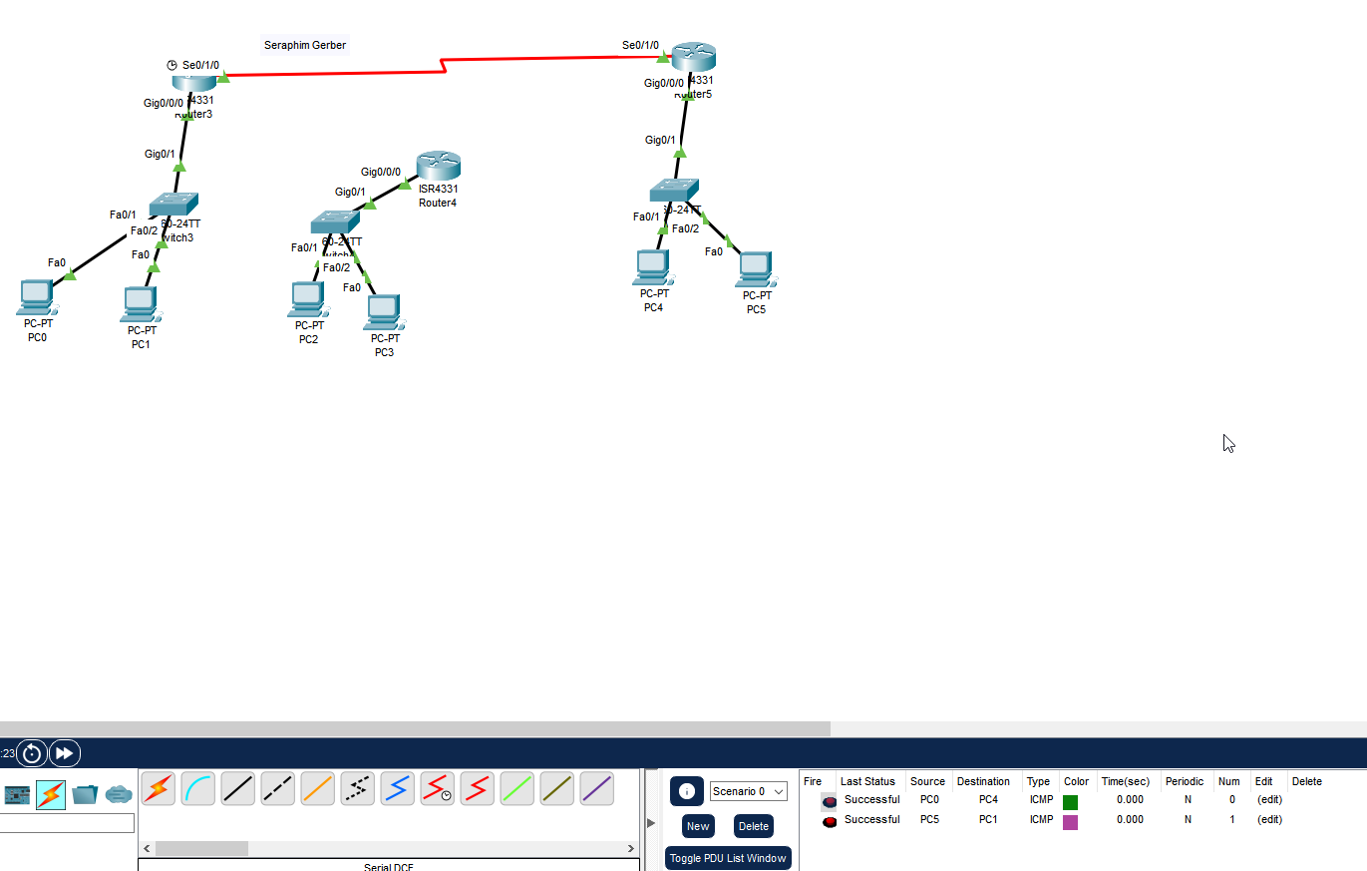

Deliverable 2. Show the successful transmission of a PDU from Foster1 to Skiff1 and Foster Last to SkiffLast in a screenshot that captures your entire PT window to include the PDU list (make sure to label your diagram with your name)

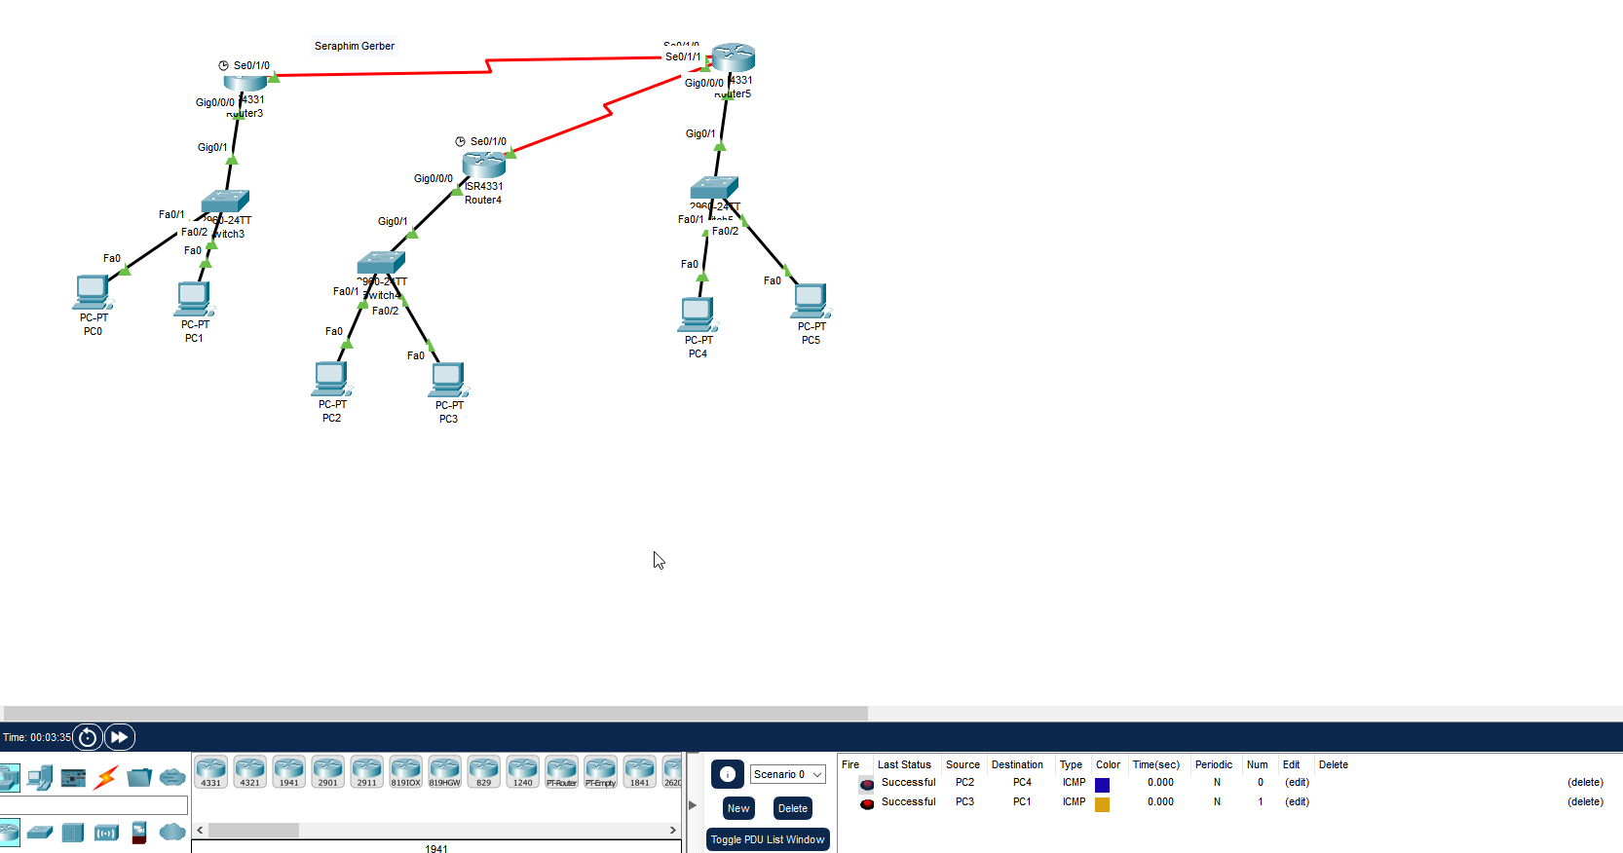

Deliverable 3. Technical Journal. Make sure to reflect on this lab, your difficulties with it and those new items covered to include configuration specifics of classful subnetting, RIP, Serial Connections and any IOS commands you experimented with. ADD LINK TO TECH JOURNAL

This lab was difficult as there were lots of things to configure. I faced several problems that I had to troubleshoot, such as forgetting to enter the RIP and change the clock rate.