Link to tech journal: <https://github.com/seraphimgerber/NET-150>

PPC uses the private class B space of 172.16.0.0/16. Currently all hosts are on the same network which is causing hate and discontent due to network performance impacts (hence, the sacking of Henry). Here is some information which may help you in designing your subnet scheme.

## Mumbai Divisions

* Manufacturing will need 612 hosts
* Engineering will need 31 hosts

## North American Divisions

* Sales is the largest division with a host requirement of 1200
* HR needs 10 hosts
* Accounting will need space for 24 hosts **(note gateways are part of this number too)**

Deliverable 2:

Using your chart from Deliverable 1, build this network from scratch in Packet Tracer (first host is the subnet gateway).

Screen Capture the below PDU Tests in one image.

Accounting First to Sales First

Sales Last to Manufacturing Last

HR First to Engineering First

Engineering Last to Sales Last

HR Last to Accounting Last

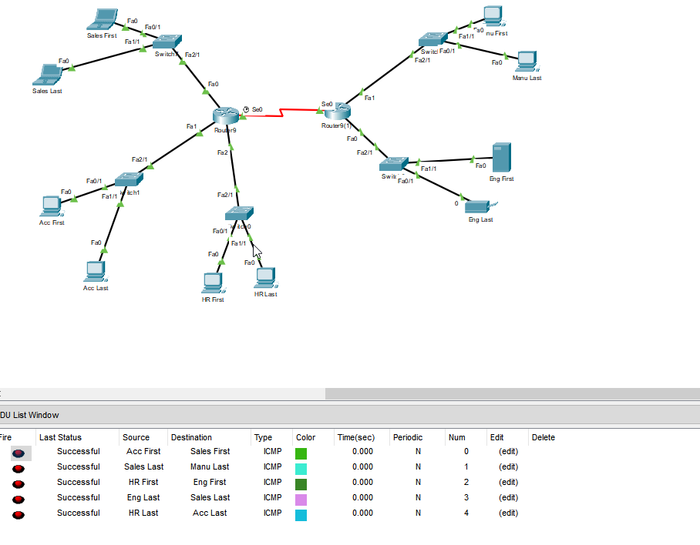

Deliverable 3.

Add to Tech Journal: Reflect on the Packet Tracer portion of your lab. What gave you the most difficulty and what lessons learned do you wish to carry forward? It can be a continuation of deliverable 1 if you wish. ADD TECH JOURNL LINK make sure it is clickable and goes directly to this lab's write up.

The Packet Tracer required lots of troubleshooting, especially when it came to ports. I had lots of difficulty finding how to add additional ports until I was able to add more modules, then it came down to finding the right device with the right module. It’s also important to ensure that clock rate is the same.