Deliverable 1: Invoke powershell on mgmt01 and query the active directory for your three Windows computers:

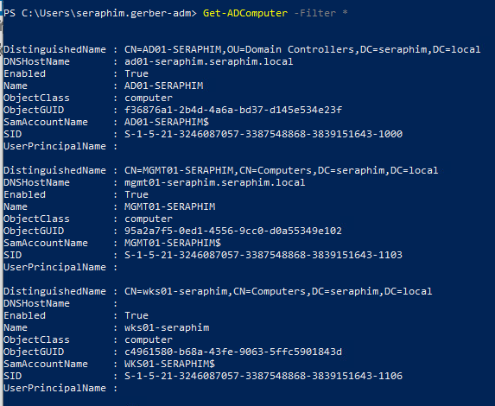

Deliverable 2: Enumerate your two named Domain Users (adjust filter for your name)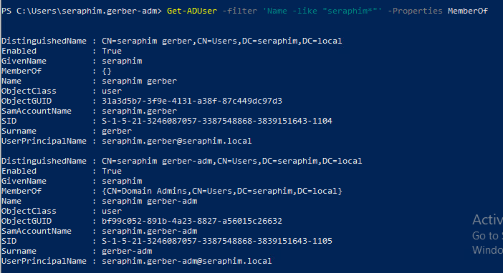

Deliverable 3: Print your DNS Server address and DNS A Records.

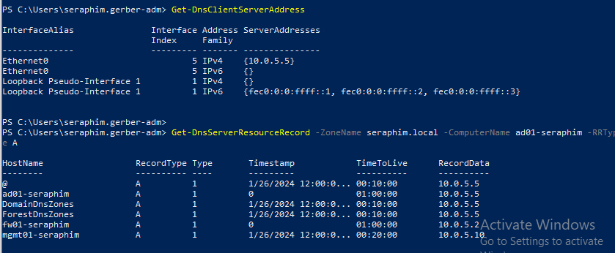

Deliverable 4: Check the first 3 hops of your route. Your network route should go through fw01's LAN interface(10.0.5.2) to the WAN default gateway 10.0.17.2 and then out through the CYBER.LOCAL default gateway on the 192.168.4.0/24 Network. You can use the powershell or the traditional tracert method. Provide a screenshot.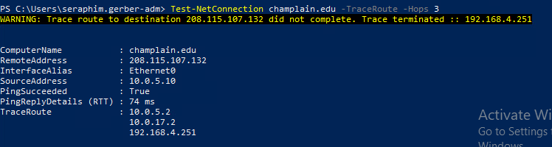

Deliverable 5: Deliverable 3 asked for A records. Figure out how to enumerate all the PTR records. Provide the command and output ptr records.

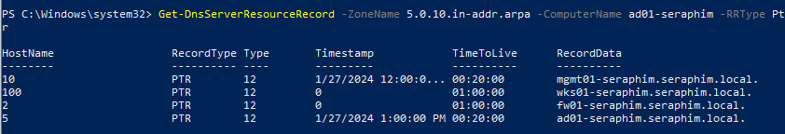

Deliverable 6: Tech Journal - This is similar to last term. This week’s journal should include a course journal page for SYS265 that has an initial entry, and include your notes from your environment configuration (in far more detail than the example). Make sure you include a list of at least 3 terms or topics from the lecture or lab that you want to learn more about, and your research results. Be sure to add your instructor’s GitHub account as a collaborator if your wiki is not public.

<https://github.com/seraphimgerber/SYS-265/tree/main>

Deliverable 7. Your deliverable meets the submission guidelines.