Deliverable 1. Take a screenshot of the output that shows some of the SNMP values from fw01 (note the nslookup to make sure of the hostname). The output should look similar to this: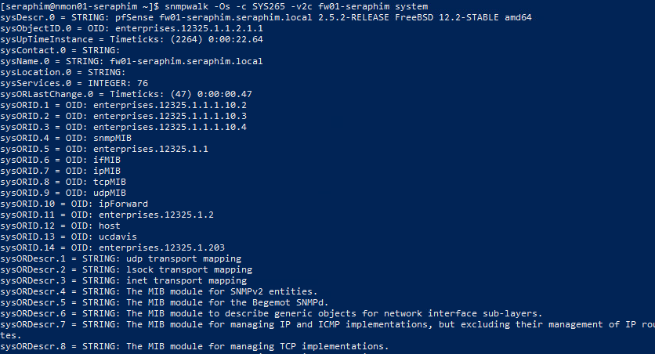

Deliverable 2. Provide the output from the following command run on nmon01.

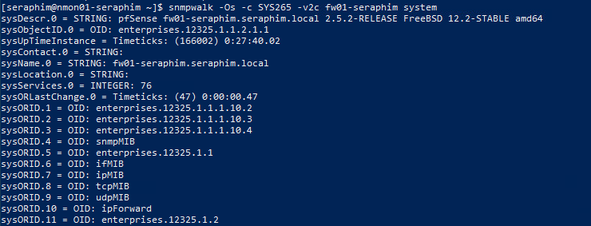

Deliverable 3. Provide the output of the SNMP system values on ad01 with the following command

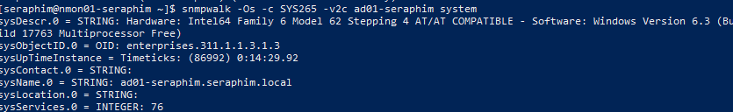

Deliverable 4. Provide a screenshot from the tcpdump session on web01 that shows the clear text community string. Remember, anyone in a position to grab packets between nmon01 and the target can see this string.

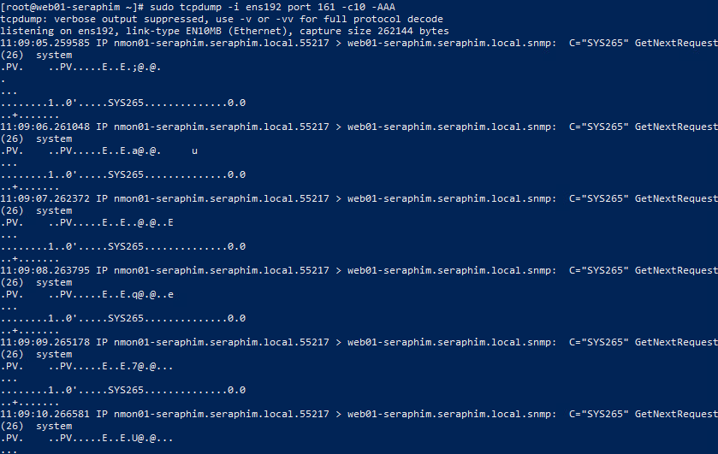

Deliverable 5: Tech Journal entry - This week’s journal should include notes re: SNMP (in far more detail than the example). Make sure you include at least 3 topics/articles from the lecture or lab that you were unfamiliar with and your research results. Be sure to add your instructor’s GitHub account as a collaborator if your wiki is not public.

<https://github.com/seraphimgerber/SYS-265>

Deliverable 6. Your deliverable meets the submission guidelines.