

CASI WHITEPAPER · NO. 1
Foundations of Integrated Corporate Carbon Accounting
This whitepaper describes the structure of Integrated Corporate Carbon Accounting (ICCA) systems that track an entity’s direct (Scope 1) and indirect (Scope 2 and upstream Scope 3) emissions over time in order to calculate key carbon emission metrics.
C. Ernst · S. Reichelstein · G. Ormazabal · T. Sellhorn
The Carbon Accounting Standards Initiative (CASI) · October 2025, revised December 2025
Contents
Foreword Introducing the Carbon Accounting Standards Initiative
Executive Summary
1 The Quest for Corporate Carbon Accounting
2 The Structure of Integrated Corporate Carbon Accounting (ICCA) Systems
3 Core Principles of Integrated Corporate Carbon Accounting
4 The Road Ahead
References
Imprint

Foreword
Introducing the Carbon Accounting Standards Initiative (CASI)
As governments and companies commit to reducing their Greenhouse Gas (GHG) emissions, the ability to measure, verify and report reliable emissions figures has become foundational to effective decision-making throughout the world’s industrial economies.
Frameworks such as the Greenhouse Gas Protocol, ISO standards, life-cycle assessments, and national emissions inventories have provided useful starting points, establishing a common language and framework. Industry-level initiatives like Catena-X and Together-for-Sustainability have advanced these frameworks with specific suggestions for standardizing the measurement of carbon emissions within different industries.
Yet, as the energy transition increasingly shapes trade policy, financial disclosures, and executive incentives, it is becoming increasingly clear that corporate emissions data too often lacks the precision and reliability required to support auditable and useful action. From climate-related financial disclosures to carbon border adjustments and emissions-based executive compensation, the need for investor-grade information about corporate carbon emissions is growing.
This whitepaper provides the foundational statement for a newly formed initiative, termed the Carbon Accounting Standards Initiative (CASI). We are a working group of company representatives and academics from the fields of accounting, corporate reporting, and climate sustainability. We are united by the belief that effective decarbonization depends on reliable investor-grade emissions data and that the principles of financial accounting offer a useful foundation for reliable carbon accounting at the corporate level. Ultimately, corporate carbon accounting must evolve to the point where emissions are tracked, allocated, and reported with the same rigor and structure as financial transactions.
In this first whitepaper we introduce the framework of Integrated Corporate Carbon Accounting (ICCA). Such accounting systems ensure that product-level carbon footprints (PCFs) seamlessly integrate with company-level carbon footprints (CCFs). Unlike existing approaches, ICCA applies rigorous accounting logic to GHG emissions and offsets, thereby enabling a coherent, reconcilable, and audit-ready infrastructure for carbon reporting.
As several recent publications by our members illustrate, such carbon accounting systems are now within reach. In this paper, we outline the problem as we see it, the solution we propose, and the architecture we believe can enable it. A series of further whitepapers will provide details and specific accounting standards for integrated corporate carbon accounting systems.
Our carbon accounting framework is compatible with, and builds on, the substantial progress already made by existing frameworks and initiatives, such as the Greenhouse Gas Protocol, ISO standards, and corporate climate disclosure regimes such as the global baseline standard IFRS S2 by the International Sustainability Standards Board (ISSB), the TCFD Recommendations (now folded into the IFRS Foundation), or ESRS E1.
The task before us is large, and we believe the path forward is collaborative. With this paper, we invite you—whether you are a policymaker, corporate leader, standard-setter, investor, or academic—to engage with us in this effort to advance the practice of corporate carbon accounting. Whether through dialogue or pilot testing, your involvement at this early stage will be essential to ensuring that our initiative advances the transition to a decarbonized economy at speed and scale.
We look forward to entering a dialogue with you as we work toward a new era of corporate carbon accounting.
Christoph Ernst, University of Mannheim
Managing Director, Carbon Accounting Standards Initiative (CASI)
Gaizka Ormazabal, IESE Business School, University of Navarra
Stefan Reichelstein, University of Mannheim and Stanford University
Thorsten Sellhorn, Ludwig-Maximilians-University of Munich

Summary
Executive Summary
Businesses in a wide range of industries are increasingly considered responsible not only for their own direct carbon emissions but also for the emissions embodied in their sales products. This whitepaper describes the structure of Integrated Corporate Carbon Accounting (ICCA) systems that track an entity’s direct (Scope 1) and indirect (Scope 2 and upstream Scope 3) emissions over time in order to calculate key carbon emission metrics.
Akin to product costing in financial accounting, ICCA systems determine the cradle-to-gate Product Carbon Footprints (PCFs) of products sold in the current time period on the basis of the company’s actual direct emissions, its operational activities, and the PCFs attributed to production inputs sourced from suppliers. The aggregate PCFs of products sold then become a central building block for determining a company’s periodic Corporate Carbon Footprint (CCF). By separating carbon stock variables from carbon flow variables, ICCA systems track emissions consistently across different time periods. Double-entry bookkeeping enables a particular ICCA architecture that records the carbon stock variables on a CO2 balance sheet, resulting in overall CO2 statements that are structurally similar to financial statements.
Provided ICCA systems are increasingly adopted by companies along the supply chain, the reported carbon PCF and CCF metrics will increasingly reflect primary data regarding actual emissions incurred within the network. The many parallels between integrated carbon accounting and traditional financial accounting facilitate the embedding of ICCA systems in automated enterprise resource planning systems, while aiding auditors in the task of certifying that key carbon metrics have been determined in accordance with established carbon accounting standards. Taken together, ICCA systems have the potential to yield investor-grade information about a company’s carbon emissions performance.

Section 1
1 The Quest for Corporate Carbon Accounting
With the tenth anniversary of the Paris Climate Agreement upon us, there is growing concern that annual global greenhouse gas emissions are still not on a downward trajectory. The challenge of meeting the goals set by the Paris Agreement therefore becomes ever more acute. While governments around the world and most of the Fortune 1000 firms have articulated net zero targets, frequently anchored to the year 2050, it is far from clear that the world is on track to stay within the global warming limits set by the Paris Agreement.
The basic proposition of the Carbon Accounting Standards Initiative (CASI) is that an integrated system of transaction-oriented carbon accounting, implemented at the level of individual companies, will lead to much needed corporate accountability for current emissions performance and any improvements therein over time. Such accountability is being demanded increasingly by regulators as well as investors, corporate customers, consumers and the general public.
More than 30 jurisdictions around the world, including the European Union, China and the state of California are currently in the process of adopting reporting mandates for corporate carbon footprints. While the details of these mandates are still to be finalized, both the EU and California appear to adopt the general classification of the Greenhouse Gas (GHG) Protocol. The framework of the GHG Protocol -- illustrated in Figure 1 -- envisions companies accounting for both their direct (Scope 1) and their indirect (Scope 2 and Scope 3) emissions.
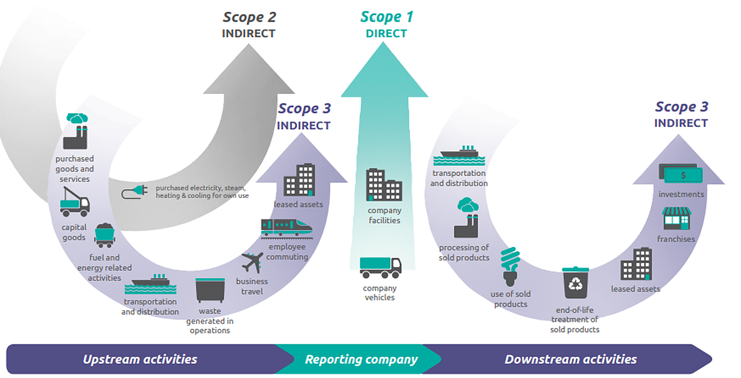
Figure 1 Framework of the Greenhouse Gas Protocol. Source: WRI (1998).
Beyond Corporate Carbon Footprints (CCFs), there is also a growing demand for reliable assessments of the Product Carbon Footprints (PCFs) of individual products and services. A variety of recent regulations in the EU and the U.S. have tied cash subsidies and income tax credits to the assessed cradle-to-gate PCFs —that is, the entire supply chain emissions incurred in the production and delivery of the product in question. Further, beginning in 2026, the EU will initiate a Carbon Border Adjustment Mechanism (CBAM) that imposes tariffs on certain primary commodities to be imported into the EU. The magnitude of these tariffs will depend on the assessed PCFs of the imported goods.
In addition to regulatory requirements, producers in carbon-intensive industries face increasing demands from their customers to provide reliable information on the cradle-to-gate PCFs of products sold. The reliability of these voluntary disclosures will be significantly strengthened if companies adopt their own in-house carbon accounting systems in accordance with established carbon accounting standards, enabling the resulting disclosures to be certified by external auditors.
Lacking their own in-house carbon accounting system, it is currently common practice for companies to estimate their direct and indirect emissions in accordance with the simple flow-accounting framework illustrated in Figure 2.
— Among the line items shown in Figure 2, the assessment of Scope 1 emissions is generally considered to be relatively straightforward, particularly in jurisdictions that have adopted a formalized MRV (Measurement, Reporting and Verification) framework in order to determine carbon taxes and/or allowance requirements for Scope 1 emissions. From the assessed direct emissions, companies can subtract any direct CO2 removals that may have been undertaken by third parties under a contractual agreement. The difference between direct emissions and direct removals yields company’s net direct emissions.
— To estimate the indirect Scope 2 and upstream Scope 3 (Scope 3.1) emissions incurred in connection with goods acquired and services consumed from suppliers, most companies rely on Life-Cycle Analysis (LCA) conducted either in-house or by external consultants.
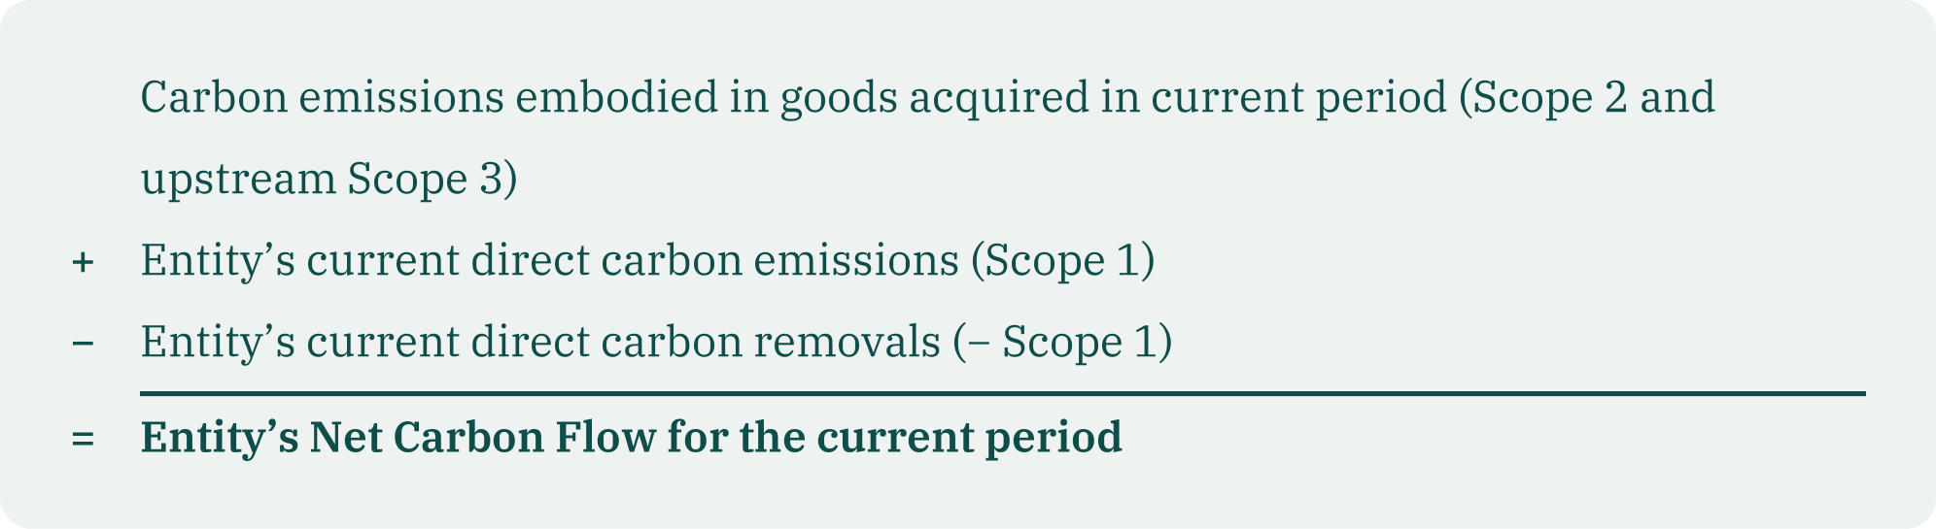
Figure 2 Summary statement of an entity’s Net Carbon Flow.
To assess a company’s full Scope 1, 2, and 3 emissions in accordance with the corporate standard of the GHG Protocol, the net carbon flow measure in Figure 2 can be supplemented with emission estimates for the use phase of products sold in the current period. Depending on the nature of the products, such estimates must by their very nature remain speculative, for instance, the carbon emissions incurred by an airplane throughout its useful life.
The calculation of the net carbon flow measure illustrated in Figure 2 does not require a meaningful carbon accounting system that assigns direct and incoming indirect emissions incurred to different activities, sales products, and time periods. Instead, the Net Carbon Flow metric simply sums up the raw aggregate carbon emission flows that have been incurred in connection with current production activities and operations.
The practice of assessing and reporting corporate carbon footprints as described here, and summarized in Figure 2, has led to widespread reliability concerns. Auditors have generally provided only limited assurance for these reports. The lack of reliability appears to be a direct consequence of companies having to resort to secondary data in order to assess the emissions embodied in goods and services acquired from suppliers. These secondary data are typically based on industry-wide historical averages and estimates.
The use of secondary, rather than primary, emissions data raises two concerns.
— If a company’s customers continue the current practice of gauging the PCF of acquired products on the basis of historical industry averages, any successful decarbonization efforts by the company itself will at best be imperfectly reflected in the databases used by the company’s customers. Further, any such improvements will only be reflected subject to delay. Critically, this dilution diminishes the incentives for the supplier to take costly measures that either reduce its own direct emissions or result in input acquisitions with lower carbon content. Yet, as companies seek to progress on their decarbonization pathways, they want to hold their suppliers accountable not only for price and quality but also the carbon emissions that were actually incurred in delivering the purchased inputs (Kurtz, 2022).
— The current practice of estimating indirect emissions based on historical industry averages is highly duplicative insofar as every link in a supply chain replicates the estimation efforts of all its predecessors in the chain (Becker, 2025). The costs of such duplicative practices can be substantially reduced by transitioning to a system in which PCF information is determined based on company-level data. The resulting PCF figures can then be verified by third parties and subsequently passed on to customers.
Section 2
2 The Structure of Integrated Corporate Carbon Accounting (ICCA) Systems
The starting point for a gradual transition to relying on primary emissions data is the adoption of in-house carbon accounting systems that enable companies to determine the cradle-to-gate PCFs of their own sales products based on their own actual direct emissions. As the set of adopters of such systems in a supply network grows, there will be valuable reliability effects in terms of increased reliance on primary data along the value chain (BASF, 2022; Kaplan and Ramanna, 2021; Kurtz 2022).
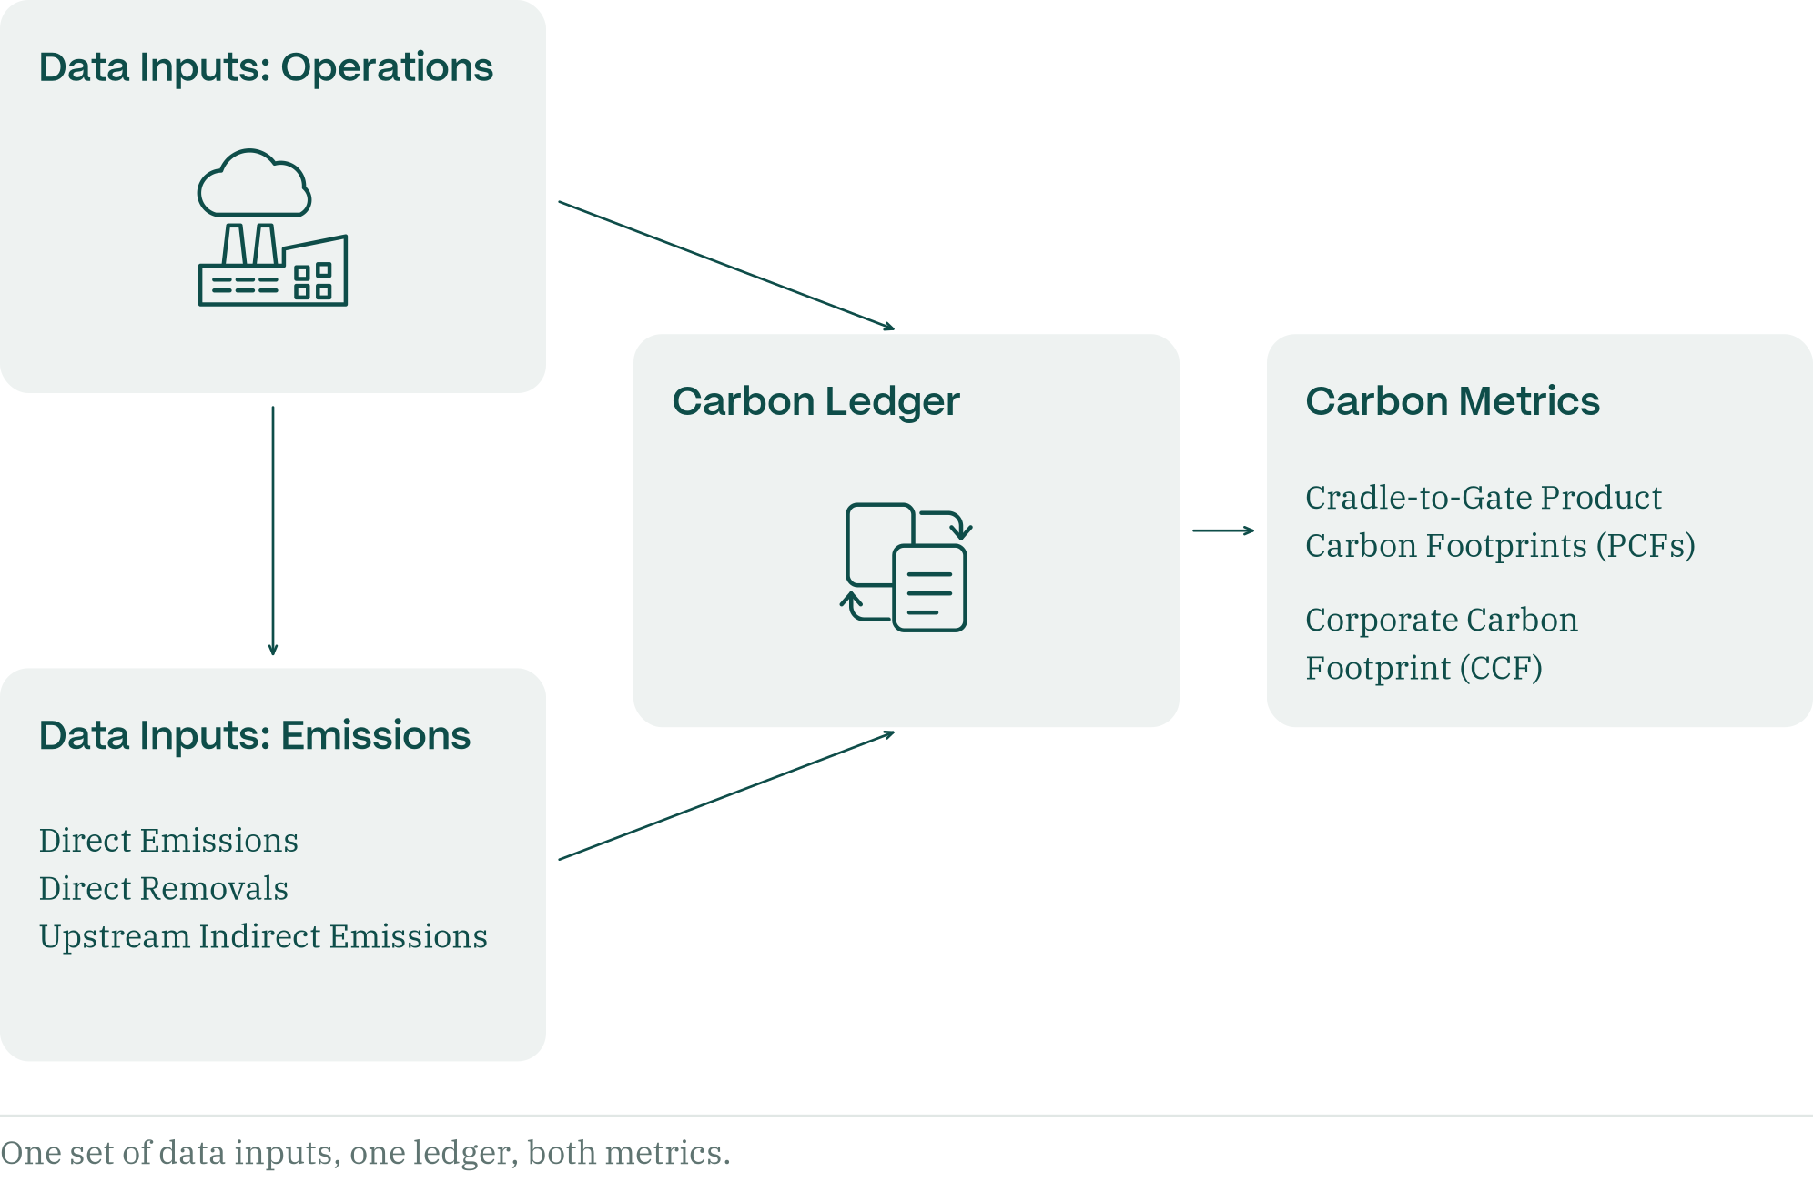
Figure 3 Schematic for Integrated Corporate Carbon Accounting: data inputs, the carbon ledger and the resulting carbon metrics.
Figure 3 illustrates the structure of carbon ledgers that enable Integrated Corporate Carbon Accounting. In effect, an ICCA system amounts to a mapping from data inputs to carbon metrics that comprise both the PCFs of an entity’s sales products and its aggregate CCF. This mapping is executed through a carbon ledger: a collection of accounts that carry their own carbon balances. The accounts of the ledger correspond to both carbon stock variables (e.g., emissions embodied in fixed assets) as well as carbon flow variables (e.g., the current CCF account). Bookkeeping entries for these accounts are determined by the operations and transactions undertaken by the business during the accounting period as well as the underlying accounting standards. Integrated corporate carbon accounting systems meet the following requirements:
i. The individual cradle-to gate PCFs and the CCF are derived from the same data inputs regarding emissions and the entity’s operating activities in the current period.
ii. The individual cradle-to gate PCFs and the CCF are determined according to the same accounting standards.
iii. The CCF metric comprises the cradle-to-gate PCFs of products and services sold in the current period as well as other carbon emissions attributed to the current period.
According to requirement iii), the emissions embodied in sales products are recognized in the CCF metric in the time period in which the product is sold, even though the emissions embodied in raw materials, fixed assets and other production inputs may have arrived at the company’s gates in earlier accounting periods. This approach to temporal matching ensures that the recognition of emissions in the CCF metric will coincide with the time period in which the cradle-to-gate PCFs of products sold are recognized by the entity’s customers in their carbon ledger.
In accordance with requirement iii) above, Carbon Emissions in Goods Sold (CEGS) becomes the principal component of a company’s periodic CCF metric. In direct analogy to Cost of Goods Sold (COGS) in a firm’s income statement, the CEGS metric aggregates the emissions attributed to different product lines, that is, the sum of all PCFs multiplied by the sales volume of the corresponding product. The calculation of CEGS is illustrated in Figure 4, where the sales quantity of the i-th product is denoted by si. In addition to CEGS, the CCF statement in Figure 4 also contains a line-item for General & Administrative Emissions. This line item reflects that certain emissions may be attributed to the current accounting period but are considered too far removed from the production process to be included in individual PCF calculations. One applicable example here is emissions associated with current travel by executives.
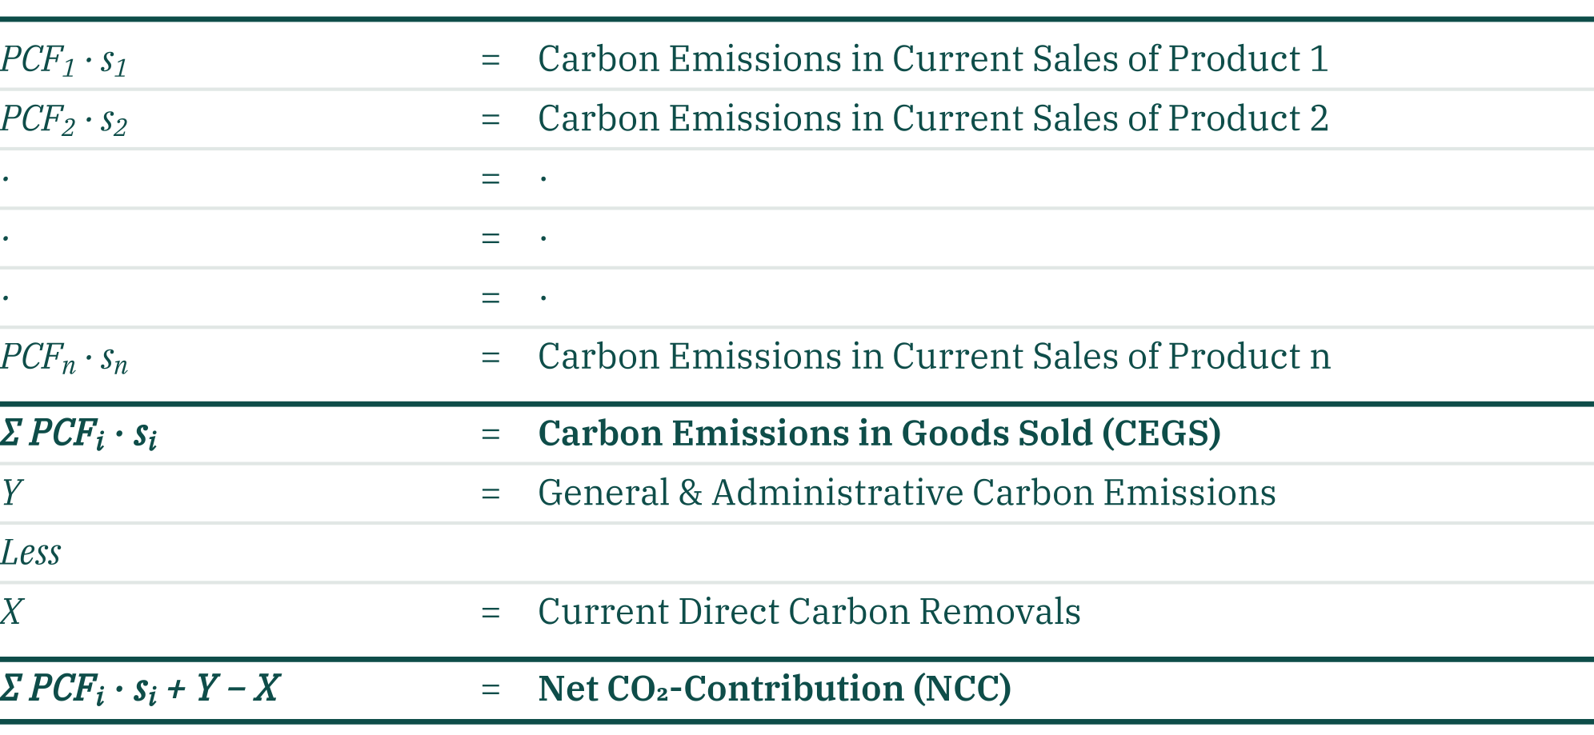
Figure 4 Corporate Carbon Footprint statement.
The corporate carbon footprint statement in Figure 4 includes direct carbon removals for the current period as a separate line item. Since direct carbon removals correspond to negative emissions, they are effectively recorded as a source of revenue in the CCF metric. Here we have implicitly assumed that, in contrast to direct emissions, direct removals are not included in the calculation of individual PCFs. This accounting treatment reflects that the recognition of carbon removals in corporate carbon reporting will likely continue to be contentious (Reichelstein, 2025b). A comprehensive discussion of the accounting treatment and recognition of carbon removals, and more broadly of carbon credits, will be the subject of future CASI whitepapers.
Regardless of the specific carbon accounting standards in place, the Net CO2-Contribution (NCC) metric derived in Figure 4 becomes the effective Corporate Carbon Footprint (CCF) metric in accordance with requirement iii) above. In direct analogy to a P&L statement in financial accounting, the Net CO2-Contribution metric is the bottom-line measure of the net direct and upstream indirect carbon emissions incurred by an entity to deliver its products and services in the current period. The NCC will generally differ from the annual Net Carbon Flow metric (Figure 2), as the latter merely records an entity’s raw carbon emission flows in any given period. A recent study by Kurtz (2025) quantifies the gap between these two metrics in the context of the 2024 emission figures for the chemical company BASF.
Companies seeking to comply with the corporate standard of the GHG Protocol, as illustrated in Figure 1, can calculate an expanded “Comprehensive Net-CO2-Contribution” metric. To that end, the cradle-to-gate PCF metrics can be supplemented with an estimate of the downstream Scope 3 emissions to be incurred during the use phase of a product. Consequently, the cradle-to-gate PCFs underlying Figures 3 and 4 will effectively be marked up to reflect the entire life cycle (cradle-to-grave) emissions associated with a product. For instance, the case study on the car maker BMW by Lu et al. (2024) details the anticipated use phase emissions for both electric and gasoline-powered vehicles.
Double counting of emissions is a commonly voiced concern in connection with the framework of the GHG Protocol. We first note that the cradle-to-gate PCFs, as introduced here, are principally not subject to double counting. Provided all parties along a supply chain adopt their own in-house ICCA system, the emissions accumulated in products comprise a share of the direct actual emissions incurred by the company in question, a share of the actual direct emissions incurred by the company‘s Tier 1 suppliers, a share of the actual direct emissions incurred by the company‘s Tier 2 suppliers and so forth. There may, however, be undercounting of the aggregate direct emissions attributed to a product when certain emission items are not included in PCF calculations, but instead, as illustrated in Figure 4, these items are charged as General & Administrative emissions to an entity’s NCC metric.
In terms of the CCF metric, double counting is an inherent consequence of the ICCA axiom that the corporate carbon footprint metric should include supply chain emissions, e.g. the emissions embodied in energy procured from the grid. As a consequence, the direct emissions of the energy supplier are not only counted in its own CCF measure, but also as part of the CCF measure of its customers. Net direct emissions is the only company-level metric that can be aggregated across parties in an economy without double counting. Yet, an entity’s net direct emissions also emerge as an ICCA metric provided companies adopt a system of double-entry bookkeeping. Direct emissions and direct removals then emerge as line items on a CO2-balance sheet (→ CASI Whitepaper No. 2).
Section 3
3 Core Principles of Integrated Corporate Carbon Accounting
The preceding discussion suggests that standards for integrated corporate carbon accounting ought to comply with the following core principles.
Completeness
Companies account and assume responsibility for their own direct (Scope 1) emissions and the indirect emissions embodied in acquired inputs and services (Scope 2 and upstream Scope 3) during an accounting period. An ICCA system is therefore complete if the carbon ledger records all direct and upstream indirect emissions corresponding to incoming goods and services received by the business.
Timely Recognition
Direct (Scope 1) emissions and direct removals are recorded in the carbon ledger for the accounting period in which they occur. Indirect emissions are recorded in the carbon ledger in the same time period in which customers acquire (take control of) goods and services. The carbon ledger must include accounts for carbon stock variables that capitalize any incoming emissions that are not recorded directly in the current CCF metric.
Temporal Consistency
In each accounting period, the ending balances of the carbon stock variable accounts become the beginning balances in the subsequent accounting period. In conjunction with the principles of Completeness and Timely Recognition, Temporal Consistency ensures that over the lifetime of a business the sum of all CCFs will be equal to the sum of all net carbon flows, as defined in Figure 2.
Accuracy
ICCA systems become more accurate as data inputs about indirect supply chain emissions are increasingly based on primary data that represent the actual emissions incurred in the supply chain. Accuracy will therefore improve as more companies in an entity’s supply network adopt their own ICCA systems. Recent contributions have proposed to quantify the level of accuracy by means of a Data Quality Scoring (DQS) index.
Unbiasedness
In most industries, the calculation of CCFs and PCFs requires pools of overhead emissions to be prorated (allocated) among different time periods and products. Such pools of overhead emissions frequently emerge in connection with shared assets or consumable inputs (e.g., electricity) that are used by multiple products. The principle of unbiasedness requires the applicable allocation rules to capture the causal link between emissions associated with specific production activities and the extent to which different products require these activities. While allocation rules that reflect the underlying causal links are intended to limit selective greenwashing, companies will generally retain some discretion in choosing among alternative allocation rules which meet this criterion.
Section 4
4 The Road Ahead
As introduced here, ICCA systems have key features in common with traditional financial and management accounting systems. In direct analogy to inventory costing for goods produced and sold, the product carbon accounting component of an ICCA system determines the emissions included in different sales products. CASI’s Whitepaper No.2 describes a specific architecture for ICCA systems based on double-entry bookkeeping. The accounts representing the stock variables in the carbon ledger can then be represented as “CO2e in Assets” on the left-hand side of a CO2-balance sheet. Further the periodic Net CO2-Contributions will reconcile to the CO2-balance sheets via an account that captures the entity’s legacy emissions and can be viewed as the carbon equivalent of the account Retained Earnings on a financial balance sheet.
CO2-statements that comprise periodic CCF measures in conjunction with a CO2-balance sheet provide analysts with comprehensive information about an entity’s contemporaneous carbon emissions performance and any improvements thereof relative to the recent past. Taken together, these metrics generate a range of Key Carbon Performance Indicators (KCPI) that will be decision-useful for management in terms of planning, incentivizing, and controlling a company’s efforts on its pathway towards decarbonization. Importantly, the ICCA framework enables analysis of these KCPIs at both at the entity level (e.g., reduction of specific emission categories or compliance with internal carbon budgets) as well as the individual product level (e.g., carbon intensity of individual products in relation to their profitability).
Auditor certification of ICCA metrics will be facilitated by integrating the carbon ledger into existing enterprise resource planning systems, thereby achieving connectivity between financial and carbon accounting (Distler et al., 2024). Once auditors are in a position to provide reasonable assurance that key carbon metrics have been determined in accordance with established carbon accounting standards, the reported carbon metrics have the potential to become investor-grade information on par with audit-certified financial information.
While this foundational whitepaper has focused on the structure and the core principles for integrated corporate carbon accounting, future CASI whitepapers will identify specific carbon accounting standards that are compatible with the ICCA framework. We intend to identify specific standards pertaining to the boundaries of emissions to be included in PCFs calculations, the recognition and treatment of carbon removals (and more broadly carbon credits), the use of market-based approaches for the emissions associated with electricity purchases, and alternative methods for allocating overhead emissions. While individual companies and NGOs, including the GHG Protocol, ISO, Together-for-Sustainability, Catena-X, or E-Ledgers have articulated a range of positions on these accounting issues, these positions have thus far not been grounded in the conceptual framework of integrated corporate carbon accounting.

Bibliography
References
Ackermann, J., Distler, B., Ernst, C., Freiberg, J., Schwarz, D., Sessar, C., Szabo, M., Wottke, N., Zicke, J. (2025). Introducing Carbon Accounting for Sustainability with SAP. https://www.sap-press.com/introducing-carbon-accounting-for-sustainability-with-sap_6054/
Asam, D., Ernstberger, J. & G. Friedl (2025). How Carbon Accounting Supports Corporate Decarbonization. Foundations and Trends in Accounting 19, 46–77.
BASF (2022). BASF Methodology for Product Carbon Footprint Calculation. https://www.basf.com/dam/jcr:66611f85-8ae8-3714-8a66-fdecde3ccee4/basf/www/global/documents/en/sustainability/we-drive-sustainable-solutions/quantifying-sustainability/product-carbon-footprint/BASF_Methodology_for_Product_Carbon_Footprint%20Calculation_August_2022.pdf
Becker, T. (2025) Automotive Supply Chain Decarbonization as a Driver for Carbon Accounting and Vice Versa. Foundations and Trends in Accounting, 19, 78–95.
BMW Group (2024). BMW Group Vehicle Carbon Footprint Reports
https://www.bmwgroup.com/en/sustainability.html#accordion-7b5922862f-item-1ee9bc3e03
CASI Whitepaper No.2. (2025). CO2-Statements: Double-Entry Bookkeeping for Integrated Corporate Carbon Accounting, https://casinitiative.org/#casi.
Catena-X. (2023). Catena-X Product Carbon Footprint Rulebook: CX-PCF Rules. Version 2.0. https://catenax.net/fileadmin/user_upload/Vereinsdokumente/Geschaeftsstelle_Dateien_Abla ge/CX-0029-ProductCarbonFootprintRulebook-v2.0.0.pdf
Cleveland-Peck, P. (2025). Exxon-Backed Coalition Sets Out Goals to Fix Carbon Accounting, Wall Street Journal, November 11, 2025.
Distler, B., Ernstberger, J., Keiling, M., Müller, F., & M. Szabo (2024). Incorporating Carbon Emissions Into Decision-Making - The Case of Transactional Connectivity. SSRN Electronic Journal. https://doi.org/10.2139/SSRN.4784259
GHG Protocol (2024). A Corporate Accounting and Reporting Standard.
GHG Protocol (2011). Product Life Cycle Accounting and Reporting Standard. ISO (2018). ISO 14064-1:2018. URL https://www.iso.org/standard/66453.html.
Kaplan, R. and K. Ramanna (2021). Accounting for Climate Change. Harvard Business Review. November-December. https://hbr.org/2021/11/accounting-for-climate-change
Kaplan, R., Ramanna, K., & S. Reichelstein (2023). Getting a Clearer View of Your Company’s Carbon Footprint. Harvard Business Review. https://hbr.org/2023/04/getting-a-clearer-view-of-your-companys-carbon-footprint
Kurtz, J. (2022). Product Carbon Footprints - Zur Vergleichbarkeit der Produkte die wir kaufen? SCOTT-ProductCO2-sting fuer die Chemie. Controlling, 34(2), 44–50. https://doi.org/10.15358/0935-0381-2022-4-44
Kurtz, J. (2025). Application of ICCA on BASF’s 2024 GHG Data. Presentation at Goethe University Frankfurt on December 4, 2025.
Lu, S., Serafeim, G., & Toffel, M. W. (2024). Driving Decarbonization at BMW. Harvard Business School, Case Study 123008-PDF-ENG. R. https://hbsp.harvard.edu/product/123008-PDF-ENG
Ramanna, K. (2024). A proto-standard for carbon accounting and auditing using the E-liability method. URL https://dx.doi.org/10.2139/ssrn.4957358.
Reichelstein, S. (2024) Corporate Carbon Accounting: Balance Sheets and Flow Statements. Review of Accounting Studies.29. 2125-2156.
Reichelstein, S., Bach, A., Ernst, C. and G. Glenk (2025). An Accounting Architecture for CO2-Statements. URL https://papers.ssrn.com/sol3/papers.cfm?abstract_id=5336017
Reichelstein, S. (2025a). Innovations in Corporate Carbon Accounting. Foundations and Trends in Accounting 19, 3–35.
Reichelstein, S. (2025b). Accounting for Carbon Credits. Accountability in a Sustainable World Quarterly, September 2025, 62–67.
Saling, P., Pistillo, A. & J. Kurtz (2025) Automated Product Carbon Footprint Calculation in the Chemical Industry to Steer Decarbonization Along the Value Chain. Foundations and Trends in Accounting 19, 127–157 (2025).
TfS (2024). Together for Sustainability: The Product Carbon Footprint Guideline for the Chemical Industry. Version 2.1. https://www.tfs-initiative.com/app/uploads/2024/03/TfS_PCF_guidelines_2024_EN_pages-low.pdf
WRI (2004). World Resources Institute: A Corporate Accounting and Reporting Standard. Revised Edition. https://ghgprotocol.org/sites/default/files/standards/ghg-protocol-revised.pdf

Imprint
About CASI
The Carbon Accounting Standards Initiative (CASI) advances the practice of corporate carbon accounting and reporting. CASI brings together academic scholars and practitioners to develop standards for integrated corporate- and product-level carbon accounting. Building on established financial accounting frameworks, the resulting carbon metrics provide comprehensive, reliable and decision-useful information about a company’s carbon emissions performance.
Authors
This whitepaper was prepared by the CASI founding members:
Christoph Ernst, Mannheim Institute for Sustainable Energy Studies, University of Mannheim · christoph.ernst@uni-mannheim.de
Gaizka Ormazabal, IESE Business School, University of Navarra · gormazabal@iese.edu
Stefan Reichelstein, Mannheim Institute for Sustainable Energy Studies, University of Mannheim and Stanford Graduate School of Business, Stanford University · reichelstein@uni-mannheim.de
Thorsten Sellhorn, Institute for Accounting, Auditing and Analysis, LMU Munich School of Management · sellhorn@lmu.de
Publication details
CASI Whitepaper No.1: Foundations of Integrated Corporate Carbon Accounting, Version 2.0, December 2025
Suggested citation: CASI (2025), CASI Whitepaper No.1: Foundations of Integrated Corporate Carbon Accounting, Carbon Accounting Standards Initiative. Available at https://casinitiative.org/#casi.
Acknowledgments
We thank Amadeus Bach, Gunther Glenk, Jochen Kurtz, Julie Mulkerin, Mike Szabo, Sandra Stock and Mykola Vlasov for their many helpful comments and suggestions.
License
© CASI 2025. This work is licensed under CC BY-SA 4.0. To view a copy of this license, visit https://creativecommons.org/licenses/by-sa/4.0/.

For brevity, we have simply referred to “carbon emissions” thus far. The actual unit of measurement for the accounting system is emitted tons of CO₂ equivalent (or CO₂e). Thereby greenhouse gases other than carbon dioxide (CO₂) are made comparable to CO₂ itself by applying a commonly accepted multiplier. That multiplier is equal to one if the greenhouse gas in question is CO₂.
For instance, the Product Life-Cycle Accounting and Reporting Standard of the Greenhouse Gas Protocol (2011) specifies that emissions associated with activities like business travel are not included in PCF calculations.
In contrast, the following identity can be established formally provided all direct and upstream indirect emissions are included in PCF calculations. The sum of all CEGS figures (which are then equal to the NCC figures) aggregated across all firms in an economy over its entire lifetime will then be equal to the total net direct emissions incurred in this economy over its lifetime (Reichelstein, 2024).
A recent article in the Wall Street Journal suggests that an Exxon-Mobile backed coalition of companies, termed Carbon Measures, seeks to exclude supply-chain emissions from corporate carbon footprint measures (Cleveland-Peck, 2025).
For a formal demonstration of this accounting identity, see Reichelstein et al. (2025).
A “Rulebook” prepared by Catena-X (2024) describes a methodology for calculating a DQS index. See also TfS (2024).
See GHG Protocol (2004, 2011), ISO (2018), TfS (2024), Catena-X (2023) and Ramanna (2024).

