“CoffeeBot”
Android Coffee Ordering System
Taylor “Seraph” Morris
System Requirement Specification

- INTRODUCTION
  - Purpose
    - This project will create an Android-based system for ordering coffee from an independently-owned coffee shop. Users will be able to order drinks from their phone and be able to receive them when they pull up to the shop.
  - Scope of Development Project
    - This will be used by small, independently-owned coffee shops, and will be able to be tailored to suit their individual menus and offers.

- GENERAL DESCRIPTION
  - Glossary
    - Client: The Android client that will run on a customer's phone, allowing them to place their orders
    - Server: Server that will run in store and receive messages from Client (depending on implementation of messaging, might not be an actual server)
    - Drink: Encompasses all items that can be ordered over this system
    - POS: Local POS system that handles the actual ringing up of orders
    - Popular Drinks: Pre-selected drinks that the Admin will determine for easy ordering
  - User Characteristics
    - Admin: Will be able to update drink database and push out new versions as necessary
    - Barista: Will receive drink orders and enter them into local POS system to be made
    - Customer: Will send in drink orders and receive them
  - Product Perspective
    - System Context Diagram

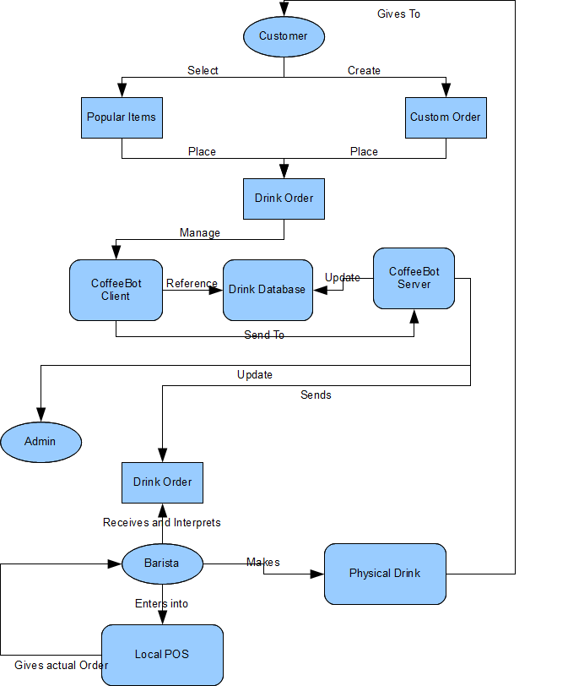

Figure 1: System Context Diagram

  - System Functional Requirements
    - Get menu of drinks and food items
    - Pick from menu of popular items
    - Create custom orders
    - Save personalized orders
    - Update menu
    - Send in order to be made
  - General Constraints and Assumptions
    - Shop must have a device in store that can receive and display orders
    - Baristas must be able to take orders from server and place them in POS system
  - User View of Product Use
    - Customer will launch app, and be greeted with a menu with options to select popular drinks, select from their saved drinks, or create a new drink.
      - Popular Drinks: User will be shown a list of pre-selected drinks
      - Saved Drinks: User will be shown a list of custom drinks that he has saved
      - Create New: User will be given a series of menu options to create a custom order
      - Confirm Order: Once their order is selected, they will be given a screen to confirm their order before placing it
    - Barista will receive a notification saying that a new order has arrived. Barista will then be able to view the complete order, enter it into the POS, and make the drink
    - Admin will have options to update the database of menu items and popular items

- SPECIFIC REQUIREMENTS
  - Interface Requirements
    - User Interface
    - Hardware Interface
    - Software Interface
    - Communication Interfaces
  - Description of Functional Requirements
    - Requirement
      - Purpose/Description
      - Inputs
      - Processing
      - Outputs
  - Data Dictionary
  - Non-Functional Requirements

- USE CASES
  - Overall Use Case Diagram
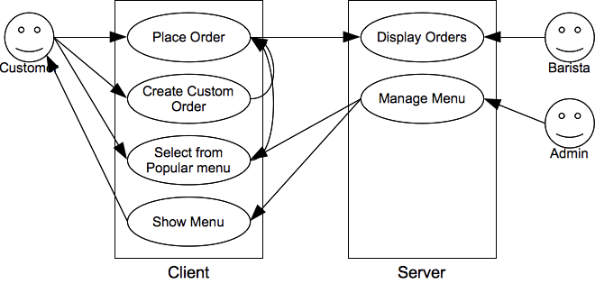

- SPECIAL REMARKS

- REFERENCES AND RESOURCES

