## System profitability

The XYX Company is there to make business and at the same time help Rwanda boost its economy by going cashless

The company means business as the main functions of business is “give people what they need or want in exchange for money” and I think the XYZ Company is doing it, as it helps people transfer the money for a small fee.

## Demo

* The system allows a new user to create an account

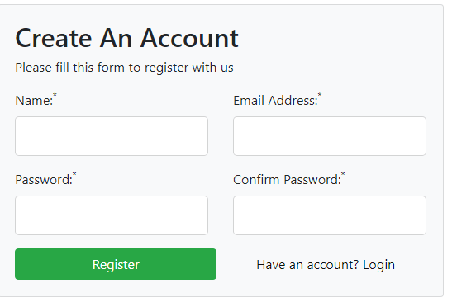

* The system allows the user to send money to other users in the system

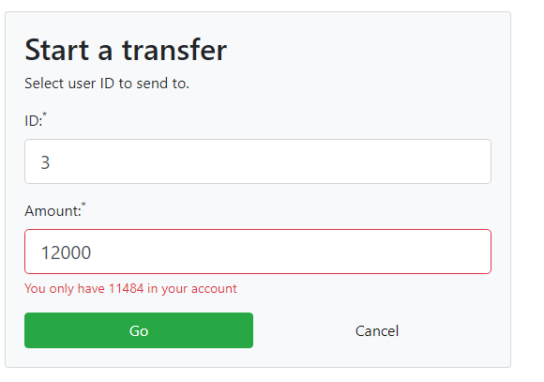

* The system allows the admin top-up balance of the user’

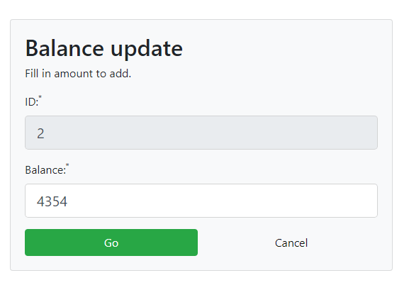

* The admin can also view all transactions

