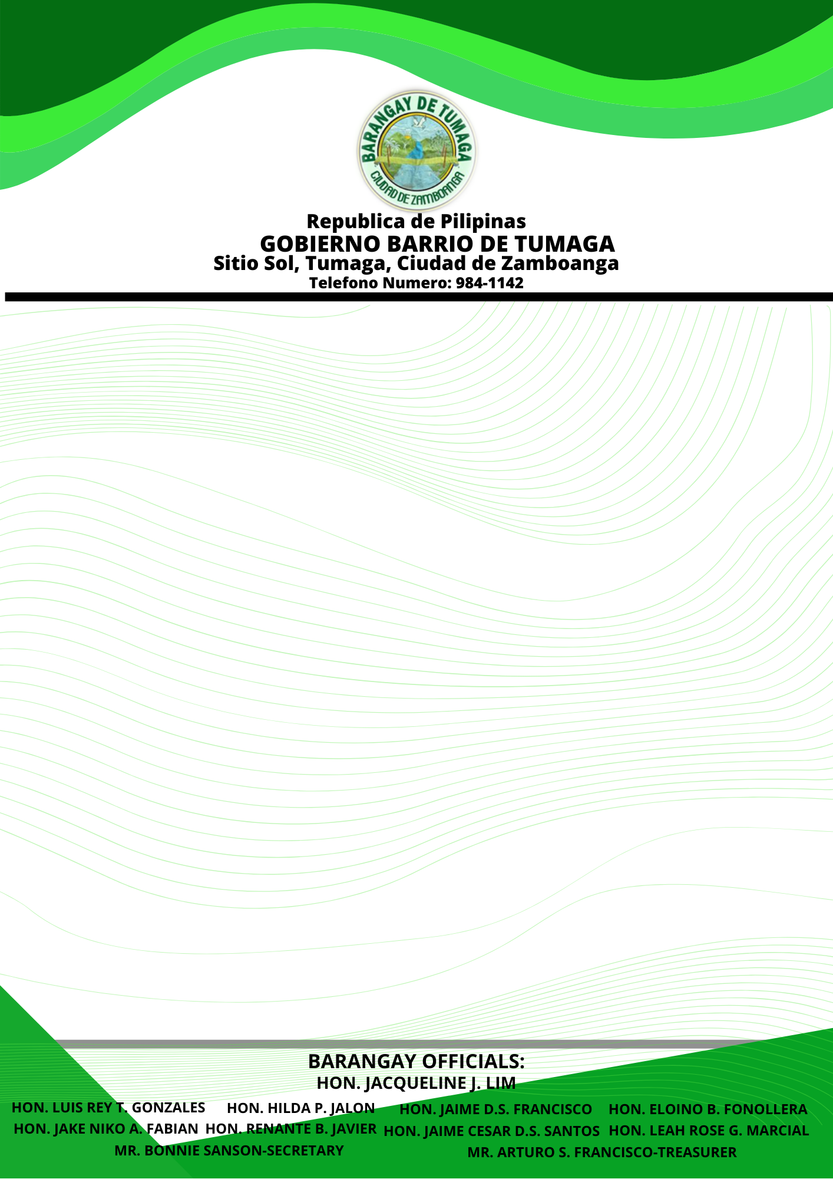

**BARANGAY CLEARANCE**

TO WHOM IT MAY CONCERN:

This is to certify that the person whose name, signature, right & left thumb appear hereon has Requested a ***BARANGAY CLEARANCE*** and per records of this office result(s) is /are listed below:

NAME : GWYNETH ANGELA S. GAGARRA

ADDRESS : PARAISO HOMES SUBD., TUMAGA, ZAMBO.CITY

AGE : 17 YEARS OLD

STATUS : SINGLE

PURPOSE : FOR WMSU CET REQUIREMENT

REMARK : NO RECORD ON COMPLAINT FILES AS OF DATE

PHOTO

_____________

SIGNATURE

Issued this 5TH day of November 2021, Barangay, Tumaga, Zamboanga City, Philippines.

**HON. JACQUELINE J. LIM**

PUNONG BARANGAY