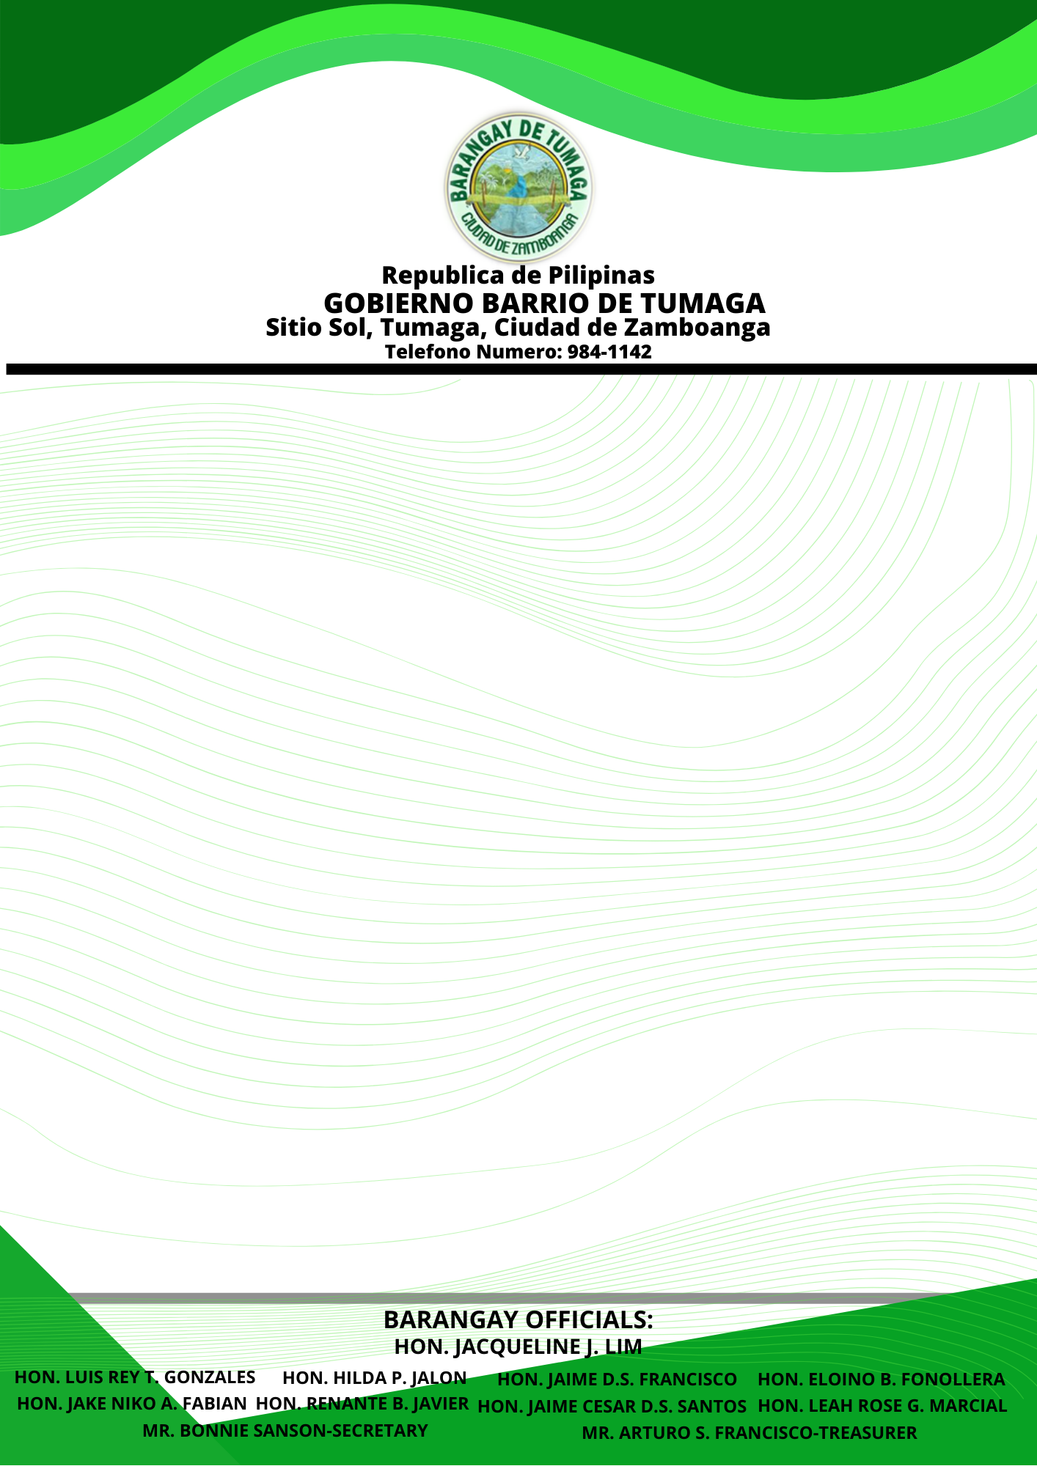

**INDIGENT CERTIFICATION**

***TO WHOM IT MAY CONCERN:***

This certifies that **JUMANGIT'S FAMILY** belongs to indigent Family that could not meet the **NECESSARY EXPENSES** of:

NAME : JELEEA ELAINE M. JUMANIGT

ADDRESS : 643 HECTOR SUAREZ, TUMAGA, ZAMBO. CITY

CIVIL STATUS : SINGLE

AGE : 27 YEARS OLD

SEX :  FEMALE

DATE OF BIRTH : JUNE 6, 1986

This certification is being issued upon the request of the above-mentioned name to seek for **FINANCIAL ASSISTANCE** from ***CITY SOCIAL WELFARE AND DEVELOPMENT (CSTD)*** and/or for whatever Legal purpose it may serve.

Issued this 1ST day of September 2021, Barangay, Tumaga, Zamboanga City, Philippines.

**HON. JACQUELINE J. LIM**

PUNONG BARANGAY