UTS
ALGORITHM DESIGN AND ANALYSIS

Name: Serafina Alamsyair NIM: 01087240001

ALGORITHM OF CHOICE
As outlined in my README file, I have decided to use Earliest Deadline First (EDF) Algorithm (greedy strategy) as it is straightforward and relatively easy to understand. It will always schedule the job with the nearest deadline first. Since the problem outlines that, during peak hours, jobs were missing deadlines, I think this solution is appropriate as it can help with minimizing lateness and improve completion time.

ANALYSIS OF ALGORITHM
- Time function:
T(n)=Tsort​(n)+Tschedule​(n)

Where:
- n = number of jobs
- T = total running time
- Tsort = time function to sort the jobs by their deadlines
- Tschedule = time function to calculate completion, lateness, and printing the output
Considering my code uses loops, it should calculate the time function as the product of iteration of all loops. As such, it would be divided to the sorting loops (nested loops), while the scheduling loops use normal looping.
As such, formula is as below:
T(n) = O(n²) + O(n)
- Asymptomatic notation: As asymptomatic notation considers only the highest rate of growth, the asymptomatic notation will be as below:

T(n) = O(n²)

This shows that the running time will increase quickly for larger jobs inputs, which will make the program run slower. As such, my solution would be optimal for a smaller job size.

SAMPLE INPUT AND OUTPUT

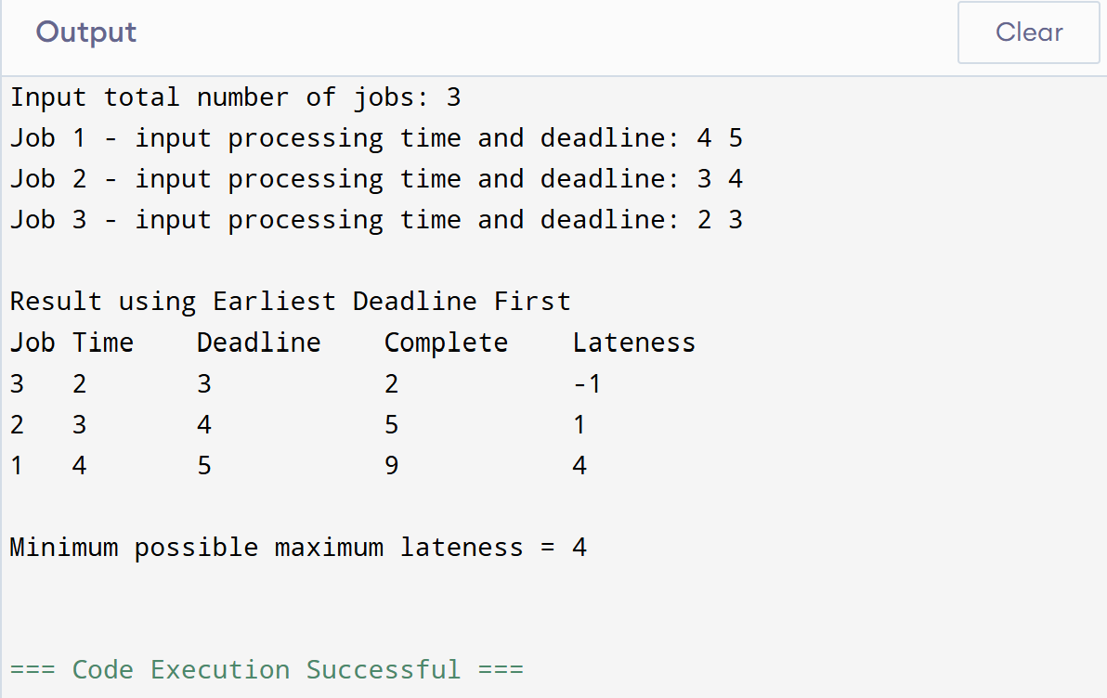

Based on the above results, the inputted jobs will be sorted based on the deadline (most urgent will be moved up to be executed first). In this case, job 3 was the most urgent (3 deadline units). As such, it was moved up.

Lateness column shows that job 3 was completed early (negative lateness units), while job 2 and 1 were completed late by 1 and 4 units respectively. Thus, the best possible worst case scenario (maximum lateness) was to be late by 4 time units.

