Appium is an open-source project and ecosystem of related software, designed to facilitate UI automation of many app platforms, including mobile (iOS, Android, Tizen), browser (Chrome, Firefox, Safari), desktop (macOS, Windows), TV (Roku, tvOS, Android TV, Samsung)
Appium with Java:
Appium with Python:
- Python Software
- Install the Appium Python Libraries
- IDE (Pycharm IDE for writing the appium code in python) or vs code
- Appium Desktop exe file
- Android Studio
- Xcode (For IOS Automation - Xcode will be available only in MacBook)
- Java ( For the latest version of Appium we required java as well-1.17.1 if we use desktop exe file)

Appium TOC shared by Raskha:
- Introduction to Appium
- Appium Installation (Windows / Mac)
- Basics of Mobile Testing with Appium
- Understanding of Native Apps
- Key Events Handing
- Miscellaneous topics on Android Automation
- Hybrid App Automation
- Miscellaneous topics on iOS Automation
- Framework - Design Pattern, Page Object Model
- Data Driven Testing
- Global Configurations
Various Mobile OS:
- Android – Google – High popularity
- iOS- Apple – High popularity
- Blackberry – Blackberry – low popularity
- Windows – Microsoft – medium popularity
Types of Mobile Applications:
- Mobile Web App:
  - Websites which we open in smartphones with the help of web browsers
- Native App
  - A native app is developed for one platform. It can be installed through play store.
Example: Whatsapp, Facebook etc
- Hybrid App
  - Hybrid App are a way to expose content from existing websites in App format. They are mixture of Web App and Native App
Tools available for Testing Mobile Apps:
- Appium
- Selendroid
- Ios-driver
- Calabash
- MoneyTalk
- Frank
- KIF(Keep it functional)
- Robotium

Open source tools Requirement:
- Application source code should not be modified for test automation
- Tests should run across Simulators/Emulators and Real devices
- Tests should be written using java or any other prog. language and any test automation frameworks
- Large open source community for continuous maintenance and support.

All the above requirements are supported by Appium.
Why Appium?
- Cross platform: we can test native, hybrid, web app
- Allows you to communicate with other apps
- No pre-compilation of your app
- Support for built-in app: alarm, phone, calendar
- Any WebDriver compatible language is supported: java, objective C, Ruby,php, C#

Limitations of Appium:
- Appium supports of android >4.1
- Script execution is very slow on iOS platform & android virtual devices
- No support for Toast messages
- No parallel execution directly but can be done with sauce labs
What is Appium?
- Appium is mobile web, native and hybrid software application test automation tool developed and supported by Sauce labs
- It is an open source software automation tool which is useful to automate android and iOS platform applications
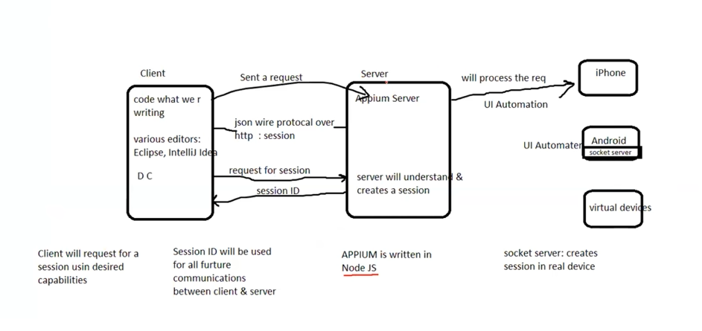
Requirement:
- Install Java
- Eclipse
- Maven plugin for Eclipse
- TestNG plugin for Eclipse (to test mobile elements)
- uiautomator2: for automating android applications
Appium UiAutomator2 Driver is a test automation framework for Android devices. Appium UiAutomator2 Driver automates native, hybrid and mobile web apps, tested on emulators and real devices. Appium UiAutomator2 Driver is part of the Appium mobile test automation tool.
- Selenium standalone server(for distributed (cross -platform)and parallel testing by integrating selenium grid with appium)
- NodeJs
- Npm: 8+
Commands:
Using npm:
- For installation: npm i -g appium
- After installation: appium
- For update: npm update -g appium
- For automation we need a driver to get installed: appium driver install uiautomator2
- node -v
- npm -v
- to run appium: appium
- to check appium properly or not: npx appium -v
- Add path: C:\Users\sekumarp\AppData\Roaming\npm to environment variables
- appium driver doctor uiautomator2
- validation: appium driver doctor uiautomator2

Android Tools:
- Android Studio - provides SDKs – IDE/ Virtual Devices(Emulator/Simulator)
- Appium Server/ Appium Desktop : CLI/GUI
- Appium Client Library – jar file add as dependency in maven
  - https://dpgraham.github.io/downloads.html

Overall requirement:
Java+Eclipse+Maven+TestNG
Android studio(IDE,SDK,Virtual devices)
Appium server(Desktop)
Appium Java client library

What is a APK file?
- Stands for Android Application Package
- This is similar to .exe which are used to install programs on windows.
- The only difference is that .apk files are designed to be used exclusively on android device and need more additional files to the run application in the android.
- To download:
  - https://www.apk4fun.com
  - https://apkpure.com

Real Device vs Simulator vs Emulator Testing:
- What is Real Testing Device?
  - Testing on read device allows to run you mobile applications and check its functionality.
  - Real device testing assures that your application will work smoothly in customer
Handsets
- What is Emulator & Simulator?
  - They are virtual devices.
  - It is a software which gives same functionality as the real phone
  - Android virtual devices: Emulator
  - iOS virtual devices: Simulator
Creating virtual device using android studio – AVD Manager:

