What is Unit Testing?
- Unit Testing is defined as a type of software testing where individual components of a software tested.
- Unit Testing of a software product is carried out during the development of an application.
And individual component may be either an individual function or procedure. Unit Testing is
Typically done by the developer.
Importance of Unit Testing:
- To verify the correctness of code
- To test every function and procedure
- To fix bug early in development cycle
- To save testing cost
- Understand the code base and enable developer to make changes quickly.

JUnit:
-> JUnit is a testing framework for Java.
-> Minimum requirement for Junit 5 is Java 8
-> It is used to write and run repeatable tests.
-> JUnit helps verify that individual units of code works as expected.
-> Junit dependencies: junit-jupiter-api, junit-jupiter-engine, junit-platform-runner, junit-jupiter-params
How JUnit Works?

-> Write tests using @Test annotations
-> Assertions are used to check if the results are as expected
-> Test runners execute tests and report results
-> JUnit can be integrated with IDEs and build tools for easy execution

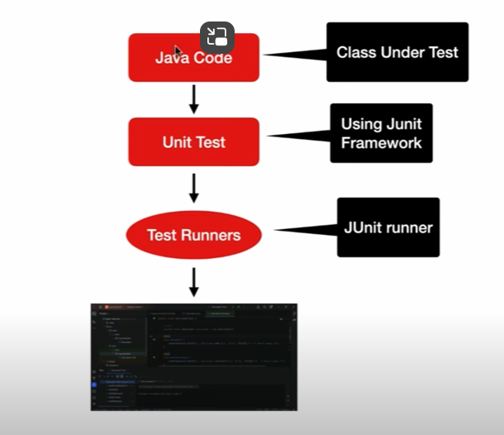

Key Features of Junit:
- Annotations make test management easy.
- Assertions are used to check expected results.
- Test runners executes your tests and report results
- Junit supports integration with build tools like Maven and Gradle

Junit Annotations:
- Annotation is a feature introduced in Java5
- Annotation is used to add metadata to Java Source code
- This will allow you to add information to an existing data object in your source code.
- Java allows users to define their own annotations too.
- Annotation can be described as @ symbol
- Junit annotations will direct the execution flow of the program
Different Annotations in Junit:
- @Test: Denotes that a method is a test method
- @BeforeEach: Denotes that the annotated method should be executed before each @Test,
@RepeatedTest, @ParameterizedTest or @TestFactory method in the current class
- @AfterEach: Denotes that the annotated method should be executed after each @Test, @RepeatedTest, @ParamterizedTest or @TestFactory method in the current class
- @BeforeAll: Denotes that the annotated method should be executed before all @Test, @RepeatedTest, @ParamterizedTest or @TestFactory method in the current class
- @AfterAll: Denotes that the annotated method should be executed after all @Test, @RepeatedTest, @ParamterizedTest or @TestFactory method in the current class
- @ParameterizedTest: Denotes that a method is a parameterized test
- @RepeatedTest: Denotes that a method is a test template for a repeated test.
- @TestFactory: Denotes that a method is a test factory for dynamic tests.
- @TestMethodOrder: Used to configure the test method execution order for the annotated test class
- @Displayname: Declare a custom display name for the test class or test method
- @Tag: Used to declare tags for filtering tests, either at the class or method level
- @Disabled: Used to disable a test class or test method
- @TimeOut: Used to fail a test, test factory, test template or lifecycle method if its execution
Exceeds a given duration.
- @Nested: Denotes that the annotated class is a non-static nested test class. @Beforeall and
@AfterAll methods cannot be tested directly in a @Nested test class unless the “per-class” test class instance life cycle is used.

Test Annotation:

- The most important annotation of Junit 5 is Test Annotation
- This annotation marks a method as Junit5 Test
- Only public methods can be marked as Junit5 Test

Junit basic concepts:
- The class or system we want to test is known as System under Test (SUT) or Class Under Test
- The method or function we want to test is known as Method Under Test
- A test class in Junit is a regular Java class that contains one or more test methods. These test
Methods are annotated with @Test and contains the logic to test a specific piece of code.
- A test method is a method within a test class that is annotated with @Test. This method contains assertions that check the expected outcomes of the code being tested.
- Assertions are used to check whether the code under test behaves as expected. Junit provides several assertion methods such as assertEquals, assertTrue, assertFalse and
assertThrows
- The test runner is responsible for executing the test methods in a test class and reporting the
Results. In Junit, the test runner is typically provided by an IDE or build tool, such as
Ecllipse, IntelliJ IDEA, Maven or Gradle.
Setting Up Environment for Junit:
- Create a Maven project in Ecllipse(we use Java 21)
- Adding Junit Maven Dependencies
Writing your First Junit Test
- Create a method to be tested(Method Under Test)
- Write a test method using @Test(unit test)
- Use assertions to validate the method’s output
- Run the test and check the results

