Login page:
Example: https://practicetestautomation.com/practice-test-login/
Parameterization and Data Driven Testing:
- What is parameterization?
  - Open browser
  - Navigate to login page
  - Enter name in username box
  - Enter password in password box
  - Click login button
  - Verify user navigates to Home page
- What is data driven testing?
- How to run a feature multiple times with different sets of data
Prerequisites:
- Project setup with required maven dependencies(libraries) added
- A sample login test
Page Object Model:
- What is Page Object Model?
  - Design pattern create Object Repository
  - A class is created for each page to identify web elements of that page
  - Also contains methods to do action on the objects
  - Separates test objects and test scripts

- Advantages of POM
  - Makes code maintainable(changes and updates are easier)
  - Makes code reusable
  - Improves readability
  - Saves time and efforts
  - Avoid rework
  - Makes tests less brittle
  - New tests creation is easier and faster
  - Improves Overall quality and efficiency

- How to implement POM in Selenium Cucumber Framework
  - Create a class for each page
  - Create locators of all objects to be used in that page
  - Create methods or actions to be performed on the objects
  - Refer in the test scripts
  - Run and validate

Prerequisites:
- Project is setup with required maven dependencies(libraries) added
- A sample login test created

Page Factory:
- A simple and easier implementation of Page Object Model in Selenium
- Selenium’s inbuilt and optimized Page Object Model concept
- As POM, has separation of objects and tests
- Uses annotation @FindBy to find WebElements
@FindBy can use id,name,css,xpath,tagName,linkText,partialLinkText etc
- Uses method initElements to initialize WebElements
On calling initElements method all objects on that page gets initialized
How to implement Page Factory Model:
- Create a class for each page
- Create locators of all objects to be used in that page using @FindBy
- Create methods or actions to be performed on the objects
- Create constructor to get driver instance and initialize Elements using method initElements
- Update Test Scripts to refer methods from PageFactory class
- Run and validate
Useful Tips:
@CacheLookUp: CacheLookUp can be used to instruct the InitElements() method to cache the element once its located and so that it will not be searched over and over again whenever calling it from any method.
Works for basic web applications but not recommended for Ajax applications.

With PageFactory, you can locate a list of Elements

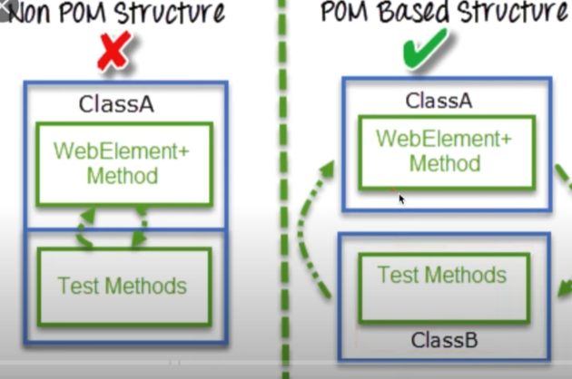
Tags in Cucumber:
Features and scenarios can be marked with Tags
Tags use @ symbol with some text Ex: @SmokeTest
In the test runner we can run specific tags
A feature or scenario can have multiple tags
Ex: @smoke @regression @important
Feature: verify login
Can run with single or multiple tags
Can run with combination of tags or using AND, OR condition
Can skip scenarios having specific tag
How to use tags:
- Create a new or use the existing feature file
- Mark the feature and scenarios with Tags: @Tagname
- Create a new or use an existing TestRunner class
- Add the Tags in CucumberOptions section
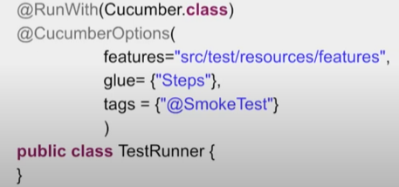
- Run test runner class with different combinations of tags
Single tag
Multiple tag
Tags with AND OR conditions
Tags=”@smoke and @regression”
Skip or Ignore tags : “@smoke and not @regression”
“(@smoke or @regression) and not @important”
Tags can be placed above the following Gherkin statements:
- Feature
- Scenario
- Scenario Outline
- Examples
It is not possible to place tags above Background or steps(given,when,Then,And and But)
Tags are inherited by child elements
Tags that are placed abaove a Feature will be Inherited by Scenario, Scenario Outline or Examples
Tags that are placed above a Scenario Outline will be inherited by Examples
Hooks:
- What are Hooks?
  - Blocks of code that runs before OR after each scenario
  - Hooks in cucumber are like Listeners in testNG
  - Can define hooks by annotations @Before @After
  - Scenario Hooks: runs before and after each scenario
  - Step Hooks: runs before and after each step
  - Conditional Hooks: hooks associated with tags for conditional execution
- Why to use Hooks?
To manage the setup and teardown
To avoid rewriting the common setup or teardown actions
Allow better management of code workflow
- When to use Hooks?
Whenever you have common setup and teardown actions to be executed before each scenario.
- How to create & use Hooks?
Steps:
- Create a new or use an existing Feature file
- Create the steps for the scenario in the Feature file
- Create the setup and teardown methods and mark with annotation
@Before @After
@BeforeSteps @AfterSteps

- Conditional Hooks
Hooks can be conditionally selected for execution based on the tags of the scenario.
To run a particular hook only for certain scenarios, you can associate a Before or After hook with a tag expression
@After(value=”@smoke”,order=2 )
NOTE: Only use hooks for low level logic such as starting a browser or deleting data from a database.
You should consider using a background as a more explicit alternative, especially if the setup should be readable by non-technical people
Background:
- What is background?
A step or a group of steps that are common to all the scenarios in a feature is defined once in a feature.
Runs before every scenario of the feature
- Why to use background?
To avoid repeating the common steps in every scenario
For better readability and maintenance
Unlike hooks, background is visible to the readers of the feature file
- When to use background?
Whenever there are common repeating steps in a feature.
When you want the common steps to be visible to the readers
- How to create and use background?
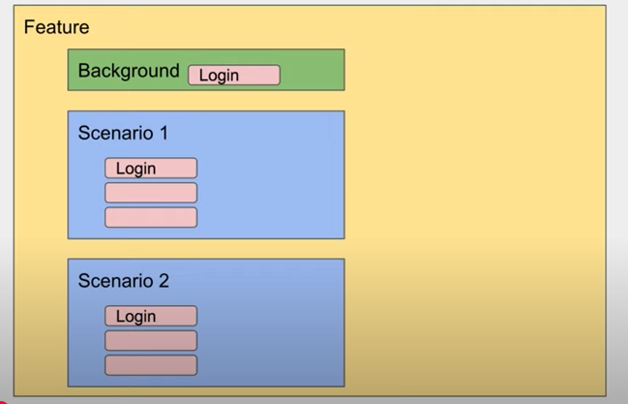
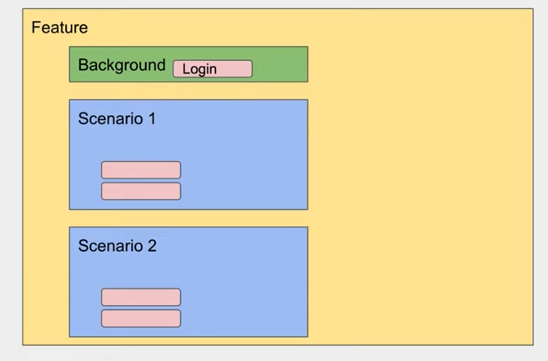

Steps:
- Create a new or use an existing Feature file
- Create the steps for the scenario in the feature file
- Create a new or use the existing TestRunner class
- Run the test runner file
- Create a background section and add common steps
NOTE:
- You can only have one set of Background steps per Feature
- If you need different Background steps for different scenarios, consider breaking up your set of scenarios into more Features
- Use background so that all stakeholders can understand the scenario

How to Create HTML Reports in Cucumber:
- Add the maven cucumber reporting dependency in pom.xml
- Add the build plugins in pom.xml
- Clean project

