2. Software Technologies

2.1 Visual Studio Code
Visual Studio Code (commonly referred to as VS Code) is an integrated development environment created by Microsoft with the purpose of easily editing source code for users across multiple operating systems such as Windows, Linux and macOS. Its popularity is reflected by flexibility, performance and extensive support for a multitude of programming languages. Useful features include syntax highlighting, debugging, intelligent code completion, code refactoring and embedded version control with Git [1].
In the context of this Bachelor Diploma Project, VS Code was used to write the scripts in Python programming language with the aim of controlling the LEGO Mindstorms EV3 robot to perform specific tasks. In figure 2.1.1 is presented the home interface of the code editor.
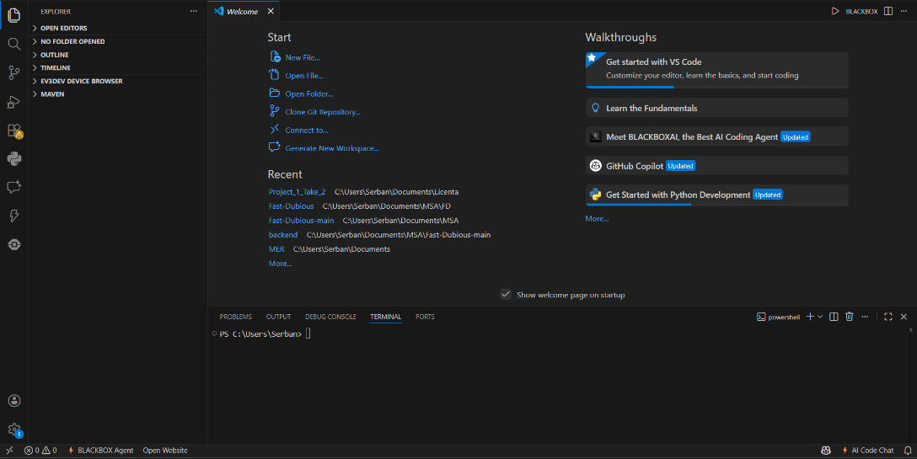

Fig. 2.1.1 Home Interface of code editor Visual Studio Code

One of the major advantages of using VS Code in developing this project was its well-organized structure of folders and files, making it easier to access the code. Furthermore, the debugger has significantly shortened the time for detecting and correcting errors and along with the intelligent code completion tool IntelliSense, has rapidly developed the software by reducing name memorization and keyboard input.
VS Code benefits from an integrated terminal which allows the execution of the scripts and commands within the editor. This feature is paramount for testing and running the code while quickly adjusting the functionalities of the robot in real time.
By using VS Code, the development of the software for the LEGO Mindstorms EV3 was optimized and adapted to fulfill the specific needs of the project, demonstrating the adaptability of this instrument in an experimental project of robotics.
2.2 Python Programming Language
Python is high-level and interpreted programming language developed by Guido van Rossum and was first launched in 1991. It is an open-source language which permits the users to modify and distribute the source code. The reason why this language is so popular is the fact that it offers simple syntax, code readability and support for multiple programming paradigms, including procedural, object-oriented and functional programming. This paves the way for a variety of applications which can be developed in a quick, flexible and efficient way.
Python has a standard library which provides a wide range of capabilities from data processing to networking communication. Besides this, Python benefits from an ecosystem of external libraries that can generate a solution to almost every programming task, if it is either data analysis, graphical user interface or artificial intelligence. Based on the fact that there are held global conferences, the community contributes to a continue evolution of the language and its ecosystem by offering aid through resources, tutorials and documentation.
2.2.1 Used Libraries
In order to realize this project, I have imported and used the necessary libraries for a simple implementation of the desired functionalities of the robot. These libraries are essential for hardware control, data processing and analysis, network communication and user interaction, thus contributing significantly to the smooth performance of the system. In this context, for both the Maze Solving and Lane Keeping applications I have used the pybricks library.
pybricks.hubs library
The pybricks.hubs library is the central backbone of Pybricks ecosystem, being used to define and control the hardware of the robot. Each hub has its own dedicated class which allows the user to access its integrated functions such as display, buttons or speaker. By using this library the user receives feedback visually and auditory through the central component EV3.
pybricks.ev3devices library

3. The Lane Keeping Application

This project implements a robust algorithm in which the LEGO Mindstorms EV3 follows a trajectory on a white surface that is bordered with the help of two black lines between which the robot is situated, thus keeping itself in a lane. Unlike traditional robots that follow a single line this robot uses two color sensors to balance itself inside the white “road” that is contrasted with the two black edges. It utilizes a custom controller combined with an emergency safety net to achieve a reliable and smooth navigation.
The robot is evaluating continuously its physical position by computing how far it has drifted from the ideal center and applying corrective steering to maintain its trajectory. In doing so, the robot uses two color sensors on each side of its front which adjust him from a disturbed state to an ideal state.
The Ideal State, described in the code by the variable setpoint, is the state in which the robot is perfectly centered, and both sensors read the exact reflection value from the white, meaning the difference is 0.
The Disturbed State is the state where the robot by drifting left or right moves over the black boundary line. This causes the sensor’s value on the black line to drop while the other sensor remains on white, so it keeps its value. In this situation, the difference between the two sensors becomes non-zero and it needs to be fed to control algorithms to be corrected.
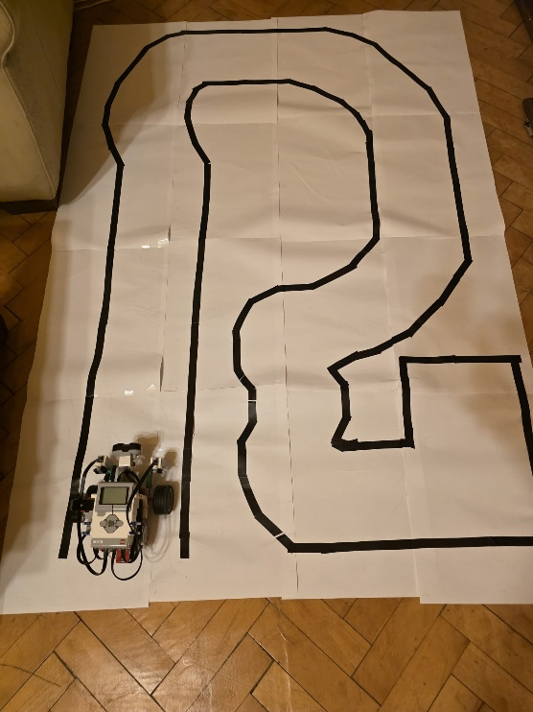
This image provides a good example of a path the robot navigates while maintaining itself bounded by the black lines. The trajectory differs from straight, curved and cornered, covering most possibilities.
The architecture of this project provides an Object-Oriented, SOLID-compliant structure. So, there is a dedicated method initializeConfiguration(task, algorithm) where all necessary variables are initialized for this type of application:
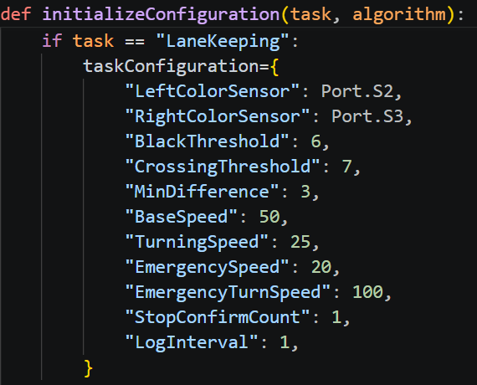
The Left and Right Color Sensors are connected to the physical ports of the robot. The Black Threshold represents the value 6 where the sensors are over of the black line, while Crossing Threshold represents the value 7 where the sensors are closing in on the black line. The Min Difference being 3 represents the tolerance zone where the sensors are over white surface, but they don’t read the exact same value (values close to 0 means dark and values close to 100 means bright). This allows the robot to continue straight, since the difference between white value and black value is way higher. Base Speed is the forward velocity of the robot being perfectly centered. It is 50 mm/s since the track isn’t long and can be easily followed. Turning Speed being 25 mm/s is the reduced forward velocity of the robot during a regulation to prevent the robot from overshooting its turns. Emergency Speed (20 mm/s) and Turn Speed (100 deg/s) are highly restrictive forward speed, respectively extreme rotational speed, used exclusively to aggressively pivot the robot away from a lane exit. The Stop Confirm Count is the number of times the robot detects the value of black on both sensors before it stops. Due to false readings caused by shadows or oversteering in narrow corridors, this variable has been introduced. After many runs of the robot when there were no more false readings, the value of times it encounters black is set to 1. The Log Interval is the number of seconds to pass to print what the robot has recorded and what action did it took. It is 1 for a more detailed log.
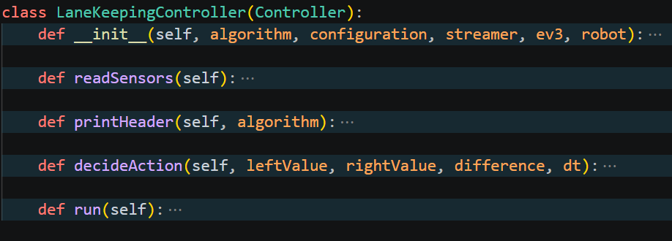
The Lane Keeping application’s functionality is described in the LaneKeepingController class, which implements the Controller interface. In this class there are defined the methods which contribute to the desired behavior of the robot when it tries to follow the lane. It firstly initializes the attributes in the constructor, retrieves the values from the sensors, prints the header of the log, decides what action needs to be taken and finally the run method which starts the robot to move.

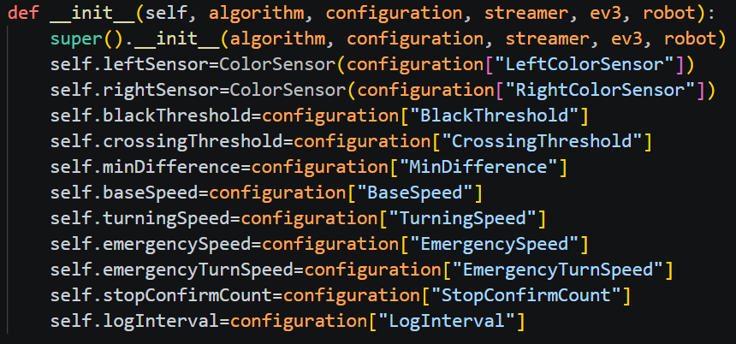
The constructor takes the inherited attributes from the super abstract class Controller and along with the more specific attributes taken from the configuration dictionary to initialize the state of the LaneKeepingController object.
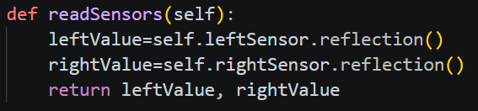
This method simply reads the values of the light reflected on the surface they are currently on and returns them.
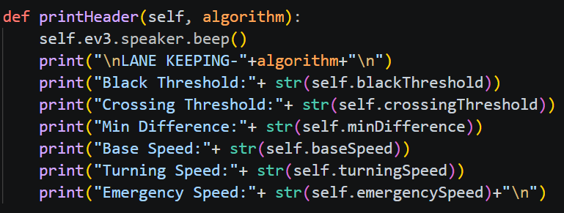
This method prints the header of the log to be able to compare the results and see how the thresholds affect the decision-making process after the run.
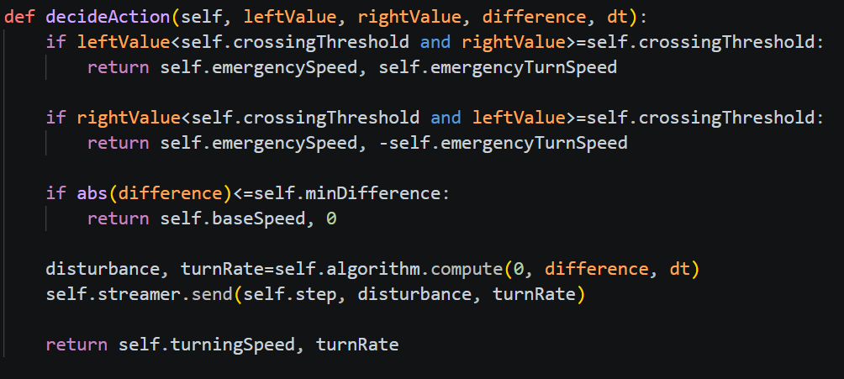
This method decides what action needs to be taken based on the values read by the sensors and the difference between them. The first case treats the moment when the left sensor reads a value close to the black and the right sensor reads a larger value. This means that the robot is crossing the black line on the left side, so the method returns the emergency speed and the emergency turn speed with positive value, meaning turning right. The second case is opposite to the first and treats the moment when the right sensor reads a value close to the black and the right sensor reads a larger value. This means that the robot is crossing the black line on the right side, so the method returns the emergency speed and the emergency turn speed with negative value, meaning turning left. The next case treats the difference with the values of the sensors being smaller or equal than the minimum difference accepted to let the robot continue straight ahead, meaning that the robot is on a bright surface and the method returns the normal speed and the speed of turning is 0 to move without deviation. If neither of these conditions are fulfilled, the disturbance and turn rate are taken from the results done by the compute() method of the selected algorithm and then sent to the PC. The method finally returns the turning speed and the turn rate (the output of the regulation) meaning that the robot is regulated by the selected algorithm.
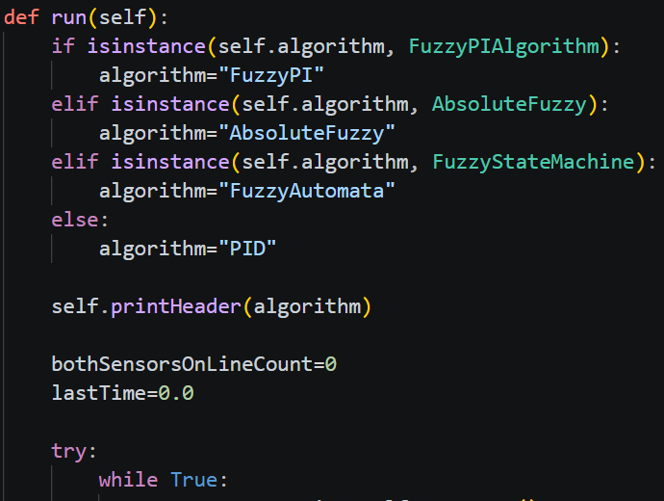
The final run() method is the main execution loop. It includes the previous three methods to execute the task. Firstly, it identifies the algorithm by checking the instance of the algorithm class and attributes it to the algorithm variable. It prints the header according to the algorithm and the constants and resets the number of times both sensors crossed the black line and the time.

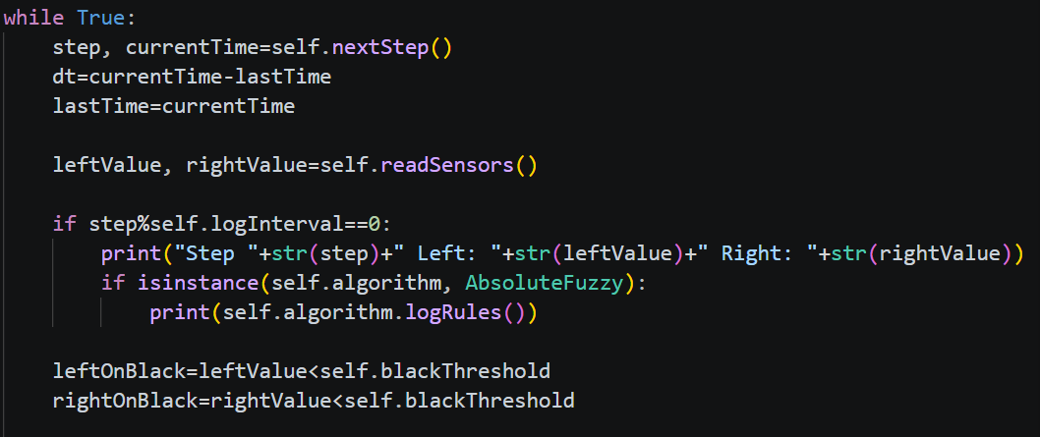
The continuous loop begins with the computation of the change in time by subtracting the current time (obtained from the now() method) with the last time and updating the last time. The left and right values are assigned with the values read by the sensors and then, based on the log interval, which in this case is 1, is printed at each multiple of it the step plus what values the sensors read. If the algorithm is Absolute Fuzzy, the rules are also printed.
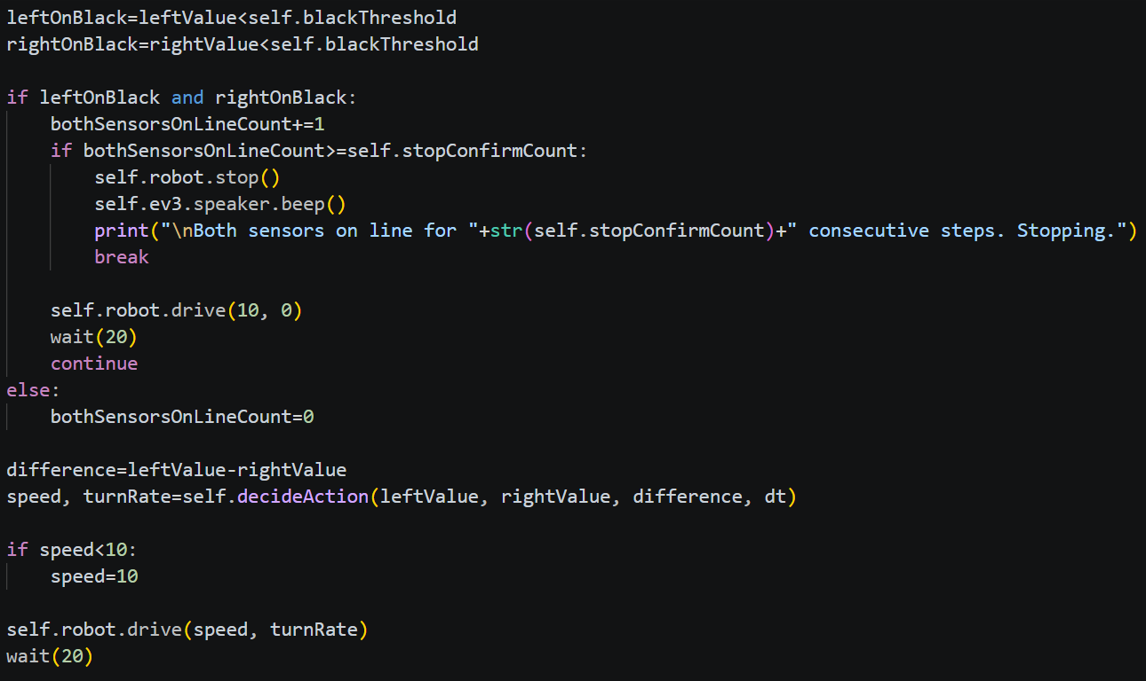
With the help of the Boolean variables left on black and right on black, the condition for the robot to stop is created by having both values of the sensors smaller than the threshold value which indicates a very dark surface. In the event of false readings, the number of times both sensors were on the black line increases until it reaches the confirmation count to stop, otherwise it reduces the speed and waits to see if indeed is on a black line or not.
If the conditions fail, the difference is computed and the speed with the turn rate are computed from the action it needs to be decided based on the left value, right value, difference and the change in time. The returned speed can’t get lower than 10 and the robot is driving based on the final speed and turn rate. The final wait is used to ensure the loop frequency remains consistent regardless of which branch was taken.
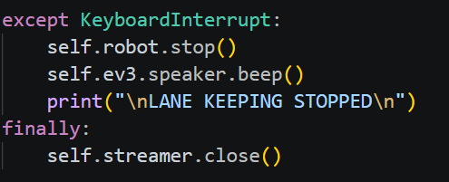
The except part of the try-except black where the program is interrupted by the user. The robot stops and the stream closes.

3.1 PID Algorithm
One possible option for the robot to succeed in following the lane is with the help of a PID controller. This algorithm that implements this type of controller uses Comparative Control, where the Error, or more specific, the Imbalance of the two color sensors, is computed at each step in order to be given as input to the controller so that it can generate the turn rate so that the Imbalance is minimized.

$\text{Imbalance = Left Reflection - Right Reflection}$

If the left one is darker (closer to the value of black), then the Imbalance is negative so that robot must turn Right to further from the black edge. If the right one has a value closer to black, then the Imbalance is higher than zero and the robot needs to turn Left. The final turn is calculated with the help of three constants:
$Turn Rate = (K_{P} × Imbalance) + (K_{I} × \int{Imbalance dt}) + (K_{D} × Imbalance d/dt)$
In this project, the PIDAlgorithm class is the blueprint of the object that has the job to execute the lane-keeping track using a PID controller.

3.1.1 Proportional Gain ($K_{P}$)
It symbolizes the present as it only takes into account the current value of the Imbalance. As the main steering force, its effect on the robot is that the further the robot is from the center, the harder it turns. In other words, if the robot is sluggish and goes off the track on curves, increase the $K_{P}$. If the robot shakes violently back and forth, decrease the $K_{P}$.
3.1.2 Integral Gain ($K_{I}$)
It represents the memory since it accumulates the Imbalance over time. If the robot has a mechanical drift, for example a slightly weaker motor, or is on a long, sweeping curve, $K_{P}$ alone might leave the robot off-center while $K_{I}$ builds slowly steering power until the robot is perfectly centered. Usually this constant is very small, less than 0.1. Otherwise, it creates Integral Windup, meaning that the robot will overreact drastically and swing off the lane.
3.1.3 Derivative Gain ($K_{D}$)
This constant is the dampener as it computes how fast the Imbalance is changing. When the robot steers back toward the center of the lane, $K_{D}$ acts as a brake. It reduces the steering power right before the robot reaches the center, preventing it from overshooting into the other black line. A higher $K_{D}$ will tighten the path so that the robot will avoid crawling widely as a snake down the lane.

3.2 Fuzzy PI Algorithm
This algorithm stands apart from a rigid mathematical model as the PID controller by acting as a human driver who adjusts the steering power based on how off the center the robot is. A Fuzzy PI controller changes the constants $K_{P}$ and $K_{I}$ depending on the state of the robot using Fuzzy Logic.
In standard programming, values are binary. Fuzzy Logic allows the robot to understand degrees of truth: slightly off-center or very far off-center by translating the crisp value of the Imbalance, adjusting dynamically the proportional and integral gains and generating the final turn rate. These three steps are implemented in the functions fuzzifyImbalance, fuzzyInference and fuzzyCompute to return the power steering necessary for the robot to drive a smooth lane-keeping path.
The fuzzifyImbalance() method takes the crisp Imbalance and translates into human-like concept under the threshold constants (imbalanceSmall = 3, imbalanceMedium = 10, imbalanceLarge = 25) to draw overlapping triangles and computes the membership function.
The fuzzyInference() method takes as arguments the percentages from the previous method and decides how aggressively the robot should steer by adjusting $K_{P}$ and $K_{I}$. For example, if the imbalance is “small”, it lowers slightly the $K_{P}$ and raises the $K_{I}$ to ease gently the robot back on the center by calculating the Weighted Average. With this Weighted Average the base gains are multiplied with blended multipliers to output the final adaptive gains.
$K_{P multiplier}=(μ_{small}×K_{P small}+μ_{medium}×K_{P medium}+μ_{large}×K_{P large})/total_weight$
$$K_{I multiplier}=(μ_{small}×K_{I small}+μ_{medium}×K_{I medium}+μ_{large}×K_{I large})/total_weight$$

Where $total_weight=μ_{small}+μ_{medium} +μ_{large}$.
The fuzzyCompute() method is the main orchestrator since it ties the fuzzy logic to standard PI math to generate the actual turn rate. It firstly calls fuzzifyImbalance() to retrieve the membership functions, then these are fed into the fuzzyInference() to get the newly adapted $K_{P}$ and $K_{I}$ gains and finally computes the output (turn rate) after the standard PI formula:
$Output=(K_{P}×Imbalance)+(K_{I}×\int{Imbalance} dt$)
It features Anti-Windup as it prevents the fuzzy_integral from growing infinitely large if the robot gets stuck by clamping it between integral_min and integral_max. Also, the final output turn rate is clamped so that the motors don’t receive impossible commands.

