Python Project 1

Team 1:

* Alin Caia: web scraping, data science, data plotting
* Daniel Chin: mysql, data plotting

Report and Analysis

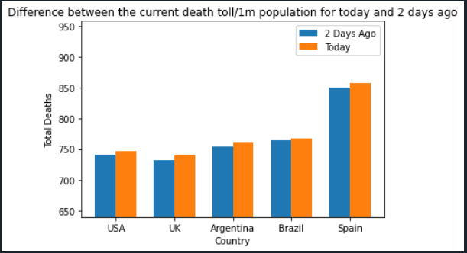

Findings on bar plot comparing the current death toll / 1m population for today and 2 days ago:

The first plot displays the differences between the current death toll/1m population for today and two days ago. The countries selected that were easily comparable are USA, UK, Argentina, Brazil and Spain. For the data that we scraped on the time of scraping, it appears that all the selected countries have had an increase in total deaths two days before the present day.

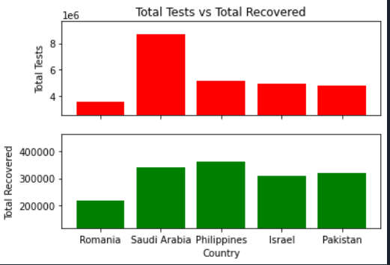

The third plot demonstrates two subplots in a single plot which covers the Total Tests and the Total Recovered for the current day (today). The upper subplot indicates that the countries Philippines, Israel, Pakistan were relatively close in terms of total tests (in the millions) while Saudi Arabia was the highest in terms of total tests. Romania had the lowest number of Total tests and total recovered in both categories for the present day. On the lower subplot for total tests, Saudi Arabia, Philippines, Israel and Pakistan were all relatively close in total recovery while Romania remained the lowest.

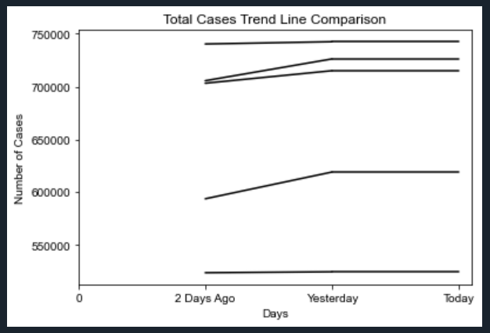

The trend line compares the number of total cases in the last 3 days for 5 countries. The legend doesn’t work on a trend line, so we cannot identify which lines belong to which country. But we can clearly see the change in number of total cases made during the 3 days for each country.