﻿ Total Count of SEX (F/M) was higher for F (37) than M (26).﻿ ﻿﻿2 in SEX (F/M) M made up 26,98% of Count of SEX (F/M).﻿﻿ ﻿﻿Average Count of SEX (F/M) was higher for F (12,33) than M (8,67).﻿﻿ ﻿﻿Count of SEX (F/M) for F and M diverged the most when the Tip de K.pn (sensibil =0, ESBL=1, Carbapenemaze=2) was 0, when F were 11 higher than M.﻿﻿

﻿

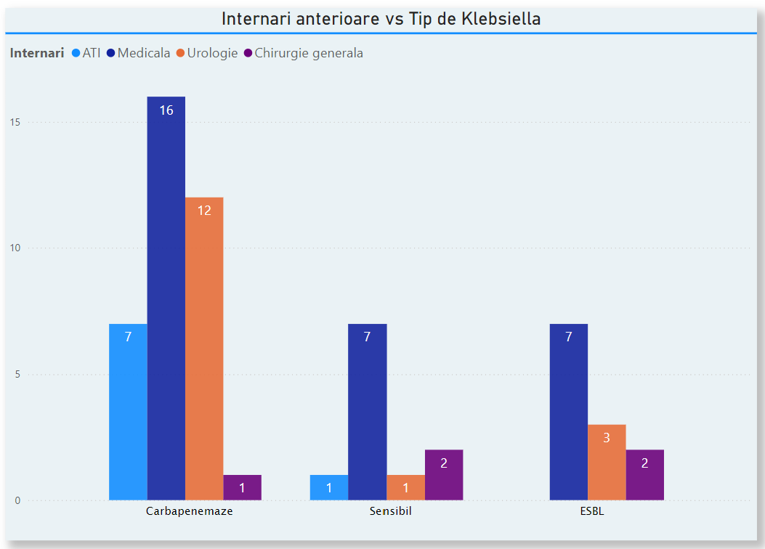Average Count of SEX (F/M) was higher for F (12,33) than M (8,67).﻿﻿ ﻿﻿Count of SEX (F/M) for F and M diverged the most when the Tip de K.pn (sensibil =0, ESBL=1, Carbapenemaze=2) was 0, when F were 11 higher than M.﻿﻿

Average Count of SEX (F/M) was higher for F (12,33) than M (8,67).﻿﻿ ﻿﻿Count of SEX (F/M) for F and M diverged the most when the Tip de K.pn (sensibil =0, ESBL=1, Carbapenemaze=2) was 0, when F were 11 higher than M.﻿﻿