**INTRODUCTION**

This java desktop application provides to the user keeping track of product and it's stocks. Main goal of the program to sale products those are in the user inventory. Also owner of the program can create profiles for his/her customers. Indeed, this program provides to analyse each customer.

**MAIN SCREEN**

* Add to Shopping List
* Add Quantity
* Change Quantity
* Change VAT
* Drop Product from Shopping Basket
* Product Packages Defination
* Clear Button
* Enter Cash
* Search a Product
* Select a Customer
* Payment and Print Order List

**PRODUCT SCREEN**

* Create New Product
* Edit Product
* Cancel Editing
* Define Product Package
* Delete Product
* Search Product

**CUSTOMER SCREEN**

* Create New Customer
* Edit Customer
* Delete Customer
* Search Product
* Analyisis of Customer

**MAIN SCREEN**

On the top table user can see all products in the inventory.  
The below table is customer’s **shopping basket.**  
On the right side there are vary of information about the sale (Total VAT, Total Discount, Change and Total Price).

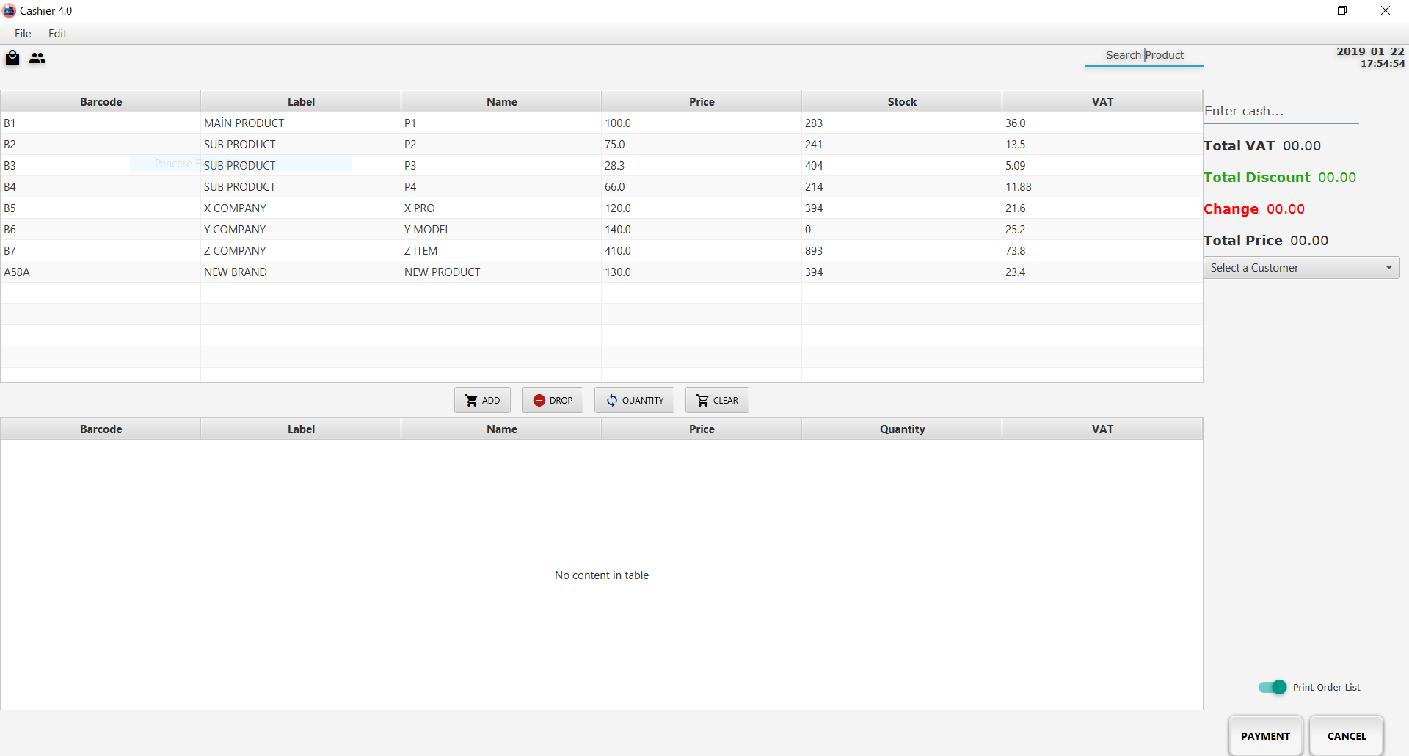

Products can be added into to he inventory by following these two steps two different ways.  
After selecting a product the user should **click on**  button or **right click** on a product and click **Add to Shopping List** choice.

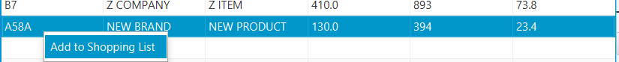

After following those steps the user will encounter with **Quantity** screen. This screen allows the user to enter quantity of desired product

If desired quantity is **out of stock capacity** then this product will not be added into the shopping basket.

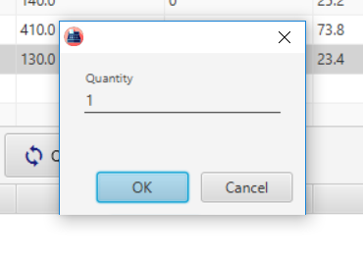 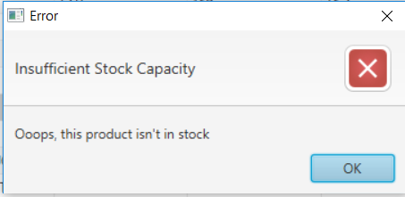

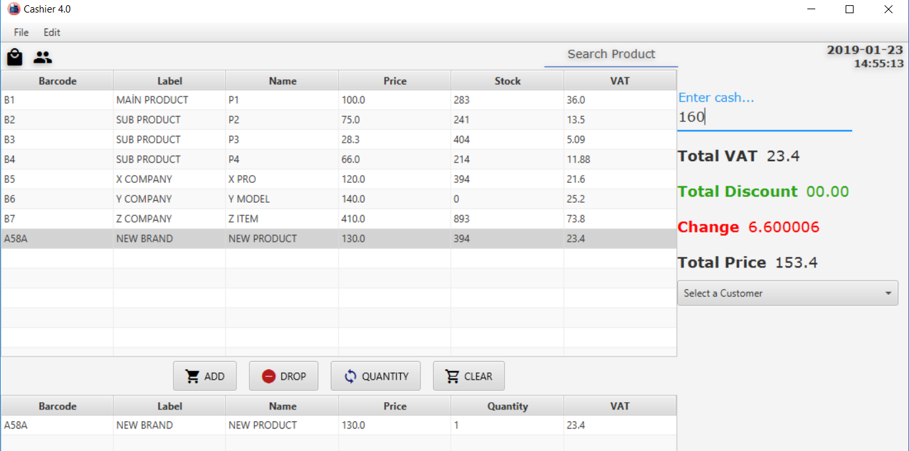

After added products into the shopping basket, the program will calculate total price and vat according to content of shopping basket.  
-**Total Price** calculating product price + product vat.  
-If the user **enter cash** that the customer give it to pay then the program will calculate how much user should give it back (**change**) to the customer.

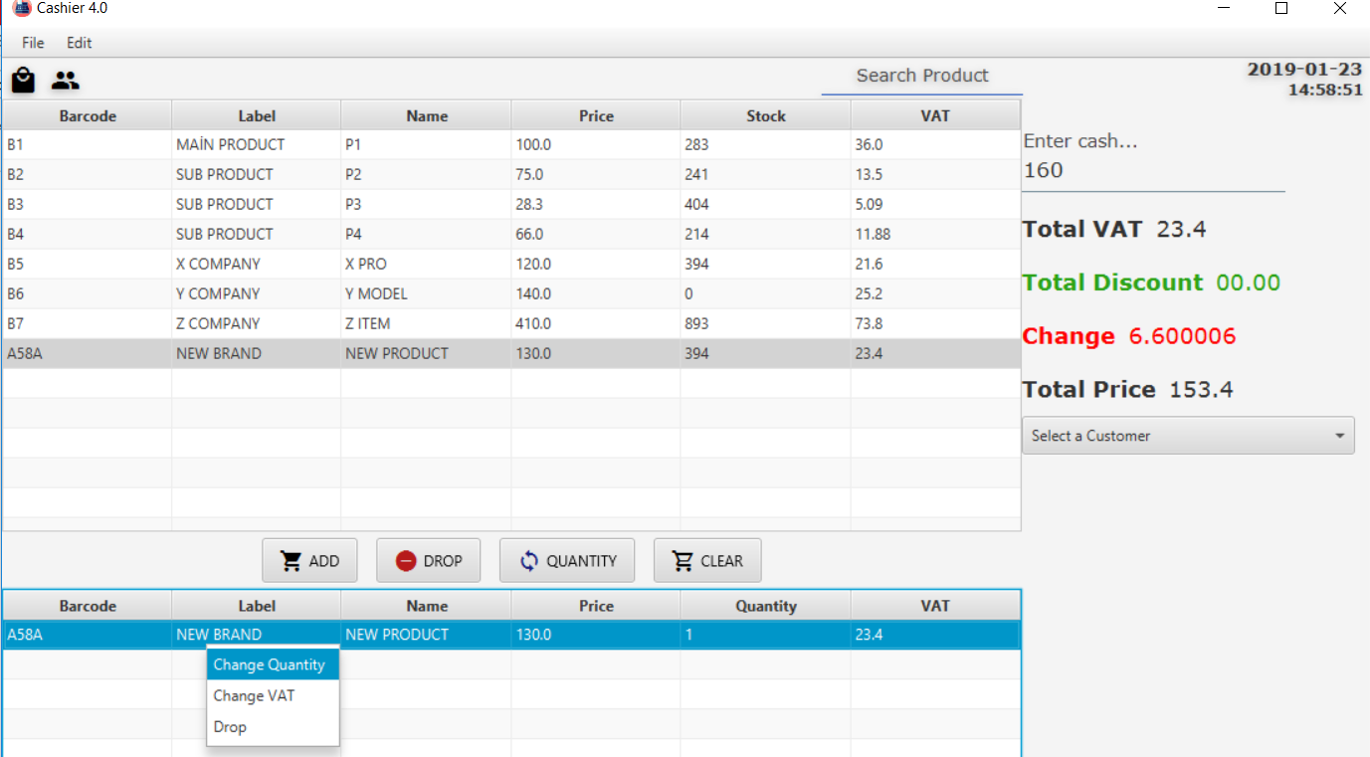

If the user will enter wrong quantity or if the user desire to **Change VAT** or **Change Quantity** of interested product by right clicking on that product or after  
selected that product user can use those buttons 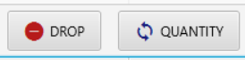 to **delete product** from the shopping basket.

**Search field** provides to the user find desired product quickly.

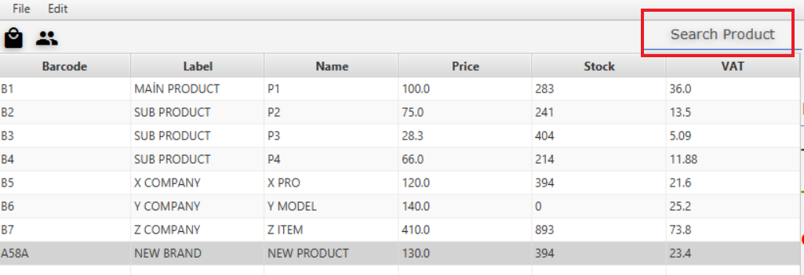

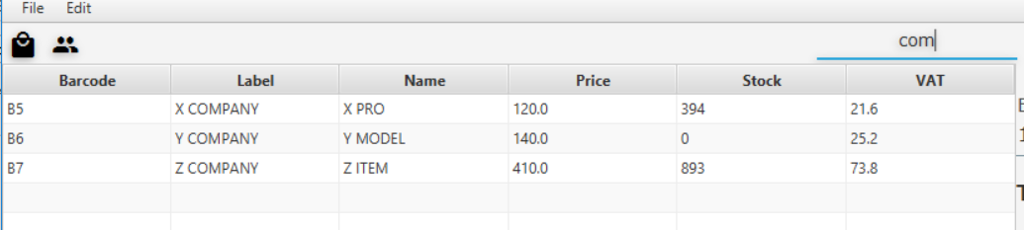

 By clicking **Clear Button** all products that are in the shopping basket can be deleted.

There are also **product packages**. Product packages force to customer to buy all necessary products(defined by the user) with the main product. (Following part you can find how to create product packages).

**Example:**

Led Signboard **(Main Product)** Price $20  
 - 3 Quantity Red Led Panel (32x16) 20$ **(Sub Product)**  
 - 10 meters Cat-5 Cable Price 7$ **(Sub Product)**

**Total Price** of the product will be calculated 20+20+7 = 47$   
In this vat assumed as 0$.

If the user wants to add that main products into the shopping basket then it’s sub products will be added automatically into the shopping basket.

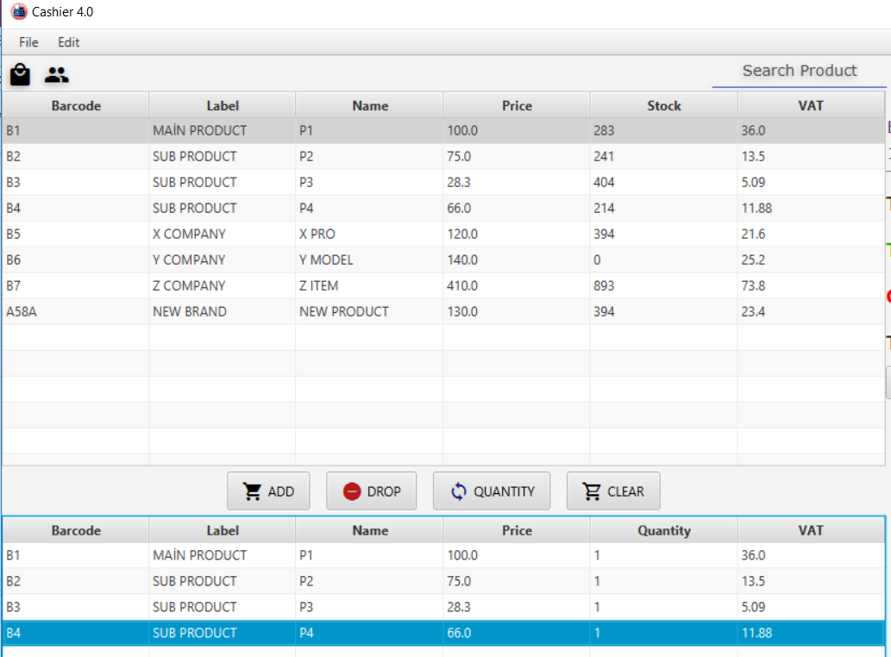

User will **not** be able to **delete** those sub products from the shopping basket **if** the main product is still in the shopping basket.  
-Sub products can be added by itself and can be deleted from the shopping basket if it did not come with the main product

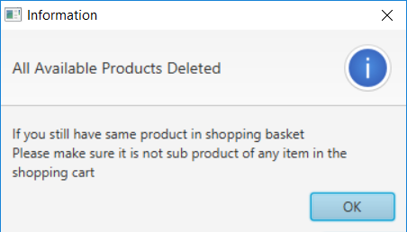

Before finish the sale the user should **select a customer** information from the right side of the program if the customer profile created before.

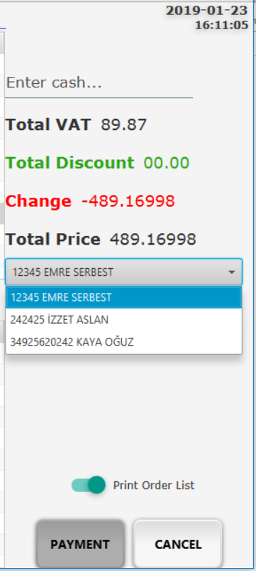

To finish the shopping click on 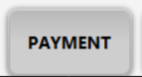 button. If the user wants to **print order** details onto **.txt** files the user should make sure that button must stay like this. 

Then directory should be selected to create .txt file.

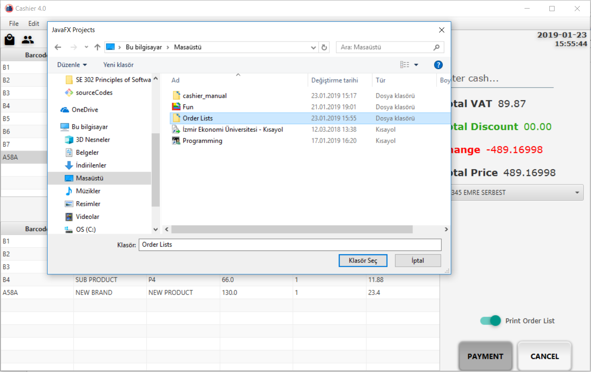

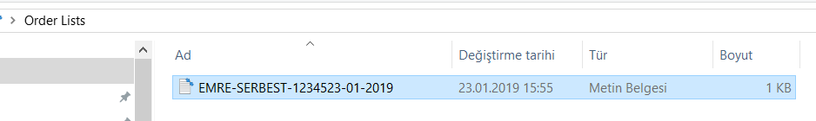

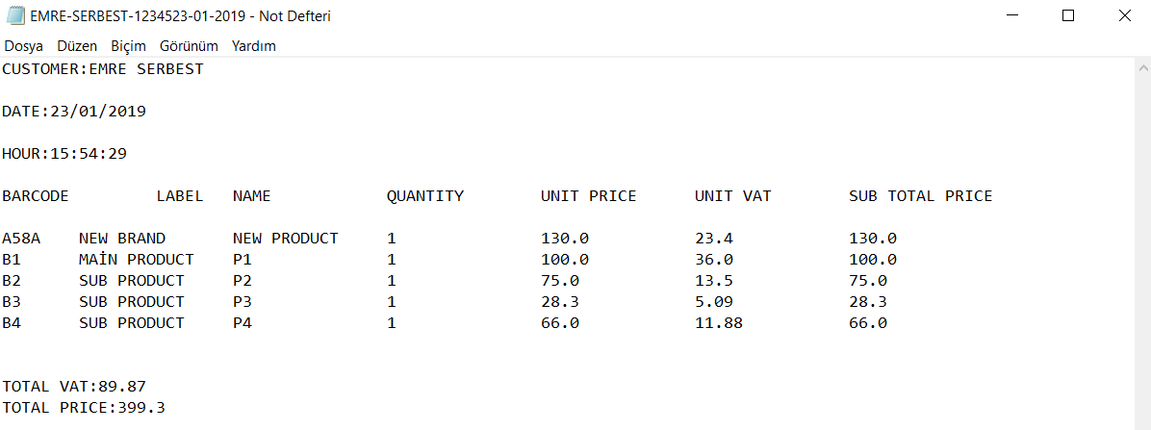

**PRODUCT SCREEN**

* **Create New Product**
* **Edit Product**
* **Cancel Editing**
* **Define Product Package**
* **Delete Product**
* **Search Product**

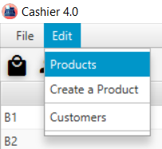The user can reach product screen from main screen by clicking  button on the tool bar.  
or by following **Edit/Products** path.

Here is the products screen.

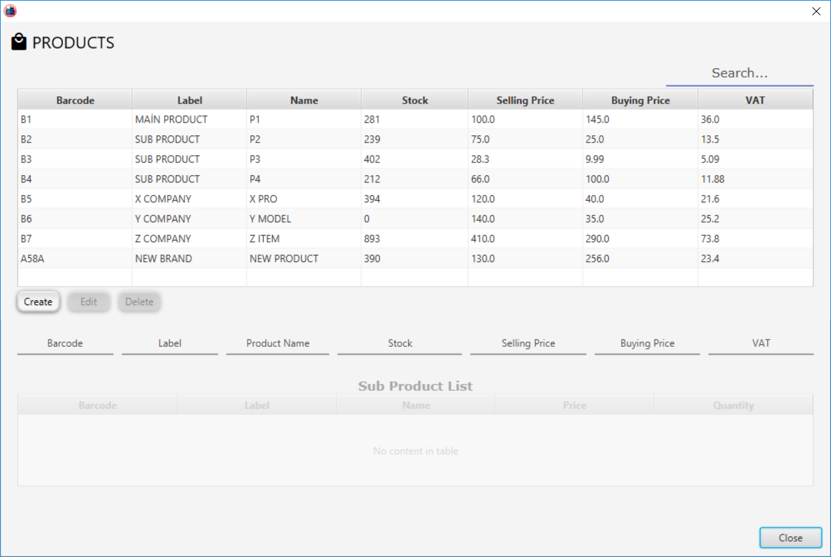

After filled up required fields the user can **create new product**.

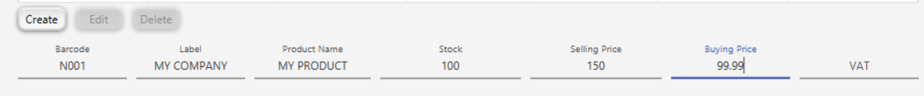

VAT field will be calculated as %18 of selling price if the user doesn not fill it up.



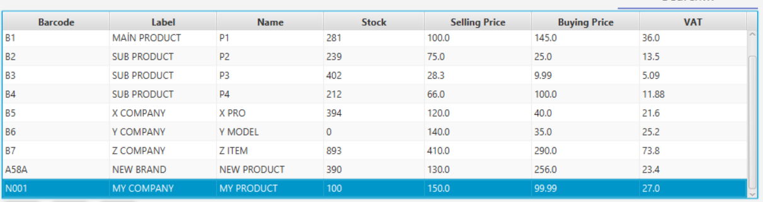

To **Edit a product** the user must select interested product on the products table then should click on edit button.

Then user can change any defined information in the past. After changed necessary information the user must click Update button. 

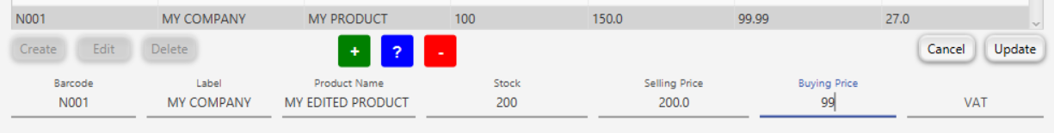

Or the user may **Cancel** editing process by clicking Cancel Button .

To **define product package** the user should select a product that wants be defined as a main product after that click on edit button .

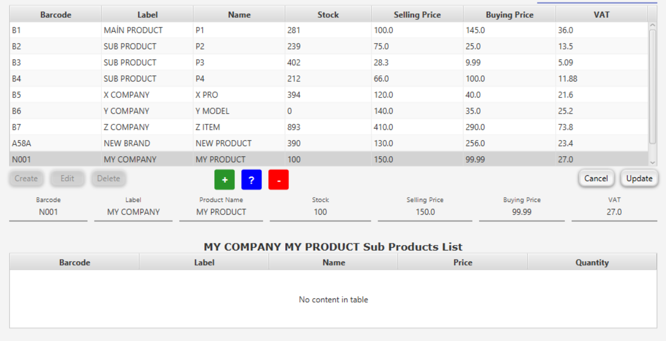

After clicking on edit button  buttons will be activated. Now editing mode is on and while editing mode is on the user can define any product (apart from editing product –main product-) as a sub product of editing product.

To define a product as a sub product the user must select a product on top table.

In this example our **main product’s** (editing product) name is **MY PRODUCT** and we are going to define **X PRO** as **sub product.**

To add X PRO as sub product first select X PRO and then click on  button then enter desired quantity here. 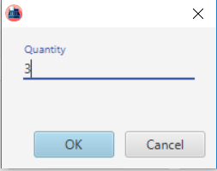

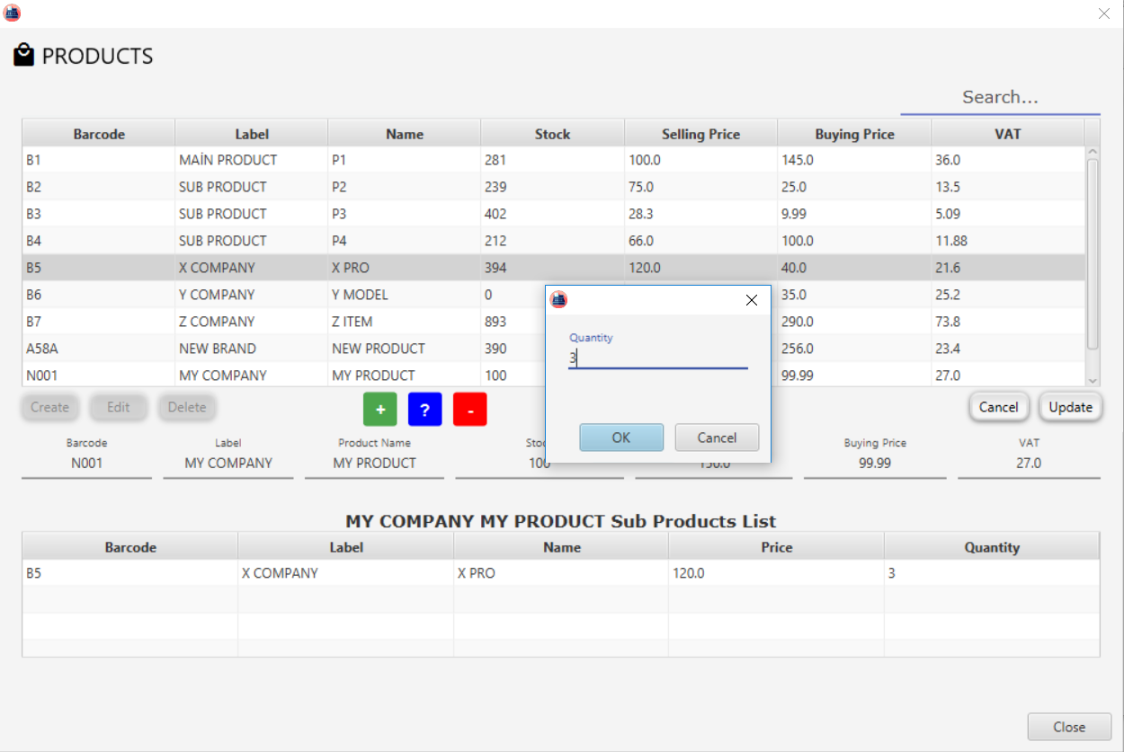

Now **X PRO** is sub product of **MY PRODUCT** if we click on update button. 

The user is able to define sub products as many as desired.

 button is provides to **change quantity of sub products.** To change quantity of sub product the user must select the desired sub product below table.

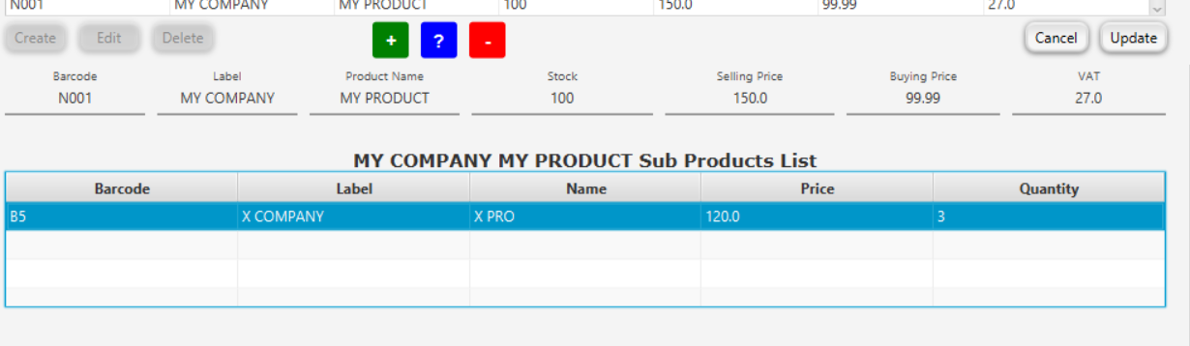To delete defined sub product click on  button after selecting that product.

After click on update button that product package will be defined.  
Now you can see my product is a main product and has sub product(X PRO).

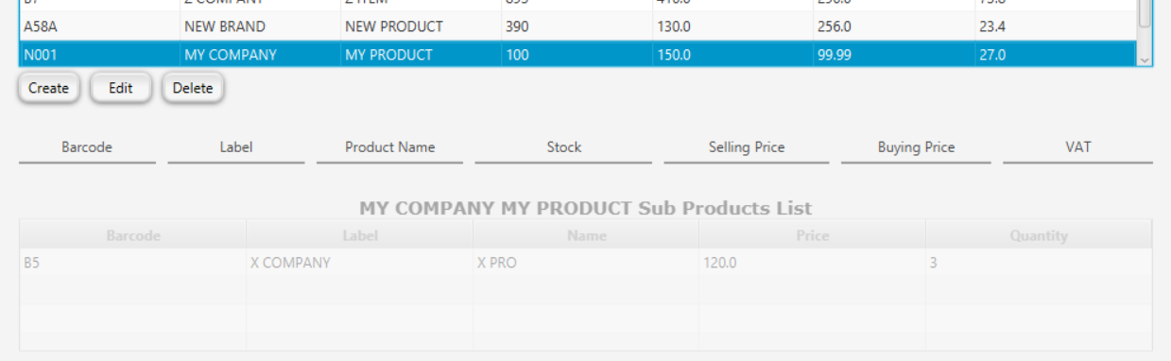

**To delete a product** the user must select interested product on the top Products table then by clicking on  delete button the user can delete the product. If selected product is a sub product of any product then the user will get an error.

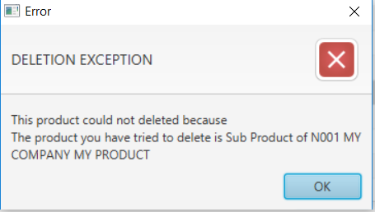

**Sub products cannot be deleted.** If the user wants to delete sub product then the user must update it’s main product’s sub products list and delete the interested product from sub products list.

**To search** a product type name of product(X PRO) or label of product(X COMPANY) or label and name together (Y COMPANY XPRO) on the search field.

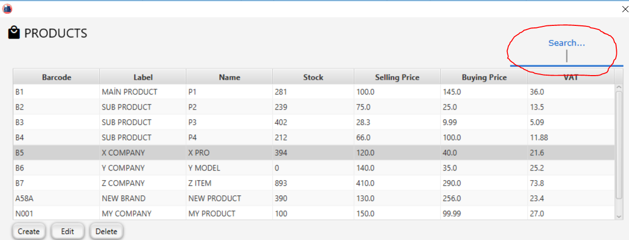

**CUSTOMER SCREEN**

* **Create New Customer**
* **Edit Customer**
* **Delete Customer**
* **Search Product**
* **Analyisis of Customer**

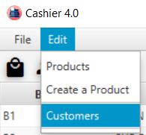The user can reach **customer screen** from main screen by clicking  button on the tool bar.  
or by following **Edit/Customers** path.

Here is Customer Screen.

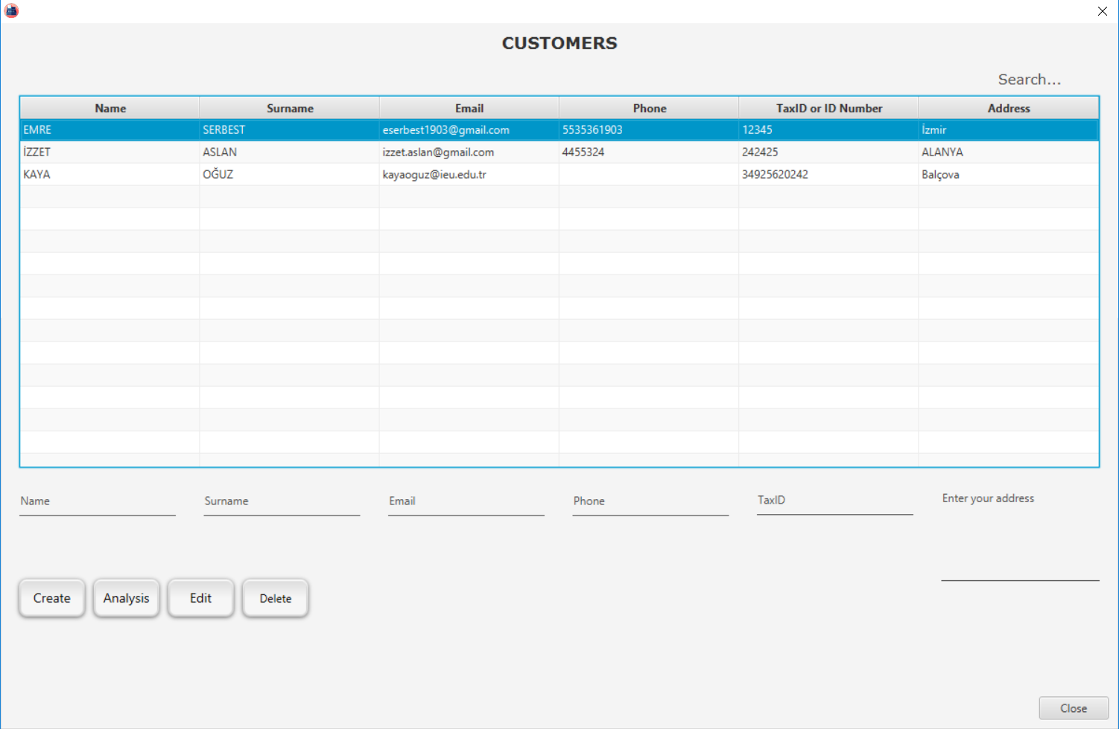

After filled up required fields the user can **create new customer**.

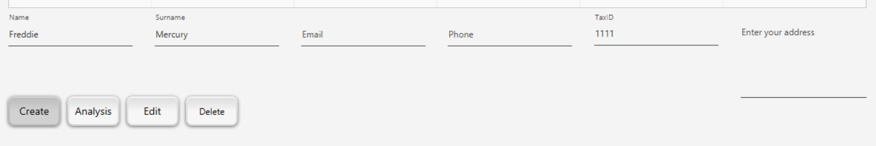

To fill up E-mail, Phone and Address fields are not must!

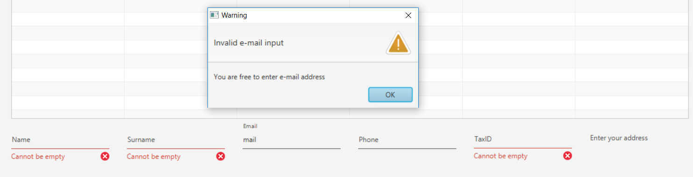

If the user enter a text into e-mail field then e-mail structure must be vaild! Example: mailaddress@outlook.com

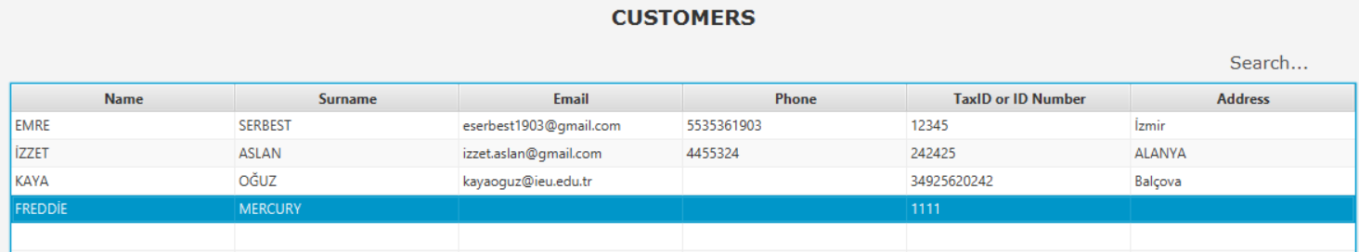

To **Edit a customer** the user must select interested customer on the customers table then should click on edit button.

Then user can change any defined information in the past. After changed necessary information the user must click Update button. 

To **delete a customer** the user must select a customer on the table then click on delete button .

To **search a customer** the user can search accoring to name, surname, name surname or Tax ID/ID number.

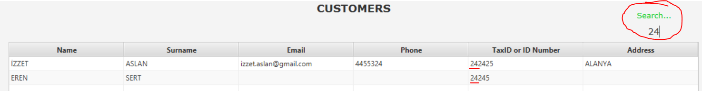

**CUSTOMER ANALYSIS SCREEN**

To reach a Customer Analysis Screen after select a customer click on **Anaylsis** button. 

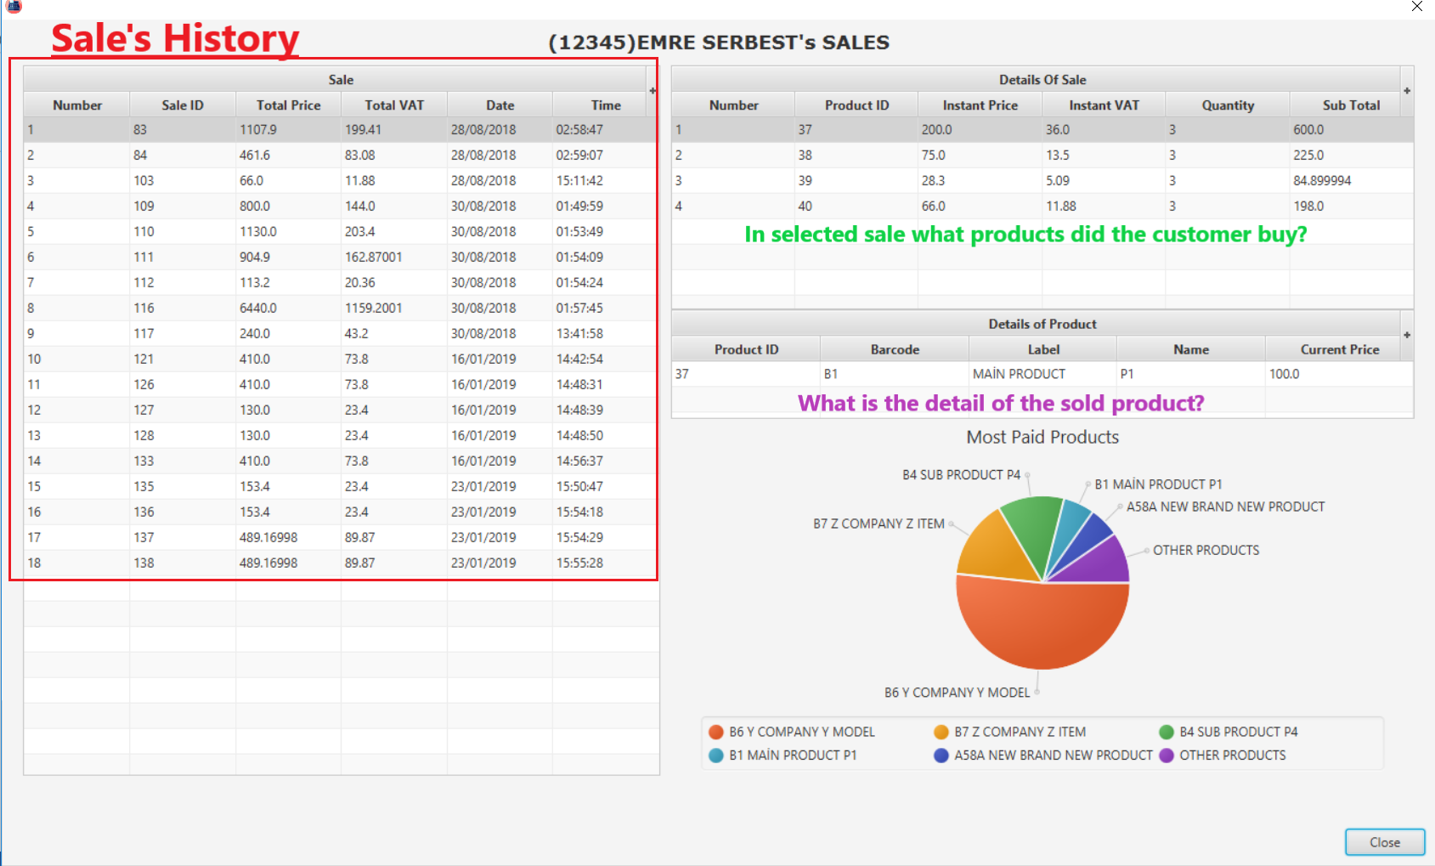

The user can see most paid 5 products of the selected customer in analysis screen on pie chart.

That application is my first JAVA GUI application this is designed on 2018 summer holiday.

Developed by Emre Serbest

E-mail: eserbest1903@gmail.com