DOCUMENTATION

ASSIGNMENT 1

STUDENT NAME: Sandor Serban Vlad
GROUP: ………… 30422

CONTENTS

1. Assignment Objective 3
2. Problem Analysis, Modeling, Scenarios, Use Cases 3
3. Design 3
4. Implementation 3
5. Results 3
6. Conclusions 3
7. Bibliography 3

Assignment Objective
The main objective of this assignment is to create a polynomial calculator in which the user can choose an operation and input two polynomials which will compute the selected operations making things easier for the user rather than calculating on a piece of paper. The secondary objectives are:
-to analyze and identify the problem which must be implemented.
-to project the calculator.
-to test and ensure the correct functionality of the calculator.

Problem Analysis, Modeling, Scenarios, Use Cases
The polynomial calculator must accept two polynomials inserted by the user as input and accept only correct values making a signal if the input is wrong.
The calculator should have the option to choose between the wanted operations, these being add, subtract, multiply, divide, differentiate and integrate of a polynomial.
The calculator should output the result of a given operation.

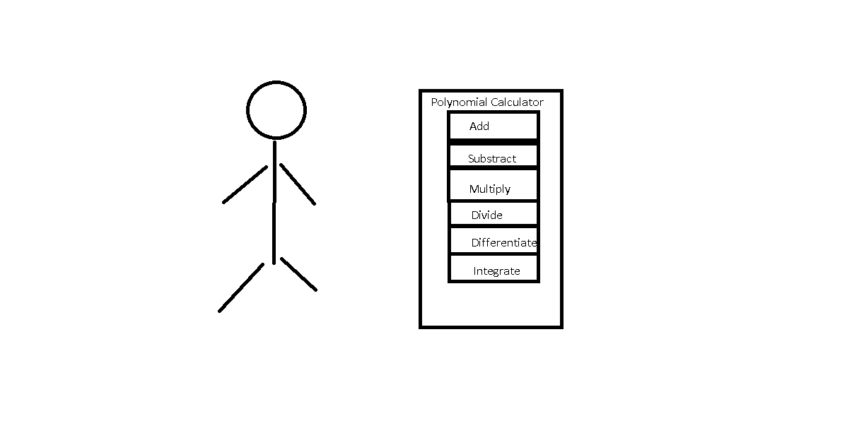

Use-case Diagram:
Success scenario:1. The user can successfully input the polynomials described as “First polynomial” and “Second polynomial” in the interface.
2. The user selects the operation that will be computed with the help of the corresponding button.
3. The calculator computes the desired operation and prints the output in the text-filed indicated by the “Result” text and the arrow pointing down.
Alternative scenario:1. The user gives an incorrect input.
2. The calculator shows an error message informing the user that the input is incorrect.

Design

1.OOP design of the application.
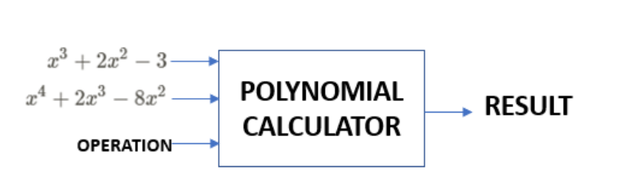
In the OOP design of the application, using the Java swing interface we will get the two polynomials and the wanted operation, following that after we press an operation button the result of that operation will be shown.

2.Packages and class with the UML diagrams

The main packages are Logic, Model and View. In the Logic package we have the Operations class, which implements the add, subtract, multiply, divide, differentiate and integrate operations. The Model package has the Polynomial and the Monomial class together with the Operations class successfully make those mathematical functions. The View package has the CalculatorController and CalculatorView class. CalculatorView is responsible for the interface of the application while the CalculatorController makes the connection between the View and the CalculatorView and Operations.

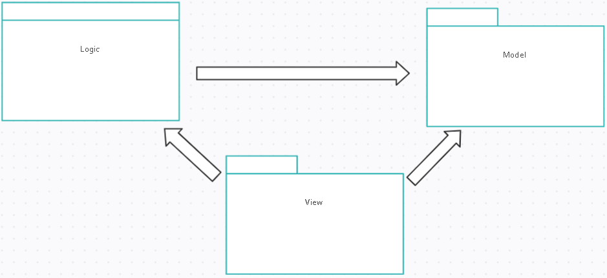

The project has the following classes:
- Monomial which has a degree and a coefficient .
- Polynomial which takes a map of monomials.
- Operations.
- CalculatorView which uses a Java swing interface.
- CalculatorController which implements the ButtonActions for the buttons for the operations.
- Main which calls the CalculatorView to run the interface.
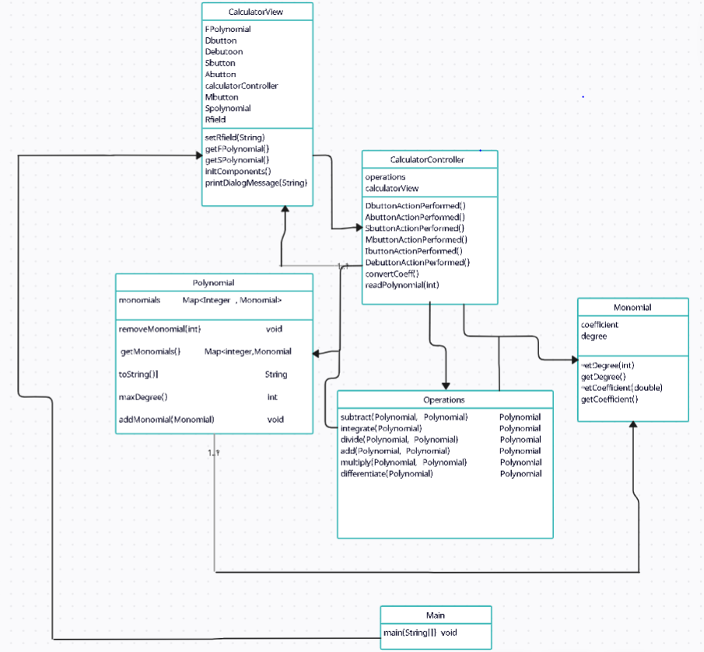

Implementation
Now we will describe each class with their fields and important methods.
1.Monomial
-Variables: coefficient and degree (double and int)

2. Polynomial
-Variables: Map<Integer ,Monomials>
-Important methods: -maxDegree()->gets the max degree of a polynomial from a monomial
-addMonomial(Monomial m)->adds a monomial to the polynomial
-toString()->outputs the resulted polynomial after a mathematical operation.

3. Operations
-Important methods: -add (Polynomial p1, Polynomial p2)->makes the addition between two polynomials we add the monomials with their corresponding degrees.
-subtract (Polynomial p1, Polynomial p2)-> makes the subtraction between two polynomials we subtract the monomials with their corresponding degrees.
-divide(Polynomial p1, Polynomial p2)->we divide polynomial p1 to polynomial p2 the result will be written in double so if we have a fraction as a coefficient it will be written as a number with decimals.
-multiply(Polynomial p1, Polynomial p2)-> )-> makes the multiplication between two polynomials, we compute each monomial one by one corresponding to their degree and then add it to the polynomial
-differentiate (Polynomial p1)->makes the derivative of polynomial p1.We go through each monomial of our polynomial. The formula for the new coefficients will be the coefficient of the current monomial times its degree. The formula for the new degree will be the degree of the current monomial minus one.
-integrate(Polynomial p1)->makes the integration of polynomial p1. We go through each monomial. The formula for the coefficients will be the coefficient of the current monomial divided by its degree plus one. The formula for the degree will be the degree of the current plus one.

4CalculatorView
:Variables: Jbuttons:Abutton(add),Dbutton(divide),Debutton(differentiate).etc
JtextFields: FPolynomial(fisrst polynomial),SPolynomial(second polynomial).

Results

1.Bad input
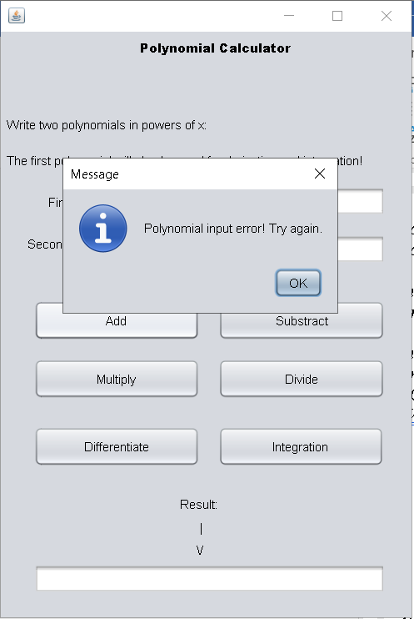

2.Add
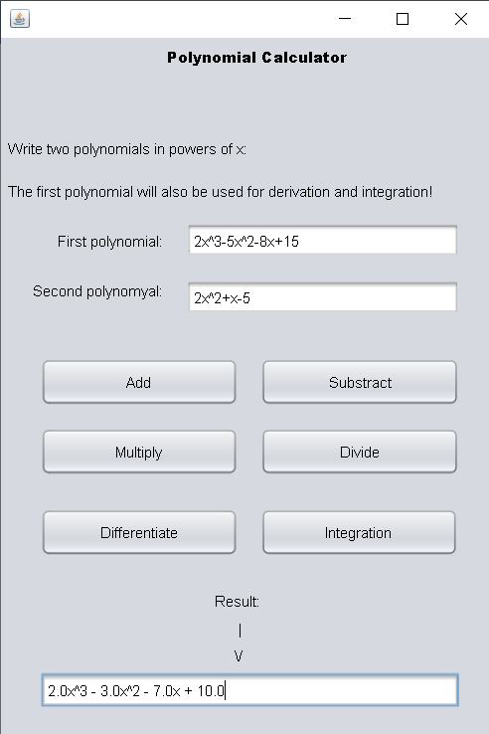

3.Subtract
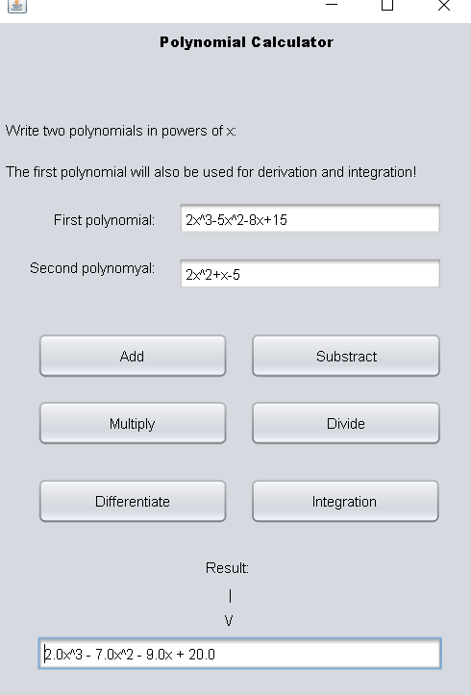

4.Multiply

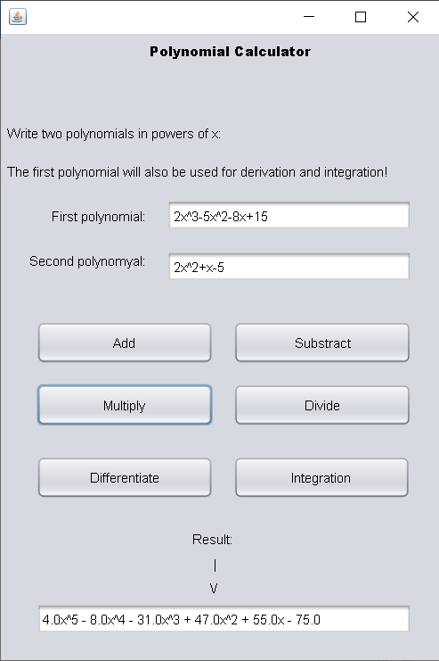

5.Divide

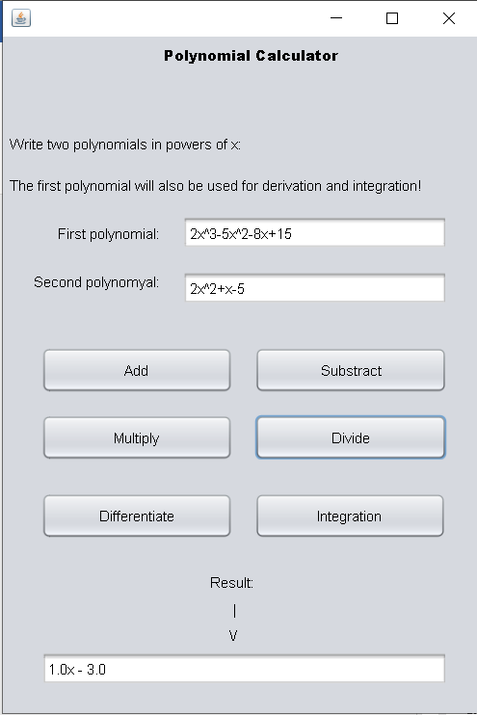

6.Differentiate

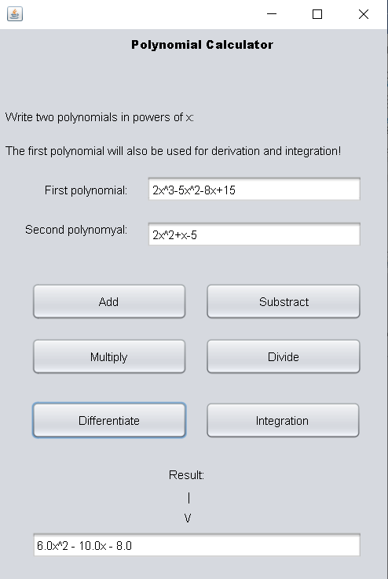

7.Integration
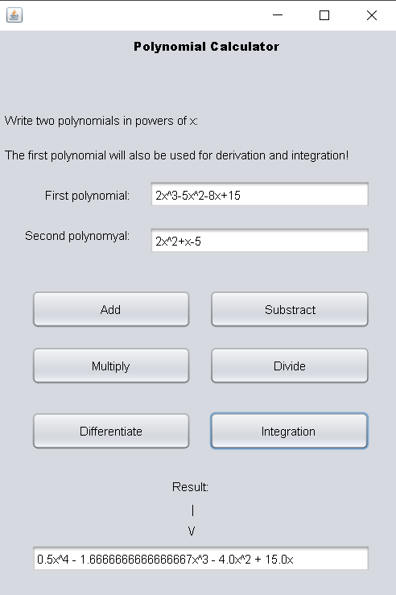

Conclusions
In conclusion I have achieved the purpose of this assignment, to implement the calculator with the 6 operations. One thing that I learned from this assignment is that the functions of the Regex package will help me in the future. They also helped me to write a more efficient and shorter code.

Bibliography
- https://app.creately.com
- https://dsrl.eu/courses/pt/materials
- https://regex101.com/

