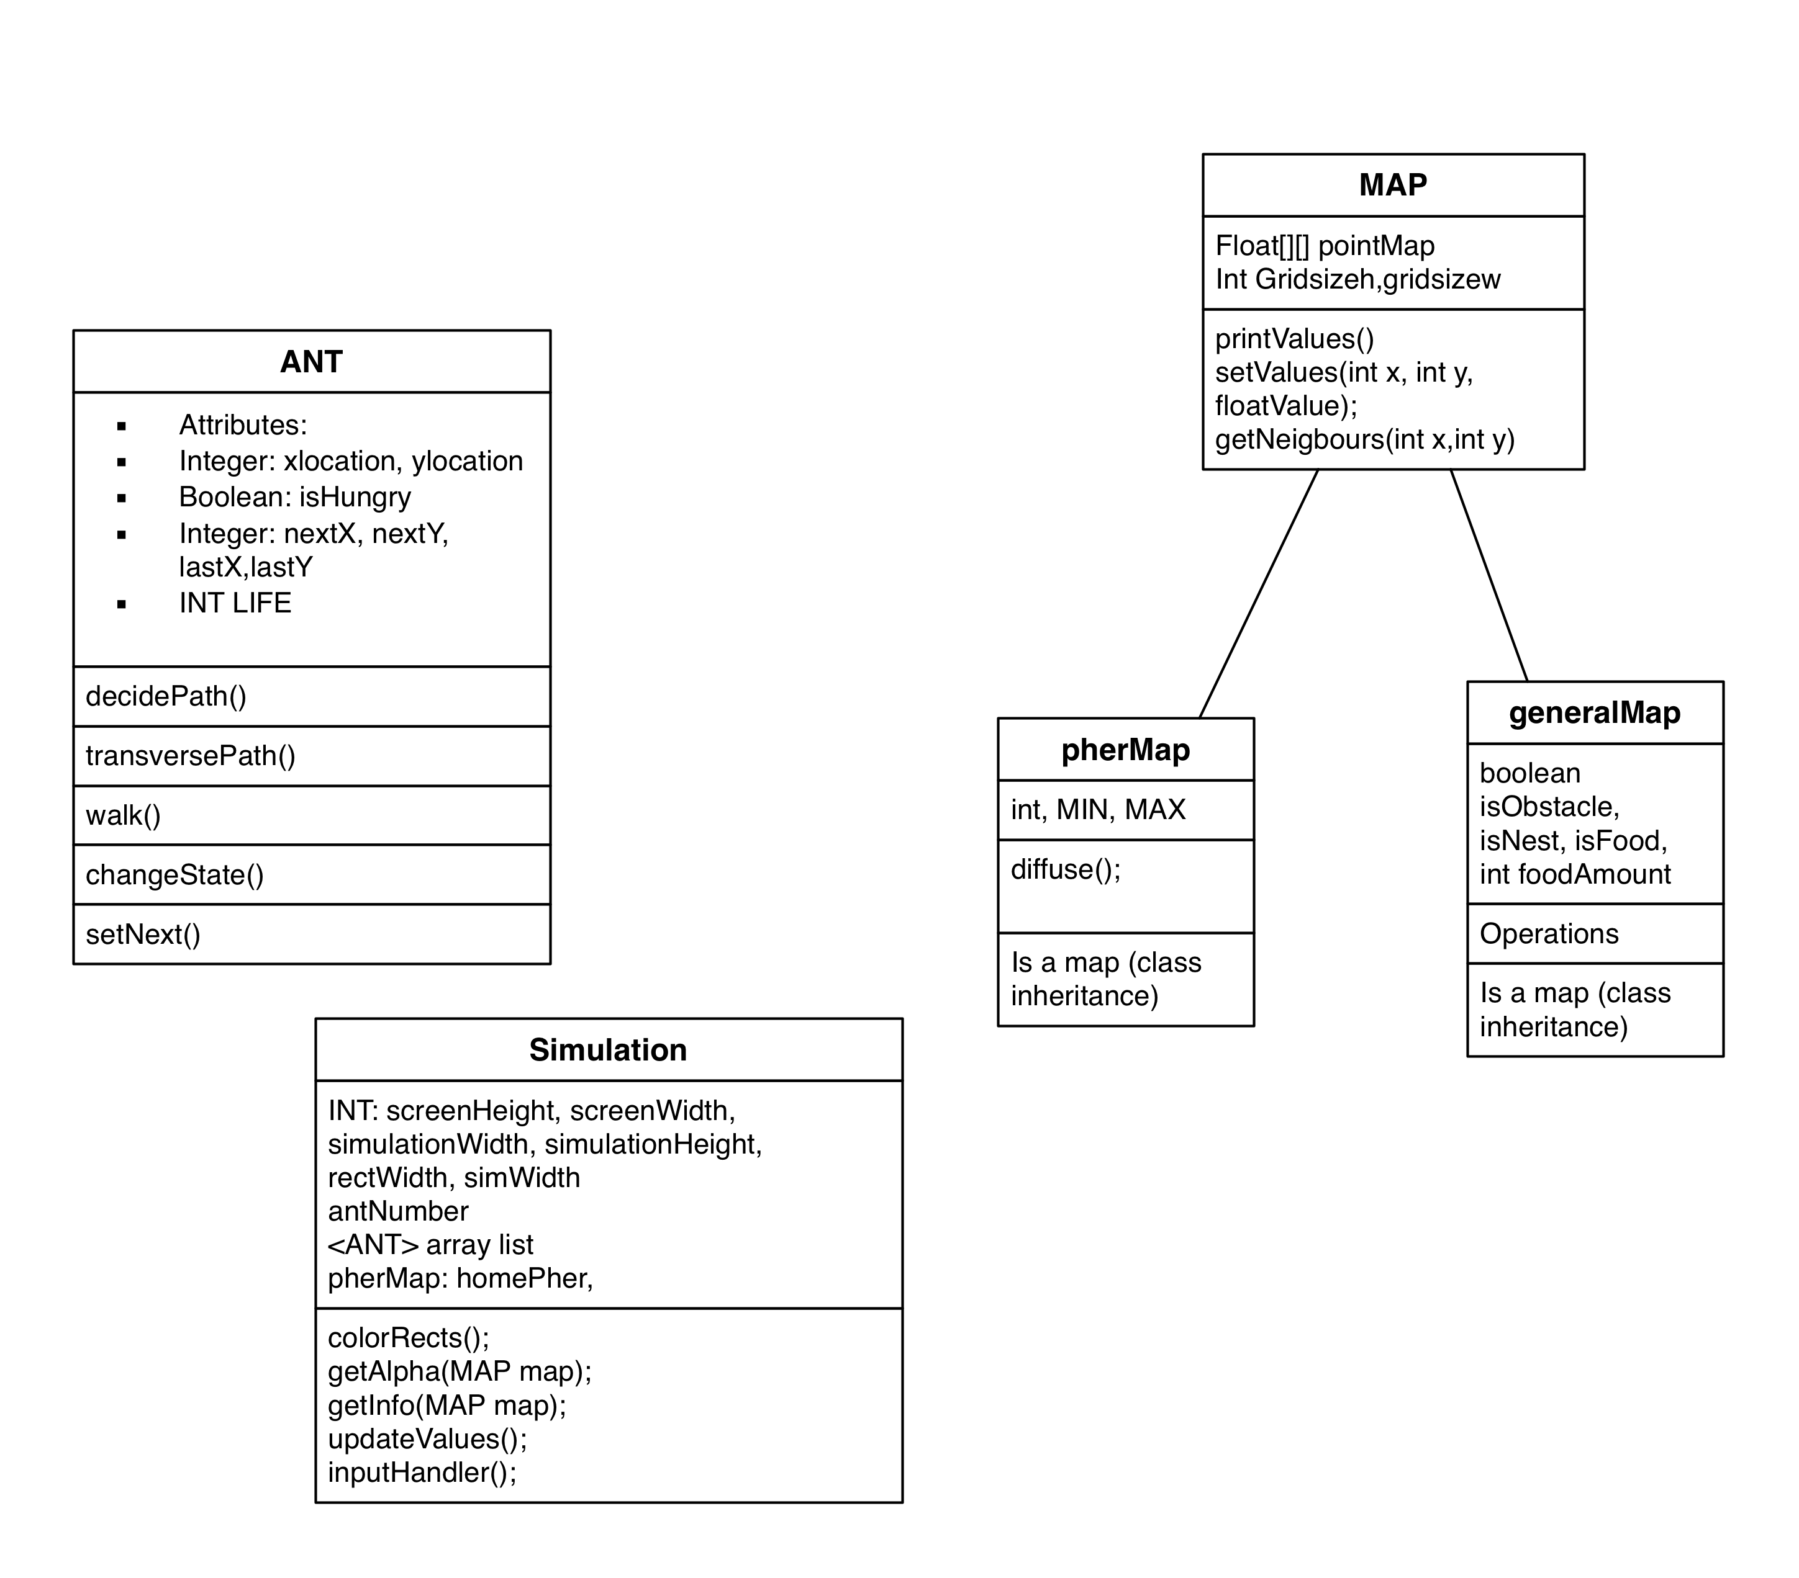
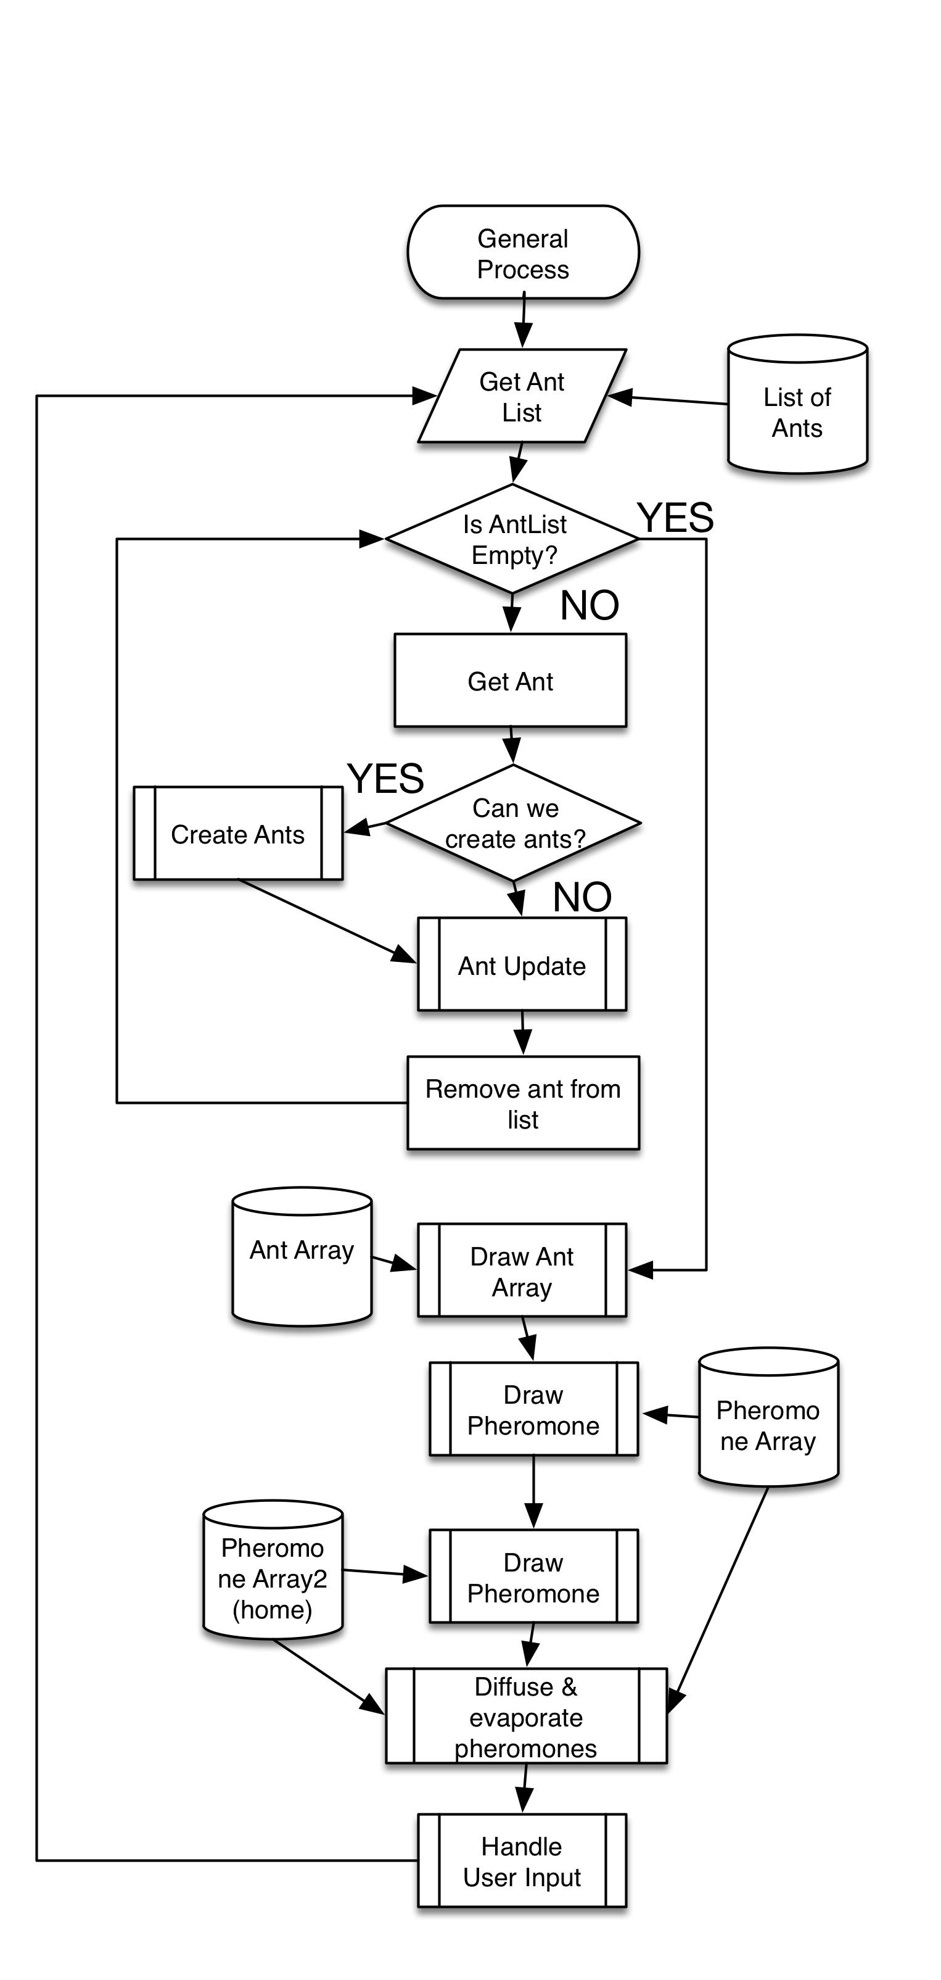
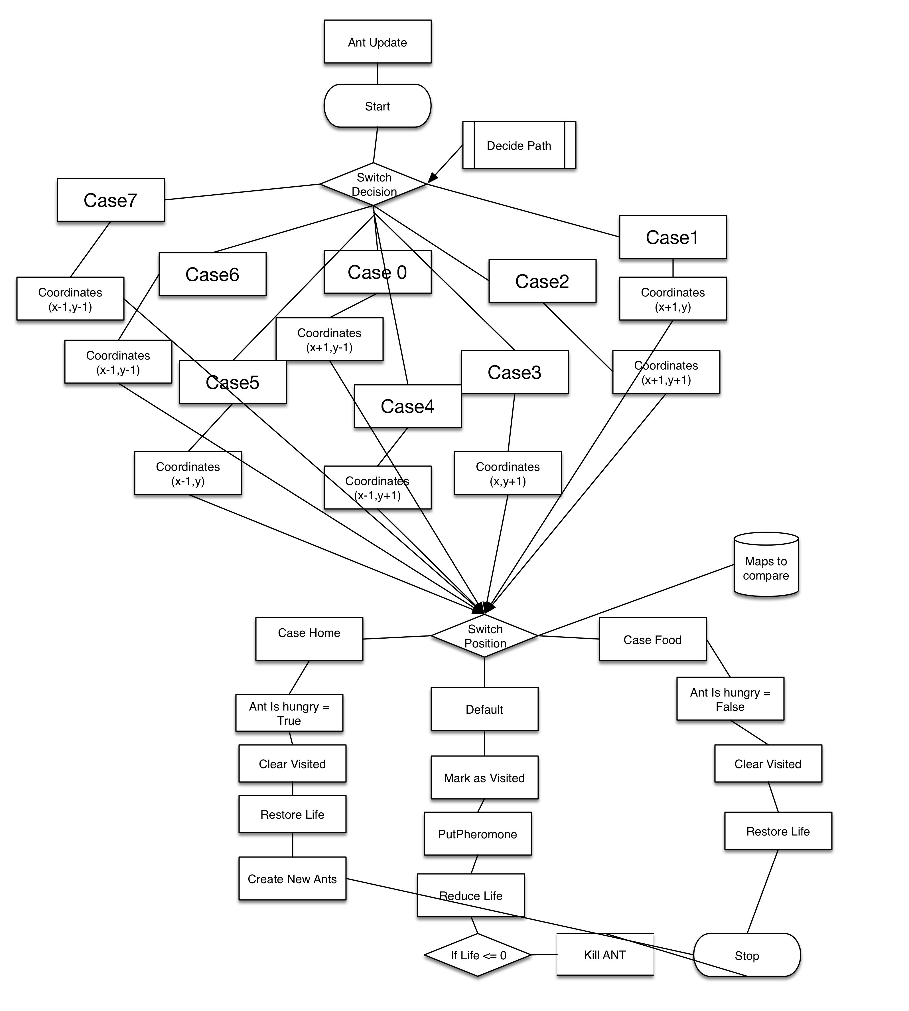
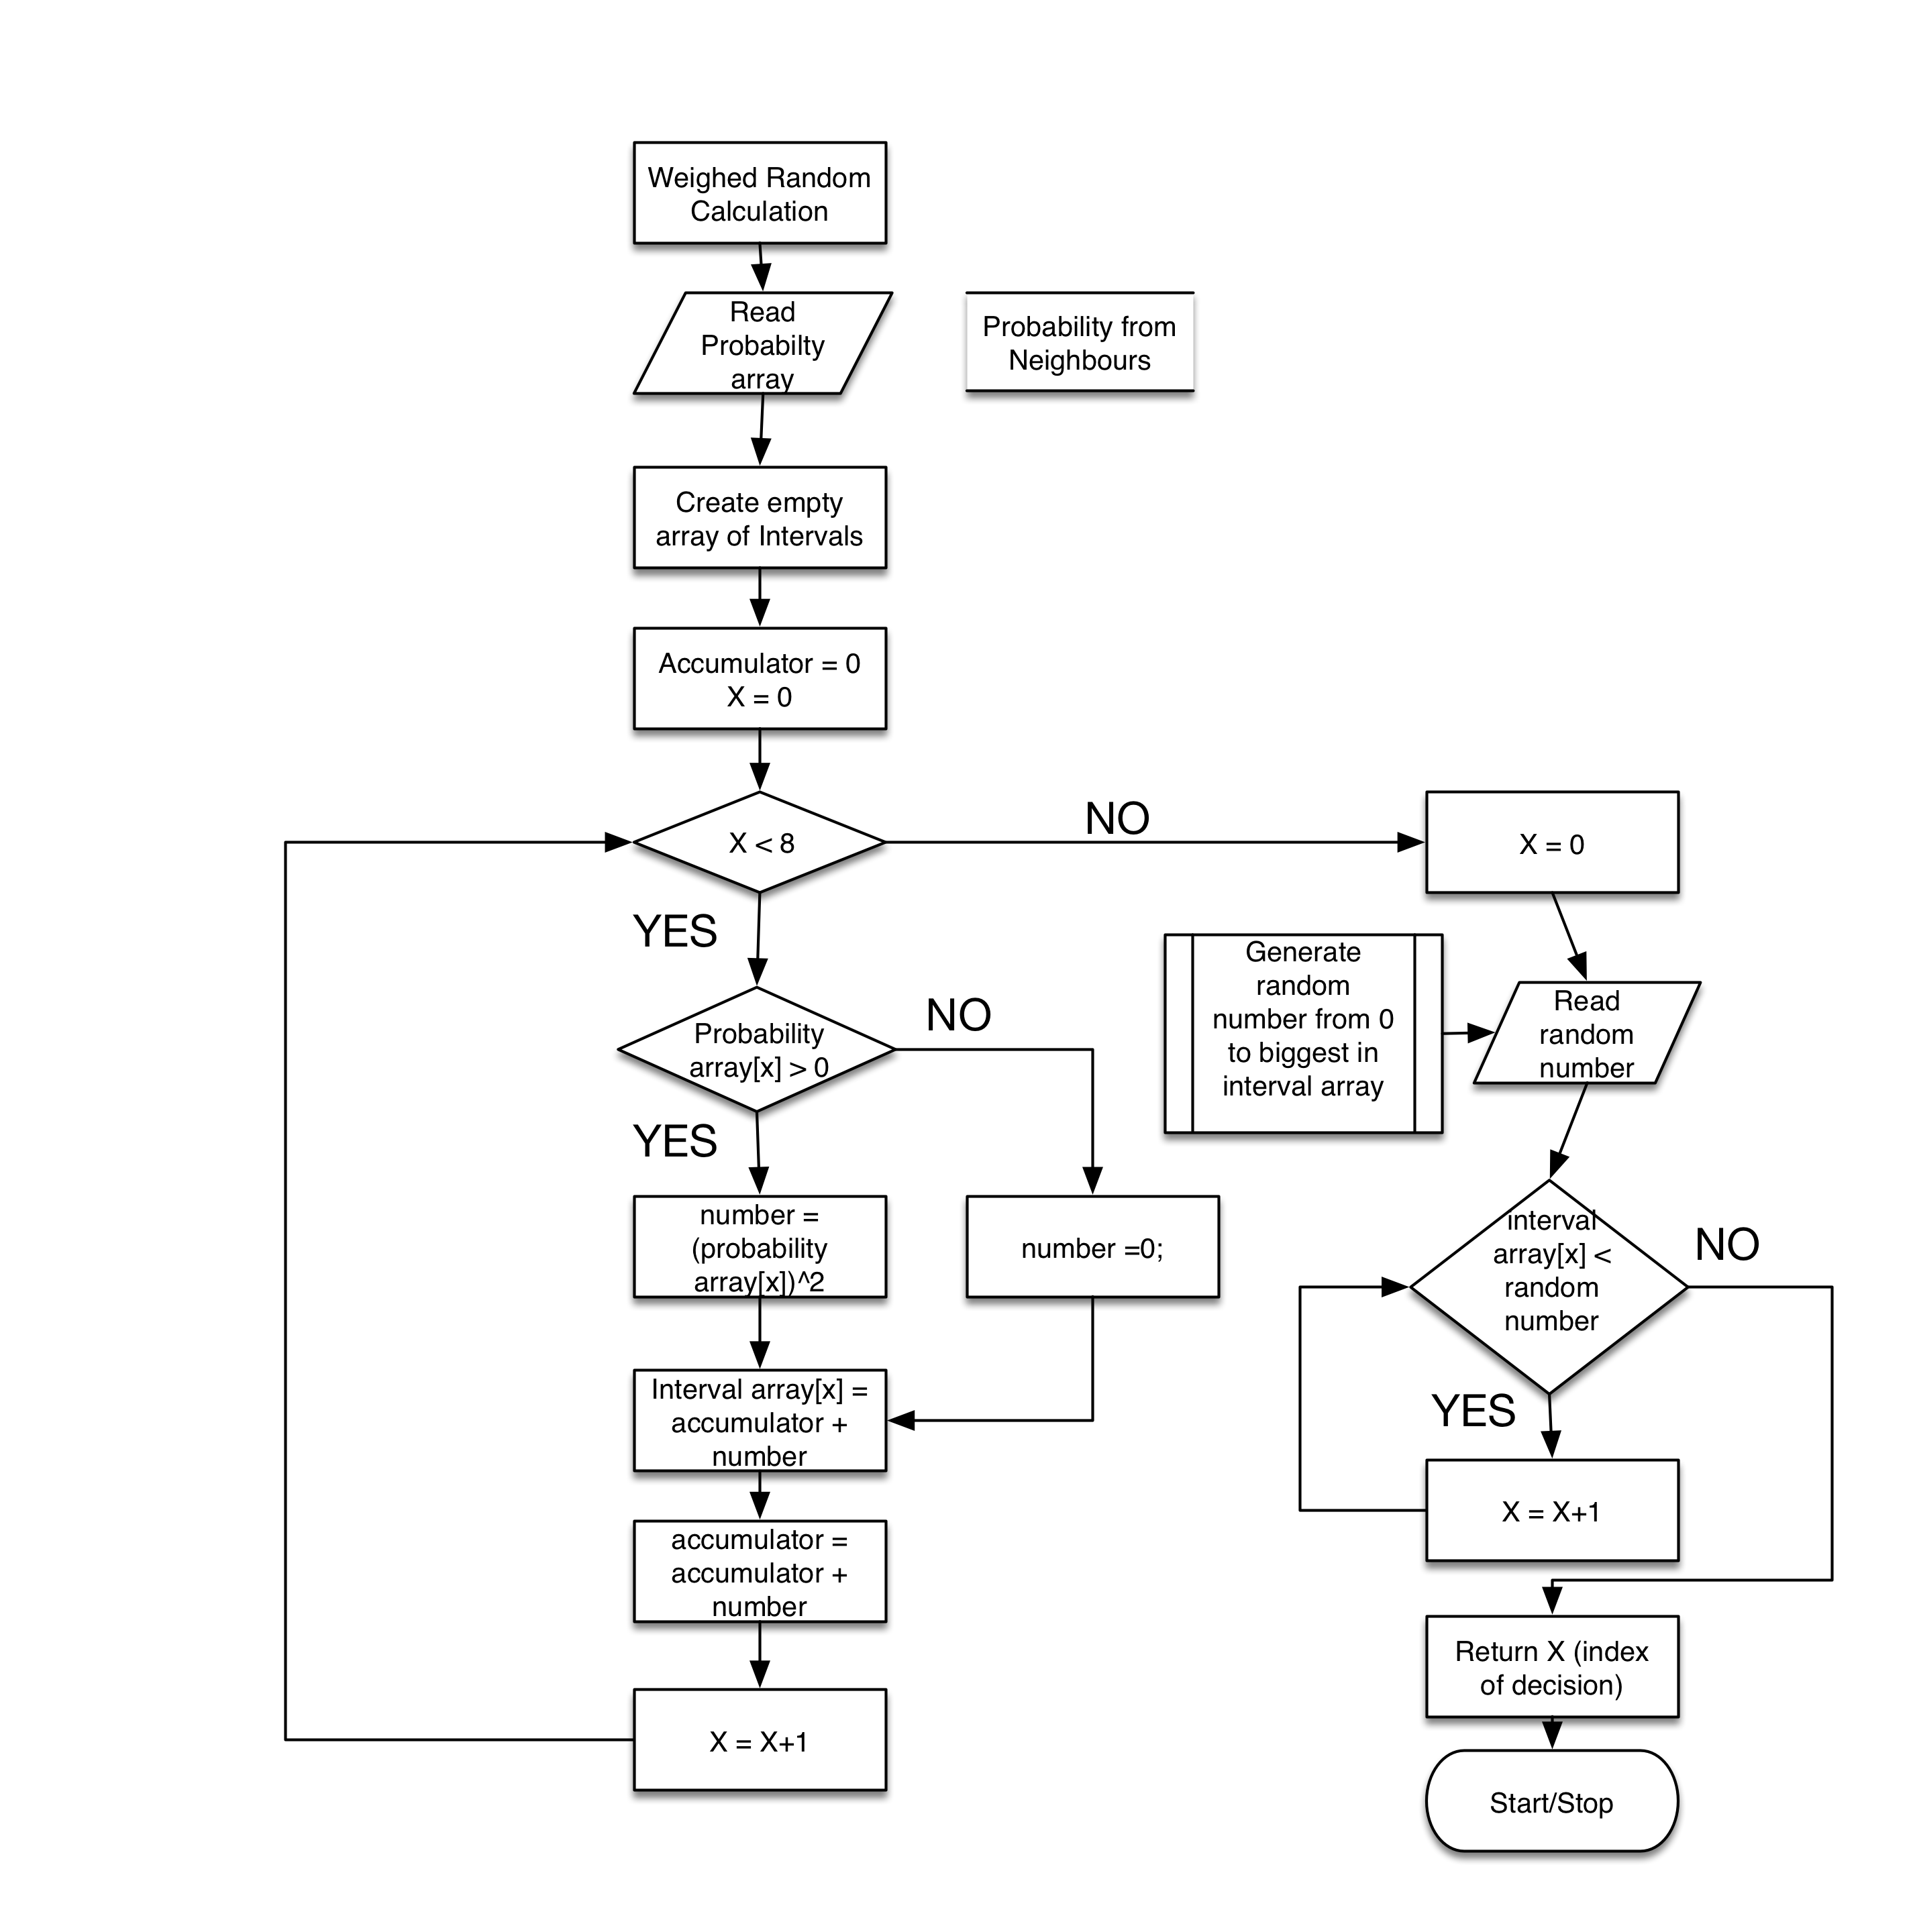
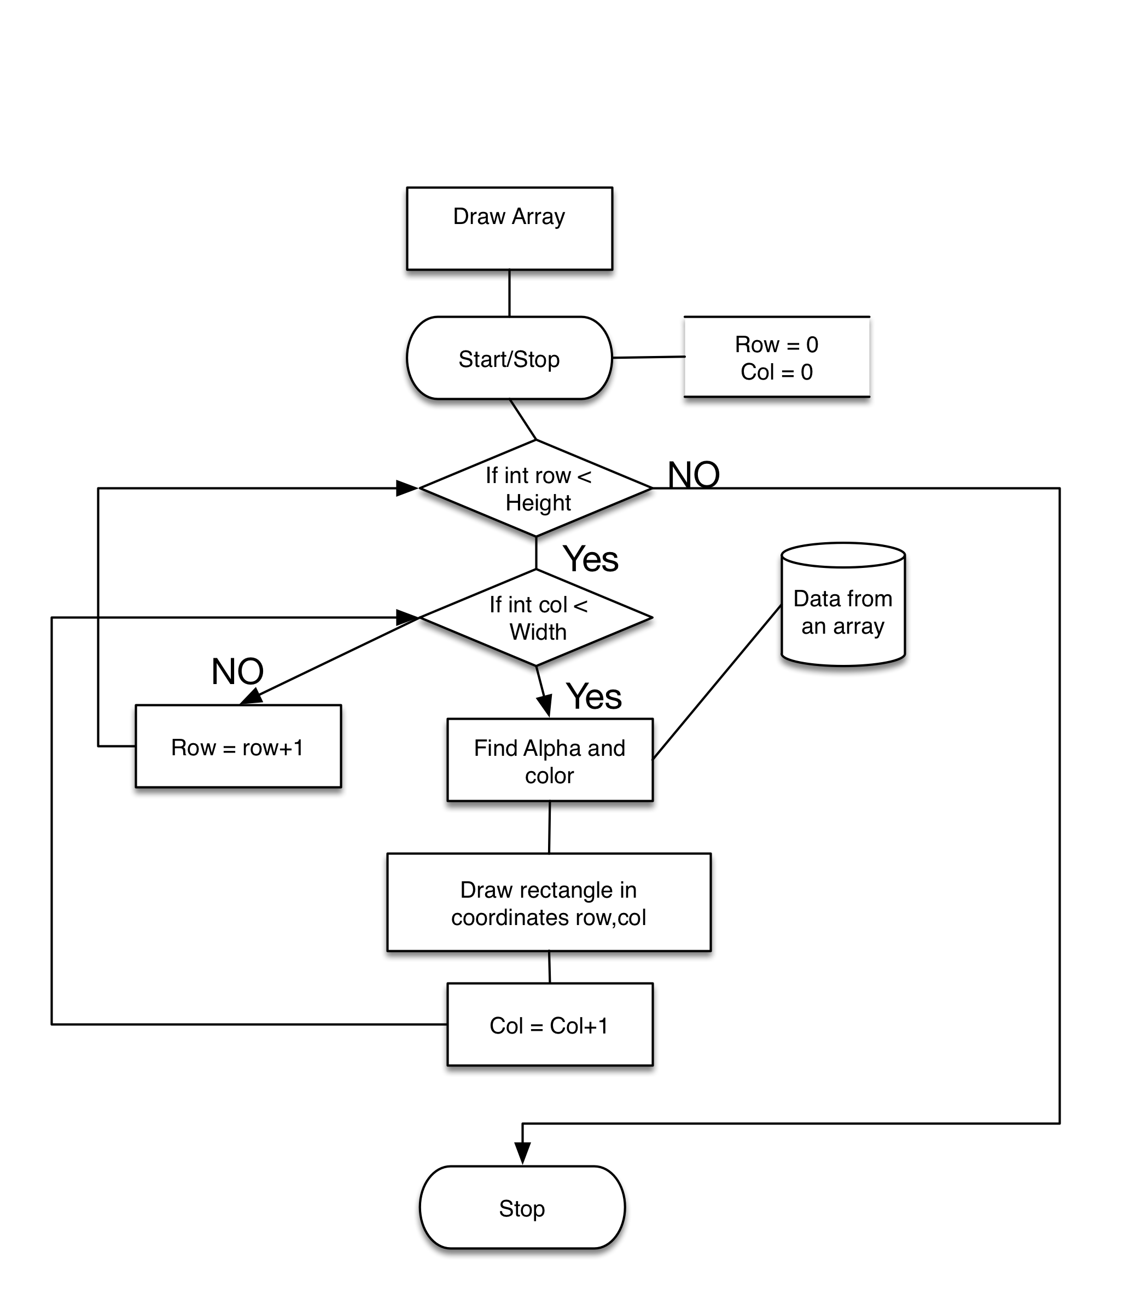
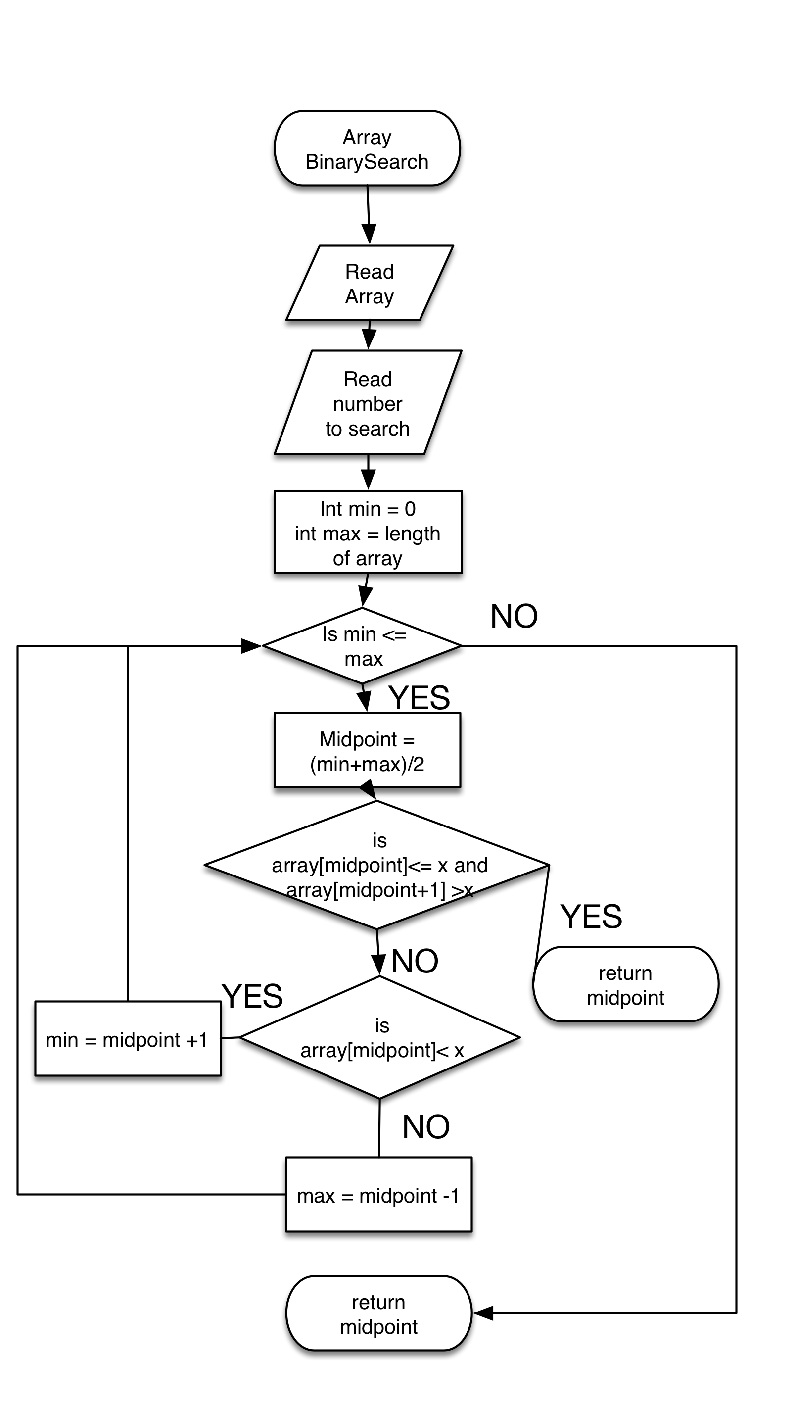
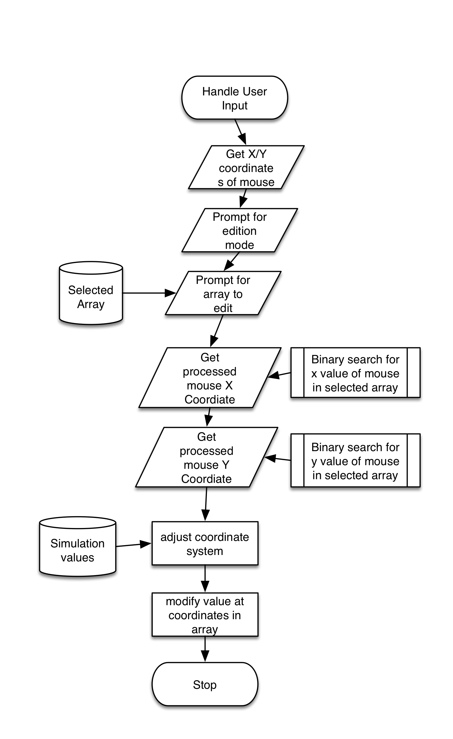

Actions to test | Method of testing
Ants converge on efficient path (the main algorithm). | Letting the simulation run
Ants avoid obstacles. | Placing obstacles and observing ants react by choosing other route
The user is able to interact with the simulation by dropping objects. | Ants respond to dropped stimuli, such as food, obstacles or pheromones.  The objects placed by the user appear on the map
The number of ants is reasonable as well as its born/death rate. | Given enough time, and sufficient food ants do not disappear or fill the screen
The graphical representation is relevant and updated correctly. | Check that the level of pheromones and ants in a given space, corresponds to its transparency or intensity.
Check edge cases | If no food is available, the simulation should either end gracefully or continue without crashing.
Objects interact with each other only in expected ways | Making sure that pheromones, ants or obstacles in a given space do not produce unexpected results, such as crashing the simulation
The probability distribution works adequately | Isolating the code and testing it with dummy inputs with known outputs.

