 |  |  |  | March 2012
Building a product modeller/configurator tool

Abstract:
The OpenConfigurator tool is a modelling and configuration tool that attempts to combine the world of Feature Modeling with that of highly usable and interactive web-based GUI’s. The tool is fully browser-based, providing a visual modelling experience directly in the browser through the use of a very flexible SVG implementation. It also provides a Configurator part with an interactive GUI where users are given real-time feedback by an engine based on Microsoft’s Z3 SMT solver. To our current knowledge, the rich visual modelling interface implemented as a browser application, as well as the feedback provided by the integration to an SMT solver are both novel.
Student: | Radu Mitache | sign.
Supervisor: | Joseph Kiniry | sign.

Table of Contents

1. Introduction 3
1.1. Background 3
1.2. Problem Statement 4
1.3. Research related goals 4
1.4. Demonstration scenario 4
2. Requirements 9
2.1. High level goals 9
2.2. Requirements specifications 11
3. Design 14
3.1. Requirements analysis 14
3.2. User interface design 15
3.2.1. Sketches 16
3.3. Architecture 16
3.3.1. High level architecture 16
3.3.2. Server side 16
3.3.3. Client side 18
3.3.4. Model Editor and visual modelling 19
3.3.5. Configuration Editor and integration with Z3 SMT solver 24
4. Implementation and other details 28
4.1. Development process 28
4.2. Code metrics 28
4.3. Issues with Javascript references 28
5. Considerations and further work 28
6. References 28

Table of Figures
No table of figures entries found.

Introduction
Software Product Lines and Product configuration have been gaining more and more attention as companies strive to provide their customers with flexibility in products offered as well as keeping their production efficient, be it software related or anything else from physical industrial products such as cars, to more intangible products such as services or various consultancy jobs.

In order to allow for complex products to be viably configured, underlying models describing their possible configurations and rules must first be created. Such models can be described through Feature Models, with every feature describing a distinctive aspect of the product.

Though a variety of tools for creating models and configuring product instances exist - either as part of the more academic/software oriented Feature Modeling world, or as part of the more industrial/business world in the form of complex product configuration tools – few or none address issues such as usability and ease-of-use.

Background
Feature modeling is a subdiscipline of the wider encompassing area of Software product line engineering. SPLE eases the development of products within an application domain by leveraging the commonalities among the products while managing the differences among them in a systematic way.

The description of a Software Product Line consists of all its members and their different relations to each other. Such a description is depicted through a Feature Model diagram where each member can be represented as a combination of one or more Features, organized into a Feature Tree.

Besides simply describing a SPL, Feature modeling is also a technique for managing commonalities and variabilities within an ordinary product line. The technique has numerous applications and it can be used to:

- Capture the results of domain analysis
- Facilitate scoping of product lines, domain-specific language families, components, platforms, and other reusable assets
- Provide a basis for automated configuration of concrete products, languages, components, platforms

Although there are quite a few papers talking about Feature Modeling “standards”, there is no single universal standard to which tools and academic terminology adhere in terms of how the different relations should be visually represented or what kind of rules and implications are used. There is though a general consensus regarding the categorization of feature models according to their complexity. This divides them into three main groups, namely:
- Basic feature models:
  - Mandatory/Optional Features
  - Or/Alternative groups of Features
  - Support for cross-tree constraints
- Cardinality-based feature models:
  - Cloneable features with user-defined cardinality bounds [m,n]
  - Support for groups of Features with user defined cardinality bounds [m,n] as to how many can be selected
- Extended feature models:
  - Support for Attributes on Features

Problem Statement
When thinking of Feature Modeling tools one assumes that the user should be able to project his mental picture of a feature tree representation into a piece of software that understands it without too much hassle. It should be as easy and simple as drawing a feature diagram on a piece of paper, which after all is what most people do, even before thinking about which tool they’ll be using.

This concept of visual interaction has been gaining ground in other fields of computer science (and not only), like for example the emergence of automatic code generation tools based on the visual design of UML diagrams, allowing users to focus on their design from a visionary level, rather than a low level programmer doing redundant tasks.

However, as mentioned previously, most feature modeling tools barely even support a non-interactive visualization of a feature tree, not to mention one which users can interact with and visually manipulate.

This project aims to build a tool which supports standard feature modeling functionality, but with focus on the visual interaction concept, as well as a modern web 2.0 approach involving high usability.

Research related goals

The development of a feature modeling tool with a fully interactive and visual modeling UI is new in this domain, as there are no other tools which offer this degree of freedom and visual interaction.
At the same time, the fact that the core modeler/configurator functionality works by communicating with an underlying SMT solver is likewise novel, just like the fact that Attributes are supported which no other tool supports.

Demonstration scenario

Below is a simple demonstration of how the application can be used. We took the following example of a feature model diagram from Automated Reasoning on Feature Models (David Benavides, Pablo Trinidad, and Antonio Ruiz-Cort´es):
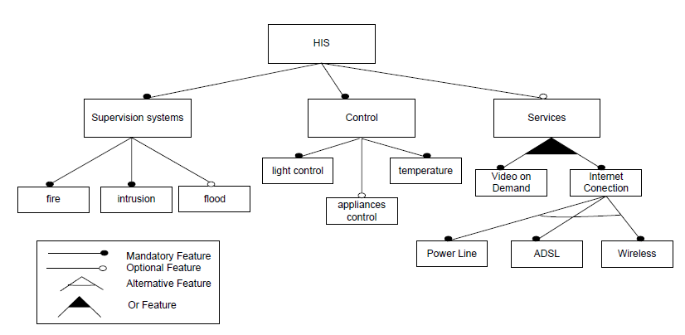
We will show step-by-step how this model can be setup in the tool and configured.

Step 1 – Start designing model

We begin by creating the Root (HIS) and its 3 child features Supervision systems, Control and Services. We also set up the relations between them, with mandatory relations for the first two and optional for the last. This is all done in the visual interface as can be seen below.

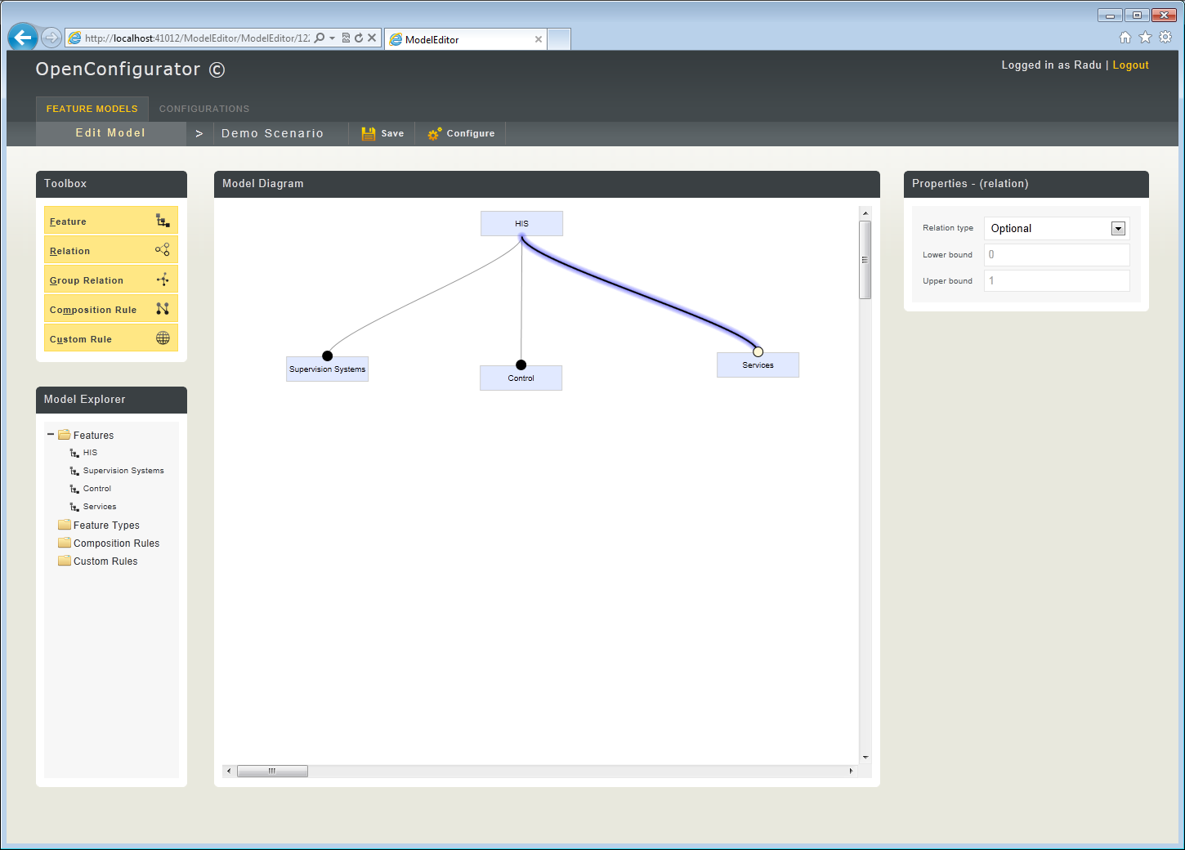

Step 2 – Finish basic design

We continue by creating the child features for “Supervision systems” and “Control” , with their corresponding relations and structure. After which, we proceed to create the child features for Services, where we use the special Group Relations to denote their structure.

At this point, the model accurately represents that in the reference paper.
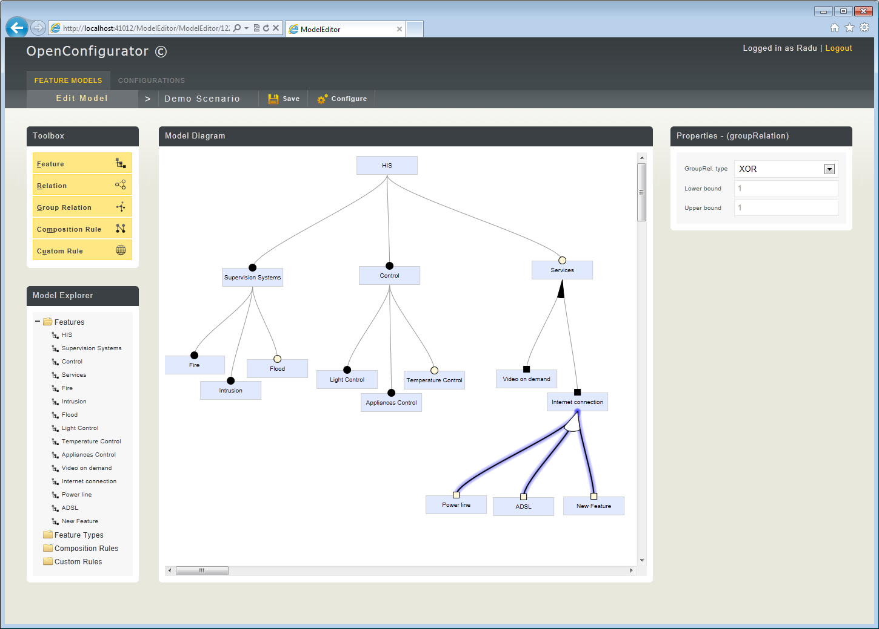

Step 3 – Adding extra flavor(Composition rules, Attributes and Custom rules)

We can make the model a bit more complex by adding some Composition Rules (cross-tree constraints). The two rules added signify that the Feature “Power Line” requires “Temperature Control” and is mutually exclusive with the feature “Flood”.

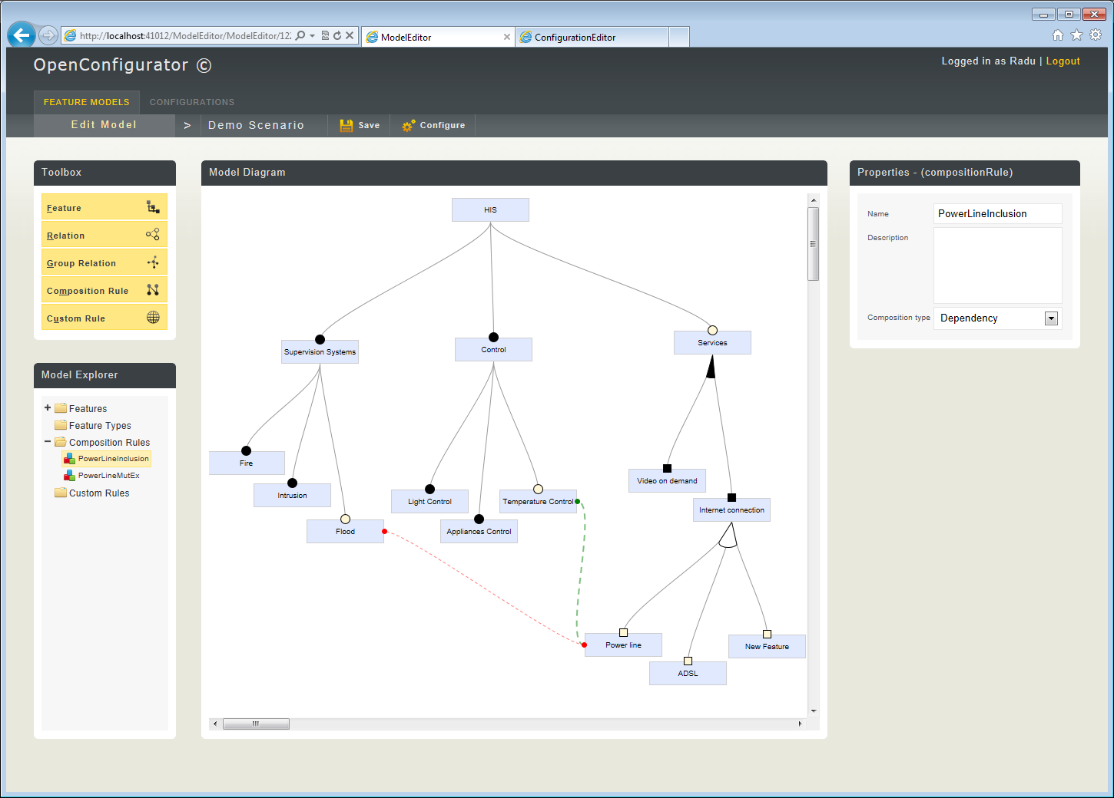

Step 4 – Adding extra flavor (Attributes and Custom rules)

Additionally we will also showcase the tool’s support for Attribute and Custom rules.

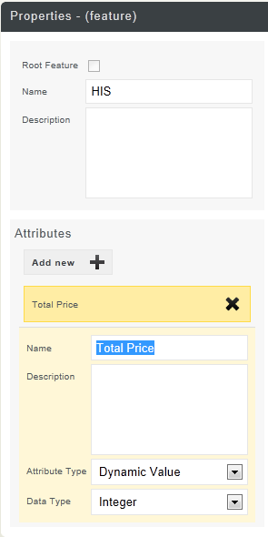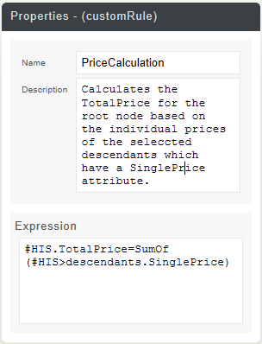

We add an attribute “TotalPrice” on the root feature, and then a “IndividualPrice” on each of its direct children features. “TotalPrice” is to be a dynamic Attribute, while “IndividualPrice” is to be a constant one.

Step 5 – Interactive configuration

Now that the model has been set up with both simple and more complex constraints and rules, we can proceed to create a configuration.

The application renders the model on which the configuration is based, in the form of Features and Groups, with selection states depicted for each Feature, as well as Attributes and their respective values.

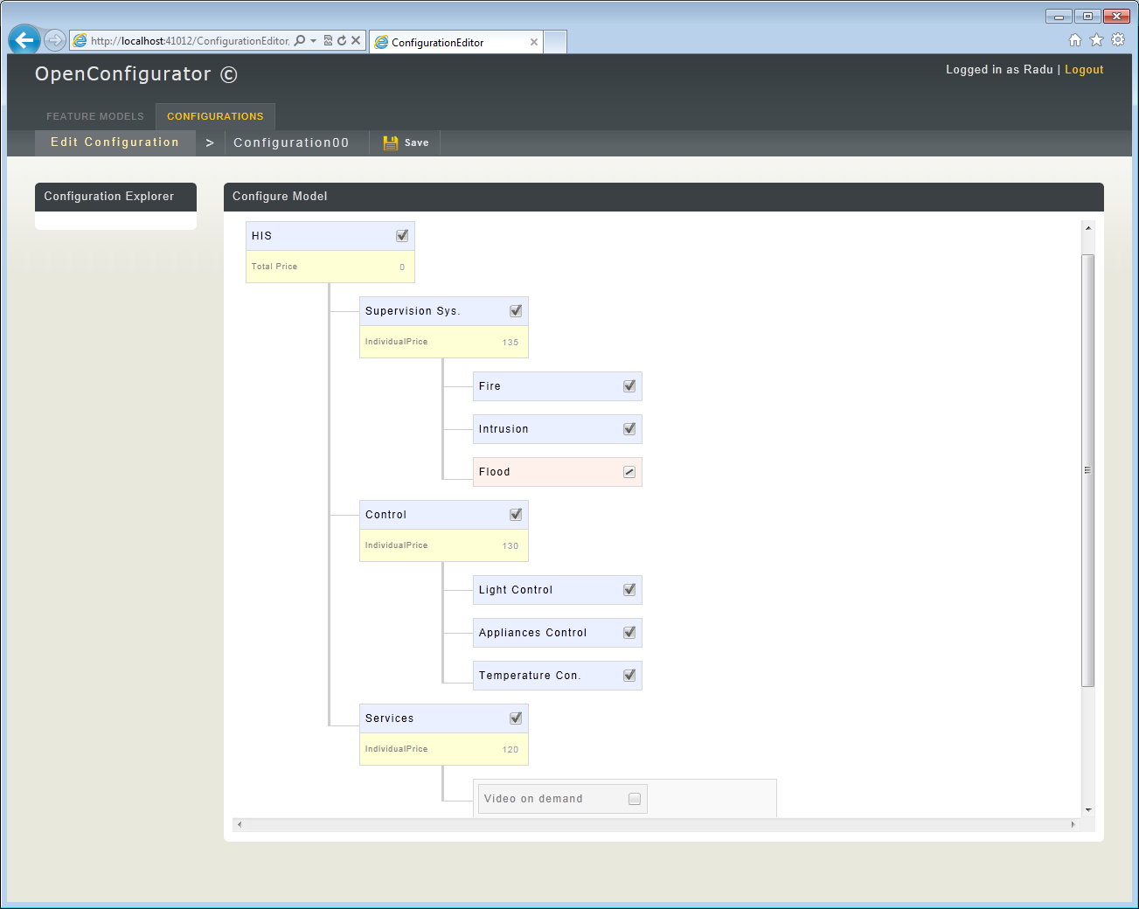

Requirements

High level goals

These are the key points of this project. Below you can find some explanations as to why these requirements are in important, both in the context of the current project as well as the wider world of feature modeling.

- Standard feature modeling functionality
- Configurator functionality with SMT solver
- Support for attributes and complex rules
- Support for visual modeling in a web 2.0 context

Standard feature modeling functionality

The tool should support standard feature models. Studying previous work and literature on what a standard feature model is, brought us to the conclusion that there is no general exact specification for one. Different papers mention different ways of representing a feature tree and slightly different interpretations of its semantics appear throughout other tools.

We thus tried to find the common denominator for what a standard feature model looks like. According to this, we came up with the notions that there must
be support for mandatory/optional features, or/xor groups of features and the possibility for defining cross tree relations, denoting implication or exclusion (known as composition rules).

Mandatory features are rather straightforward and mean that a mandatory Feature must always be selected if it’s parent Feature is selected. Optional Features simply mean that a Feature can be deselected regardless of its parent Feature, but if it is selected then its parent must also be so.

Feature groups mean that a feature can contain a whole group of subfeatures, which are bound together by an OR (1 to *) or an XOR (1 and only 1) statement.

Cross tree relations are needed when wishing to specify constraints on features which are part of different branches of the tree. These are usually exclusion, if a feature is selected then another feature cannot be selected as well (and viceversa), or if a feature is selected another feature must also be selected.

These elements of a standard feature model, in order to make sense when performing logical operations, must be translated into logical statements. The encoding is as follows:

- Optional child feature: ChildFeature implies ParentFeature
- Mandatory child feature: ChildFeature mutually implies ParentFeature
- Exclusion: not (FeatureA and FeatureB)
- Requires: FeatureA implies FeatureB
- XOR Group: ((ChildFeature1 or ChildFeature2 … or ChildFeatureN) mutually implies ParentFeature)and not(ChildFeature1 or ChildFeature2) and not (ChildFeature1 or ChildFeature3) … and not(ChildFeatureI or ChildFeatureJ)
- OR Group: (ChildFeature1 or ChildFeature2 … or ChildFeatureN) mutually implies ParentFeature

Configurator functionality with SMT solver
Most tools which include a configurator part that provides real-time feedback (in order to aid users and always have a valid configuration) have implemented it by translating the feature model into a mathematical representation and then having an underlying SAT solver figure out the validity of the configuration. The point of the solver is to provide consequences to the user when he or she selects a feature or modifies the value of an attribute so that that validity of the validity of the model is not broken.

This tool proposes instead to use a modern SMT solver. Besides the fact that it is novel, it is interesting since it might open up new paths in interactive configuration due to the capabilities of modern SMT solvers. It also allows us to encode attributes and rules into the mathematical model.

Support for attributes and complex rules
Attributes are basically fields on Features used to further describe them. They can be something that has a constant value (constant), dynamic (calculated according to some rules, example : a price) or given by the user (user input). They are typically integers, but can also be boolean values.

Complex rules are basically rules used for more complex expressions which can affect Features (selected, unselected) and Attributes. They are used for:
- Enforcing additional constraints, other than simple implies, excludes for which composition rules are used.
- Consequences
- Calculation of dynamic Attribute values
- Triggers

The interest for attributes and complex rules lies in the fact that they are necessary when working with feature diagrams which depict more complex models. Without them, it would be impossible to fully characterize systems with non-functional specifications for example.

Support for visual modeling in a web 2.0 context
This is important due to the way users think about feature models. The whole idea behind feature modeling is that a model can be represented as a simple visual diagram, no matter how big or complex it really is. For someone used to feature modeling, the freedom offered by pen and paper can be considered an ideal. This same freedom has so far been inexistent in terms of what various tools provide.

Earlier feature modeling tools had serious limitations on how the UI looked and behaved. Some of the basic ones had user interfaces which were nothing more than a form of text-based input/output. More recent tools have attempted to provide a better sort of visual representation, one which attempts to display an actual feature tree diagram. Unfortunately, even these have limitations. Since their GUI’s weren’t built to handle advanced visual representations such as complex feature diagrams, their final GUIs lack somewhat in accuracy and freedom of interaction.

The result is that users lack overview when manipulating models and thus make mistakes or spend time on trying to understand their feature models. There is a well known usability concept regarding user interfaces, that they should always try to match the same mental model that users have and expect. If it doesn’t, it leads to poor usability, meaning among other things mistakes, low performance and time spent on translating back and forth between their mental model (or what they draw on paper) and what the GUI is showing.

The idea behind this a web 2.0 context is that it helps a lot in ease-of-use and deployment of the project, not to mention the fact that nowadays everything is being moved over to the web even hardcore traditional desktop applications.

Requirements specifications

The requirements specifications are detailed requirements derived from the higher level goals.

Brief glossary

- Feature – feature in a feature model.
- Relation – relation between a parent and child feature, can be mandatory or optional.
- GroupRelation – a relation between a parent feature and multiple children. Can be OR or XOR.
- CompositionRule – a relation between two arbitrary features (located anywhere in the tree). Can be Implication, Mutual Implication or Mutual Exclusion.
- CustomRule – a complex rule written in text form.

Domain model

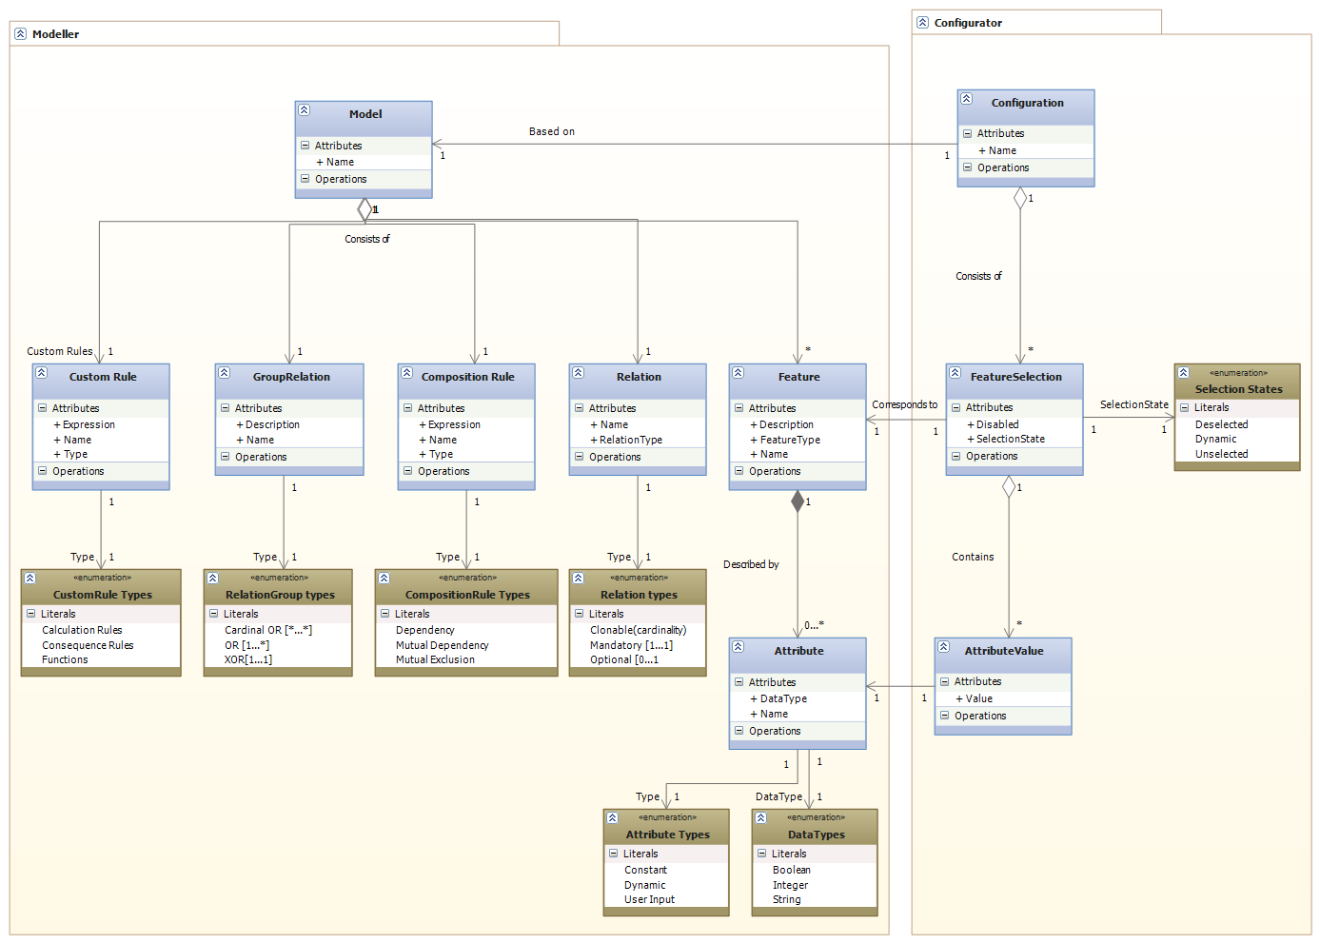

Use case diagram

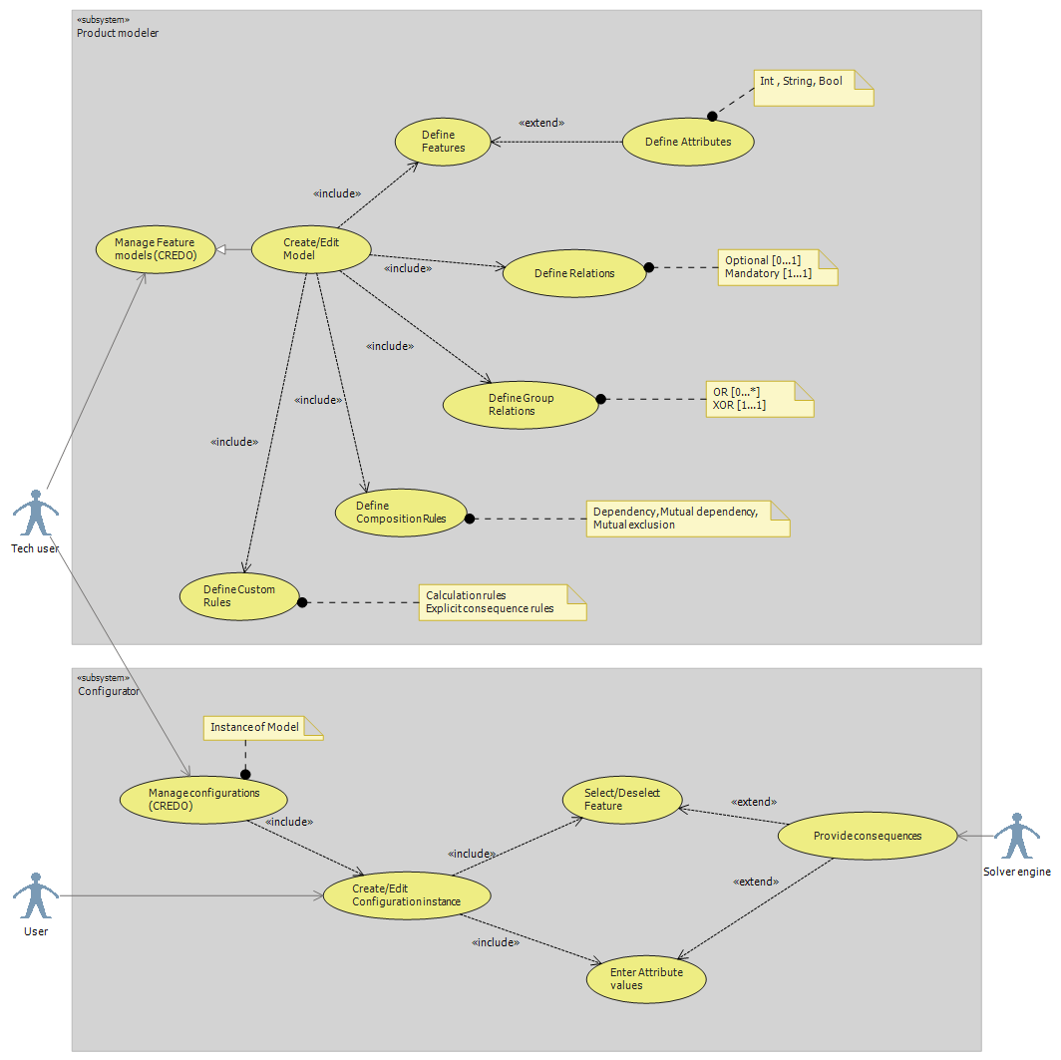

Actors

There are only three actors:
- The tech user, representing an advanced user who is responsible for creating models.
- The normal user, representing a user who does not necessarily need to know about feature models, but who knows what kind of a configuration he wants.
- The Solver Engine, more of a technical system rather than an actor, which is responsible for providing users with dynamic feedback and consequences when they fill out configurations.

Use case descriptions

Modeller area:
This is where users can create and manipulate Feature Models. It includes a lot of lower level use cases which deal with creating/modifying/deleting Features, creating Relations, GroupRelations, CompositionRules, CustomRules. Below are a few descriptions for some of the more important use cases:

- Manage Feature models:
Simple use case where users can get an overview of existing models, delete or open them, or create new ones.
- Create/Edit Model:
Abstract use case made up of a lot of smaller use cases which allow users to manipulate (Create, Read, Update, Delete) different elements in a Feature Model.

Configurator area:
This is where users create and configure Configurations based on Models. Users makes selections of which Features they want, enter values for Attributes and the SolverEngine provides consequences as to what should be disabled for the semantic model to be valid (satisfiable).
- Manage Configurations:
Simple use case where users can get an overview of existing configurations, delete or open them, or create new ones.
- Create/Edit Configuration:
Allows users to interactively configure a Configuration instance. Users can toggle Features on or off and enter values for Attributes.
- Provide Consequences:
This is where the Solver engine comes into play. Whenever the User toggles a Feature or modifies an Attribute Value, the Solver provides the necessary consequences (toggles Features automatically on or off) in order to keep the Model valid.

Non-functional requirements
- Should be able to work in any modern browser
- Visual and interactive UI for creating models and configuring

Secondary requirements
In the original problem formulation, there were also a number of requirements/goals which unfortunately had to be downprioritized, therefore not making it into the final release. These are listed below and briefly explained.

- Online collaboration
- User defined visual representations for Configurations
- Feature model abstractions, through several layers of models mapped to each other

Design

Requirements analysis
In this section we will go into detail with some of the analysis for some of the requirements which happened to influence some critical design decisions early in the design phase.

Browser based application

This is a non-functional requirement which was derived from one of the higher goals of the project, namely the fact that the application should provide a web 2.0 interface. Having it as a web 2.0 application will make it easier to use and more accessible to people outside of the research domain.

In terms of technical details, a browser based application needs to be developed using some sort of a web development framework. There are many existent, and one had to be chosen. Considering my thorough personal experience with web applications and Microsofts Asp.net platform for previous projects in past the choice was rather straightforward.

As for the general architecture, asp.net offers a number of different solutions, from web forms with aspx pages rich in events and widgets, to MVC with customizable Views and innerviews. The choice which was found to be most suitable for this project was MVC since it offers a lot of freedom in terms of controlling exactly what the different Views render to the client’s browser.

Highly interactive GUI with visual modeling capabilities
Considering the GUI had to give the user a high degree of freedom as well as a very visual and interactive experience, a powerful and flexible implementation was necessary.

For a standard rich web application project, there are a number of libraries which make development easier and provide such functionality. Among these JQuery stands out as being one of the most lightweight and easy to integrate with any development framework, especially with ASP.net.

For the part regarding a visual modeling interface, the only way this could be achieved inside a browser was either through the use of a 3rd party based implementation (such as Adobe Flash or Flex), or by making use of modern browsers’ own rendering capabilities. The latter was chosen due to compatibility issues as well as being a native browser solution, which offered a high degree of control, flexibility and integration with the rest of the application.

Making use of a browser’s rendering capabilities means using a combination of Javascript and Canvas or SVG to render graphics directly in the client. Canvas is a pixel based drawing platform supported by all browsers (and recently greatly enhanced in HTML5). Its drawbacks are however that it is purely bitmap based, having no notion of objects or support for manipulating them as such. On the other hand, SVG (scalable vector graphics) is a vector based drawing system supported by most browsers and intended for manipulating scalable vector representations. It has built-in support for a lot of the functionality necessary, such as event handlers for user interaction (click, mouse over events, etc) or vector state handling.

Thus, analyzing the pros and cons of Canvas and SVG, SVG was chosen since it would be more suitable considering it could support a visual modeling interface without too much hassle. As for the specific SVG implementation, this could be done either with pure SVG or with another library. Since the pure SVG implementation would run into browser compatibility issues, a library was chosen (RaphaelJS) which had an advantage over other SVG libraries that it also works on IE 7 and IE 8 (it uses an alternative VML implementation for this).

Standard feature modeling functionality
In order to implement this, users need to be able to create Feature Models involving Features, Relations, GroupRelations and CompositionRules. This is pretty straightforward as the SVG based design should support creating visual representations for each of these objects, while the data itself can be stored in a database.

Advanced feature modeling supporting Attributes and CustomRules
Attributes and CustomRules extend a standard feature model by providing a way to further describe Features as well as a way to create complex syntax based rules. Attributes can be easily added to Features, represented in the UI and stored in the database just like all the other elements.

These rules are either constraints, calculation formula or some other type of rule-based logic. For this we would need a parser

Interactive Configurator functionality using an SMT solver
This solution for this requirement implies using an SMT solver to provide the feedback. For this there are two issues. Which SMT solver to use ? and how to integrate it with the web application ?

A bit of research into the world of SMT solver tools came with one very strong candidate, Microsoft’s Z3. Since it is .net based and provides the required functionality (and more), it was easy to take a quick decision. As for the integration, since it is available as .net it would be straightforward to call it from the webapplication’s business layer.

User interface design
The User Interface design has a very important role in this application since it is directly reflected in one of the application’s main goals, visual modeling functionality.

Sketches

Architecture
This section presents a detailed description of the underlying architecture, principles and design patterns used and covered.

High level architecture

When designing the architecture, I had in mind several key principles. These were modularity and extendibility. In order to achieve a high level of modularity I implemented a hybrid between N-Tier and MV.

As you can see in the diagram below, the architecture is split into a number of logical layers as in a typical N-tier app. However, in the Presentation Layer we have Controllers and Views, with the Business Logic Layer replacing the Model.

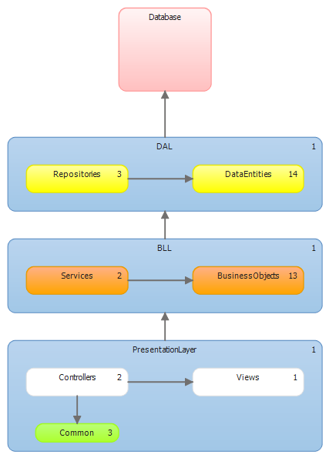 | Basically, both the N-tier and MVC are implemented this way, each providing its own benefits.  The layers are split into Presentation, Business Logic and Data Access with the Database being its own layer.  The idea for designing the architecture like this is that it provides both the high level modularity implied when having layers, as well as the control over Views and Controllers provided by MVC.

Server side

The server side architecture basically consists of the Database, DAL, BLL and part of the Presentation Layer.

Database
The database design is based on the domain model and use case diagrams, allowing us to store the necessary data in order to accomplish all the requirements. Basically we have the implementation of the domain model into a MSSQL server database, with all the required tables and attributes to store any necessary data.

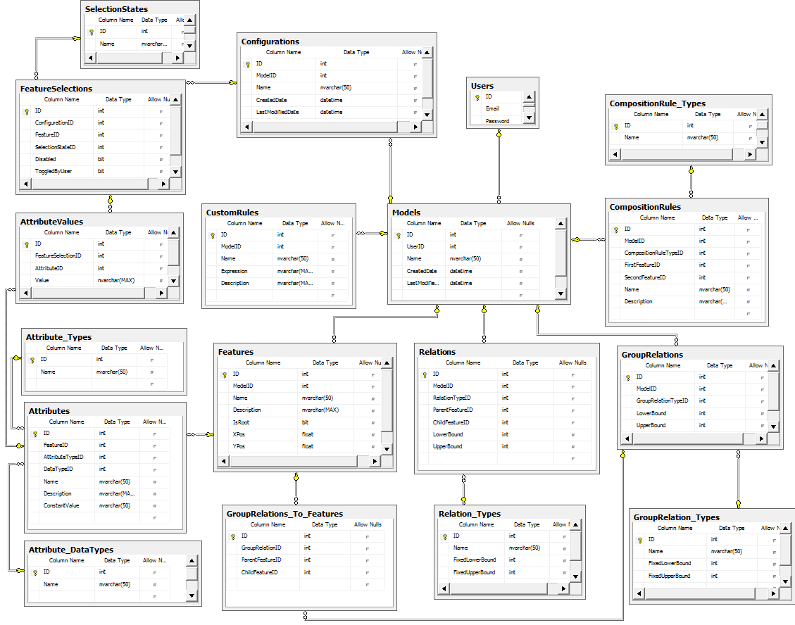

Data access layer
The DAL is built using an ORM tool, namely Microsoft’s Entity Framework. This allows us to map Entities to different tables and fields in the database. Based on a diagram, it autogenerates the code for the different object.

The data access layer basically consists of a number of data objects which are mapped to database tables, but contain no logic of their own. The logic to handle CRUD operations resides in a generic Repository class which is responsible for persistence.

Whenever a DataObject needs to be updated or modified, it is passed to an instance of the corresponding Repository type which then proceeds to interact with the Database and synchronize the changes.
Business Logic Layer
The BLL very closely resembles the initial Domain Model presented in the Requirements section. It basically encompasses all of the Business Logic in the application further splitting it into Business Objects and Services.

The Business Objects are basically wrappers for the DataObjects in the DAL, with additional business logic added to fields and properties.

The services are responsible for manipulating and retrieving collections of BusinessObjects, but also for performing sensitive operations such as providing feedback to users while interacting with a Configuration instance (section 3.2.2).

Additionally the BLL also contains the logic for the application’s CustomRule parser, which is responsible for parsing rule text-based syntax and executing the logic.

Presentation Layer
The server side part of the Presentation Layer consists of a number of Controllers handling different Views. The client side consists of the Views and their related Javascript code (section 3.2.3).

There is a Controller for each view, each Controller containing methods which are called from the client side code as well as methods called when first loading a view.

Client side

The client side part of the application is where the bulk of the application’s functional code resides. Here we have the Views where users interact with the application’s core business logic. Each view corresponds to an html page accessible through HTTP and each View consists of HTML and Javascript code (written using Jquery syntax).

A brief overview of all the views:

- Login:
Page where users can log in to the application.
- Models:
Page where users can see an overview of existing Models, edit/delete them or create new ones.
- ModelEditor:
Where Models are visually manipulated
- Configurations:
Page where users can see an overview of existing Configurations, edit/delete them or create new ones.
- ConfigurationEditor:
Page where users can create interactive Configuration instances.

Model Editor and visual modelling
The Model Editor is the part of the application which provides the user with the ability to visually design feature model diagrams.

Its architecture contains code both on the client as well as on the server, though the bulk of the code resides on the client. The server side code basically consists of a Controller which has methods through which the client-side code can retrieve or persist data to the Database by going through the application layers (BLL and DAL).

The design for the client side part of the Model Editor consists of a number of components set up in an MVC pattern. This means that there is a data Model, a Controller and a number of Views, all present solely on the client and implemented in Javascript. This design allows us to limit the amount of data that would have to be fetched and sent back and forth from the client to the server every time the client had to interact with the model, were the model on the server.

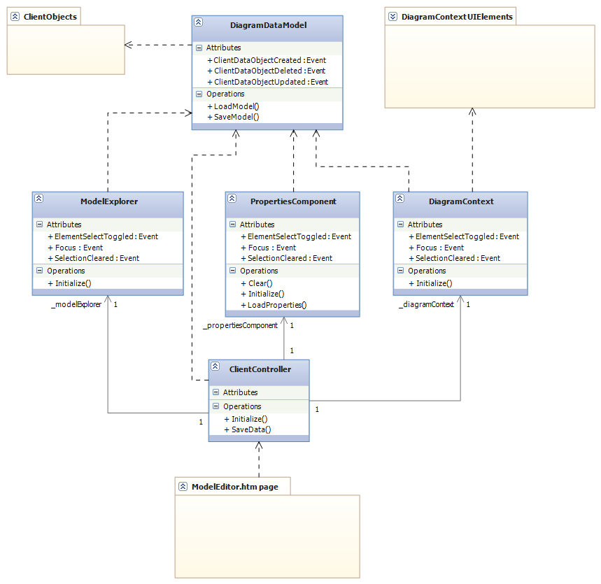

The client-side Model in the MVC is responsible for handling the data as well as interacting with the server side Controller to retrieve or persist data to the Database. It consists of a set of ClientObjects, which are basically wrappers for BusinessObjects with additional UI logic. This UI logic includes an object identification system, enabling the Client to use its own ID’s instead of those coming from the database. This is necessary in order to be able to identify temporary objects which do not have database ID’s, thus abstracting persistence details from the client-side.

The diagram shows the detailed structure of the inner MVC design, highlighting the dependencies between the components. The Views call the Model when the user modifies data, the Model indirectly refreshing the Views by notifying them that its data has changed, with the Controller being responsible for setting up synchronization events between the Views and between the Views and Model.

The components in the design are listed below, with brief descriptions:
- DiagramDataModel:
This is the client-side Model. It contains the raw client data, consisting of ClientObjects, as well as all the methods to manipulate this data and sync it with the data on the server. It is responsible for keeping track of ClientObjects and their unique ID’s.
- ClientObjects:
These are the objects which wrap BusinessObjects with additional UI level logic. They correspond to Features, Attributes, Relations, GroupRelations, CompositionRules and CustomRules.

- ModelExplorer:
This is one of the Views. It provides a tree-based representation of the Model allowing for easy navigation to Features and other objects.
- PropertiesComponent:
This is also a View, but one that displays objects in detail. It allows users to modify specific properties on objects.
- DiagramContext:
This is the most advanced View which offers a visually interactive graphical representation of the model. It has its own set of objects, called UIElements, which wrap graphical logic onto the existing ClientObjects.
- UIElements:
This is a special collection of objects used by the DiagramContext view. They each encapsulate an element in a feature model diagram, providing their behavior and graphical representation in the visual context.
- ClientController:
The controller is responsible for handling inputs from the user and calling the appropriate Views or Model methods. It is also responsible for setting up the Event/Eventhandler connections between Views and Model.
- ModelEditor.htm page:
This is the simple htm.page, consisting of static html markup as well as a few lightweight scripts.

A key design relies on a publisher/subscriber pattern for the communication between the different components. It is implemented as an Event/Eventhandler pattern in Javascript and it allows for low coupling between the components as well as adding a layer of indirection.

Using this event/eventhandler pattern, the View’s are synchronized with each other, so whenever something is selected in one of them, the other two have the same selection. They also receive updates from the Model, who raises the corresponding events, of which the Views have set their EventHandlers on.

PropertiesComponent

The PropertiesComponent is a View which allows users to modify the individual properties of UIElement. Using it, users can for example modifying the properties of a Feature or its Attributes.

It contains a set of different controls which encapsulate HTML rendering logic as well as simple events. The control types are:
- Textbox
- Textarea
- Checkbox
- Dropdown
- Composite
These can be used to specify what UI the PropertiesComponent should display when a certain type of ClientObject is selected. The controls are mapped to the actual data fields of a ClientObject and will take care of loading data or notifying the PropertiesComponent that the user has updated it.
For each different type of ClientObject that can be edited, the PropertiesComponent contains a set of details of which controls are mapped to which fields. The UI specifications are made up of a list of mappings, between data fields and control types.

DiagramContext

The DiagramContext is the most important of the views, being responsible for visually rendering a feature model as well as allowing users to visually interact with it. The design principle behind it is that it should behave like a vector based diagramming tool (such as Visual Studio’s UML editor for example), where elements can be selected, moved and manipulated.

It contains its own set of special objects (UIElements), which are correspond to the ClientObjects that are visually represented .It keeps track of its UIElements and takes care of operations such as creating/deleting/updating existing instances, as well as sending updates to the Model or receiving them from the it.

This graphical representation is rendered with the help of the RaphaelJS library built on top of SVG.

UIElements

The UIElements are objects used by the DiagramContext view to provide an interactive visual modeling interface. They are split into a number of subclasses, which can be seen in the diagram below.

Even though SVG with RaphaelJS provides quite a lot in terms of manipulating graphical objects and handling their state, it still has some limitations. These limitations include issues with handling composite SVG elements. RaphaelJS and SVG cannot handle grouped elements which consist of multiple child elements.

Thus, simple operations such as moving a UIFeature, need some sort of handler which knows how to move all of its children and keep their position synchronized. For example it doesn’t handle composite objects well enough, like having a text label inside a box and then moving them both around. Therefore, the UIElement objects encapsulate the logic that can keep track of their position and structure into their super class.

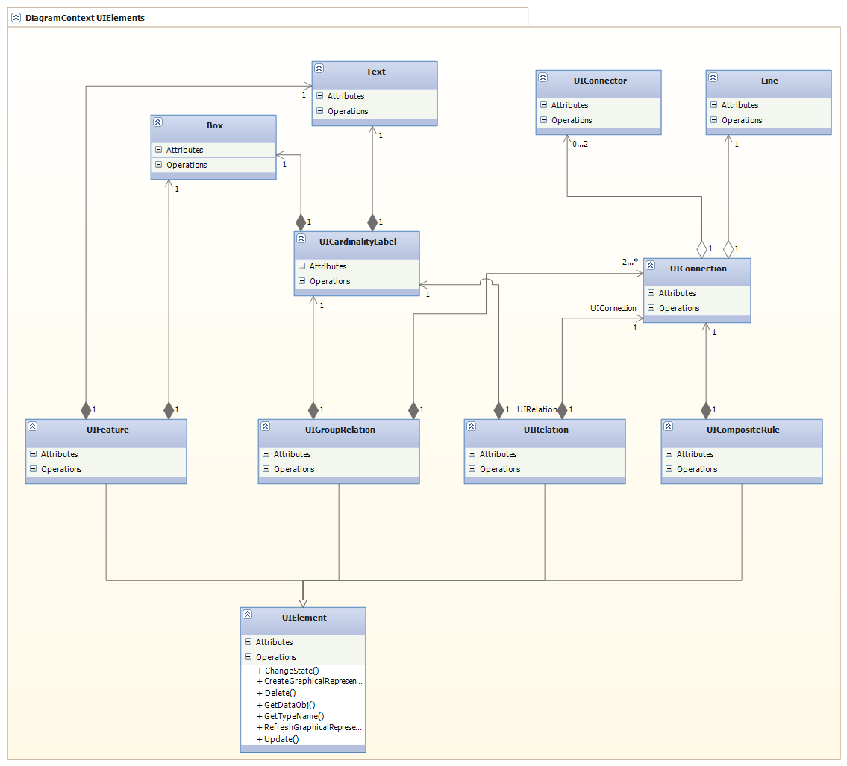
The can be split into three categories. First category is the composite objects which represent a whole element in a feature model diagram:
- UIElement:
Super class from which the other elements inherit their base behavior. Since Javascript inheritance isn’t very much in tone with OOP principles, it is basically a guideline sort of inheritance. This means that the elements that “inherit” from it actually just duplicate the code.
- UIFeature:
Represents a Feature. Keeps track of which Relations or GroupRelations it is part of. Built using a Box and Text as its inner elements.
- UIRelation:
Represents a relation between two Features, can be either mandatory or optional. Built using a UIConnection and one or two UIConnectors. Can also have a UICardinalityLabel.
- UIGroupRelation:
Represents a relation which denotes a feature group, between one parent Feature and multiple child Features. Built using multiple UIConnections and UIConnectors, as well as a
- UICompositeRule:
Represents a cross tree constraint. Is represented as a dashed line and is built using a Line and one or two UIConnectors.
The second category is made up of objects which are used as building blocks for the former:
- UICardinalityLabel:
Used for displaying numeric cardinality. It can be displayed for any types of Relations or GroupRelations.
- UIConnection:
Used for displaying a connection between two features. The connection is a line which is drawn using an algorithm which calculates the closest distance between the two Features. Each Feature has 4 connection points (N, E, S, W) at the middle of its four margins.
- UIConnector:
Simple element which can depict a connector for the end of a line. Example, the empty/full circle depicting an optional/mandatory feature.

The last category is simple elements are pure SVG objects. These are Box, Text and Line.

Configuration Editor and integration with Z3 SMT solver

The ConfigurationEditor is a page which is responsible for allowing the user to perform interactive configurations of a model. It displays a visual overview of a Model with selections and values for Features and Attributes. Users can manipulate this representation by toggling Features on/off or entering values for Attributes. The editor responds by providing dynamic consequences through the use of a backend Solver service.

Client side

On the client side we have a design similar to that of the ModelEditor page. We have an MVC pattern whose components reside entirely on the client.

All of the code related to the UI lies on the client side. It’s architecture is very similar to that of the Model Editor, as it also has a client based MVC. It differs from the ModelEditor in terms of how the UIElements are rendered and what kind of ClientObjects it uses. The graphical representation of Features and their selection state (taken as a whole represent a Configuration) is realized through simple HTML rendering rather than using SVG.

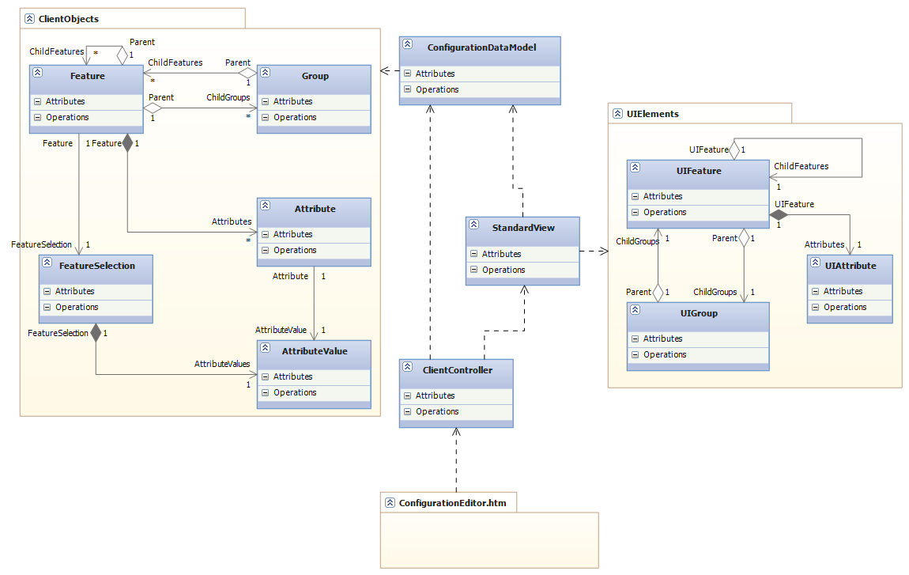
The classes are presented and briefly described:

- ConfigurationDataModel:
- ClientObjects:
- StandardView:
- ClientController
- UIElements
- ConfigurationEditor.htm

Server side
On the server we have the ConfigurationEditor controller which contains methods to provide a communication bridge between the client and the services in the Business Logic Layer.

The controller also interacts with a special service in the BLL, responsible for providing consequences to the user whenever a Feature is toggled or the value of an Attribute modified. This special service is the SolverService.

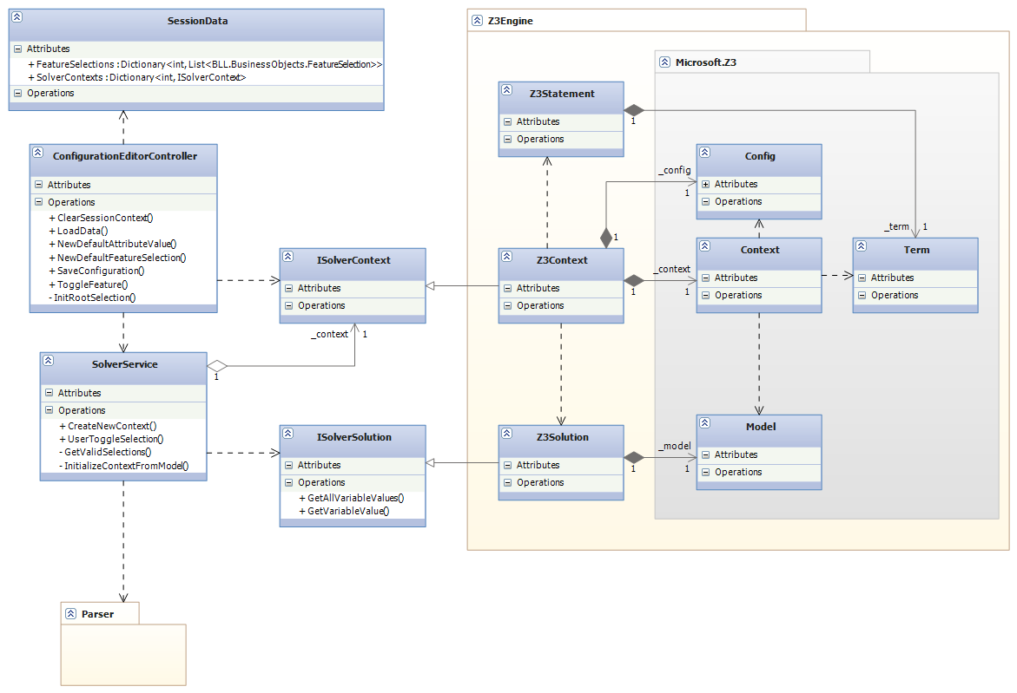
Descriptions for the classes above:

- SessionData:
Special class which provides strongtyped access to data which needs to be stored in the application’s SessionState. The data in this case is a set of FeatureSelections and a SolverContext, which are stored for every different Configuration that is being edited.
It is stored for different Configurations in order to allow the user to open multiple tabs with different Configuration instances at the same time in their browser.
The data itself is necessary because HTTP and implicitly the asp.net MVC framework are stateless. So if one wants to maintain any sort of state across different requests (calls to the Controller) SessionState must be used. There are also other ways of doing it.

- ConfigurationEditorController:
This is the controller responsible for handling requests from the client page.
- SolverService:
Special service which communicates with a Solver and returns consequences and calculations in the form of FeatureSelections and AttributeValues.
- ISolverContext:
This represents a mathematical context, abstracted through an interface. It has methods which can be used to manipulate a context as well as attempt to return a solution.
- ISolverSolution:
Represents an abstracted solution returned from a Context. Allows for asking for variable values.
- Z3Engine:
This is an actual implementation of a custom wrapper for Microsoft’s Z3 SMT solver. It contains a Z3Context which can give Z3Solutions when asked for. It is based on a direct .net wrapper from Z3.
- Z3Statement:
A wrapper for Z3’s own Terms.
- Z3Context:
Wrapper for Z3’s inner mathematical context representation.
- Z3Solution:
Wrapper for Z3’s solution class.
- Microsoft.Z3:
A .Net wrapper from Microsoft for Z3.
SolverService and integration with Z3

The SolverService is a service just like all the others, but is responsible for communicating with the Microsoft Z3 solver, instead of the data access layer. It is given a set of FeatureSelections, which represent the state of an interactive Configuration, as well as a mathematical Context and is asked to toggle one FeatureSelection and give feedback as to what consequences the action will have.

Whenever a new Configuration is loaded, the SolverService is called to initialize a mathematical context corresponding to its underlying Feature Model. This context is setup by looping through all the different elements in the Model and converting them to variables and constraints in the context.

The initial Context initialization is done in the following steps:
- All Features are instantiated as Boolean variables, using the FeatureID as their variable identifier.
- Relations are instantiated as logical constraints:
  - Optional: ChildFeature implies ParentFeature
  - Mandatory: ChildFeature mutually implies ParentFeature
- GroupRelations are instantiated as logical constraints:
  - OR: (ChildFeature1 or ChildFeature2 … or ChildFeatureN) mutually implies ParentFeature
  - XOR: ((ChildFeature1 or ChildFeature2 … or ChildFeatureN) mutually implies ParentFeature)and not(ChildFeature1 or ChildFeature2) and not (ChildFeature1 or ChildFeature3) … and not(ChildFeatureI or ChildFeatureJ)
- CompositionRules are also instantiated as logical constraints:
  - Dependency: FeatureA implies FeatureB
  - Mutual Dependency: FeatureA mutually implies FeatureB
  - Mutual Exclusion: not (FeatureA and FeatureB)

This context is then stored in the Session for later use. In order to have a valid starting point for a Configuration instance, by default, an assumption is created that sets the Root Feature to be selected. Then, with the root Feature selected, feedback is given for the first time by the Solver.

The feedback given by the Solver has the purpose of maintaining the validity of the underlying Model while configuring. Whenever the user toggles a Feature, the Solver finds out what Features must be on or off in order for the Model to still be satisfiable. Thus, the user is never allowed to make a decision that breaks the Models.

The algorithm for providing feedback is inspired from [5]:

GetValidSelections()
- foreach x that was not assigned to by the user
- do CanBeTrue := TEST-SAT(x)
- CanBeFalse := TEST-SAT(¬x)
- if ¬(CanBeTrue ^ CanBeFalse)
- then error “Unsatisfiable constraint!”
- if ¬CanBeTrue then SET(x, FALSE)
- if ¬CanBeFalse then SET(x, TRUE)
- if CanBeTrue ^ CanBeFalse
- then RESET(x)
- UNLOCK(x)
- else LOCK(x)

The GetValidSelections () method is invoked whenever the user makes a decision. The pseudocode for ToggleDecision():

ToggleDecision()
- foreach x that was not assigned to by the user
- do CanBeTrue := TEST-SAT(x)
- CanBeFalse := TEST-SAT(¬x)
- if ¬(CanBeTrue ^ CanBeFalse)

What happens when GetValidSelections () is executed, is that for each variable that the user hasn't assigned, the algorithm tries to see what happens to the satisfiability of the model if the variable is true or false. Based on this, if either true or false makes the model unsatisfiable, then the variable must be assigned the opposite value.

Parser

The Parser is responsible for parsing and executing text based rules.

Implementation and other details

Development process

Code metrics

Issues with Javascript references

Considerations and further work
- Cloneable features ?
- Cardinality for GroupRelations
- Handling of larger models:
  - Performance for Solver stuff
  - Performance for SVG
- Understandable feedback from Solver
- Better usability for Configurator, allow users to do anything instead of disabling
- Type inheritance

References

- Goetz Botterweck, Mikolas Janota and Denny Schneeweiss - “A Design of a Configurable Feature Model Configurator”
- Don Batory - “Feature Models, Grammars, and Propositional Formulas”
- Krzysztof Czarnecki and Chang Hwan Peter Kim - “Cardinality-Based Feature Modeling and Constraints: A progress report"
- Mikolas Janota - ”Do SAT solvers make good configurators?”
- Mikolas Janota - ”SAT Solving in Interactive Configuration”
- Danilo Beuche and Holger Papajewski - ” Variability management with feature models”
- Mikolas Janota and Joseph Kiniry – “Reasoning about Feature Models in Higher-Order Logic”

