Final project report

Our web service allowing people to be able to make online shopping. By this service the user will have full options to discover the goods. The service will go along with a paying service for online paying using credit card. In the future planning we can add more options of goods and make it as an application for smart phones

Also to make the ability of ordered the gift from this site .

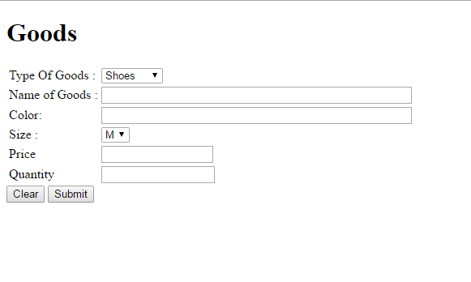

The client can choose the type of good he/she want,then the name of it by the specific code , the color ,size price and the quantity