Chapter Ten

Principles of Risk Management

This chapter contains 30 multiple choice questions, 10 short problems, and 5 longer problems.

Multiple Choice

- ________ that “matters” because if affects people's welfare. ________ exists whenever one does not know for sure what will occur in the future.

  - Uncertainty is risk; Uncertainty
  - Risk is uncertainty; Uncertainty
  - Risk is uncertainty; Risk
  - Uncertainty is risk; Risk

Answer: (b)

- ________ is a measure of willingness to pay to reduce one's exposure to risk.

  - Risk aversion
  - Risk avariciousness
  - Risk predilection
  - Risk inflation

Answer: (a)

- When choosing among investment alternatives with the same expected rate of return, a risk averse individual chooses the one with the ________ risk.

  - surest
  - most uncertain
  - lowest
  - highest

Answer: (c)

- ________ is a particular type of risk people face because of the nature of their business or pattern of consumption.

  - Operational efficiency exposure
  - Opportunity exposure
  - Risk exposure
  - Risk reduction

Answer: (c)

- ________ are investors who take positions that increase their exposure to certain risks in the hope of increasing their wealth.

  - Operations insurers
  - Foreign exporters
  - Hedgers
  - Speculators

Answer: (d)

- The riskiness of an asset or a transaction ________ be assessed in isolation or in the abstract.

  - can
  - cannot
  - must
  - it varies according to the situation

Answer: (b)

- By definition, ________ are investors who take positions to reduce their exposures.

  - operations insurers
  - foreign exporters
  - hedgers
  - speculators

Answer: (c)

- The risk of loss arising from obsolescence due to technological change or changes in consumer taste is an example of ________.

  - unemployment risk
  - liability risk
  - financial-asset risk
  - d consumer-durable asset risk

Answer: (d)

- The risk arising from holding different kinds of financial assets such as equities or fixed income securities denominated in one or more currencies is an example of ________.

  - unemployment risk
  - liability risk
  - financial-asset risk
  - consumer-durable asset risk

Answer: (c)

- Business risks of the firm are borne by its ________.

  - shareholders
  - creditors
  - employees
  - all of the above

Answer: (d)

- ________ consists of figuring out what the most important risk exposures are for the unit of analysis.

  - Risk assessment
  - Selection of risk management techniques
  - Implementation
  - Risk identification

Answer: (d)

- Which of the following is most likely to need a lot of life insurance?

  - a single person with no dependents
  - a divorced person with no dependents
  - a double-income couple with no kids
  - married person with children

Answer: (d)

- ________ is the quantification of the costs associated with the risks that have been identified in the first step of risk management.

  - Risk assessment
  - Selection of risk management techniques
  - Implementation
  - Review

Answer: (a)

- Selling a risky asset to someone else and buying insurance are examples of ________.

  - risk avoidance
  - loss prevention and control
  - risk transfer
  - risk retention

Answer: (c)

- One is said to ________ a risk when the action taken to reduce one’s exposure to a loss also causes one to give up the possibility of a gain.

  - insure
  - diversify
  - hedge
  - pay a premium with

Answer: (c)

- When you ________ you pay a premium to eliminate the risk of loss and retain the potential for gain.

  - insure
  - diversify
  - hedge
  - speculate

Answer: (a)

- In order for diversification to reduce your risk exposure, the risks must be ________

  - less than perfectly correlated with each other
  - more than perfectly correlated with each other
  - uncorrelated
  - none of the above

Answer: (a)

- The demand for ways to manage risk has been increased by ________.

  - increased volatility of exchange rates
  - increased volatility of interest rates
  - increased volatility of commodity prices
  - all of the above

Answer: (d)

- Moral hazard and adverse selection are examples of ________.

  - transactions costs
  - incentive problems
  - transference costs
  - both a and b

Answer: (b)

- ________ is defined as quantitative analysis for optimal risk management.

  - Portfolio theory
  - Corporate theory
  - Diversification theory
  - Probability theory

Answer: (a)

- An asset portfolio's expected return is identified with the ________ of the distribution, and its risk with the ________.
  - variance; average
  - mean; standard deviation
  - standard deviation; average
  - median; normal distribution

Answer: (b)

- Suppose you buy shares of RayFran stock at a price of $110 per share and intend to hold them for a year. Suppose RayFran pays a dividend of $3.50 per share over that year. Compute the total rate of return on a share of RayFran stock if at the end of the year you sell it for $122.50 per share.

  - 10.20%
  - 11.36%
  - 13.06%
  - 14.55%

Answer: (d)

- The ________ a stock's volatility, the ________ the range of possible outcomes and the ________ the probabilities of those returns at the extremes of the range.

  - larger; narrower; larger
  - larger; narrower; smaller
  - larger; wider; larger
  - larger; wider; smaller

Answer: (c)

- Consider the probability distribution of rate of return on RayFran stock:

Rate of Return Probability
40% 0.25
15% 0.55
–8% 0.20

Compute the expected rate of return on RayFran stock.

  - 9.75%
  - 15.60%
  - 16.65%
  - 19.85%

Answer: (c)

- Refer to question 24. Now compute the standard deviation of RayFran stock.

  - 12.95%
  - 13.10%
  - 16.10%
  - 25.90%

Answer: (c)

- Consider a stock with an expected return of 15% and a standard deviation of 8% that is normally distributed. What is the 0.95 confidence interval for this stock's rate of return?

  - (7%, 23%)
  - (–9%, 39%)
  - (–1%, 39%)
  - (–1%, 31%)

Answer: (d)

For questions 27 through 30, use the following table:

Historical Returns
Year | Toys’R’Me | S.A.O. Rouge
1  2  3  4  5 | 15%  20%  -5%  12%  10% | 13%  17%  -7%  8%  6%

- What are the mean returns for Toys’R’Me and S.A.O. Rouge, respectively?
  - Toys R Me: 12.4%; S.A.O. Rouge: 10.2%
  - Toys R Me: 10.4%; S.A.O. Rouge: 7.4%
  - Toys R Me: 10.4%; S.A.O. Rouge: 10.2%
  - Toys R Me: 7.4%; S.A.O. Rouge: 10.4%

Answer: (b)

- What is the standard deviation of returns for Toys R Me? For S.A.O. Rouge?
  - Toys R Me: 8.4%; S.A.O. Rouge: 7.4%
  - Toys R Me: 8.40%; S.A.O. Rouge: 8.16%
  - Toys R Me: 10.4%; S.A.O. Rouge: 7.4%
  - Toys R Me: 10.4%; S.A.O. Rouge: 8.16%

Answer: (b)

- Suppose the returns for Toys R Me and S.A.O. Rouge are normally distributed. Determine the 0.68 confidence interval for Toys R. Me.
  - (8.4%, 10.4%)
  - (–14.8%, 35.6%)
  - (–6.4%, 27.2%)
  - (2.00%; 18.80%)

Answer: (d)

- Determine the 0.95 confidence interval for S.A.O. Rouge.
  - (7.14%, 8.16%)
  - (–0.76, 15.56%)
  - (-8.92, 23.72%)
  - (–17.08, 31.88%)

Answer: (c)

Short Problems

- Briefly distinguish between the three methods available to transfer risk: hedging, insuring and diversifying.

Answer:
Hedging: One is said to hedge a risk when the action taken to reduce one’s exposure to a loss also causes one to give up the possibility of a gain.
Insuring: Insuring means paying a premium to eliminate the risk of loss and retain the potential for gain.
Diversifying: Diversifying means holding similar amounts of many risky assets instead of concentrating all of your investment in only one. Diversification thereby limits your exposure to the risk of any single asset.

- Outline the steps in the risk-management process.

Answer:
The risk management process can be broken down into five steps:

1. Risk identification
2. Risk assessment
3. Selection of risk management techniques
4. Implementation
5. Review

- Think of a bookstore. What risks is such a business exposed to, and who bears them?

Answer:
Major risks:
Risk that inventory will not arrive on time
Risk that employees will be late or absent
Risk that computers/registers will break down
Risk of new competition in the area (especially - the “superstores”)
Risk that distributors' prices will increase dramatically

These risks are borne by shareholders, owners, employees, creditors, customers, suppliers.

- Explain why the sale/purchase of a house is similar to a forward contract in nature.

Answer:
Both parties eliminate the uncertainty associated with price volatility in the housing market during the months of settling the contract between them. Even though the transfer of ownership for the house won't happen for many months, the buyer and seller of a house can contractually settle on a transaction price for the house.

- Explain the difference between insuring and hedging.

Answer:
When you hedge, you eliminate the risk of loss by giving up the potential for gain. However, when you insure, you pay a premium to eliminate the risk of loss and retain the potential for gain.

- Discuss the two factors limiting the efficient allocation of risks.

Answer:
Transactions costs and incentive problems are the two key factors limiting the efficient allocation of risks. Transactions costs include the costs of establishing and running institutions such as insurance companies or securities exchanges and the costs of writing and enforcing contracts.

Moral hazard and adverse selection are examples of incentive problems, which stand in the way of the development of institutions for efficient risk sharing. Moral hazard exists when having insurance against some risk causes the insured party to take greater risk or to take less care in preventing the event that gives rise to the loss.

The problem with adverse selection relates to the fact that those who purchase insurance against risk are more likely than the general population to be at risk.

- In the case of insuring a ship, explain how the moral hazard problem can lead to unwillingness on the part of the insurance company to insure against certain types of risk.

Answer:
If a ship owner buys insurance for his vessel, the existence of insurance may reduce the owner's incentive to spend money on the upkeep of the vessel. Failure to take such precautions makes a safety hazard a more likely occurrence. In an extreme case, the owner may be tempted to sabotage the ship in order to collect the insurance money, if the coverage exceeds the market value of the ship.
Due to this potential moral hazard, companies may limit the amount they will insure or simply refuse to insure under certain circumstances or require rigid inspections of a vessel to make sure its meets minimum safety standards.

Consider the following table to answer questions 8 through 10:

Historical Returns
Year | OutDell | MiniMoo
1  2  3  4  5 | -10%  -2%  5%  10%  18% | 5%  15%  -7%  12%  22%

- What is the mean share for OutDell? For MiniMoo?

Answer:
OutDell:
E(r) = [–10% + (–2%) + 5% + 10% + 18%]/5
= 4.2%
MiniMoo:
E(r) = [5% + 15% +(– 7%) + 12% + 22%]/5
= 9.4%
MiniMoo has the higher expected return.

- What is the standard deviation of returns for OutDell? For MiniMoo?

Answer:
OutDell:
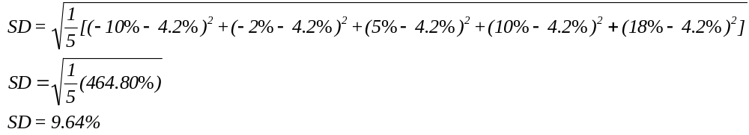
MiniMoo:
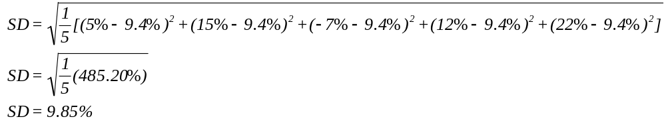

- Suppose the returns for OutDell and MiniMoo have normally distributed returns with means and standard deviations calculated in questions 8 and 9. For each stock, determine the range of returns within two standard deviations of the mean.

Answer:

OutDell:

0.95 confidence interval = 4.2 ± (2 x 9.64)
= 4.2 ± 19.28
= (–15.08%, 23.48%)

MiniMoo:

0.95 confidence interval = 9.4 ± (2 x 9.85)
= 9.4 ± 19.70
= (–10.30%, 29.10%)

Challenging Questions

- Consider the following investment opportunity. You have the opportunity to open a restaurant in your town for $180,000. If business is healthy and strong, you could net $100,000 in after-tax cash flows each year over the next six years.

a) Would you consider hedging or insuring? Why?
b) What risk is such a business exposed to:

Answer:
a) You would be more likely to consider insuring. You would insure the restaurant against fire or other disasters, take all necessary safety precautions. You would also want to retain the potential for gain in operating your business.

b) Risk that employees will be late or absent.
Risk that inventory will not arrive on time.
Risk that equipment will break down.
Risk that fire may occur.
Risk that restaurant may be robbed.
Risk that the restaurant may be vandalized.
Risk that raw material prices will increase unpredictability.
Risk of new competition in the area.

- Consider a person's life cycle - that is, at various ages say, mid-twenties, late thirties to early forties, mid-fifties and late sixties and beyond. What risks is a person likely to face in each of these age groups and how would cash, bonds and stocks be perceived at these various stages of life?

Answer:

Mid-twenties: A person may tend to be more aggressive in terms of risk tolerance. Stocks are more likely to be the choice of investment, followed by bonds and cash.
Late thirties to early forties: For “DINK,” the capacity for risk is still quite high. However, those who are parents may be faced with college tuition, life insurance, etc. so some risk options diminish. A person in this group would perhaps be a little less aggressive with stocks.
Mid-fifties: People in this group need to start thinking more about retirement and income protection. Major health costs may also be a consideration as it is for people in the sixties and beyond group. There tends to be little or no capacity for risk and the securities or investments sought at this stage tend to be very conservative.

- Use the following table:

State of Economy | Rate of Return on DinkiDi | Probability
Strong  Normal  Weak | 60%  12%  -20% | 0.20  0.60  0.20

a) Compute the mean return on DinkiDi stock.
b) Compute the standard deviation on DinkiDi stock.
c) Comment on value you obtained in (b).

Answer:
a. E(r) = (0.20)(60%) + (0.60)(12%) + (0.20)(–20%)
E(r) = 12% + 7.2% + (–4%)
E(r) = 15.2%

b. 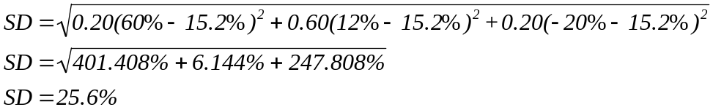

c. On its own, the value obtained in (b) does not mean as much as it would were it compared relative to another number or some industry standard.

- Suppose you are a U.K. citizen who has won a writer’s 30,000 pound scholarship to study in France. How can you hedge your foreign exchange risk? How can you insure against it?

Answer:

To hedge the risk you would enter into a contract now to sell your 30,000 pounds at a fixed per euro.

To insure against a decline in the euro price of the pound, you could pay a premium no for a put option that would give you the right to sell your 30,000 pound scholarship at a fixed euro price per pound.

- Use the table below:

Historical Returns
Year | DinkiDi | SirPass
1  2  3  4  5  6 | 11%  16%  –5%  –3%  15%  8% | 8%  17%  –7%  –4%  17%  11%

a) What is the mean return for DinkiDi? For SirPass?
b) What is the standard deviation for DinkiDi? For SirPass?
c) Suppose the returns for DinkiDi and SirPass have normally distributed returns with means and standard deviations calculated in both a and b. Calculate the range of returns within two expected deviations of the mean.

Answer:
a. DinkiDi:
E(r) = 1/6 (11 + 16 – 5 – 3 + 15 + 8)
= 7%
SirPass:
E(r) = 1/6 (8 + 17 – 7 – 4 + 17 + 11)
= 7%
Both stocks have the same mean return.

b. DinkiDi:
σ = 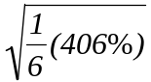
= 8.23%
SirPass:
σ = 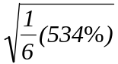
= 9.43%
SirPass has a wider dispersion or higher volatility.

c. 0.95 confidence intervals:
DinkiDi: 0.95 Confidence Intervals = 7 ± (2 x 8.23)
= (–9.46%, 23.46%)
SirPass: 0.95 Confidence Intervals =7 ± (2 x 9.43)
= (–11.86%, 25.86%)

