**PROJECT REPORT**

**On**

**All In One Grocery Store**

Submitted to Rajasthan Technical University

in partial fulfillment of the requirement for the award of the degree of

**B.TECH.**

**in**

**COMPUTER ENGINEERING**

**Submitted By**

**Rajat Bhardwaj (PIET16CE086)**

**Vaidehi Kalra (PIET16CE113)**

**Ravneet Singh (PIET16CE089)**

**Under the Guidance of**

**Dr. Ajay Maurya**

at



**POORNIMA INSTITUTE OF ENGINEERING & TECHNOLOGY, JAIPUR**

**Rajasthan Technical University, KOTA**

**APRIL, 2020**

**CERTIFICATE**

This is to be certified that the project entitled “All In One Grocery Store” has been submitted for the Bachelor of Computer Science and Engineering, Poornima Institute of Engineering & Technology, Jaipur during the academic year 2019-2020 is a bonafide piece of project work carried out by “ **Rajat Bhardwaj, Ravneet Singh & Vaidehi Kalra**” towards the partial fulfillment for the award of the Degree (B.Tech.) under the guidance of “ **Dr. Ajay Maurya** ” and supervision and no part of thereof has been submitted by them for any degree or diploma.

Project Guide Project Coordinator Mr. Deepak Moud

Dr. Ajay Maurya Prof. (Dr.) Rekha Jain (H.O.D CSE)

(Professor) (Professor)

**CANDIDATE’S DECLARATION**

We, **Rajat Bhardwaj** **(PIET16CE086), Ravneet Singh (PIET16CE089) & Vaidehi Kalra (PIET16CE113)** B.Tech (Semester- VIII) of “**Poornima Institute of Engineering & Technology, Jaipur”** hereby declare that the Project Report entitled **“ All In One Grocery Store ”** is an original work and data provided in the study is authentic to the best of our knowledge. This report has not been submitted to any other Institute for the award of any other degree.

|  |  |  |
| --- | --- | --- |
| **Rajat bhardwaj** | **ravneet singh** | **vaidehi kalra** |
| **(PIET16CE086)** | **(PIET16CE089)** | **(PIET16CE113)** |

|  |  |
| --- | --- |
| **Place: PIET, Jaipur** |  |
| **Date: 13/03/2020** |  |

**ACKNOWLEDGEMENT**

It is our pleasure to be indebted to various people, who directly or indirectly contributed in the development of this work and who influenced our thinking, behavior and acts during the course of study.

We express our sincere gratitude to ***Prof.*** (***Dr). Dinesh Goyal,*** Director, PIET for providing us an opportunity to undergo this Major Project as the part of the curriculum.

We are thankful to ***Mr. Deepak Moud, HOD, CS*** for his support, cooperation, and motivation provided to us during the training for constant inspiration, presence and blessings.

We are thankful to ***Dr. Ajay Maura*** for his/her support, cooperation, and motivation provided to us during the training for constant inspiration, presence and blessings.

We also extend our sincere appreciation to ***Prof. (Dr.) Rekha Jain*** who provided her valuable suggestions and precious time in accomplishing our Project report.

Lastly, we would like to thank the almighty and our parents for their moral support and friends with whom we shared our day-to-day experience and received lots of suggestions that improved our quality of work.

|  |  |  |
| --- | --- | --- |
| **RAJAT BHARDWAJ** | **RAVNEET SINGH** | **VAIDEHI KALRA** |
| **( PIET16CE086)** | **(PIET16CE089)** | **(PIET16CE113)** |

**TABLE OF CONTENTS**

|  |  |  |
| --- | --- | --- |
| **CHAPTER NO.** | **TOPICS** | **PAGE NO.** |
|  | TITLE PAGE | I |
|  | CERTIFICATE | II |
|  | CANDIDATE’S DECLARATION | III |
|  | ACKNOWLEDGEMENT | IV |
|  | TABLE OF CONTENTS | V |
|  | LIST OF FIGURE | VII |
|  | LIST OF TABLES | VIII |
|  | ABSTRACT | IX |
| 1 | **INTRODUCTION** | 1 |
|  | Project Aim and Objective  Problem Statement  Software Requirements  Hardware Requirements | 1  2  2  2 |
| 2 | **LITERATURE SURVEY** | 3 |
| 3 | **PROJECT MANAGEMENT** | 5 |
|  | Project Integration Management  Project Scope Management  Project Time Management  Project Cost Management  Project Quality Management  Project Human Resource Management  Project Communication Management  Project Risk Management  Project Procurement Management  Project Management Tools | 5  5  6  6  7  7  7  8  8  9 |
| 4 | **TECHNOLOGY APPLIED** | 12 |
|  | Agile project management and Scrum  Core values of agile  Principles of agile  Steps in the agile methodology  POs and their relevance to project | 12  13  14  15  17 |
| 5 | **PRODUCT BACKLOG DESIGN** | 22 |
|  | Product Backlog  Sprint Backlog-1  Sprint Backlog-2  Sprint Backlog-3  Sprint Backlog-4 | 22  24  27  29  32 |
| 6 | **PROJECT IMPLEMENTATION** | 35 |
|  | Sprint Backlog-1  Sprint Backlog-2  Sprint Backlog-3  Sprint Backlog-4 | 36  37  38  39 |
| 7 | **RESULTS** | 40 |
|  | Outcome  Future Scope | 40  40 |

**LIST OF FIGURES**

|  |  |  |
| --- | --- | --- |
| **S. NO.** | **FIGURE TITLE** | **PAGE NO.** |
| 1 | Architecture Diagram | 35 |
| 2 | Database Schema | 35 |
| 3 | Home Page UI | 36 |
| 4 | Sign Up Page | 36 |
| 5 | Product Page | 36 |
| 6 | Cart View | 37 |
| 7 | Checkout Page | 37 |
| 8 | Log In Page | 37 |
| 9 | Thank You Page | 38 |
| 10 | Contact Us Page | 38 |
| 11 | Admin Page | 38 |
| 12 | Orders Details | 39 |
| 13 | Product Details Admin View | 39 |
| 14 | Add Product Admin View | 39 |

**LIST OF TABLES**

|  |  |  |
| --- | --- | --- |
| **S. NO.** | **TABLE NO. WITH TITLE** | **PAGE NO.** |
| 1 | Product Backlog | 22 |
| 2 | Sprint Backlog 1 | 24 |
| 3 | Sprint Backlog 2 | 27 |
| 4 | Sprint Backlog 3 | 29 |
| 5 | Sprint Backlog 4 | 32 |

**ABSTRACT**

In the course of the most recent two decades, the Indian web based business segment has seen quick development. Expanding web accessibility and cell phone entrance are the two principle drivers of this development. Additionally, developing agreeableness of online installments and good socioeconomics has changed the way organizations impart, collaborate and work with clients. It has adjusted the way the Indian web based business part

works. As the Internet plays step by step a progressively vital job to associate data and individuals, the weight has kept on ascending on business sectors which have just utilized online administrations, and particularly on business sectors to which selling items online is novel. The pattern of the retailing store is changing as a developing number of retailers are moving their concentration from general physical retailing to new organizations, for example, electronic retailing or e-following.

Food supplies have been customarily purchased in stores, where buyers have a chance to contact furthermore, investigate items before the buy and furthermore control the transportation of delicate items. E-basic food item retailing is still at the earliest stages arrange and the volume of web staple goods purchasing comes up short for e-food merchants in India to continue beneficial development over the long haul.

The idea of buying transitory items including fish over the web incites some incredulity among most clients as the unwavering quality what's more, responsibility of the administration comes into question. E-basic food item retailers can construct brand value, producing rehash business and this will bring about market entrance right now advantage of online basic food item shopping is comfort. By requesting on the web, one can rapidly scan for the items one needs and request them without having to genuinely stroll through those long passageways.

All In One Grocery Store is a web application that provides various types of groceries at one place. It has two kinds of users. One of them is the admin who handles all the products, product categories and quantity of products which displays on home page. Another user is the customer who buys products.

The basic idea of this website is to satisfy all the grocery needs of customers at one place. This website allows a customer to yield orders for products from a store or its outlet. It provides services for self-pickup and at-home delivery. Customers have to provide their address and complete details of their contact and with this information they can get their order at home. Hence, this is time saving web application.

**KEYWORDS/ ABBREVIATION:** Self-Pickup, At-Home Delivery

**CHAPTER 1**

**INTRODUCTION**

**Project Aim and Objective:**

All In One Grocery Store is a type of web based business that permits buyers to legitimately purchase crisp nourishment staffs or produce from a vender over the web. An online basic food item shop brings out the physical relationship of purchasing produce like it is done in a nearby market. The biggest web-based retailing organizations are e-Bay and Amazon.com, the two of which are situated in the US. These online shops have with time had the option to add to their deals the capacity to sell new nourishment and other home items through the web.

Online markets have been a thing that has come to remain with the general public of today since most monetary exchanges can be accomplished on the web. Web get to has tremendously developed over the present reality and has offered ascend to interconnectivity even to the remotest zones on the planet. This for the most part implies it is conceivable to be at any area and arrive at some other area on the planet without venturing a foot out of your premises. This takes performing multiple tasks to another level since you can be in a gathering and visit a market found a few kilometers away simultaneously. This has made organizations to develop without spending as much as they would have in the event that they needed to manufacture another part of their business in another area.

Anyway this wonder has not trapped in the Indian business society, henceforth it has offered ascend to the subject of this undertaking. All In One Grocery Store is a site that will be utilized to sell and purchase produce that can be normally found in any nearby market. In our business sectors, merchants contact their clients who are available in the market at a specific time.

At the point when a client approaches purchase a lot of bananas from an organic product vender, the clients is asked the amount she needs to purchase, she is served and afterward the client leaves. The merchant now has no record of the client and this implies no chance to get of getting input from the client which goes far to develop business. This site will be intended to expand benefits by stretching out administrations and produce to an alternate client base by methods for online commercial which cuts across numerous fringes of our reality.

This site will hold a great deal data that will build the benefits of business at a little expense. In connecting with different clients over the web, the idea is planned for infiltrating divisions of our Indian populace who are for the most part pre-busy with exercises which makes it unimaginable for them to step out of their day by day exercises to buy their requirements. It is likewise expected to give a wellspring of salary to many employment searchers who might be keen on setting up their own business over the web.

The Website will have these fundamental capacities:

* Customer Information.
* Catalogue of things sold or accessible in the shop.
* Hold customer shopping inclination in a database.
* Interface for client service or relations.
* Delivery capacities

**Problem Statement** :-

This website expects to build up an internet looking for clients with the objective so it is anything but difficult to shop your groceries from a broad number of web-based shopping locales accessible on the web. With the assistance of this you can complete an internet grocery shopping from your home. Here is no convincing motivation to go to the crowed stores during celebration seasons. You simply require a PC or a PC and one significant installment sending choice to shop on the web. To get to this web-based shopping framework all the clients should have an email and secret word to login and continue your shopping. The login qualifications for a web-based shopping framework are under high security and no one will have the ability to break it without any problem. Upon fruitful login the clients can buy a wide scope of things, for example, beans, fruits, vegetables, and so forth can be dispatched utilizing web based shopping framework. Also, obviously you will get your mentioned arranged things at your entryway step. It is basic. You will pick your preferred things from assortment of internet shopping destinations taking a gander at cost and quality. No compelling reason to go physical shops with this you will have more opportunity to go through with your family. It Just need a PC and an installment making alternatives like net banking, MasterCard, check card or any other online payment method. Almost a wide scope of things can be brought through internet shopping system. You can buy products from remote spots from your room and you will get your groceries at your home. It is very secure.

**Software Requirements:-**

* Bootstrap
* Xampp
* Sublime Text
* Web browser

**Hardware Requirements:-**

* Laptop/Mobile to access Web browser with minimum requirements of 1 GB Ram

**CHAPTER 2**

**LITERATURE SURVEY**

Amol Ranadive (2015) has made a study which looks into the levels of acceptance among consumers in Vadodara city. It focuses the factors that affect the consumers buying intentions and shopping preferences. The results of the study conducted have reaffirmed that the framework of Theory of Planned Behavior (TPB) is applicable to the measurement of consumer’s behavioral intentions while shopping for groceries online. This study presents

substantial empirical support for the sufficiency of Ajzen’s TPB model in online shopping behavior. Thus with all the other three variables of the TPB, the study demonstrates the predictive utility of the TPB to determine online shopping behavior, specifically for grocery shopping in the city of Vadodara.

Vijayasarathy (2004), in his research, used a sample of 281 consumers to test a model of consumer intention to use online shopping. The study found compatibility, usefulness, ease of use, and security to be significant predictors of attitude towards online shopping, but privacy was not. Another finding showed that intention to use online shopping was strongly influenced by attitude toward online shopping, normative beliefs, and self-efficacy.

Raijas, A. (2002) also found that "the simplicity to mastermind staple products" may decidedly impact customer's objective to purchase by methods for online grocery stores. Customers felt disturbing and without a doubt drop the purchase if they comprehend that the method or procedures to purchase by methods for online nourishment vendors is obfuscated (Odekerken-Schroder, G. also, Wetzels, M. 2003). In the examination of Elliot, S. in addition, Fowell , S. (2000), one explanation online client are not content with the web shopping experience is the jumbled of webpage course and complex techniques.

Taking into account Keh, H.T. moreover, Shieh, E. (2001), a huge degree of people hope to purchase through on the web, anyway they are persistently standing up to the issue of can't get the solicitation expeditiously and step by step schedule of movement is sporadic. At the present time, demand accessibility basic influenced future online essential nourishment thing buying point (Hansen, T., 2005).

Gulten Bozkurt (2010) study depended on the examination of the purchaser natural attributes of standard staple customers who purchase online from the individuals who purchase in the store. It additionally focused on the nourishment shopping propensities between purchasers who purchase online against the individuals who purchase in the store. The outcomes gotten right now that there was no variety between the on the web and the physical store members comparable to natural attributes when looking for nourishment or staple goods.

**CHAPTER 3**

**PROJECT MANAGEMENT**

Project management has evolved from few simple principles to a wide subject with many complex concepts. To make it easier for people to understand project management, all PMBOK knowledge areas are classified into nine categories by PMBOK Guide. It is one of the most comprehensive model documents for project managers. In this article, we will take a deeper look at each of these knowledge areas to give you a better perspective of project management.

1. **Project Integration Management**

PMI defines project integration management as, “Processes and activities needed to identify, define, combine, unify and coordinate different processes and activities with project management process groups.” In short, project managers will have to keep an eye on every aspect of a project and check if everything is going according to the plan.

Good project integration is not possible without good teamwork. In order to be successful, you should have the resources who know their role and responsibilities. It is the responsibility of project managers to make project objectives clear and manage the inter-dependencies effectively to complete projects successfully. Therefore, project managers should focus on the bigger picture and follow a strategic approach to project management. Keep an eye on the obstacles and address them quickly before the problem gets out of hand.

1. **Project Scope Management**

Scope creep and lack of proper scope document is one of the main [reasons behind project failure](https://blog.taskque.com/causes-project-failure/). Furthermore, defining and documenting all the work comes under scope management. Project team should know what the deliverables are and what problems your project will solve. All this makes it easier for your team members to achieve the goals and helps clients in knowing what to expect from the projects. Therefore, project scope should also contain [milestones related to projects](https://blog.taskque.com/project-milestones-achieve/).

There are five sub-processes involved in the project scope management process.

* Collect requirements (Document stakeholder requirements)
* Define scope (Detailed description of project and what it will do)
* Create work breakdown structure (Dividing projects into smaller tasks)
* Verify scope (Getting acceptance of project deliverables from stakeholders)
* Control scope (Difference between actual and approved scope)

1. **Project Time Management**

One of the biggest challenges for project managers is to complete projects on time. However, most project managers do not understand this knowledge area. Hence, most projects under their supervision fail to complete before the deadline. There are six sub-processes associated with the project time management knowledge area that every project manager should know in order to complete projects on time.

Here are the six sub-processes:

* Define activities
* Sequence activities
* Estimate the resources required
* Estimate the time required
* Develop a schedule
* Control schedule

1. **Project Cost Management**

Most project managers consider managing costs against their project as their biggest challenge. However, cost management can be a difference maker between a successful project and a project failure. Many projects are abandoned due to budget constraints. If you do not want this to happen to your projects, then you should learn the art of effective project cost management and complete projects within the specified budgets. Latest tools and techniques can help you in this regard.

Here are three main sub-processes involved in project cost management.

* Estimate costs
* Determine budget
* Control costs

Make sure that you keep an eye on budget and expenditures so that you do not end up exceeding the budget. Unfortunately, most project managers do not pay attention to cost management from the beginning, spends a major chunk initially without any record and struggles to keep the project inside the budget later on. To keep project costs in check, you should track every dollar and where it is spent.

1. **Project Quality Management**

No matter how you define quality, a high-quality project is one which satisfies the customer needs and does not contain any defects and deficiencies. In order to achieve the highest project quality, project managers and their team should focus on customer requirements they have gathered initially, try to know what the customer wants and which problems your project will solve.

Develop a prototype of the project and give it to the end user to use it. Their feedback will allow you to make necessary adjustments before you deliver the final product to the customer. At the end of it all, the project should completely align with the user requirements in order to be called a high-quality project. Hence, all the requirements should be well documented so that your team can deliver a project that satisfies customer’s requirement.

1. **Project Human Resource Management**

Another knowledge area of project management that usually is ignored is project human resource management. It is the set of processes and activities involved in organizing, leading and managing project teams. It is how you manage the most valuable asset of your company i.e. people. To be successful at it, project managers should have a clear strategy when it comes to hiring and staffing people and inducting them into project teams. Hiring the right people can increase the chances of your success.

Project Human Resource Management process involves following sub-processes:

* Developing a human resource plan
* Hire the project team
* Develop a project team
* Manage project team

1. **Project Communication Management**

Poor project communications can wreak havoc on your project progress. Moreover, it can take your project towards failure. So, if you want to complete projects successfully, all team members should be on the same page. Moreover, they should work as a team to achieve the common objective. If you want that to happen, then you will have to communicate effectively and regularly. Project managers can enhance collaboration and communication among their team members by using [task management software](https://taskque.com/) that offers communications and collaboration features. Here are some of the key activities that project managers need to undertake to ensure uninterrupted communications throughout the project:

* Identify stakeholders
* Plan communications
* Distribute information
* Manage stakeholder expectations
* Report performance

1. **Project Risk Management**

Most project managers consider risk management as the most important factor in completing projects successfully. Therefore, effective risk management plays an important role in preventing your projects from failure. In addition to this, project managers can reduce the risk by following a proactive approach and managing risks at the initial stage. Project managers who ignore minor risks have to suffer from project failure because these minor risks can turn into major risk and can lead to a project disaster if left unattended. Here are some of the activities that project managers will have to undertake in project risk management:

* Plan risk management
* Identify risks
* Perform qualitative and quantitative risk analysis
* Plan risk response
* Monitor and control risks

1. **Project Procurement Management**

The Project Procurement Management knowledge area covers all the aspects related to purchase and acquiring of products and services needed to complete projects effectively. Although, the procurement process is quite transparent and conducted through a contract or agreement, it important for project managers to ensure that there are no discrepancies. Whether you are a buyer or seller, you need to understand both perspectives to get a better knowledge of the project procurement process. Additionally, cost benefit analysis, cost utility analysis, and risk analysis also comes under project procurement management.

* Plan procurement
* Conduct procurement
* Administer procurement
* Close procurement

**Project Management Tools:**

Project management required tools to manage the work , time and resources. At present many of the software are available for project management. Some of the popular software tools are as follows.

### [Trello](http://send.getapp.com/aff_c?offer_id=677&aff_id=1371" \t "_blank)

Trello is a project management tool; instead this app is a free visual way to to glance at the entire project with a single view. With Trello you can organize cards; these cards can be your thoughts, conversations and to-do lists and be placed on a board for everyone to collaborate on.

### [Basecamp](http://send.getapp.com/aff_c?offer_id=637&aff_id=1371" \t "_blank)

Basecamp is the granddaddy of project management apps. Basecamp is considered the leading project management tool around. It boosts a simple and easy to use interface to collaborate with your team and client. It allows you to create multiple projects and setup discussions, write to-do lists, manage files, create and share documents, and organize dates for scheduling.

### [Teamwork Projects](http://send.getapp.com/aff_c?offer_id=947&aff_id=1371" \t "_blank)

Teamwork Projects is the ultimate productivity tool to manage projects with your team. Teamwork allows you to keep all your projects, tasks and files all in one place and easily collaborate with a team. Teamwork helps you to visualise the entire project through a marked calendar and Gantt chart and setup reporting. Teamwork supports file management with Google Drive, Box.com and Drop box. As well as integration with leading apps such as third party accounting software and customer support apps.

### [Resource Guru](https://resourceguruapp.com/" \t "_blank)

Billed as the "simple way to schedule people, equipment and other resources", Resource Guru is a streamlined resource scheduling and leave management tool that’s designed to keep your projects on track. You can plan your team's workloads; receive daily booking reminders, report on KPIs, and more. Apple, Saatchi & Saatchi and Deloitte are among some of the cloud-based team calendar’s heavyweight customers.

### [ActiveCollab](http://send.getapp.com/aff_c?offer_id=949&aff_id=1371" \t "_blank)

ActiveCollab recently released its new version 5.0. The new revamped app is now more powerful and focused project management tool. It offers team collaborating features, task management, time tracking and importing expenses. One of the biggest asset of ActiveCollab is it offers invoicing features. You are able to track payments and expenses and have invoices paid directly within ActiveCollab with PayPal, and other credit card payments.

### [Zoho Projects](http://send.appdoubler.com/aff_c?offer_id=101&aff_id=1371" \t "_blank)

Zoho offers a wide range of business software including Projects. Zoho Projects is a proficient tool to project plan and project coordinator from start to finish. It boost all the features you need for project management with some advance features including reporting, integration with Google Apps and Drop box, bug tracking, setup Wiki Pages to build a repository of information, forums and more.

### [Jira](http://send.getapp.com/aff_c?offer_id=281&aff_id=1371" \t "_blank)

Jira is specifically targeted for software development teams. Jira offers abilities to raise issues and bugs. Jira makes it real easy to track bugs and see which issues are still outstanding and how much time was spent on each task. Jira offer other products including Confluence a document collaboration tool, and Hip Chat a team chat and video and file sharing platform and other products.

### [Asana](http://send.getapp.com/aff_c?offer_id=587&aff_id=1371" \t "_blank)

Asana is the easiest way for teams to track their work so everyone knows who's doing what, by when. With tasks, projects, conversations and dashboards, Asana keeps your work organized, and teammates accountable so you can move work forward faster. Asana also lets you keep track of your work wherever you are with mobile apps for both iOS and Android.

### [Podio](http://send.getapp.com/aff_c?offer_id=951&aff_id=1371" \t "_blank)

Podio is an ever growing tool to organise and communication tool for any business. Podio allows you to personalise this platform to fit your business needs. Besides being able to communicate with a team, setup task management, use as a file storage system, like a traditional project management app, Podio can be an internal intranet for all your colleagues and departments to interact.

### [Freedcamp](https://freedcamp.com/" \t "_blank)

Whatever your project may be, either setting up an event, a web project or organising a wedding, Freedcamp helps you organise and plan effectively. Freedcamp has an organised dashboard to view the entire project at a glance. You can easily setup tasks, use sticky notes to visually setup tasks and organise them into the calendar. Freedcamp provides advance add-ons for high level business use including CRM, invoicing, issue tracking and setting up wiki pages.

### [Wrike](http://send.getapp.com/aff_c?offer_id=239&aff_id=1371)

Wrike is advance application to help you work smarter. By making sure you are always staying on track and ensure you have the adequate resources to finish on time and on budget. Setting up tasks, engage your team and integrate with your business tools including Google Apps, Microsoft Excel, Drop box and many more is so easy with Wrike.

**CHAPTER 4**

**TECHNOLOGY APPLLIED**

Agile is a [project management methodology](https://www.cio.com/article/2950579/methodology-frameworks/how-to-pick-a-project-management-methodology.html) that uses short development cycles called “sprints” to focus on continuous improvement in the development of a product or service.

Although incremental software development methods go as far back as 1957, agile was first discussed in depth in the 1970s by William Royce who published a paper on the development of large software systems. Later in 2001, the Agile Manifesto, a "formal proclamation of four key values and 12 principles to guide an iterative and people-centric approach to software development," was published by 17 software developers. These developers gathered together to discuss lightweight development methods based on their combined experience.

**Agile project management and Scrum**

[Scrum](https://www.cio.com/article/3223139/project-management/what-is-a-scrum-master-a-key-role-for-project-success.html) is a powerful framework for implementing agile processes in software development and other projects. This highly adopted framework utilizes short iterations of work, called sprints, and daily meetings, called scrums, to tackle discrete portions of a project in succession until the project as a whole is complete. There are three key roles within Scrum: the [Scrum master](https://www.cio.com/article/3223139/project-management/what-is-a-scrum-master-a-key-role-for-project-success.html), product owner, and Scrum team members:

* The product owner creates and prioritizes a product backlog (work to be done).
* Teams select items from the backlog and determine how to complete the work.
* Work must be completed within a sprint (usually two to four weeks).
* The Scrum master meets with teams briefly each day to get progress updates.
* Sprint reviews are conducted at the end of each sprint.
* The process starts again until all work or backlog is complete.

Agile project management is a modern, flexible approach to [project management](https://www.workfront.com/solutions/project-management-software/). It allows you to break large projects down into more manageable tasks, which are tackled in short iterations or sprints. This enables your team to adapt to change quickly and deliver work fast.

Today, agile project management methodology is used by software developers, construction companies, educational organizations, and even [marketing teams](https://www.workfront.com/solutions/marketing). Many organizations can benefit from agile project management, and it’s simple to set up and utilize.

While you can take advantage of software, books, or agile coaches, each agile team is unique, and understanding the basics can help you put together an agile project methodology that works for you and your team.

## Core values of agile

The Agile Manifesto outlines 4 core values and 12 guiding principles which are important for any team adopting an agile methodology.

Those 4 core values are:

### Individuals and interactions over processes and tools

As sophisticated as technology gets, the human element will always serve as an important role in any kind of project management. Relying too heavily on processes and tools results in an inability to adapt to changing circumstances.

### Working software over comprehensive documentation

As important as documentation is, working software is more. This value is all about giving the developers exactly what they need to get the job done, without overloading them.

### Customer collaboration over contract negotiation

Your customers are one of your most powerful assets. Whether internal or external customers, involving them throughout the process can help to ensure that the end product meets their needs more effectively.

### Responding to change over following a plan

This value is one of the biggest departures from traditional project management. Historically, change was seen as an expense and one to be avoided. Agile allows for continuous change throughout the life of any given project. Each sprint provides an opportunity for review and course correction.

## Principles of agile

Agile project methodologies can be as diverse and unique as each individual team, but **these 12 principles should always guide your decisions and product development**.

1. Our highest priority is to satisfy the customer through early and continuous delivery of valuable software (or whatever else you deliver).
2. Welcome changing requirements, even late in development. Agile processes harness change for the customer’s competitive advantage.
3. Deliver projects frequently, from a couple of weeks to a couple of months, with a preference for the shorter timescale.
4. Coordinating team members must work together daily throughout the project.
5. Build projects around motivated individuals. Give them the environment and support they need and trust them to get the job done.
6. Face-to-face conversation is the most efficient and effective method of conveying information to and within different teams.
7. The final product is the primary measure of progress.
8. Agile processes promote sustainable development. All stakeholders should be able to maintain a constant pace indefinitely.
9. Continuous attention to technical excellence and good design enhances agility.
10. Simplicity—the art of maximizing the amount of work not done—is essential.
11. The best architectures, requirements, and designs emerge from self-organizing teams.
12. At regular intervals, the team reflects on how to become more effective, then tunes and adjusts its behavior accordingly.

## The team members

Each agile project methodology has its own unique list of team members, and while the titles may change, there are a few universal [characteristics that agile team members](https://www.workfront.com/blog/building-and-growing-an-agile-marketing-team-with-andrea-fryrear) should have:

1. **T-shaped.** A valuable team member has a wide breadth of basic knowledge about their subject but also deep knowledge, experience, and ability in one (or more) specific areas.
2. **Cross-functional.** Cross-functional team members have skills outside their traditional areas. They might know some basic graphic design principles and data analysis or even some HTML/CSS.
3. **Adaptable.** If they have a diverse skill set, they know how to use it. No matter the environment, their output remains consistent.
4. **Curious.** Part of optimizing and becoming more efficient is asking the right questions and challenging the way things have always been when it’s appropriate.
5. **Entrepreneurial.** An agile team member is one that doesn’t wait to be told what to do. They’re ready to fill in and develop campaigns where they see a need.
6. **Team-oriented.** Team players prioritize the success of the team over their own personal glory. If everyone is delivering on time and syncing well together, they see that as a win.
7. **Committed to excellence.** One of the key benefits of agile projects is delivering quality work, faster. Team members who are committed to excellence don’t settle for average. They’re not hung up on perfection, but they’re dedicated to always producing their best work.

## Steps in the agile methodology

The goal of agile is to produce shorter development cycles and more frequent product releases than traditional waterfall project management. This shorter time frame enables project teams to react to changes in the client’s needs more effectively.

[Scrum](https://www.workfront.com/blog/rolling-out-scrum-on-your-marketing-team-part-1-with-andrea-fryrear) and [Kanban](https://www.workfront.com/blog/rolling-out-kanban-with-andrea-fryrear) are two of the most common. But each agile project methodology will follow [the same basic process](http://www.dummies.com/careers/project-management/agile-project-management-for-dummies-cheat-sheet/), which includes:

### Project planning

Like with any project, before beginning your team should understand the end goal, the value to the organization or client, and how it will be achieved.

Project scope can be developed here, but **remember that the purpose of using agile project management is to be able to address changes and additions to the project easily**, so the project scope shouldn’t be seen as unchangeable.

### Product roadmap creation

A roadmap is a breakdown of the features that will make up the final product. This is a crucial component of the planning stage, because team will build these individual features during each sprint.

At this point, a product backlog is developed, which is a list of all the features and deliverables that will make up the final product.

### Release planning

In traditional waterfall project management, there is one implementation date that comes after an entire project has been developed. When using an agile project methodology, project uses shorter development cycles (called sprints) with features released at the end of each cycle.

Before kicking off the project, a high-level plan is prepared for feature releases and at the beginning of each sprint, revisit and reassess of the released plan is performed.

### Sprint planning

Before each sprint begins, the stakeholders need to plan what will be accomplished by each person during that sprint, how it will be achieved, and assess the task load. It’s important to share the load evenly among team members so they can accomplish their assigned tasks during the sprint.

It is also needed to [visually document your workflow](https://www.workfront.com/blog/how-to-visualize-your-agile-marketing-workflow-and-why-you-should-with-andrea-fryrear) for team transparency, shared understanding within the team, and identifying and removing bottlenecks.

### Daily meetings

To help team accomplish their tasks during each sprint and assess whether any changes need to be made, hold short daily meetings. During these meetings, each team member will briefly talk about what they accomplished the day before and what they will be working on that day.

**These daily meetings should be only 15 minutes long.** They aren’t meant to be extended problem-solving sessions or a chance to talk about general news items. Some teams will even hold these meetings standing up to keep it brief.

### Sprint review and retrospective

After the end of each sprint, team will hold two meetings: first, a sprint review with the project stakeholders to show them the finished product. This is an important part of keeping open communication with stakeholders.

An in-person or video conference meeting allows both groups to build a relationship and discuss product issues that arise.

Second, a sprint retrospective meeting with stakeholders to discuss what went well during the sprint, what could have been better, whether the task load was too heavy or too light for each member, and what was accomplished during the sprint.

If team is new to agile project management, don’t skip this essential meeting. It helps to estimate how much team can tackle during each sprint and the most efficient sprint length for future projects.

## POs and Their Relevance to project

**PO1: Engineering knowledge:** Apply the knowledge of mathematics, science, engineering fundamentals and an engineering specialization to the solution of complex engineering problems.

In this project creation process engineering knowledge of the software engineering and Electronics engineering have been applied. we have used software engineering , HTML,xml, Java , Android , Java Script , Php , J2EE, Data Base , Oracle , my sql , mango and other programming language and database to the project. We have applied all above engineering subjects in our projects.

**PO2: Problem analysis:** Identify, formulate, review research literature, and analyse complex engineering problems reaching substantiated conclusions using first principles of mathematics, natural sciences, and engineering sciences.

In our projects we have identified a problem, once verified by the client we have worked to identify the solution using all of our theoretical and practical knowledge.

**PO3: Design/development of solutions:** Design solutions for complex engineering problems and design system components or processes that meet the specified needs with appropriate consideration for the public health and safety, and the cultural, societal, and environmental considerations.

**PO4: Conduct investigations of complex problems:** Use research-based knowledge and research methods including design of experiments, analysis and interpretation of data, and synthesis of the information to provide valid conclusions.

**PO5: Modern tool usage:** Create, select, and apply appropriate techniques, resources, and modern engineering and IT tools including prediction and modelling to complex engineering activities with an understanding of the limitations.

In the project development we have applied Integrated Development Environment IDE for the rapid development of the code, used web server for the software development.

**PO6: The engineer and society**: Apply reasoning informed by the contextual knowledge to assess societal, health, safety, legal and cultural issues and the consequent responsibilities relevant to the professional engineering practice.

In 1961, the Conference of Engineering Societies of Western Europe and the United States of America defined "professional engineer" as follows.

A professional engineer is competent by virtue of his/her fundamental education and training to apply the scientific method and outlook to the analysis and solution of engineering problems. He/she is able to assume personal responsibility for the development and application of engineering science and knowledge, notably in research, design, construction, manufacturing, superintending, and managing and in the education of the engineer. His/her work is predominantly intellectual and varied and not of a routine mental or physical character. It requires the exercise of original thought and judgement and the ability to supervise the technical and administrative work of others. His/her education will have been such as to make him/her capable of closely and continuously following progress in his/her branch of engineering science by consulting newly published works on a worldwide basis, assimilating such information and applying it independently. He/she is thus placed in a position to make contributions to the development of engineering science or its applications. His/her education and training will have been such that he/she will have acquired a broad and general appreciation of the engineering sciences as well as thorough insight into the special features of his/her own branch. In due time he/she will be able to give authoritative technical advice and to assume responsibility for the direction of important tasks in his/her branch.

**PO7: Environment and sustainability:** Understand the impact of the professional engineering solutions in and environmental contexts, and demonstrate the knowledge of, and need for sustainable development.

Sustainability is the ability to continue a defined behavior indefinitely. Sometimes environmental, social and economic are termed to be the three pillars of sustainability.

**PO8: Ethics**: Apply ethical principles and commit to professional ethics and responsibilities and norms of the engineering practice. Engineers uphold and advance the integrity, honor and dignity of the engineering profession by:

1. Using their knowledge and skill for the enhancement of human welfare;
2. being honest and impartial, and servicing with fidelity the public, their employers and clients;
3. Striving to increase the competence and prestige of the engineering profession; and
4. Supporting the professional and technical societies of their disciplines.

**PO9. Individual and Team work**: Function effectively as an individual and as a member or leader in diverse teams, and in multidisciplinary settings.

To work successful in team a team member must have following capabilities.

1. **The Ability to Listen**

It is important to listen to one another's ideas. Too often in a business setting, you have a group of people simply waiting for their turn to speak, not paying one iota of attention to the persons on their left or right. So it is a good teamwork skill to have the ability to listen

1. **Check Your Ego**

This isn't saying abandon your ego all together, because that isn't healthy. But leaving your ego at the door temporarily is a very important team work skill. The reason this is so essential is because there is always someone better than you at something, no matter how brilliant you are.

1. **Critique**

By critique, I mean constructive criticism. Be able to give others constructive criticism and be able to listen to others critique your ideas and work. There shouldn't be any offense taken to constructive criticism. You all want to succeed, and this is a vital step in doing so.

1. **Delegation**

The mentality must be applied to teamwork. Delegate roles to those who do them best.

1. **Show Respect**

If you and another person happen to be paired up and can't stand each other, you can still put that aside for a couple of hours, treat each other civilly, and complete the tasks at hand. You may even overcome the dislike toward one another.

1. **Be Helpful**

This is simple. If one of your teammates does not understand an idea, discussion, or task that is being completed, take the necessary time to explain it to them and work with them. There are no weak links when everyone helps one another. Some take longer to learn than others, but that doesn't mean that they are of less intelligence. If in a meeting someone asks a question because they don't understand, don't frown at them. Just answer the questions patiently and concisely.

1. **Question One Another**

If someone brings up a topic of discussion and a solution to this topic, question them. Respectfully question, don't badger. Rather, ask them how it will work, why it will work over the long-run, and how everyone else can implement the idea.

1. **Participation**

Have the entire team encourage shy people to engage in the topics of discussion. Don't demand it, but make them realize that you really want to hear their ideas.

1. **Rational Debate**

Bad ideas are bad for teams. Spirited, friendly, rational debate is where facts come forward, ideas are born, and quality rises to the top.

1. **Set the Right Environment**

Try to make the space in which your team is assembled as comfortable, relaxing, and inviting as possible. You do not want your team to be tense and with frayed nerves.

**PO 10: Communication:** Communicate effectively on complex engineering activities with the engineering community and with society at large, such as, being able to comprehend and write effective reports and design documentation, make effective presentations, and give and receive clear instructions.

**PO11: Project Management and Finance:** Demonstrate knowledge and understanding of the engineering management principles and apply these to one’s own work, as a member and leader in a team, to manage projects and in multidisciplinary environments.

Project management is the application of processes, methods, knowledge, skills and experience to achieve the project objectives. In general project is a unique, transient endeavour, undertaken to achieve planned objectives, which could be defined in terms of outputs, outcomes or benefits.

**PO12: Life-long learning**: Recognize the need for and have the preparation and ability to engage in independent and lifelong learning in the broadest context of technological change.

Life Long Learning means is the provision or use of both formal and informal learning opportunities throughout people's lives in order to foster the continuous development and improvement of the knowledge and skills needed for employment and personal fulfillment

**CHAPTER 5**

**PRODUCT BACKLOG DESIGN**

1. **PRODUCT Backlog**

As described in the Scrum Guide, the Product Backlog is an ordered list of everything that is known to be needed in the product. It is the single source of requirements for any changes to be made to the product. The Product Owner is responsible for the Product Backlog, including its content, availability, and ordering.

Table 5.1: Product Backlog

|  |  |  |  |  |
| --- | --- | --- | --- | --- |
| **SPRINT BACKLOG** | **US ID** | **BACKLOG ITEM** | | |
| **AS A/AN** | **I WANT TO** | **SO THAT** |
| 1 | SB1/US1 | Buyer | Access the website/app | I Can see the product listing |
| 1 | SB1/US2 | Buyer | See all the products | I Can see the variety of the products |
| 1 | SB1/US3 | Buyer | Search the product through search bar | I Can Search the choice of product by keyword |
| 1 | SB1/US4 | Buyer | View The Cart | I Can See The Products which are available in my cart |
| 1 | SB1/US5 | Buyer | Login | I can see my saved content |
| 1 | SB1/US6 | Buyer | Signup | I Can start purchasing the product |
| 1 | SB1/US7 | Buyer | Contact to service provider | I can send a query |
| 1 | SB1/US8 | Buyer | See the product category wise | I Can see the product category wise |
| 1 | SB1/US9 | Buyer | to add a product in my cart | I Can place an order |
| 1 | SB1/US10 | Buyer | to update a product quantity inside a cart | I Can change the quantity of the product in cart |
| 1 | SB1/US11 | Buyer | to delete a product inside a cart | I can remove the product from cart |
| 1 | SB1/US12 | Buyer | to see the cart total | I Can See the total amount of product which I have added in cart |
| 1 | SB1/US13 | Buyer | to See the specific product detail | I Can check the details of the specific product |
| 1 | SB1/US14 | Buyer | to go to checkout | I Can select type of method of delivery |
| 1 | SB1/US15 | Buyer | See the order summery at checkout page | I Can see the products which I have added in cart |
| 2 | SB2/US1 | Buyer | select the self-pickup option | I Can select pickup delivery option |
| 2 | SB2/US2 | Buyer | select address from saved addresses | I Can select delivered to this address option |
| 2 | SB2/US3 | Buyer | add new delivery address | I Can add new address |
| 2 | SB2/US4 | Buyer | place an order | I can get the product |
| 2 | SB2/US5 | Buyer | see the thank you page | I Can assure my product confirmation |
| 2 | SB2/US6 | Buyer | receive the order details in main | I have a proof of order |
| 2 | SB2/US7 | Buyer | Remove product from cart | I Can delete the product from cart if no longer required |
| 2 | SB2/US8 | Buyer | See the sub total of each item | I Can see the cost of each item |
| 2 | SB2/US9 | Buyer | See the banner area at home page | I Can see the special offers |
| 2 | SB2/US10 | Buyer | See the logout button | I Can logout from the website |
| 2 | SB2/US11 | Buyer | See the hot offers on home page | I Can see the currently running offer in the store |
| 2 | SB2/US12 | DBA | Create database | I Can store all customer information to serve customer better |
| 2 | SB2/US13 | DBA | Fire Select Queries | I Can View The Records |
| 2 | SB2/US14 | DBA | Fire Update Queries | I Can Keep The Database Updated |
| 2 | SB2/US15 | DBA | Fire Delete Queries | I Can Remove Unwanted Or Faulty Data |
| 3 | SB3/US1 | DBA | Take Backup | I Can Save The Old Records In The Database For Future Use |
| 3 | SB3/US2 | DBA | Delete Backup | I Can Delete The Records Which Is Not Needed Any More |
| 3 | SB3/US3 | Admin | Login Into The System Using given credentials | I Can Access The Admin panel |
| 3 | SB3/US4 | Admin | See the error in login | I Can Enter the correct credentials |
| 3 | SB3/US5 | Admin | See the homepage of admin panel | I can access the general content of admin |
| 3 | SB3/US6 | Admin | See list of all the orders | I can prepare the order |
| 3 | SB3/US7 | Admin | See the specific items ordered | I can prepare order specifically |
| 3 | SB3/US8 | Admin | See the total amount to be collected | I can collect that amount from customer at the time of delivery |
| 3 | SB3/US9 | Admin | See the type of order | I Can deliver the order accordingly |
| 3 | SB3/US10 | Admin | See all the products present in database | I can update the details |
| 3 | SB3/US11 | Admin | Filter the product category wise | I Can see the products of particular category |
| 3 | SB3/US12 | Admin | Edit product details | Customer can see the latest details of the product |
| 3 | SB3/US13 | Admin | Delete the product from the database | Customer cannot see the unwanted product |
| 3 | SB3/US14 | Admin | See the successfully updated message after product updated successfully | I Can assure that product details is updated |
| 3 | SB3/US15 | Admin | See the successfully deleted message after product deleted successfully | I Can assure that product is deleted from the database |
| 4 | SB4/US1 | Admin | Add a new product | Customer can see the newly added product |
| 4 | SB4/US2 | Admin | Upload image of the product | Customer can see the image of the newly added product also |
| 4 | SB4/US3 | Admin | See the successfully added product message after product added successfully | I Can assure that product is added in database |
| 4 | SB4/US4 | Admin | Add new category | I can add products in that category |
| 4 | SB4/US5 | Admin | See the successfully added category message after category added successfully | I Can assure that category is added in database |
| 4 | SB4/US6 | Admin | Delete category | Category is no longer visible in the website/app |
| 4 | SB4/US7 | Admin | See the successfully deleted category message after category deleted successfully | I Can assure that category is deleted from database |
| 4 | SB4/US8 | Admin | All the users in the website | I can see the list of users |
| 4 | SB4/US9 | Developer | Create android project | I can develop web view |
| 4 | SB4/US10 | Developer | create Web view in android application project | I can develop application |
| 4 | SB4/US11 | Developer | create Splash screen | Customer do not see blank page |
| 4 | SB4/US12 | Developer | Upload the android application to play store | User can download the application |
| 4 | SB4/US13 | Buyer | Install the android application | I Can do all the work in android phone |
| 4 | SB4/US14 | Buyer | Order the product via android application | I Can order the product by mobile |

1. **Sprint Backlog**

The sprint backlog is a list of tasks identified by the Scrum team to be completed during the Scrum sprint. During the sprint planning meeting, the team selects some number of product backlog items, usually in the form of user stories, and identifies the tasks necessary to complete each user story.

During the project there are four sprint backlogs:

1. Sprint Backlog 1

2. Sprint Backlog 2

3. Sprint Backlog 3

4. Sprint Backlog 4

**Sprint Backlog-1** Table 5.2: Sprint Backlog 1

|  |  |  |  |  |
| --- | --- | --- | --- | --- |
| **US ID** | **USER STORY** | **TASK ID** | **TASKS** | **TM** |
| SB1/US1 | As a Buyer I want to access the website/app so that I Can see the product listing | SB1/US1/T1 | Create A Website/App | RS |
| SB1/US1/T2 | Design product list page | VK |
| SB1/US1/T3 | Connection with database to fetch record | RB |
| SB1/US1/T4 | List the product to front end | RS+RB+VK |
| SB1/US1/T5 | Testing of the module | RS |
| SB1/US2 | As a Buyer I want to see all the product so that I can see the variety of the products | SB1/US2/T1 | Design product list page category wise | VK |
| SB1/US2/T2 | Connection with database to fetch record | RB |
| SB1/US2/T3 | List the product to front end category wise | RS+RB+VK |
| SB1/US2/T4 | Testing of the module | RS+RB+VK |
| SB1/US3 | As a Buyer I want to search the product through search bar so that I can search the choice of product by keyword | SB1/US3/T1 | Design the search bar to enter the keyword | RS |
| SB1/US3/T2 | Validate user input at Client Level & server level. | VK |
| SB1/US3/T3 | Connection with database to fetch record according to keyword | RB |
| SB1/US3/T4 | Testing of the module | RS+RB+VK |
| SB1/US4 | As a Buyer I want to View the cart so that I can see the products which are available in my cart | SB1/US4/T1 | Understanding the cart.js library | RS |
| SB1/US4/T2 | Show the cart with a click of view cart button | VK |
| SB1/US4/T3 | Show cart when a new product is added into cart | RB |
| SB1/US4/T4 | Calculate the subtotal of the cart | RS+RB+VK |
| SB1/US4/T5 | Testing of the module | RS+RB+VK |
| SB1/US5 | As a Buyer I want to Login so that I can see my saved content | SB1/US5/T1 | Designing the Login page | RS |
| SB1/US5/T2 | Validate user input at Client Level & server level. | VK |
| SB1/US5/T3 | Connection with database to check the authenticity of the user | RB |
| SB1/US5/T4 | Logging in the user if Email Id and password is correct | RS+RB+VK |
| SB1/US5/T5 | Display error in case Email Id or password is incorrect | RS |
| SB1/US5/T6 | Testing of the module | VK |
| SB1/US6 | As a Buyer I want to Sign up so that I start purchasing the product | SB1/US6/T1 | Designing the Signup page | RB |
| SB1/US6/T2 | Validate user input at Client Level & server level. | RS+RB+VK |
| SB1/US6/T3 | Connection with database to insert the data | RS+RB+VK |
| SB1/US6/T4 | Signing up the user to homepage | RS |
| SB1/US6/T5 | Testing of the module | VK |
| SB1/US7 | As a Buyer I want to contact the service provider so that I can send a query | SB1/US7/T1 | Designing of Contact us page | RB |
| SB1/US7/T2 | Validate user input at Client Level & server level. | RS+RB+VK |
| SB1/US7/T3 | Connection with database to insert the data | RS |
| SB1/US7/T4 | Testing of the module | VK |
| SB1/US8 | As a Buyer I want to see the product category wise so that I can see the products category wise | SB1/US8/T1 | Designing the Product page | RB |
| SB1/US8/T2 | Connection with database to fetch the product category wise | RS+RB+VK |
| SB1/US8/T3 | Displaying the product dynamically | RS+RB+VK |
| SB1/US8/T4 | Testing of the module | RS |
| SB1/US9 | As a Buyer I want to add a product in my cart so that I can place an order | SB1/US9/T1 | Adding product in cart Using cart.js | VK |
| SB1/US9/T2 | Displaying total in cart | RB |
| SB1/US9/T3 | Testing of the module | RS+RB+VK |
| SB1/US10 | As a Buyer I want to update a product quantity inside a cart so that I can change the quantity of the product in cart | SB1/US10/T1 | Update product quantity in cart Using cart.js | RS |
| SB1/US10/T2 | Update cart product quantity and total amount | VK |
| SB1/US10/T3 | Testing of the module | RB |
| SB1/US11 | As a Buyer I want to delete a product inside a cart so that I can remove the product from cart | SB1/US11/T1 | Delete product from cart Using cart.js | RS+RB+VK |
| SB1/US11/T2 | Update cart and total amount | RS+RB+VK |
| SB1/US11/T3 | Testing of the module | RS |
| SB1/US12 | As a Buyer I want to see the cart total so that I can see the total amount of product which I have added in cart | SB1/US12/T1 | Displaying total amount in cart Using cart.js | VK |
| SB1/US12/T2 | Designing the display layout | RB |
| SB1/US12/T3 | Testing of the module | RS+RB+VK |
| SB1/US13 | As a Buyer I want to see the specific product detail so that I can check the details of the specific product | SB1/US13/T1 | Designing the Product detail page | RS |
| SB1/US13/T2 | Connection with database to fetch particular product details | VK |
| SB1/US13/T3 | Displaying the particular product inside a page dynamically | RB |
| SB1/US13/T4 | Testing of the module | RS+RB+VK |
| SB1/US14 | As a Buyer I want to go to checkout page so that I can select type of delivery | SB1/US14/T1 | Designing the Checkout page | RS+RB+VK |
| SB1/US14/T2 | Fetching products details from cart | RB |
| SB1/US14/T3 | Displaying the products fetched from cart | VK |
| SB1/US14/T4 | Calculating the total amount with delivery charge | RS+RB+VK |
| SB1/US14/T5 | Testing of the module | RB |
| SB1/US15 | As a Buyer I want to see the order summary at the checkout page so that I can see the products which I have added in cart | SB1/US15/T1 | Calculating order summary | RS+RB+VK |
| SB1/US15/T2 | Calculating total cost according to products added by buyer | RB |
| SB1/US15/T3 | Testing of the module | VK |

**Sprint Backlog-2** Table 5.3: Sprint Backlog 2

|  |  |  |  |  |
| --- | --- | --- | --- | --- |
| **US ID** | **USER STORY** | **TASK ID** | **TASKS** | **TM** |
| SB2/US1 | As a buyer I want to select the self-pickup option so that I can select the pickup delivery type | SB2/US1/T1 | Designing the GUI for the pickup button. | RS |
| SB2/US1/T2 | Connection with database to insert the data | VK |
| SB2/US1/T3 | Testing of the module on local host and then on server. | RB |
| SB2/US2 | As a buyer I want to select address from saved address so that I can select delivered to this option | SB2/US2/T1 | Designing of GUI | RS+RB+VK |
| SB2/US2/T2 | Connection with Database to fetch the record. | RS |
| SB2/US2/T3 | Displaying the fetched data on screen. | VK |
| SB2/US2/T4 | Selecting the address on click. | RB |
| SB2/US2/T5 | Testing of the module on local host and then on server. | RS+RB+VK |
| SB2/US3 | As a Buyer I want to add new delivery address so that I can add new address | SB2/US3/T1 | Designing the GUI for the Add Address button. | RS+RB+VK |
| SB2/US3/T2 | Connection with database to insert the data. | RS |
| SB2/US3/T3 | Testing of the module on local host and then on server. | VK |
| SB2/US4 | As a buyer I want to place an order so that I can get the products | SB2/US4/T1 | Designing of GUI for placing the order button. | RB |
| SB2/US4/T2 | Validating user input at client level | RS+RB+VK |
| SB2/US4/T3 | Validating user input at server level | RS |
| SB2/US4/T4 | Connection with Database to insert the record. | VK |
| SB2/US4/T5 | Testing of the module on local host and then on server. | RB |
| SB2/US5 | As a buyer I want to see the thank you page so that I can assure my product confirmation | SB2/US5/T1 | Designing of Thank You page. | RS+RB+VK |
| SB2/US5/T2 | Send Email via coding using the Mandrill App | RS+RB+VK |
| SB2/US5/T3 | Connection with database to insert the order details in the database. | RS |
| SB2/US5/T4 | Testing of the module on local host and then on server. | VK |
| SB2/US6 | As a buyer I want to receive the order details in mail so that I have a proof of order | SB2/US6/T1 | Designing of format of email (to be sent). | RB |
| SB2/US6/T2 | Validating user input at client level | RS+RB+VK |
| SB2/US6/T3 | Validating user input at server level | RS |
| SB2/US6/T4 | Testing of the module on local host and then on server. | VK |
| SB2/US7 | As a buyer I want to remove product from cart so that I can delete the product from cart if no longer required | SB2/US7/T1 | Designing of GUI for Remove Product button. | RB |
| SB2/US7/T2 | Connection with Database to update the status of the cart. | RS+RB+VK |
| SB2/US7/T3 | Testing of the module on local host and then on server. | RS+RB+VK |
| SB2/US8 | As a buyer I see the subtotal of each item in cart so that I can see the cost of each item | SB2/US8/T1 | Connection with Database to fetch the status of the cart. | RS |
| SB2/US8/T2 | Displaying the fetched data on screen. | VK |
| SB2/US8/T3 | Displaying the total cost for all the items in the cart. | RB |
| SB2/US8/T4 | Testing of the module on local host and then on server. | RS+RB+VK |
| SB2/US9 | As a buyer I want to see the banner area at home page so that I can see the special offers | SB2/US9/T1 | Connection with Database to fetch all the offers and discounts. | RS |
| SB2/US9/T2 | Designing of GUI. | VK |
| SB2/US9/T3 | Adding link to offers so that we can go on products page. | RB |
| SB2/US9/T4 | Testing of the module on local host and then on server. | RS+RB+VK |
| SB2/US10 | As a buyer I want to see the logout button so that I can logout from the logout | SB2/US9/T1 | Designing of GUI for Logout button. | RS+RB+VK |
| SB2/US9/T2 | Testing of the module on local host and then on server. | RS |
| SB2/US11 | As a buyer I want to see the hot offers on home page so that I can see the currently running offer in the store | SB2/US10/T1 | Connection with Database to fetch all the offers and discounts. | VK |
| SB2/US10/T2 | Designing of GUI. | RB |
| SB2/US10/T3 | Testing of the module on local host and then on server. | RS+RB+VK |
| SB2/US12 | As a DBA I want to create database so that I can store all the customer information to serve customer better | SB2/US11/T1 | Creating a database for storing all the records. | RS |
| SB2/US11/T2 | Creating specified tables in the database for particular entities. | VK |
| SB2/US11/T3 | Connection with Database to fetch all the offers and discounts. | RB |
| SB2/US13 | As a DBA I want to fire select query so that I can view the records | SB2/US12/T1 | Connection with Database. | RS+RB+VK |
| SB2/US12/T2 | Writing a select query to fetch the specific records. | RS+RB+VK |
| SB2/US12/T3 | Testing of the module on local host and then on server. | RS |
| SB2/US14 | As a DBA I want to fire update query so that I can keep the database updated | SB2/US14/T1 | Connection with Database. | VK |
| SB2/US14/T2 | Writing an update query to update the specific records. | RB |
| SB2/US14/T3 | Testing of the module on local host and then on server. | RS+RB+VK |
| SB2/US15 | As a DBA I want to fire delete query so that I can remove unwanted of faulty data from database | SB2/US15/T1 | Connection with Database. | RS |
| SB2/US15/T2 | Writing a delete query to delete the specific unrequired records. | VK |
| SB2/US15/T3 | Testing of the module on local host and then on server. | RB |

**Sprint Backlog-3** Table 5.4: Sprint Backlog 3

|  |  |  |  |  |
| --- | --- | --- | --- | --- |
| **US ID** | **USER STORY** | **TASK ID** | **TASKS** | **TM** |
| SB3/US1 | As a DBA I want to take backup so that I can save all the old records for security purpose | SB3/US1/T1 | Validating user input | RS |
| SB3/US1/T2 | Connection with database to back up the record. | VK |
| SB3/US1/T3 | Testing of the module on local host and then on server. | RB |
| SB3/US2 | As a DBA I want to delete old backup is that I can delete the records which are not needed any more | SB3/US2/T1 | Validating user input | RS+RB+VK |
| SB3/US2/T2 | Submitting form and getting the data | RS |
| SB3/US2/T3 | Connection with database to delete the record. | VK |
| SB3/US2/T4 | Testing of the module on local host and then on server. | RB |
| SB3/US3 | As a admin I want to login into the admin panel using given credentials so that I can access the admin panel | SB3/US3/T1 | Designing of GUI | RS+RB+VK |
| SB3/US3/T2 | Validating user input | RS+RB+VK |
| SB3/US3/T3 | Submitting form and getting the data | RS |
| SB3/US3/T4 | Connection with database to login. | VK |
| SB3/US4 | As a admin I want to see the error in login so that I can I can enter the correct credentials | SB3/US4/T1 | Designing the GUI | RB |
| SB3/US4/T2 | Validating user input | RS+RB+VK |
| SB3/US4/T3 | Connection with database to check the error in login... | RS |
| SB3/US4/T4 | Show error message if not able to login | VK |
| SB3/US4/T5 | Testing of the module on local host and then on server. | RB |
| SB3/US5 | As a admin I want to see the homepage of admin panel so that I can access the general content of admin | SB3/US5/T1 | Designing the GUI | RS+RB+VK |
| SB3/US5/T2 | Validate user input at client level & server level. | RS+RB+VK |
| SB3/US5/T3 | Connection with database to login into admin panel. | RS |
| SB3/US5/T4 | Testing of the module on local host and then on server. | VK |
| SB3/US6 | As a admin I want to see the list of all the order so that I can prepare the order | SB3/US6/T1 | Designing the GUI | RB |
| SB3/US6/T2 | Validate user input at client level & server level. | RS+RB+VK |
| SB3/US6/T3 | Connection with database to view list of all orders. | RS |
| SB3/US6/T4 | Testing of the module on local host and then on server. | VK |
| SB3/US7 | As a admin I want to see the specific items ordered so that I can prepare order specifically | SB3/US7/T1 | Designing the GUI | RB |
| SB3/US7/T2 | Validate user input at client level & server level. | RS+RB+VK |
| SB3/US7/T3 | Connection with database to view specific list of orders. | RS+RB+VK |
| SB3/US7/T4 | Testing of the module on local host and then on server. | RS |
| SB3/US8 | As a admin I want to see the total amount to be collected so that I can collect that amount from customer at the time of delivery | SB3/US8/T1 | Designing the GUI | VK |
| SB3/US8/T2 | Validate user input at client level & server level. | RB |
| SB3/US8/T3 | Connection with database to view total amount to be collected. | RS+RB+VK |
| SB3/US8/T4 | Testing of the module on local host and then on server. | RS |
| SB3/US9 | As a admin I want to see the type of order so that I can collect that amount from customer | SB3/US9/T1 | Designing the GUI | VK |
| SB3/US9/T2 | Validate user input at client level & server level. | RB |
| SB3/US9/T3 | Connection with database to view type of orders. | RS+RB+VK |
| SB3/US9/T4 | Testing of the module on local host and then on server. | RS+RB+VK |
| SB3/US10 | As a admin see all the products present in database so that I can update the details | SB3/US10/T1 | Designing the GUI | RS |
| SB3/US10/T2 | Connection with database to view all products available. | VK |
| SB3/US10/T3 | Testing of the module on local host and then on server. | RB |
| SB3/US11 | As a admin I want to filter the products category wise so that I can see the products of particular category | SB3/US11/T1 | Designing the GUI | RS+RB+VK |
| SB3/US11/T2 | Connection with database to view filtered products category wise. | RS |
| SB3/US11/T3 | Testing of the module on local host and then on server. | VK |
| SB3/US12 | As a admin I want to edit the product details so that customer can see the latest details of the product | SB3/US12/T1 | Designing the GUI | RB |
| SB3/US12/T2 | Validate user input at client level & server level. | RS+RB+VK |
| SB3/US12/T3 | Connection with database to edit product details. | RS+RB+VK |
| SB3/US12/T4 | Testing of the module on local host and then on server. | RS |
| SB3/US13 | As a admin I want to delete the product from the database so that customer cannot see the unwanted data | SB3/US13/T1 | Designing the GUI | VK |
| SB3/US13/T2 | Validate user input at client level & server level. | RB |
| SB3/US13/T3 | Connection with database to delete product details. | RS+RB+VK |
| SB3/US13/T4 | Testing of the module on local host and then on server. | RS |
| SB3/US14 | As a admin I want to see the successfully updated message after product details updated successfully so that I can assure that product details are updated | SB3/US14/T1 | Designing the GUI | VK |
| SB3/US14/T2 | Connection with database to see updated product details. | RB |
| SB3/US14/T3 | Testing of the module on local host and then on server. | RS+RB+VK |
| SB3/US15 | As a admin I want to see the successfully deleted message after product deleted successfully so that I can assure that product is deleted from the database | SB3/US15/T1 | Designing the GUI | RS+RB+VK |
| SB3/US15/T2 | Connection with database to see message of deleted product details. | RB |
| SB3/US15/T3 | Testing of the module on local host and then on server. | VK |

**Sprint Backlog 4**

Table 5.5: Sprint Backlog 4

|  |  |  |  |  |
| --- | --- | --- | --- | --- |
| **US ID** | **USER STORY** | **TASK ID** | **TASKS** | **TM** |
| SB4/US1 | As a Admin I want to add a new product so that customer can see the newly added product | SB4/US1/T1 | Designing the GUI | RS |
| SB4/US1/T2 | Validate user input at client level & server level. | VK |
| SB4/US1/T3 | Connection with database to add the product in the database. | RB |
| SB4/US1/T4 | Testing of the module on local host and then on server. | RS+RB+VK |
| SB4/US2 | As a Admin I want to upload image of the product so that I customer can see the image of products | SB4/US2/T1 | Designing the GUI | RS |
| SB4/US2/T2 | Validate user input at client level & server level. | VK |
| SB4/US2/T3 | Connection with database to check the details of product. | RB |
| SB4/US2/T4 | Connection with database to upload the image in the database. | RS+RB+VK |
| SB4/US2/T5 | Testing of the module on local host and then on server. | RS+RB+VK |
| SB4/US3 | As a Admin I want to see the successfully added product message after product added successfully so that I can assure that product is added in database | SB4/US3/T1 | Designing the GUI | RS |
| SB4/US3/T2 | Connection with database to check the details of product. | VK |
| SB4/US3/T3 | Testing of the module on local host and then on server. | RB |
| SB4/US4 | As a Admin I want to add new category I can add products in that category | SB4/US4/T1 | Designing the GUI | RS+RB+VK |
| SB4/US4/T2 | Connection with database to add new category of the product. | RS |
| SB4/US4/T3 | Validate user input at client level. | VK |
| SB4/US4/T4 | Validate user input at server level. | RB |
| SB4/US4/T5 | Testing of the module on local host and then on server. | RS+RB+VK |
| SB4/US5 | As a Admin I want to see the successfully added product category message after category added successfully so that I can assure that category is added in database | SB4/US5/T1 | Designing the GUI of the message. | RS+RB+VK |
| SB4/US5/T2 | Validate user input at client level & server level. | RS |
| SB4/US5/T3 | Connection with database to check the category of product. | VK |
| SB4/US5/T4 | Testing of the module on local host and then on server. | RB |
| SB4/US6 | As a Admin I want to delete category so that deleted category is no longer visible in the website/app | SB4/US6/T1 | Designing the GUI | RS+RB+VK |
| SB4/US6/T2 | Validate user input at client level & server level. | RS |
| SB4/US6/T3 | Connection with database to delete the category of product. | VK |
| SB4/US6/T4 | Testing of the module on local host and then on server. | RB |
| SB4/US7 | As a Admin I want to see the successfully deleted category message after category deleted successfully so that I can assure that category is deleted from database | SB4/US7/T1 | Designing the GUI of the message. | RS+RB+VK |
| SB4/US7/T2 | Validate user input at client level & server level. | RS+RB+VK |
| SB4/US7/T3 | Connection with database to check the category of deleted product. | RS |
| SB4/US7/T4 | Testing of the module on local host and then on server. | VK |
| SB4/US8 | As a Admin I want to see all the users in the website so that I can see the list of users | SB4/US8/T1 | Designing the GUI | RB |
| SB4/US8/T2 | Connection with database to check the details of all the products. | RS+RB+VK |
| SB4/US8/T3 | Load all data from the database. | RS |
| SB4/US8/T4 | Testing of the module on local host and then on server. | VK |
| SB4/US9 | As a Developer I want to create android project so that I can android application of that product | SB4/US9/T1 | Understanding the components of Android Studio. | RB |
| SB4/US9/T2 | Install Android Studio. | RS+RB+VK |
| SB4/US9/T3 | Start Writing the code. | RS+RB+VK |
| SB4/US9/T4 | Testing of the module on real device. | RS |
| SB4/US10 | As a Developer I want to create Web View in android application project so that I can create web view of product | SB4/US10/T1 | Designing the GUI | VK |
| SB4/US10/T2 | Connection of Android project with database | RB |
| SB4/US10/T3 | Validate user at client level & server level. | RS+RB+VK |
| SB4/US10/T4 | Testing of the module on local host and then on server. | RS |
| SB4/US11 | As a Developer I want to create Splash Screen so that customer do not see blank page | SB4/US11/T1 | Designing the GUI | VK |
| SB4/US11/T2 | Connection with database to load data. | RB |
| SB4/US11/T3 | Check whether data is successfully loaded | RS+RB+VK |
| SB4/US11/T4 | Testing of the module on local host and then on server. | RS+RB+VK |
| SB4/US12 | As a Developer I want to upload the android application to play store so that user can download the application | SB4/US12/T1 | Buy the developer server to upload app on play store. | RS |
| SB4/US12/T2 | Complete the credentials to upload the application. | VK |
| SB4/US12/T3 | Upload The application. | RB |
| SB4/US12/T4 | Maintain the application. | RS+RB+VK |
| SB4/US13 | As a Buyer I want to install the android application so that I can do all the work in mobile device | SB4/US13/T1 | Open Play store | RS |
| SB4/US13/T2 | Download the application | VK |
| SB4/US13/T3 | Open the application. | RB |
| SB4/US14 | As a Buyer I want to order the product via android application so that I can order the product by mobile | SB4/US14/T1 | Open the application. | RS+RB+VK |
| SB4/US14/T2 | Login into the application. | RS+RB+VK |
| SB4/US14/T3 | Buy the desired product. | RB |
| SB4/US14/T4 | Logout of the application successfully. | VK |

**CHAPTER 6**

**PROJECT IMPLEMENTATION**

**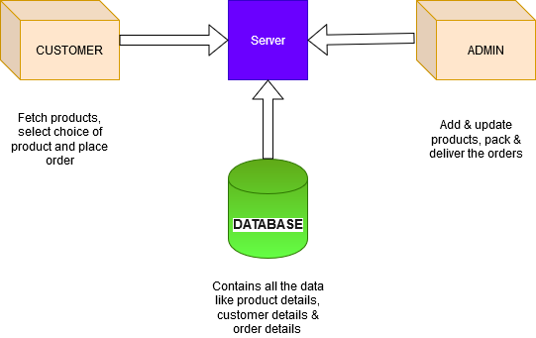Architecture Diagram:**

Fig. 1: Architecture diagram

**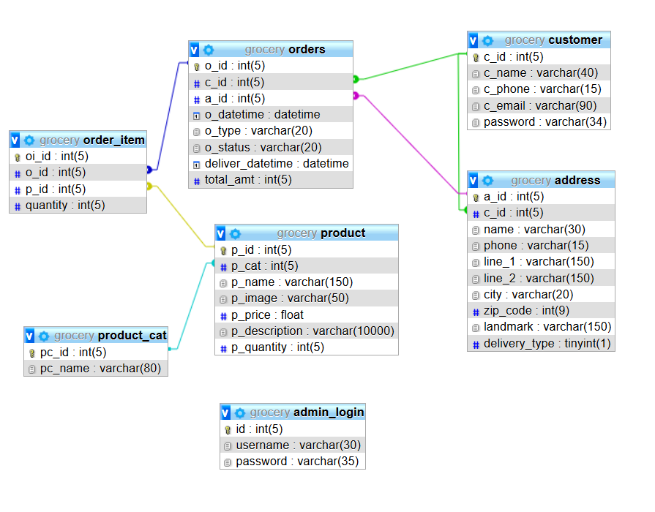Database schema design:**

Fig. 2: Database schema

1. 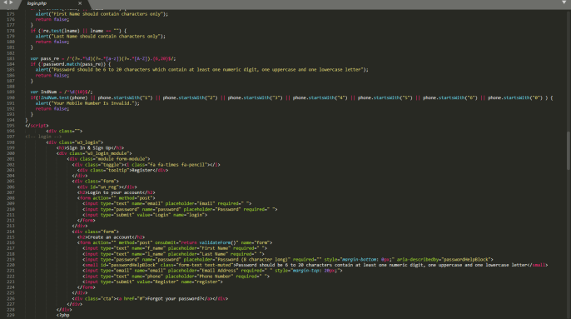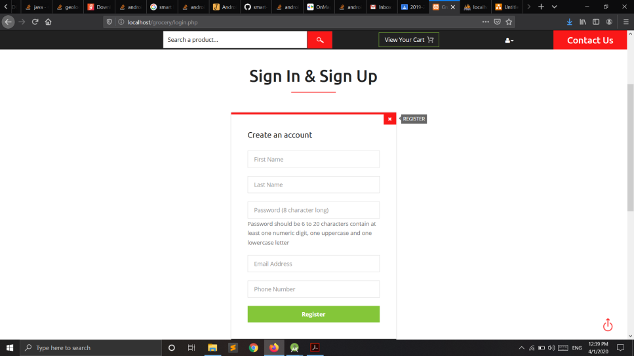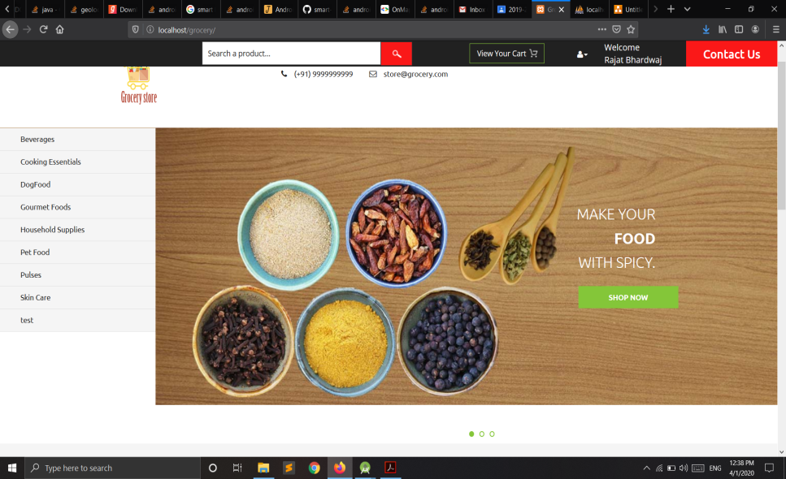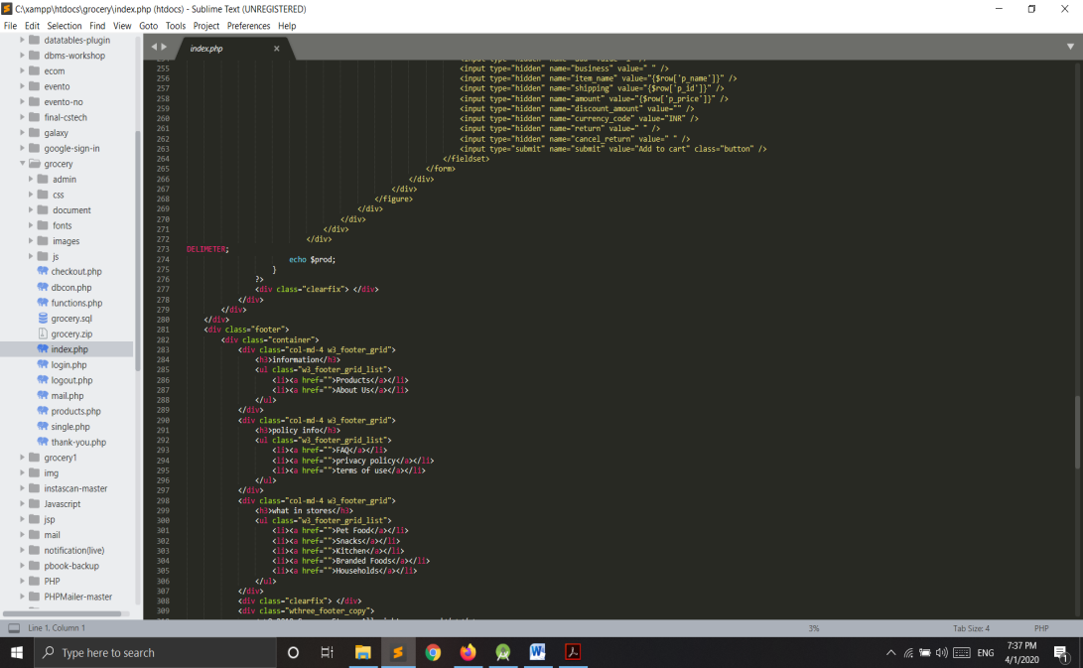Sprint Backlog-1  
    Fig. 3: Home Page UI

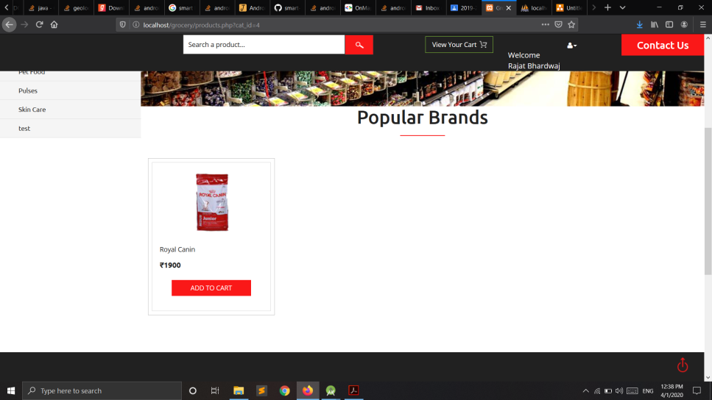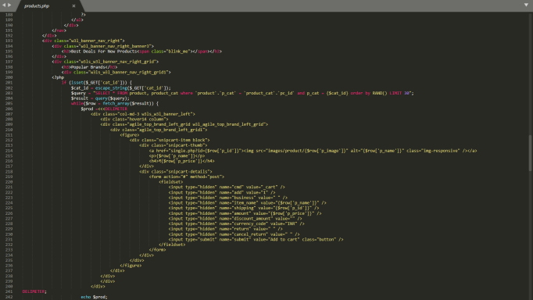 Fig. 4: Sign up page

Fig. 5: Product Page

1. 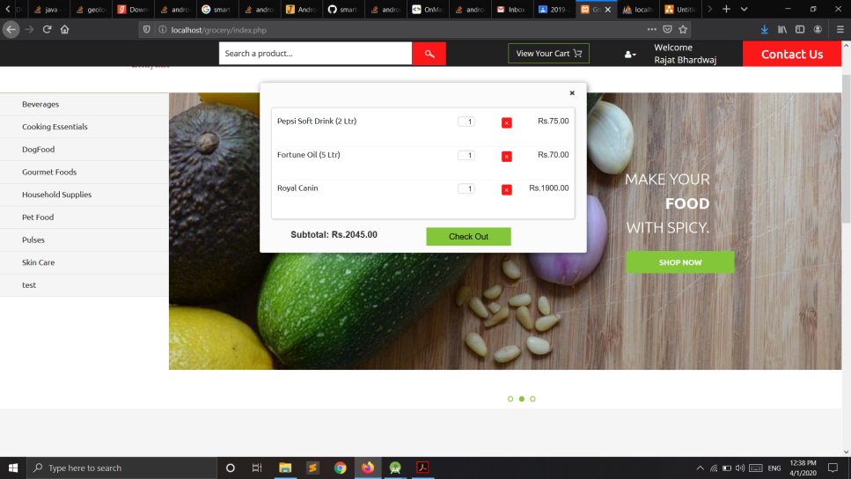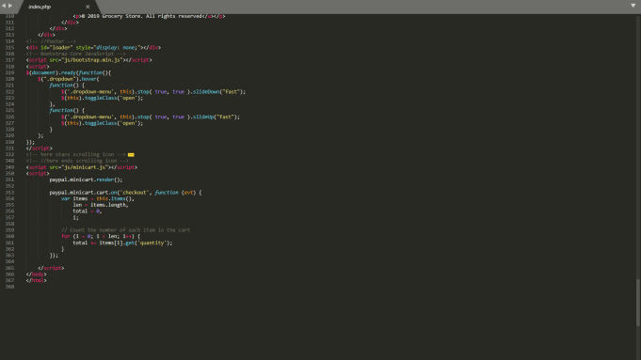Sprint Backlog-2  
    Fig. 6: Cart View

Fig. 7: Checkout Page 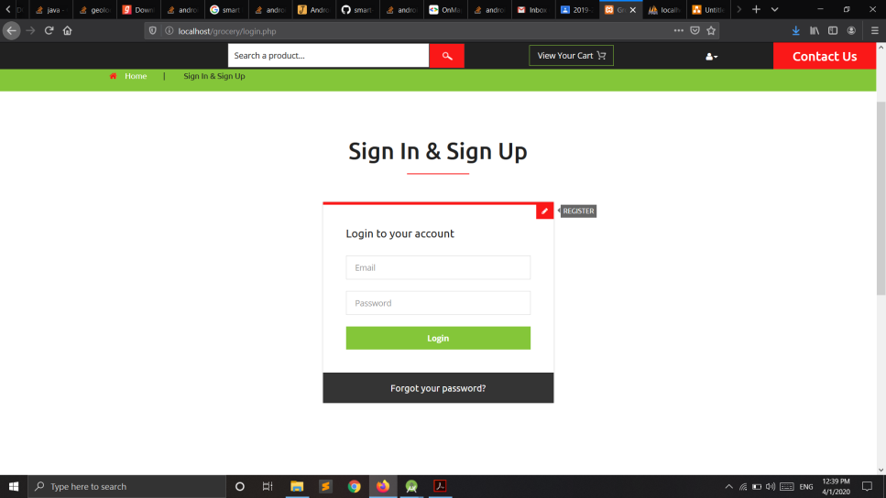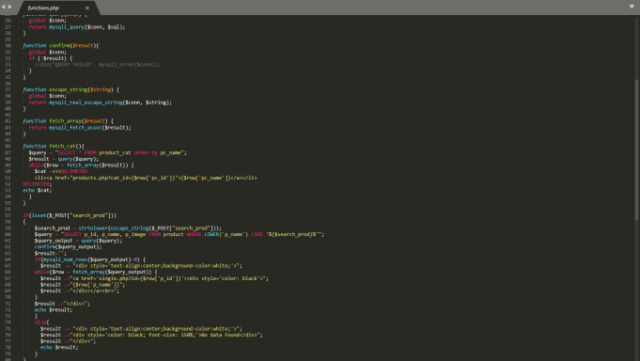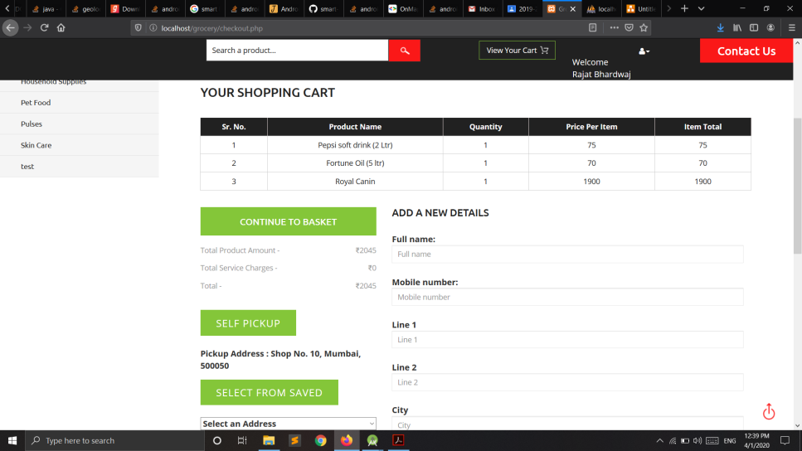

Fig. 8: Sign in page

1. 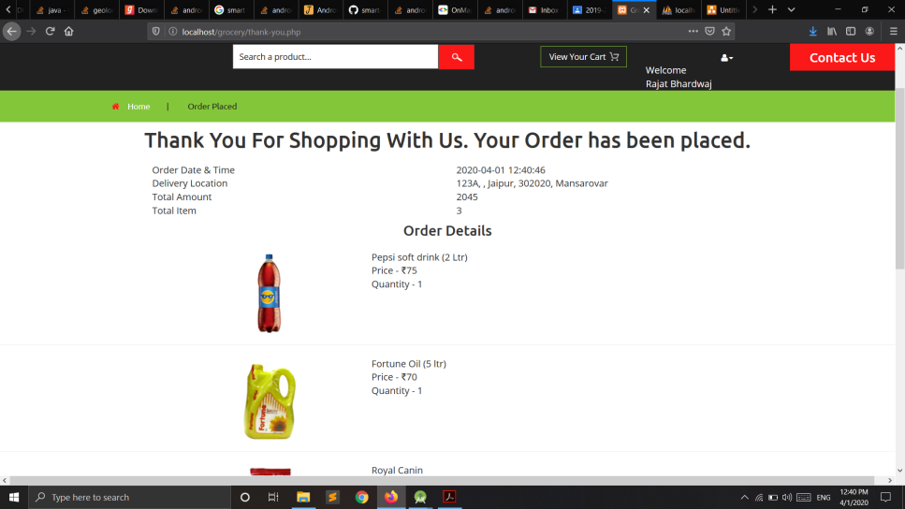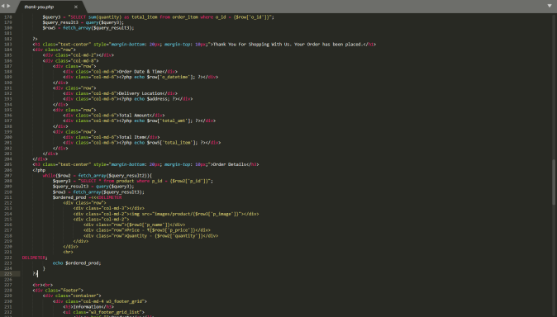Sprint Backlog-3

Fig. 9: Thank You Page 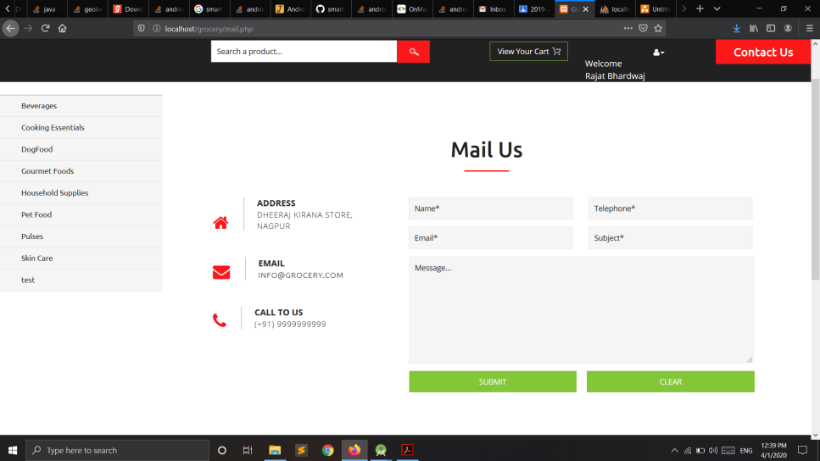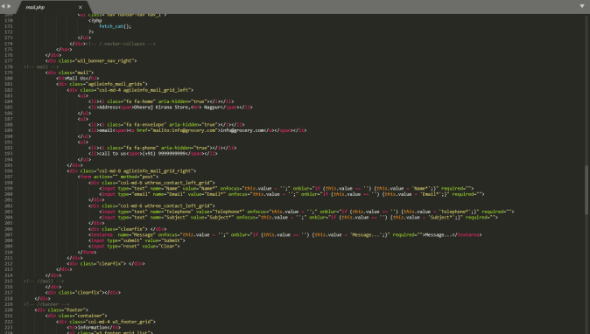

Fig. 10: Contact Us Page

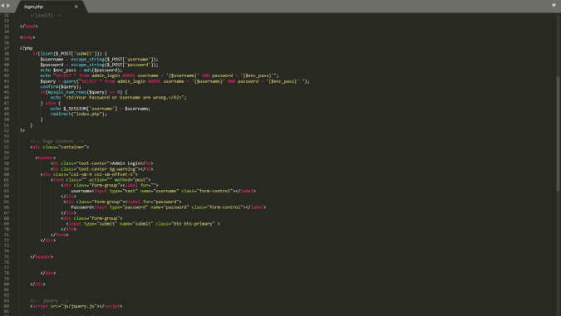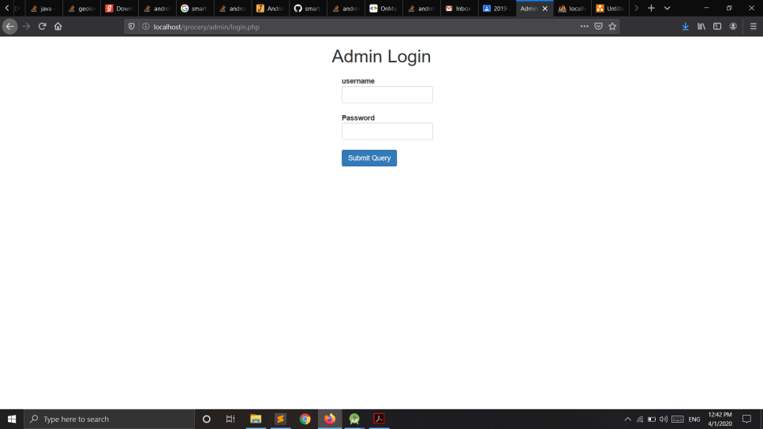

Fig. 11: Admin Login

1. 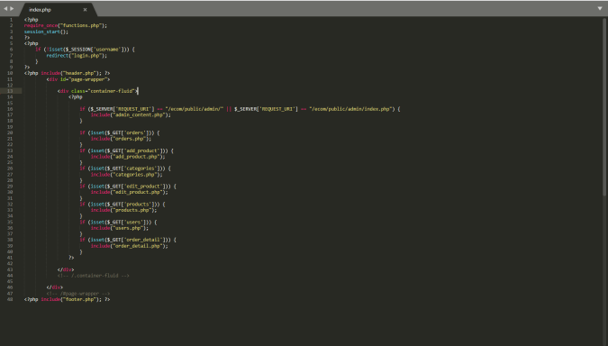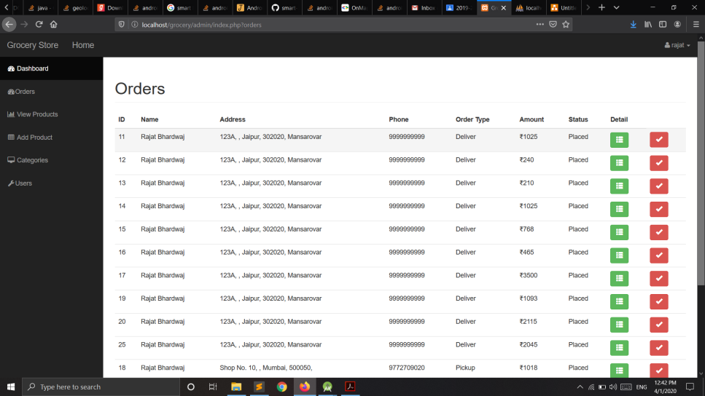Sprint Backlog-4  
    Fig. 12: Orders details

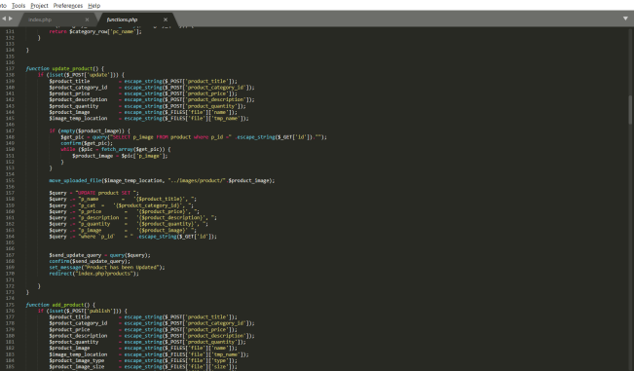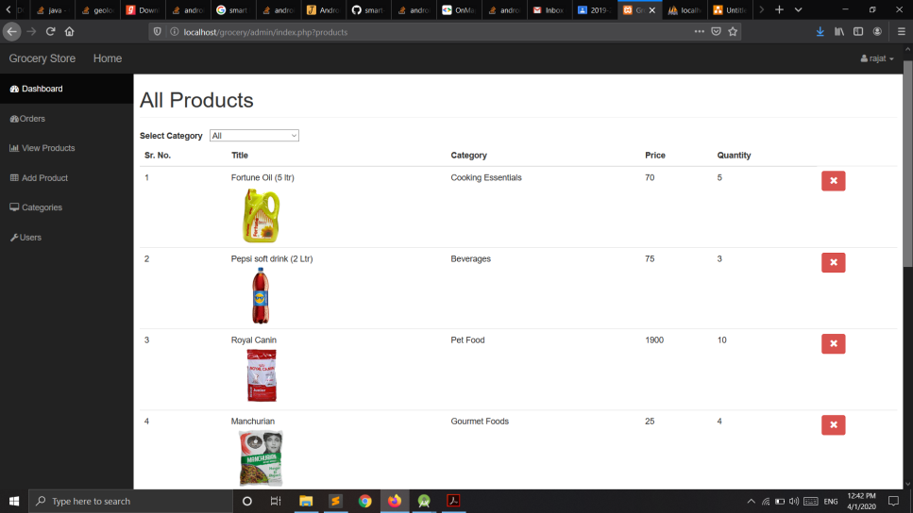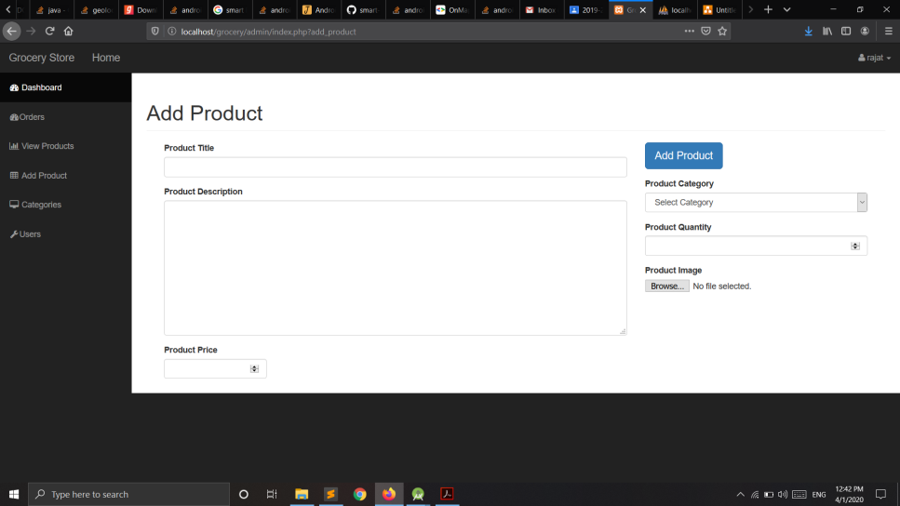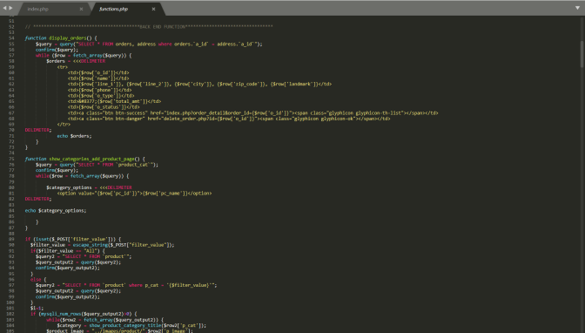  
 Fig. 13 Product details Admin View

Fig. 14: Add Product Admin View

**CHAPTER 7**

**RESULTS**

The online basic food item industry is one of the developing ventures in India. clients since they get access to the web all the more frequently and will in general purchase things online consistently like to shop from the brands in the online that give them the best client assistance and fulfillment among different brands that the significant explanation for buying food supplies online is sparing of time and exertion and there are no time limitations in shopping.

The desire for a client while purchasing staple goods on the web and in physical market is entirely unexpected. most of the respondents become more acquainted with about the brand from the Internet.

This chapter gives an end on how the venture has been coordinated. What has been accomplished during this venture and furthermore our own musings in building up the site. My own contemplations in how present improvement may shape the eventual fate of online shopping for food.

The essential point of this undertaking has been met. All the destinations that were set out have been finished and giving positive outcomes at last.

Albeit a few clients remark that they didn't think looking for staple goods online was perfect, it has figured out how to persuade them to attempt later on.

When understanding articles and taking a gander at sites it was found that online staple goods shopping sites needed intuitiveness to assist the shopper with imagining the nature of the nourishments, which made basic food item sites not a mainstream technique for shopping crisp nourishments.

**Future Scope:**

E-grocery is going on in India in a major way. The E-shopping will supplant conventional coming up shopping sooner rather than later. Despite the fact that the conventional shopping is still to remain yet the web based purchasing could change the manner in which individuals experience shopping basic food item. The examination is to distinguish whether individuals are evolving the manner in which they shop their nourishment and basic food item from the nearby Kirana store to online web stores. The examination is directed to uncover the purchaser's mentality on e-staple and their inclination towards the equivalent. This investigation will assist with seeing if e-basic food item will surpass the inclination of utilizing the conventional method for shopping also, increment the reaction of online shopping for food in future. There are various open doors for creative new administrations.