function [result K_plus] = sampleIBP(alpha, num_objects)

# **the parameter α influences how likely it is that multiple observations will share the same features**

result = zeros(num_objects, 1000);

**#Generate Poisson – alpha is a concentration parameter**

t = poissrnd(alpha);

result(1,1:t) = ones(1,t);

K_plus = t;

**#Loop through each object (row)**

for i=2:num_objects

**#Loop through each column**

for j=1:K_plus

**# Probability of getting the current dishes(Culinary Metaphor)**

**(not using Binomial-Beta process)**

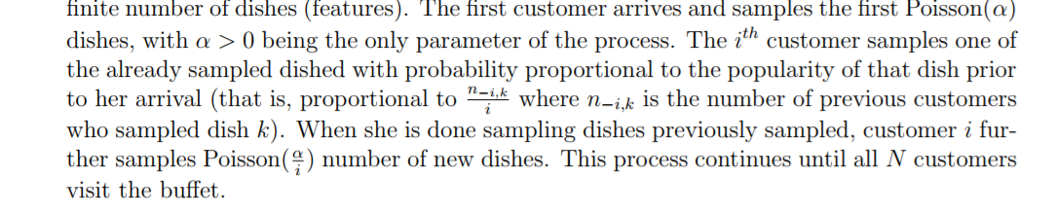

p(1) = log(sum(result(1:i,j)))-log(i);

p(2) = log(i - sum(result(1:i,j))) - log(i);

p = exp(p-max(p));

if rand < p(1)/sum(p)

result(i,j) = 1;

else

result(i,j) = 0;

end;

end;

**#New dishes**

t = poissrnd(alpha/i);

result(i,K_plus+1:K_plus+t) = ones(1,t);

K_plus = K_plus+t;

end;

result = result(:,1:K_plus);