% This is an implementation of the algorithm described in the Computational

% cognition cheat sheet titied "The Indian Buffet Process."

% Written by Ilker Yildirim, September 2012.

**##A is a coefficient matrix 🡪 X = ZA + error (Latent Feature Linear Gaussian) X = n*p Z = n*(K) A = K*p**

num_objects = 100;

object_dim = 36;

sigma_x_orig = .5;

**# Ignore above**

% The sampler

% Compute Harmonic number for N.

**#Harmonic function is part of the prior function (X)**

HN = 0;

for i=1:num_objects HN = HN + 1/i; end;

E = 1000;

BURN_IN = 0;

SAMPLE_SIZE = 1000;

#Graphical model of IBP

% Initialize the chain.

sigma_A = 1;

sigma_X = 1;

alpha = 1;

K_inf = 10;

**# Initiate prior (Z)**

[Z K_plus] = sampleIBP(alpha, num_objects);

**# More detail on sampleIBP**

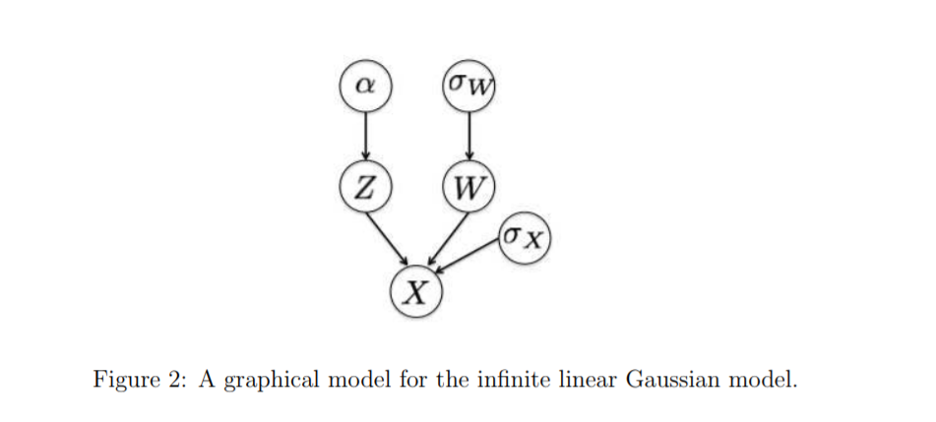

**#Store chain of Z K and alpha**

chain.Z = zeros(SAMPLE_SIZE,num_objects,K_inf);

chain.K = zeros(SAMPLE_SIZE, 1);

chain.sigma_X = zeros(SAMPLE_SIZE, 1);

chain.sigma_A = zeros(SAMPLE_SIZE, 1);

chain.alpha = zeros(SAMPLE_SIZE,1);

s_counter = 0;

**# LOOP each entry**

for e=1:E

% Store samples after the BURN-IN period.

if (e > BURN_IN)

s_counter = s_counter+1;

chain.Z(s_counter,:,1:K_plus) = Z(:,1:K_plus);

chain.K(s_counter) = K_plus;

chain.sigma_X(s_counter) = sigma_X;

chain.sigma_A(s_counter) = sigma_A;

chain.alpha(s_counter) = alpha;

end;

disp(['At iteration ', num2str(e), ': K_plus is ', num2str(K_plus), ', alpha is ', num2str(alpha)]);

for i=1:num_objects

% The matrix M will be handy for future likelihood and matrix

% inverse computations.

**M** = (Z(:,1:K_plus)'*Z(:,1:K_plus) + (sigma_X^2/sigma_A^2)*diag(ones(K_plus,1)))^-1;



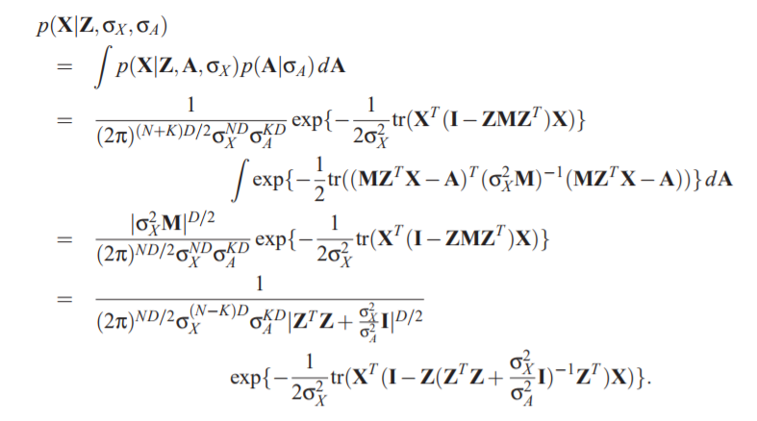

**K_Plus = TOTAL FEATURE**

for k=1:K_plus

% That can happen, since we may decrease K_plus inside.

if (k>K_plus)

break;

end;

if Z(i,k) > 0

% Take care of singular features

if sum(Z(:,k)) - Z(i,k) <= 0

Z(i,k) = 0;

Z(:,k:K_plus-1) = Z(:,k+1:K_plus);

K_plus = K_plus-1;

M = (Z(:,1:K_plus)'*Z(:,1:K_plus) + ...

(sigma_X^2/sigma_A^2)*diag(ones(K_plus,1)))^-1;

continue;

end;

end;

% This equations are for computing the inverse efficiently.

% It is an implementation of the trick from Griffiths and

% Ghahramani (2005; Equations 51 to 54).

M1 = calcInverse(Z(:,1:K_plus), M, i, k, 1);

M2 = calcInverse(Z(:,1:K_plus), M, i, k, 0);

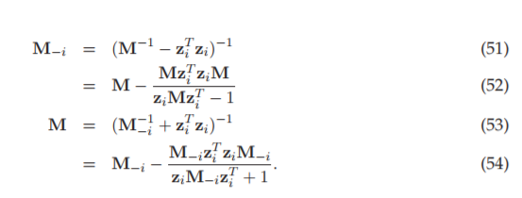

% Compute conditional distributions for the current cell in Z.

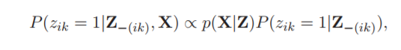

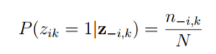

Z(i,k) = 1;

P(1) = likelihood(X, Z(:,1:K_plus), M1, sigma_A, sigma_X, K_plus, num_objects, ...

object_dim) + log(sum(Z(:,k))- Z(i,k)) -log(num_objects);

Z(i,k) = 0;

P(2) = likelihood(X, Z(:,1:K_plus), M2, sigma_A, sigma_X, K_plus, num_objects, ...

object_dim) + log(num_objects - sum(Z(:,k))) - log(num_objects);

P = exp(P - max(P));

% Sample from the conditional.

if rand < P(1)/(P(1)+P(2))

Z(i,k) = 1;

M = M1;

else

Z(i,k) = 0;

M = M2;

end;

end;

**% Sample the number of new dishes for the current object.**

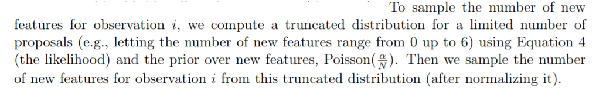

trun = zeros(1,5);

alpha_N = alpha / num_objects;

for k_i=0:4

Z(i,K_plus+1:K_plus+k_i) = 1;

M = (Z(:,1:K_plus+k_i)'*Z(:,1:K_plus+k_i) + (sigma_X^2/sigma_A^2)*diag(ones(K_plus+k_i,1)))^-1;

trun(k_i+1) = k_i*log(alpha_N) - alpha_N - log(factorial(k_i)) + ...

likelihood(X, Z(:,1:K_plus+k_i), M, sigma_A, sigma_X, K_plus+k_i, num_objects, object_dim);

end;

Z(i,K_plus+1:K_plus+4) = 0;

trun = exp(trun - max(trun));

trun = trun/sum(trun);

p = rand;

t = 0;

for k_i=0:4

t = t+trun(k_i+1);

if p < t

new_dishes = k_i;

break;

end;

end;

Z(i,K_plus+1:K_plus+new_dishes) = 1;

K_plus = K_plus + new_dishes;

end;

**% Metropolis steps for sampling sigma_X and sigma_A**

M = (Z(:,1:K_plus+new_dishes)'*Z(:,1:K_plus+new_dishes) + ...

(sigma_X^2/sigma_A^2)*diag(ones(K_plus+new_dishes,1)))^-1;

l_curr = likelihood(X, Z(:,1:K_plus+new_dishes), M, sigma_A, sigma_X, ...

K_plus+new_dishes, num_objects, object_dim);

if rand < .5

pr_sigma_X = sigma_X - rand/20;

else

pr_sigma_X = sigma_X + rand/20;

end;

M = (Z(:,1:K_plus+new_dishes)'*Z(:,1:K_plus+new_dishes) + ...

(pr_sigma_X^2/sigma_A^2)*diag(ones(K_plus+new_dishes,1)))^-1;

l_new_X = likelihood(X, Z(:,1:K_plus+new_dishes), M, sigma_A, pr_sigma_X, ...

K_plus+new_dishes, num_objects, object_dim);

acc_X = exp(min(0, l_new_X - l_curr));

if rand < .5

pr_sigma_A = sigma_A - rand/20;

else

pr_sigma_A = sigma_A + rand/20;

end;

M = (Z(:,1:K_plus+new_dishes)'*Z(:,1:K_plus+new_dishes) + ...

(sigma_X^2/pr_sigma_A^2)*diag(ones(K_plus+new_dishes,1)))^-1;

l_new_A = likelihood(X, Z(:,1:K_plus+new_dishes), M, pr_sigma_A, sigma_X, ...

K_plus+new_dishes, num_objects, object_dim);

acc_A = exp(min(0, l_new_A - l_curr));

if rand < acc_X

sigma_X = pr_sigma_X;

end;

if rand < acc_A

sigma_A = pr_sigma_A;

end;

% Sample alpha from its conditional posterior.

alpha = mygamrnd(1+K_plus, 1/(1+HN),1);

% Save the chain at every 1000th iteration.

if mod(e,1000) == 0

s = strcat('chain_ibp_',num2str(e));

save(s, 'chain');

end;

end;