**GUARDIAN HANDBOOK**

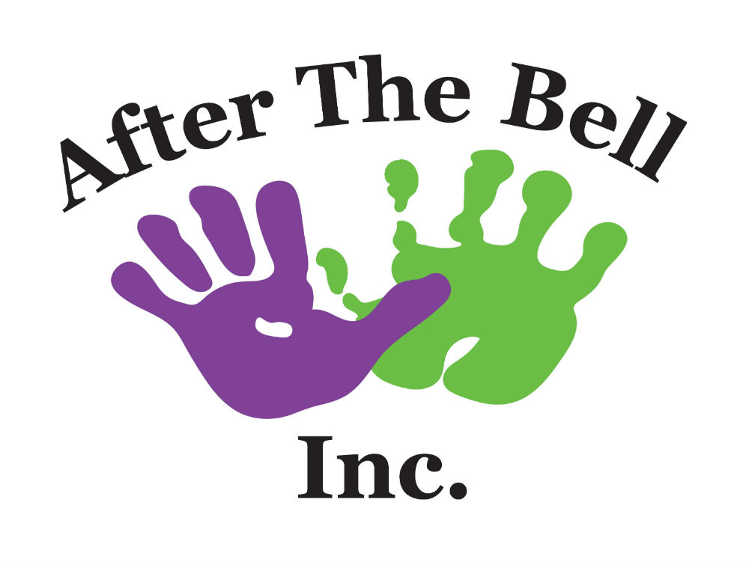

Last updated by Serena Cassell

Last updated date January 12, 2021

Table of Contents

Introduction 3

Philosophy 3

Mission Statement 3

Goals and Objectives 3

How After The Bell Inc. Operates 3

Non-School Days 4

Summer Program 4

Closure Dates 4

Arrival, Departure, and Release of Children 4

Attendance Records 4

Snacks 4

Cubbies 5

Clothing 5

Fire Drills and Emergency Evacuations 5

Transportation Policy 5

Unexpected Absenteeism 5

Medication Policy 5

Illness Policy 6

Breastfeeding Policy 6

Child Behaviour Guidance Policy 6

Staff Responsibilities 6

Fees, Subsidies & Withdrawal 6

Subsidy 7

Documents for Review 7

Registration Process 7

Feedback 7

Family Communication 8

Guardian Resources 9

# Introduction

Welcome to After The Bell Inc. This handbook was developed to provide guardians with an understanding of how the center operates. If you have any questions, comments or concerns please feel free to speak to any of the After The Bell Inc. employees.

After The Bell Inc. is dedicated to providing high quality childcare for children between the ages of 4-12 years. The team is led by the Program Owner.

# Philosophy

After The Bell Inc. believes that all children deserved to be cared for, respected and are entitled to a safe and healthy environment.

After The Bell Inc. also believes in open communication with guardians and community partners to create a better place for children.

Positive activities and interactions between the staff and children will encourage and educate the children about responsibility, honesty, fairness, compassion, and respect.

# Mission Statement

Building key assets in children today so that they turn into healthy and happy adults of tomorrow.

# Goals and Objectives

* To provide a safe and accepting environment for all children
* To recognize each child as an individual
* To provide care to any child regardless of sex, religion, or race
* To demonstrate appropriate behaviours
* To present fun and interesting activities for children
* To develop positive relationships with children, guardians, and community partners
* To offer children nutritionally balanced options

# How After The Bell Inc. Operates

Typical after school care daily schedule (Ages 4-12 years)

|  |  |
| --- | --- |
| **Time of Day** | **Activity** |
| 7:00 a.m. – 7:45 a.m. | Free time |
| 7:45 a.m. – 8:00 a.m. | Clean-up and get ready for school |
| 8:00 a.m. – 8:50 a.m. | Walk or bus to school |
| 3:00 p.m. – 4:00 p.m. | Wash hands and afternoon snack |
| 4:00 p.m. – 5:00 p.m. | Planned activities or homework |
| 5:00 p.m. – 6:00 p.m. | Free time and clean-up |

# Non-School Days

After The Bell Inc. provides care on non-school days. The staff will plan workshops, field trips, or arrange to have special guests visit the center on these days.

# Summer Program

An all-day program is offered during the summer months. An additional charge of $100 per month will apply to off-set the costs of staff, field trips, and transportation.

# Closure Dates

After The Bell Inc. is closed on the following statutory holidays:

|  |  |  |
| --- | --- | --- |
| **New Year’s Day** | **Canada Day** | **Remembrance Day** |
| **Good Friday** | **Labour Day** | **Christmas Day** |
| **Victoria Day** | **Thanksgiving Day** | **Boxing Day** |

Please note the center is closed in lieu for any statutory holidays that fall on a weekend.

The Program Owner will decide on all other closure dates.

# Arrival, Departure, and Release of Children

Center hours are 7:00 a.m. to 6:00 p.m. during regular school months and 7:00 a.m. to 5:30 p.m. during the summer months.

The Family Information Agreement Form has a list of personnel authorized to remove your child from the center. The staff are not permitted to release your child into the custody of any person who is not on this list. This policy is for the protection of your children.

Guardians who permit their child to walk home alone from school must provide the staff with written consent. After The Bell Inc. does not allow any child to walk home alone from the center under any circumstances.

# Attendance Records

The employees at After The Bell Inc. record the times each child is in attendance to the nearest 5 minutes. In addition, each staff has a list that is updated as children come and go to ensure that all children are accounted for at all times.

# Snacks

Every day the children are provided with a nutritious afternoon snack which consists of two of the four food groups identified by Health Canada and includes at least 1 serving of fruit or vegetables. The two week rotational menu is posted on the Information Board. Staff will provide a relaxing and enjoyable snack environment to ensure smooth play to meal transitions. Staff will encourage children to eat when they are hungry and stop when they are full by being aware of the children‘s hunger cues. No child will be forced to eat.

After The Bell Inc. only purchases and accepts donations of food or beverages from an establishment permitted by Department of Agriculture.

Lunches brought from home must be healthy and contain food from the four food groups.

# Cubbies

All children are given a personal cubby and hook to place their belongings. Please ensure you go through your child’s cubby every Friday to keep it clean and organized.

# Clothing

All children must have a pair of indoor and outdoor shoes for safety reasons. Keeping an additional set of clothes on premises is also recommended.

# Fire Drills and Emergency Evacuations

Every month an unannounced fire drill is conducted to prepare children for emergency evacuations. The children are guided to the nearest emergency exits and follow the planned procedures.

In the rare event that evacuation of the premises takes place our three relocation sites are as follows:

* **Cole Harbour:** Joseph Giles Elementary
* **Cole Harbour:** Cole Harbour Place
* **Cole Harbour**: Cole Harbour High School

Guardians will be contacted as soon as possible in the event of relocation.

# Transportation Policy

Children within walking distance to the center will be escorted to and from school. All other children will be transported in a 15 passenger van by a fully qualified transport provider.

# Unexpected Absenteeism

It is imperative that the staff are notified when children will be absent from the center. If your child does not show up after school we will contact you immediately. Failure to contact the center three times may result in immediate termination of care.

# Medication Policy

All staff are trained in First Aid Certification and may administer or supervise the self-administration of medication. In order for the staff to legally administer medication to your child, you must have the medication in its original container and have a medication form filled out. We only administer medication that is prescribed by a doctor.

The medication form must include specific directions such as time to be given, dosage to be given and the guardian’s signature. Guardian’s must update this form a minimum of once per month for ongoing medications.

# Illness Policy

If your child becomes ill, you will have to find alternate childcare. This policy aims to reduce the spread of illness to other children and staff.

Alternate childcare arrangements must be made if your child has or experiences any of the following:

* temperature over 38° celsius
* vomiting or diarrhea
* lethargy
* an undiagnosed rash or discoloration of the eyes
* persistent pain
* is not well enough to attend school
* a communicable disease

# Breastfeeding Policy

After The Bell Inc welcomes all mothers to comfortably breastfeed their children in our facility.

# Child Behaviour Guidance Policy

Children are encouraged to make appropriate choices while at After The Bell Inc. Please read and sign the Child Behaviour Guidance Policy Form included in the registration package. In addition to this policy all staff are trained on After The Bell Inc.’s child guidance policy and annual reviews occur with each staff member.

# Staff Responsibilities

After The Bell Inc employees must behave in a manner that does not harm any child who is attending After The Bell Inc, and in particular, must not do or permit any of the following:

* Corporal Punishment (striking a child directly or with any physical object; shaking; shoving; spanking; or any other form of aggressive physical contact)
* Requiring a child to repeat physical movements
* Using harsh, humiliating, belittling, or degrading responses in verbal, emotional, physical, or any other form.
* Confining or isolating a child.
* Depriving a child of basic needs, including food, shelter, clothing, or bedding.

# Fees, Subsidies & Withdrawal

All fees are due and payable by cheque to After The Bell Inc. on the first day of each month and a late charge or $1/day applies. We accept personal cheques, cash, and money orders. A $100 deposit is required at the time of your child’s registration that will count towards your first months’ fees.

Guardians will be notified one month in advance of fee increases.

Guardians must provide one month’s written notice if terminating care. After The Bell Inc. reserves the right to collect fees owing for the month.

# Subsidy

After The Bell Inc. has no influence in determining your eligibility for subsidy. Should you need this financial assistance, you will have to apply to the Provincial authorities. Please speak to the Program Owner for the appropriate application forms.

# Documents for Review

An Information Board is found in the main lobby of our center which includes the list of documents that are to be posted for all guardians to review as per the Nova Scotia Day Care Act & Regulations. They include, but are not limited to, a copy of The Day Care Act & Regulations, Guardian Handbook, License to Operate, most recent inspection report, behaviour policy, snack menu, program plan and routine, current members of the Parent Committee, most recent Parent Committee meeting minutes, and notification of funding provided by the Minister.

# Registration Process

All guardians who wish to register their child must complete a Registration Package.

# Feedback

Please direct any questions, comments or concerns to the Program Staff. If your feedback is not adequately addressed, please contact the Program Owner by phone (404-5437) or e-mail ([mandy.fahie@bellaliant.net](mailto:mandy.fahie@bellaliant.net))

# Family Communication

## Registration Process

1. To register with After The Bell Inc. please visit our **website at afterthebell.ca**. At the top of the page select the enrollment tab and click on the PDF form Registration Package. Print off this form and fill it out in its entirety, missing information will delay your child’s start date. This includes but not limited to Immunization Records.

1. Submit the completed forms in person at the centre **– 320 Flying Cloud Drive** (main single door facing parkway) between 2pm and 5pm, Monday to Friday OR email completed forms to **afterthebell06@gmail.com**

## Social Media and Contact Information

1. Our Facebook page is a private group. Please search for **After The Bell Guardian Information Group**. Once you find the group, add group. You will be required to answer several questions to prove you are a guardian of a child at ATB.

1. Emails can be sent to afterthebell06@gmail.com

1. Phone calls can be made to the landline at (902)404-5437. Mandy’s cell is also available for other concerns at (902)579-5437.

## Guardians Who Wish to Volunteer

1. Guardians who wish to volunteer or share talents / cultural experiences are welcome. Prior to either you must have a Child Abuse Registry and a Vulnerable Sector Check. You can find both online in a google search.

1. Parent Committee welcomes all applications for new members.

# Guardian Resources

## Nova Scotia Early Childhood Development Services – Head Office

NS Department of Community Services

Nelson Place - 5675 Spring Garden Road

Halifax, Nova Scotia B3J 1H1

**Mailing Address**

NS Department of Community Services

P. O. Box 696

Halifax, Nova Scotia B3J 2T7

## Children’s Aid Society of Halifax

6009 Quinpool Road - 4th Floor Willow Tree Tower

Halifax, Nova Scotia, B3K 5J7

Phone: (902) 425-5420

Fax: (902) 422-9424

## Halifax Regional School Board

90 Alderney Drive

Dartmouth, Nova Scotia B2Y 4S8

Tel: (902) 464-2000

Website: <http://www.hrsb.ns.ca/>

## Nova Scotia Child Safety and Injury Prevention Program

IWK Grace Health Center - 5850 University Ave, PO Box 3070

Halifax, Nova Scotia B3J 3G9

Telephone: (902) 420-6492

Fax: (902) 420-6774

Email: bbruce@iwkgrace.ns.ca

## Nova Scotia Department of Education

Nova Scotia Department of Education and Early Childhood Development

2021 Brunswick Street, P.O. Box 578

Halifax, Nova Scotia B3J 2S9

Telephone: (902) 424-5168

Toll Free: 1-888-825-7770

Fax: (902) 424-0511

Website: <https://www.ednet.ns.ca/>