Sexual Violence in the United States

Serena Lee
Department of Government & Politics, University of Maryland
GVPT 628: Advanced Topics in Coding for Political Analysis
Professor Lund
December 16, 2025

Abstract
Sexual violence is a pressing issue in the United States, yet a difficult topic to conduct research on given its sensitive, personal nature. According to the CDC (2017), one in two women and one in five men have experienced some form of unwanted sexual contact in their lives, and many others have experienced verbal sexual harassment. In this study, I aim to conduct a time-series analysis on sexual violence in the United States from 1992-2024 using the data from National Crime Victimization Survey (NCVS). My findings indicate while incidents of sexual violence have increased since 2009, a smaller proportion of these incidents have been reported to the police. Most who do report the incident to the police cite protecting others as their primary reason, and most who do not report cite that the incident was not something to be handled by the police. This indicates a need for non-police support for victims of sexual violence. Finally, I employ a model that uses World Bank indicators to predict the number of sexual violence incidents in a given year, though its application for policy options is limited.

I. Introduction
Sexual violence is a pressing issue in the United States, yet a difficult topic to conduct research on given its sensitive, personal nature. The two main goals of sexual violence research are prevention and care: how can we prevent sexual violence, and how can we care for its victims? According to the National Sexual Violence Resource Center, 81% of women have reported experiencing some form of sexual harassment and/or assault in their lifetime (NSVRC, 2025). The majority of cases are not reported to the police for many different reasons, including fear of repercussions, protecting the offender, or simply being unsure if the unwanted behavior “counts” as sexual violence. To try and quantify sexual violence in the U.S., the CDC hosts the National Intimate Partner and Sexual Violence Survey (NISVS) once per year. While sexual violence primarily targets women, many men have experienced it as well. According to the 2016-2017 NISVS, one in two women and one in five men have experienced some form of unwanted sexual contact in their lives, and one in four women compared to one in twenty-six men have experienced rape (Basile et.al., 2022). Most criminal reports show the perpetrator as a stranger; however, population surveys indicate the perpetrator is much more likely to be someone the victim knows like a romantic partner, family member, friend, or acquaintance (Tavera, 2006).

II. Methods
In this study, I aim to conduct a time series analysis of sexual violence in the United States from 1992-2024 using the data from the National Crime Victimization Survey (NCVS) in those years. The NCVS is a yearly survey given to a nationally representative sample of about 240,000 people in 150,000 households and collects data on interpersonal and property crimes. It provides data at the incident, household, and individual levels; for the purposes of this study, I use incident level data. For my analysis, one year of data includes only incidents that occurred within that calendar year. For each incident, NCVS provides information on the offender, details of the crime/incident, whether it was reported, and the victim’s experience with the justice system. I chose to use this data for a variety of reasons, including its objectivity of sexual violence as a crime and its ability to compare sexual violence incidents against a variety of crimes.
In this report, I provide visualizations of the distribution of NCVS among a variety of factors (Section III) before moving on to a brief time-series analysis of these variables (Section IV). Next, I focus on reporting statistics in comparison to other common crimes (Section V) before employing a leave-one-out cross validation (LOOCV) model that predicts yearly frequencies of sexual violence incidents using World Bank indicators (Section VI).

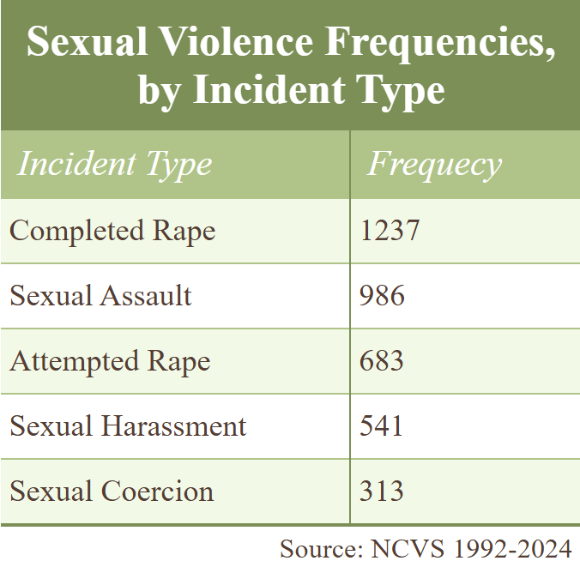
III. Distribution
Table 1
Of the 329,678 incidents captured by the NCVS from 1992 to 2024, 3,760 of these were sexual violence, which consists of rape (completed or attempted), sexual assault, sexual harassment (verbal), and sexual coercion (unwanted sexual contact without force). Of sexual violence incidents, most were rape or assault, while accounts of harassment or coercion were less so (Table 1). This distribution of incident types is likely impacted by the limitations of population surveys as discussed earlier; many victims of sexual harassment or sexual coercion feel unsure if a crime has occurred, or even certain it has not. For example, marital rape is often in a form of sexual coercion, where a woman willingly engages in unwanted sexual activity because she believes it is her duty to please her husband (Tavara, 2006). Given cases similar to these, sexual coercion is likely underreported on population surveys in comparison to more overt, violent crimes, like rape or sexual assault. While women accounted for just a little over half of total respondents, women were the target of 89% of sexual violence incidents captured by the NCVS.

III.I Race
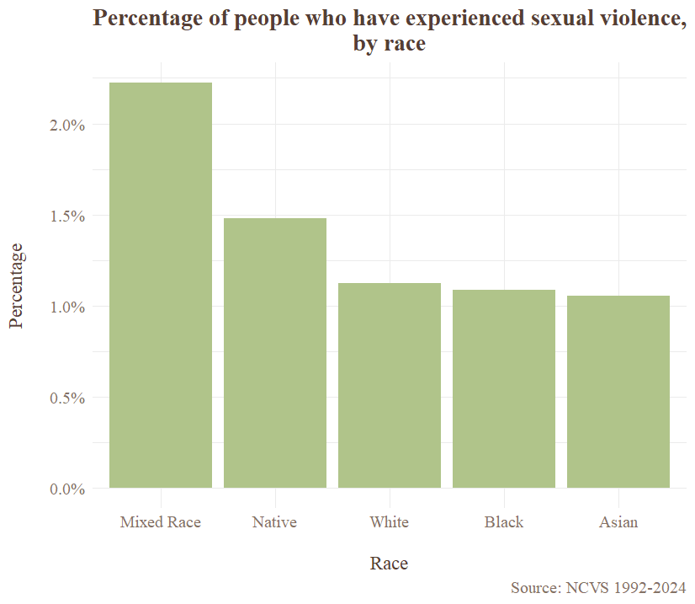
Race has an impact on the likelihood of a person experiencing sexual violence. Most research suggests minorities are disproportionately targeted by sexual violence offenders. Looking at Figure 1, the most likely candidates for sexual violence are mixed-race and native (Native American/ Alaska Native) populations; however, the NCVS only started allowing respondents to select a mixed-race option after the survey question was redesigned in 2003. This indicates mixed-race respondents from 1992-2002 are mislabeled as one of the other race categories, potentially skewing these results.
Figure 1

III.II Age
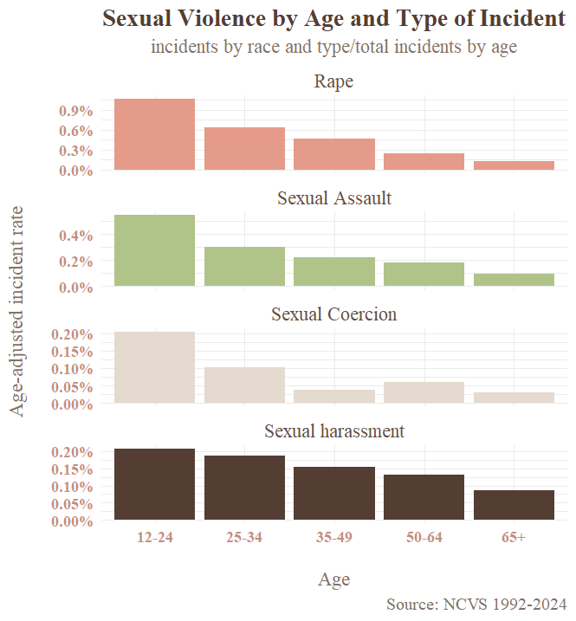
Age is one of the most important factors affecting sexual violence levels. The 2016-2017 NCVIS found more than 80% of female rape victims that were raped for the first time were under age 25, and around half were minors (Basile et. al., 2022). In general, risk of sexual violence decreases after age 25.
Figure 2
This basic notion is supported by my analysis of the NCVS (Figure 2). Separated by incident type, sexual coercion has the strongest negative correlation with age. This makes intuitive sense, given younger populations are more vulnerable to power imbalances, which increases the risk of agreeing to unwanted sexual activity through coercive means. Sexual harassment deviates from the common pattern, with levels still decreasing as age increases but at a much slower rate, remaining relatively steady up to age 50. Physical occurrences of sexual violence (rape and assault) are much more concentrated in the under 25 age group.

IV. Time-Series Analysis
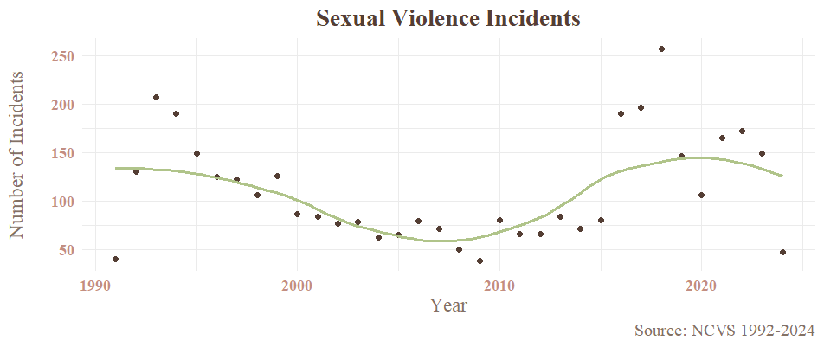
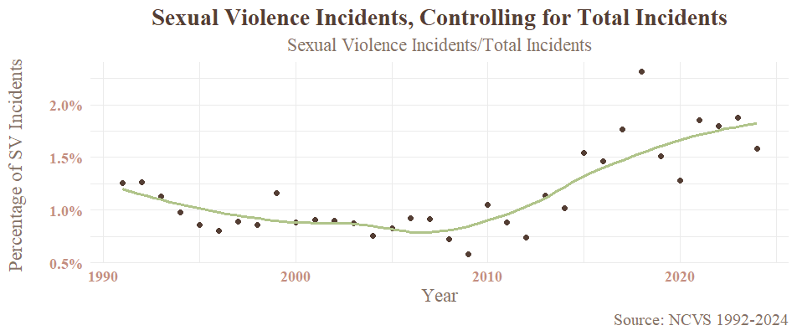
One advantage of the NCVS is the survey questions have remained detailed and consistent over the years, making it an excellent candidate for a time series analysis. Looking at the first graph in Figure 3, reports of incidents of sexual violence decrease until around 2009. Post 2009, cases increase, though the relationship is weaker and tapers off post 2020. A slightly different measure of sexual violence over time is the proportion of sexual violence incidents of total incidents over time. This accounts for odd variations in specific years, such as the decrease in personal and property crimes seen in 2020 due to covid, though does add some complexity for interpretation. This relationship, depicted in the second graph of Figure 3, is tighter than the raw frequencies: a decrease until 2009 followed by a steady increase through 2021.
Figure 3
Both measures are in agreement; since the 2010’s, cases of sexual violence picked up by the NCVS are increasing. This could be indicative of two main reasons: either there are truly more cases of sexual violence occurring or more people are willing to disclose their experiences of sexual violence as the stigma lessens over time. Regardless, there is no evidence that any measures to counter sexual violence have been incredibly effective given the rising number of cases seen in the NCVS.
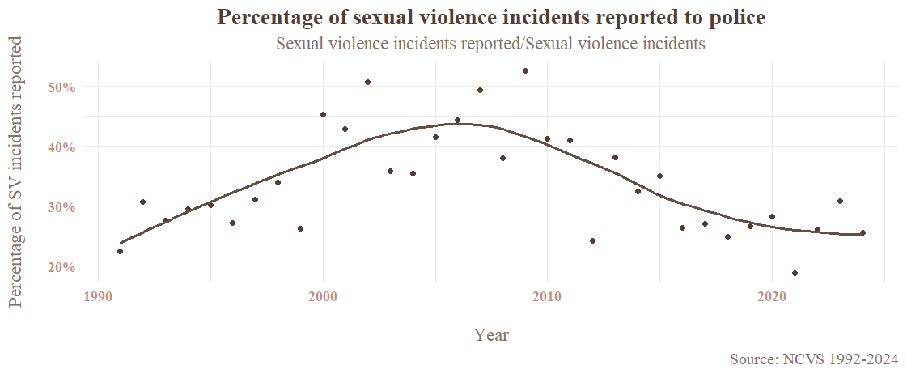
In the next section (Section V), I dive into the phenomenon of non-reporting among sexual violence victims. Despite efforts to decrease the stigma around sexual violence, the percentage of cases reported to the police have actually decreased in recent years (Figure 4). Understanding why sexual violence is reported at lower rates than most crimes is crucial to the goal of learning how to provide care for victims of sexual violence.
Figure 4

V. Reporting
Only 31% (1177/3760) of incidents of sexual violence in the NCVS were reported to the police. This is consistent with other surveys that estimate around a third of cases are not reported (NSVRC, 2025). These are conservative estimates given even population surveys miss cases of sexual violence for one reason or another, as discussed in Section I. Additionally, victims of crimes in general (sexual violence or not) under 25 are the least likely to report the crime to the police.
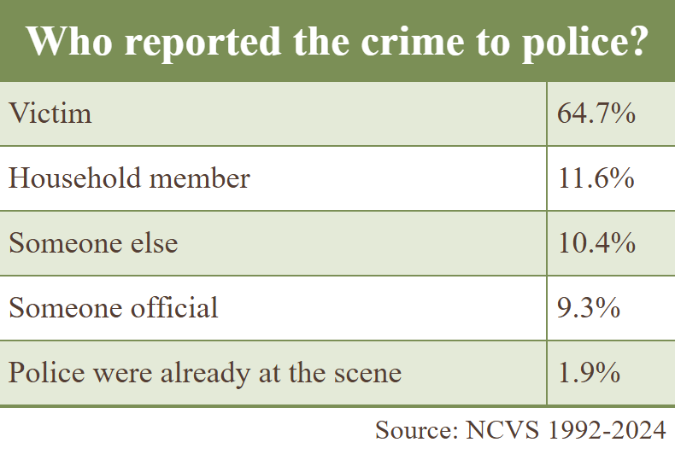
While the majority of the time the victim themself is the one to report the incident to the police, around three out of ten cases are reported to the police by someone else (Table 2). This is important to keep in mind when looking at why people report sexual violence to the police; it is not always the victim themselves in question.
Table 2
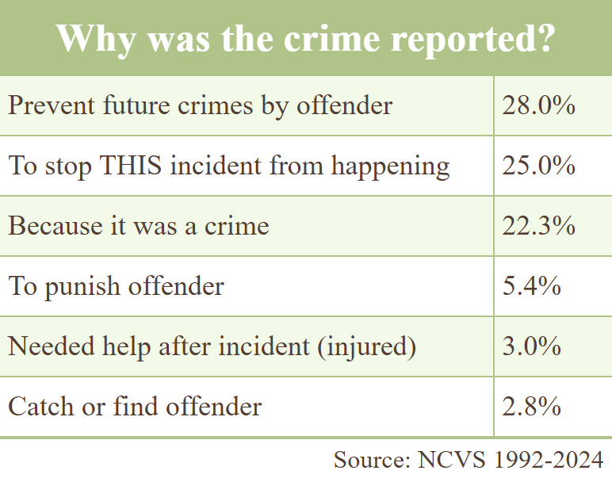
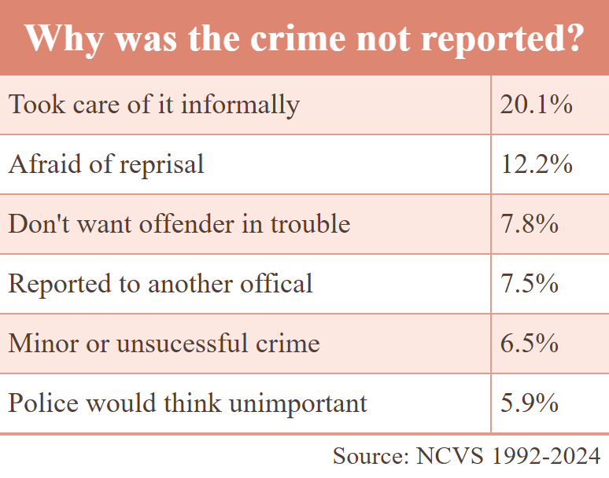
Many people who report cases of sexual violence to the police often cite their primary reason for reporting as being for the good of others rather than themselves; 28% of respondents said they reported it to prevent the offender from committing future crimes, whether that be family members or others (Table 3). Less so are reasons such as asking for help or finding the offender, the latter of which is likely due to the fact that most victims are at minimum acquainted with the offender before the incident occurs. Top reasons for why respondents do not report cases of sexual violence are primarily indications that the incident is not thought to be police business: taking care of it informally, reported to another official, minor or unsuccessful crime, or police would think it unimportant together make up almost 45% of respondent answers. Other reasons are fear of reprisal and not wanting offenders in trouble, the latter indicative of cases where the offender is close to the victim.
Table 3
Table 4
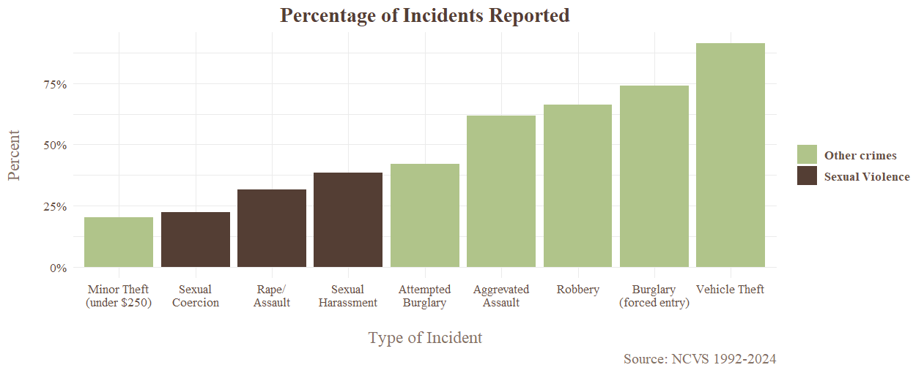
How does reporting of sexual violence differ from other common crimes? Other than minor crimes such as low-value theft, most crimes are reported at much higher rates (Figure 5). The most reported crime is motor vehicle theft at a whopping 91% (I sure would want some help if someone stole my car). Other often violent crimes such as aggravated assault, robbery, and burglary are reported in over twice as many cases than rape and sexual assault.
Figure 5
Counter to the hypothesis that people are less likely to report less severe cases of sexual violence, sexual harassment (verbal threat of sexual assault) is reported at a higher rate than rape and sexual assault. Combined with the finding in Section III that finds sexual harassment at higher rates in older adults than other forms of sexual violence, it is plausible that young people facing sexual violence are less likely to report to the police. However, sexual coercion rates do fit with this line of reasoning, sitting as the least reported form of sexual violence. Sexual coercion typically happens with an offender that the victim doesn’t want to get in trouble with the law or holds power over the victim, which are two of the most common reasons victims do not report.

VI. Predictive Model
While victimology and understanding reporting habits can help tackle the question of how to help sexual violence survivors, that leaves the question of how to prevent sexual violence. To understand the conditions that might encourage higher volumes of sexual violence, I employed a leave-one-out cross validation (LOOCV) model using year-aggregated data from World Bank indicators using their Application Programing Interface (API) to request data to combine with the NCVS data. I used data from the years 1992-2023 (2024 indicators are unavailable at this time). The indicators I chose were basic economic and social indicators: average population density, the Consumer Price Index (CPI, a measure of inflation), % of the population using the internet, and GDP per capita (a measure of growth and average wellbeing). The LOOCV model works by predicting number of incidents of sexual violence one target year at a time based on correlations between my indicators and sexual violence in every other year besides the target year. The results of the model are displayed in Figure 6.
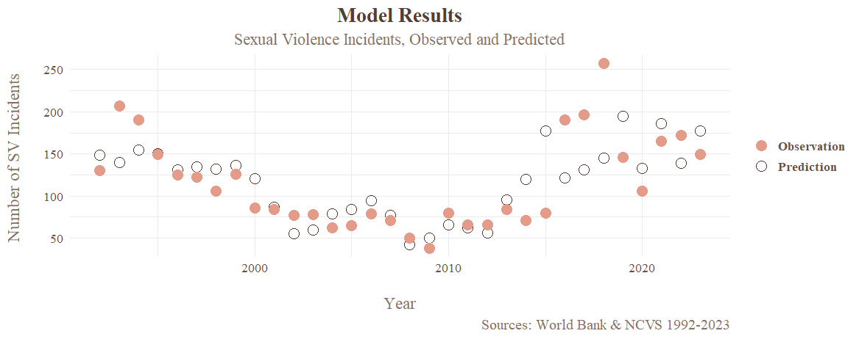
Overall, as a predictive tool the model does moderately well. It has an R-Squared value of 0.4628, indicating 46.28% of the variation in sexual violence incident frequencies can be explained by my four indicators of choice. Analyzing Figure 6 reveals the model does a much better job at predicting the relationship before 2014 and performs worse in recent years.
Figure 6
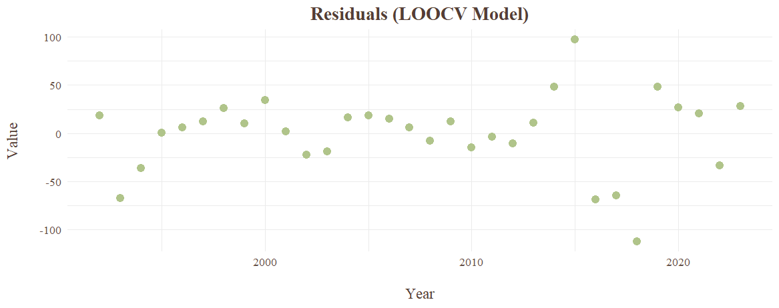
Figure 7 shows this phenomenon more clearly, with the residuals (the distance from observation to prediction) increasing in the latter years. This is troubling for the future of this particular model, indicating these predictors are less likely to be successful in future years given the overall increasing variance of sexual violence incidents since 2009.
Figure 7
The main question posed from this model is which indicators are correlated with increased sexual violence, and which are correlated with decreases? Taking a simple regression model using these same indicators, we find sexual violence has a positive correlation with population density and GDP per capita and a negative correlation with the CPI and internet usage. More dense populations tend to have more crimes, and it is possible that increased internet usage suggests a better-informed population of whom spend less time socializing in-person (thus less likely to experience personal crimes). A potential issue with this model is all indicators have their own relationship with time itself, which may weaken the effect of these indicators. Further tests to discover different indicators that do a better job predicting more recent frequencies of sexual violence would be more fruitful in finding ways to decrease levels of sexual violence in future years.

VII. Conclusions
According to my analysis of the National Crime Victimization Survey, incidents of sexual violence are increasing while the percentage of cases reported is decreasing. The younger population, who are least likely to report crimes in general, are targeted the most frequently in sexual violence cases, in particular sexual coercion. Schools should begin or continue to implement policies to educate the youth on the dangers of sexual violence, as well as educate students about consent to tackle sexual coercion. One exception to the age trend is sexual harassment, for which older adults are almost as vulnerable as the younger population. Since sexual harassment occurs at all ages, this issue cannot be left up to schools. Workplaces must take cases of sexual violence seriously and double down on prevention efforts.
Finally, victims of sexual violence need care, which may or may not come from the police. To increase reporting cases to the police, educating on the importance of reporting to protect other people may convince more victims to speak up against the offender. Also, victims need assurance of protection from the alleged perpetrator, regardless of if the perpetrator goes to court or gets convicted, in order to make sure victims do not fear reprisal. It is clear that many people do not feel comfortable reporting these incidents to the police or feel that their experience is not a police matter. Shifting the focus from reporting to the police to non-police care by supporting services that provide protection, therapy, and other forms of care to victims could be a way to reach victims that do not wish to deal directly with the legal system.

VII. References
Basile, K.C., Smith, S.G., Kresnow, M., Khatiwada, S., & Leemis R.W. (2022) The National Intimate Partner and Sexual Violence Survey: 2016/2017 Report on Sexual Violence. National Center for Injury Prevention and Control, Centers for Disease Control and Prevention. https://www.cdc.gov/nisvs/documentation/index.html
NSVRC- National Sexual Violence Resource Center. (2025). Statistics. U.S. Department of Health and Human Services. https://www.nsvrc.org/statistics/
Tavara, L. (2006). Sexual violence. Best Practice & Research Clinical Obstetrics & Gynaecology 20(3), 395-408. https://doi.org/10.1016/j.bpobgyn.2006.01.011.
United States Bureau of Justice Statistics (2025, September 29). National Crime Victimization Survey, Concatenated File, Legacy Version, [United States], 1992-2024 (ICPSR 39273; V1). [Data series and codebook]. ICPSR. https://doi.org/10.3886/ICPSR39273.v1

