## Chapter 1 - Introduction

### 1.1 Introduction to ANN Technology

＊Conventional computers > Human:

1. Scientific and mathematical computation
2. Creation and manipulation (操作) of databases
3. Control fuctions
4. Graphics
5. Word processing

106-2 第1題 (a) Give 3 example tasks that conventional computers outperform the human brain.

**Answer:** as above，選3個

＊Human > Conventional computers:

Learn, Analyze, Organize, Adapt, Comprehend, Associate, Recognize, Plan, Decide

考古： 106-2 第1題 (b) Give 3 example tasks that the human brain outperforms conventional computers.

**Answer:** as above，選3個

### 1.2 Neurophysiology

＊Three major components constructing the human nervous system:

1. Brain: multipolar
2. Spinal cord (脊隨神經): bipolar, multipolar
3. Periphery (周圍): unipolar, bipolar

106-2 第2題 (a) Three characteristcs of biological nervous systems:

1. Brain
2. Spinal cord
3. Periphery

註：這題不知道為啥這幾個答案被扣1分

106-2 第2題 (b) Three characteristics of artificial neural networks:

1. Dynamics
2. Adaptivity
3. Fault-tolerance

106-2 第2題 (c) Three basic functions of artificial neural networks:

1. Analyze
2. Learn
3. Feedback

##### ＊Single-neurons physiology’s three types of neurons:

1. Unipolar (單極): 末梢神經感覺器官
2. Bipolar (雙極): 聯絡神經脊隨
3. Multipolar (多極): 中樞神經腦

106-2 第3題 There are three major types of neurons. What are the types? Address their functions.

**Answer:** as above，記得寫功能

##### ＊Synaptic Function

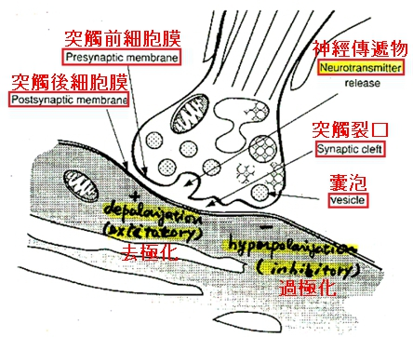

註: 去極化 (興奮)、過極化 (抑制)

106-2 第5題 Draw a figure to illustrate the synaptic function between two neurons.

**Answer: (**上方圖的簡化版)



### 1.3 Artificial Neural Networks

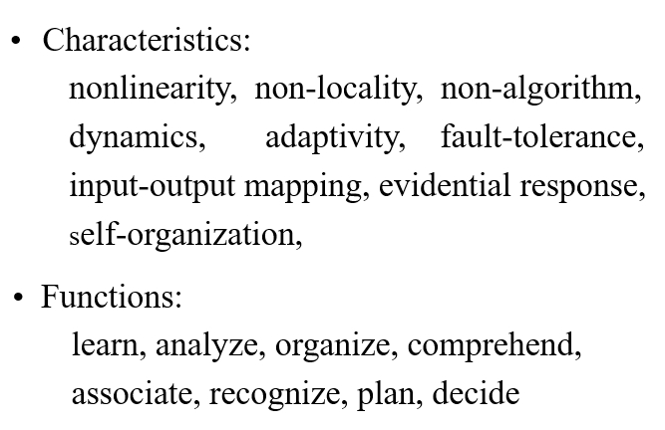

106-2 第2題 (a)(b) [在文件第1頁]

##### ＊XOR problem

106-2 第13題 Figure (a) shows a perceptron and figure (b) shows a truth table of the XOR problem. Illustrate graphically why the XOR problem cannot be solved by the perceptron.

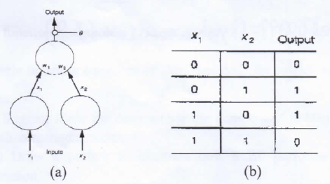

**Answer:**

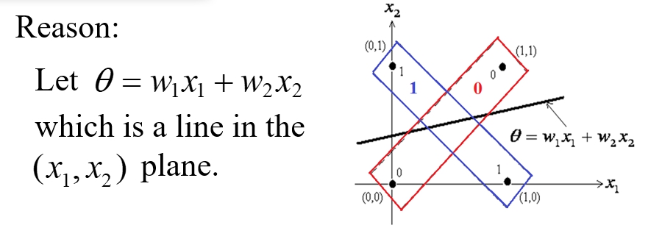

詳細可參考：[機器學習- 神經網路(多層感知機 Multilayer perceptron, MLP)運作方式](https://medium.com/@chih.sheng.huang821/%E6%A9%9F%E5%99%A8%E5%AD%B8%E7%BF%92-%E7%A5%9E%E7%B6%93%E7%B6%B2%E8%B7%AF-%E5%A4%9A%E5%B1%A4%E6%84%9F%E7%9F%A5%E6%A9%9F-multilayer-perceptron-mlp-%E9%81%8B%E4%BD%9C%E6%96%B9%E5%BC%8F-f0e108e8b9af)

**疑似只在去年第1章的投影片出現，今年的找不到 (第6~8題)**

106-2 第6題 There are three basic neural circuits in the McCullock-Pitts Theory. What are the circuits?

**Answer:** Convergence, Divergence, Feedback

106-2 第7題 Give the propositional expressions and draw the neural circuits of (a) disjunction and (b) conjoined negation

**Answer:**

1. 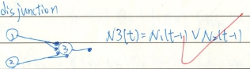
2. 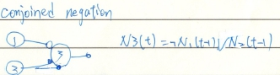

106-2 第8題 Write propsitional expressions for N3(t) and N4(t) in the follwing neural circuit.

**Answer:**



106-2 第9題 Graphically illustrate the Hebb’s learn theory.

找不到出處

## Chapter 2 - Adaline and Madaline

Adaline: Adaptive Linear neuron

Madaline: Multiple Adaline

考古： 106-2 第11題 What is the full names of adaline and madaline?

**Answer:** as above

### 2.1 Adaline (Bernard Widrow, Stanford Univ.)

#### 2.1.1 Least Mean Square (LMS) Learning

106-2 第14題

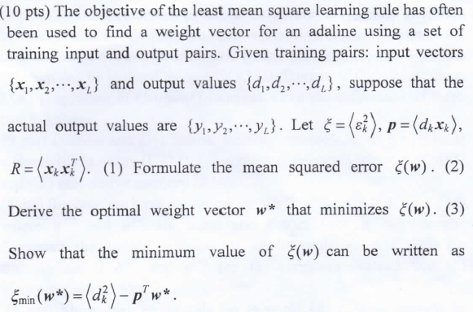

**Answer:**

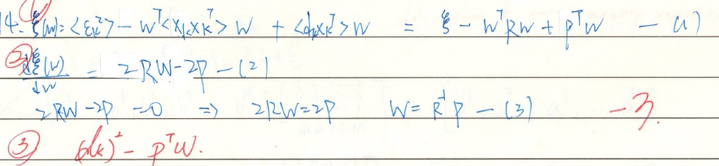

#### 2.1.2 Steepest Descent

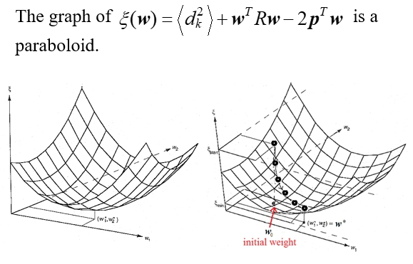

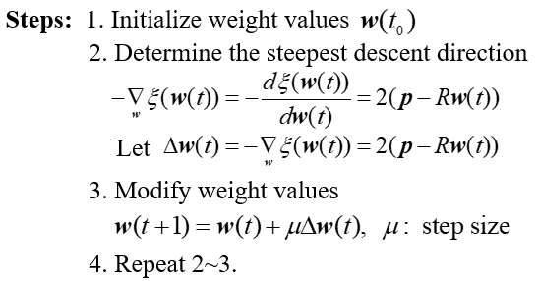

106-2 第12題 Describe the steps of the steepest descent learning method for determining the weight vector of adaline using a set of traing input and output pairs.

**Answer:**

1. Initialize weight values w(t0)
2. Determine the steepest descent direction
3. Find the weight
4. Repeat 2~3

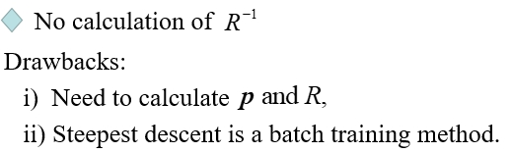

106-2 第15題 Address the drawbacks with the steepest descent learning approach?

**Answer:**

1. 必須計算 p 和 R
2. Steepest descent learning 是一個 batch training method

#### 2.1.3 Stochastic Gradient Descent

#### 2.1.4 Conjugate Gradient Descent

＊Drawback: can only minimize quadratic functions

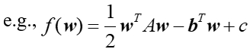

＊Advantage: guarantees to find the optimum solution in at most n iterations, where n is the size of matrix A.

106-2 第16題 Address the advantages and disadvantages of the conjugate gradient descent learning method?

**Answer:**

1. Advantagea: 保證在最多n次迭代中找到最佳解，其中n是矩陣A的大小
2. Disadvantage: 只能最小化二次函數(quadratic functions)

### 2.3 Applications

#### 2.3.1 Echo Cancellation in Telephone Circuits

#### 2.3.2 Predict Signal

#### 2.3.3 Reproduce Signal

#### 2.3.4 Adaptive beam - forming antenna arrays

### 2.4 Madaline

#### 2.4.2 Madaline Rule OO (MRII)

＊Training algorithm: a trial-and-error procedure with a minimum disturbance principle (those nodes that can affect the output error while incurring the least change in their weights should have precedence in the learning process)

106-2 第17題 What does the minimum disturbance principle mean when training a madaline.

**Answer:** Those nodes that can affect the output error while incurring the least change in their weights should have precedence in the learning process.

翻譯米糕：儘管對 weights 的改變不大，那些可以影響 ouput error 的 nodes 應該在 learning process 有優先權

#### 2.4.3 A Madaline for Traslation - Invariant Pattern Recognition

106-2 第20題 作業2

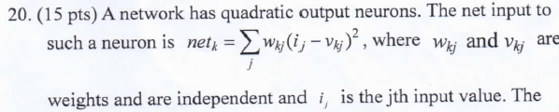

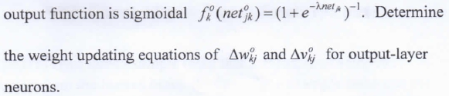

**Answer:**

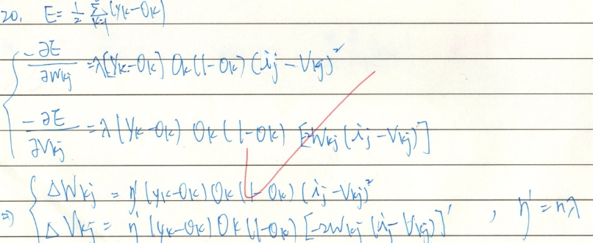

## Chapter 4 - Backpropagation (BP)

#### ＊BP architecture characteristics: multilayer, feedforward, fully connected

106-2 第18題 Address the characteristics of back-propagation (BP) neural network.

**Answer:** 每層的輸出為下一層的輸入，而 BP 是由最末層把值送到第一層更新。

##### ＊Potential problems being solved by BP

1. Data trnslation
2. Best guess

##### ＊Suffer from:

1. Noise, distortion. incomplete
2. Time consuming

### 4.1 BP Neural Network

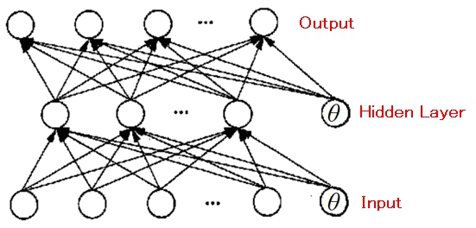

During training, self-organization of nodes on the intermediate layers s.t. different nodes recognize different features or their relationships. Noisy and incomplete patterns can thus be handled.

106-2 第22題 Draw a picture to illustrate how a BP performs image compression.

**Answer:** 畫出上圖

#### 106-2 第19題 What learning rule and objective function are employed when training BP?

#### **Answer:** Self-organization of nodes on the intermediate layers s.t. different nodes recognize

#### different features or their relationships. Noisy and incomplete patterns can thus be handled.翻譯米糕：Nodes 的 Self-organization 在中間層上，使得不同 nodes 可辨識不同 features 或關係。如此一來，Noisy 和 不完整的 patterns 便可被處理。

#### 4.1.2 BP NN Learning

### 4.2 Generalized Delta Rule (GDR)

### 4.3 Practicl Considerations

### 4.4 Applications

還沒解完 106-2 第21題 Suggest ideas for determining the numbers of hidden layers and their constituent nodes.

**Answer:**

## Chapter 12 - Boltzmann Machine

### 12.1 Indtroduction

##### ＊The major difference between BM and traditional NN is that the output function of PEs characterized by

BM: a nondeterministic function characterized by a stochastic function of inputs

NN: a deterministic function of inputs

##### ＊Prerequisites for learning BM: (Boltzmann Machine Concepts) **記一下**

1. Information theory
2. Statistical dynamics
3. Simulated annealing
4. Energy function

#### 12.1.1 Information Theory

#### 12.1.2 Statistical Machanics

#### 12.1.3 Simulated Annealing

#### 12.1.4 Energy Function

##### ＊Dynamic system: a system whose state changes with time.

106-2 第10題 What is a dynamic system?

**Answer:** The system evolve over time.

##### ＊State: a collection of adaptable quantitative and qualitative items that characterizing the system, e.g., weights, data flows …..

##### ＊Two types of dynamics in a neural network:

1. Training phase: iteratively update weights
2. Production phase: asymptotically converge to the solution patterns

106-2 第4題 There are two major neural operations or phase. What are they? Address their functions.

**Answer:**

1. Training: 不斷更新 weight
2. Production: recall the value

### 12.2 Boltzmann Machine

##### ＊Three different types of BM: **記一下**

1. Completion network
2. I/O network
3. Restricted Network

#### 12.2.1 Boltzmann Completion Network

#### 12.2.2 Learning

＊Training the Boltzmann machine ( ch.12 p.39 )

#### 12.2.3 Practical Considerations

### 12.3 Symptom-Diagnosis Application Diagnose why a car will not start

## **備註**

好像沒在範圍內：6~9, 23~30

## **Chapter 6 - AM and BAM**

我們懷念他.jpg