ANN Exam. (Chs. 1, 2, 4, 12); Total: 100 pts

- (3 pts) Give examples of drawbacks that an input pattern may have, which artificial neural networks can tolerate, i.e., the abilities of artificial neural networks.
ANN的input pattern是輸入一組vector x，乘上一組weight加上一組bias，再經過一個activation function進入下一層網路，最後可能有個分類器，在output layer中每個neuron代表的都是他屬於該類別的機率。而這種input pattern的缺點在於欲處理的問題必須跟過往的訓練資料有一定的pattern，因為在測試階段weight、bias都是固定的，也就是要抽的特徵類型都已經固定了，所以輸入的測試資料必須跟訓練資料有一致性才能做預測。
2. (4 pts) The following figure shows the structure of a single processing element (PE) in a neural network, in which 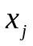denotes input and 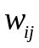 specifies synaptic weight. Formulate the net input, activation, and output of the PE.
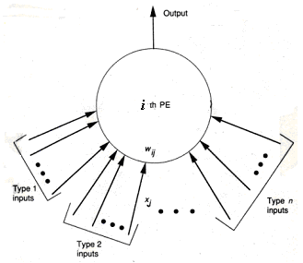
net input: 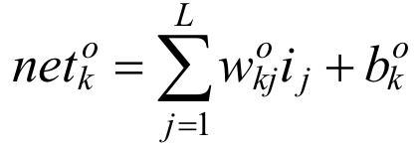
其中w是weight，b是bias
activation: 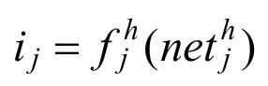
其中f函數是activation function
output: 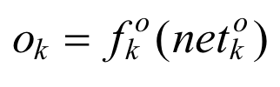

- (6 pts) Describe the steps of the steepest descent learning method for determining the weight vector of an adaline using a set of training input and output pairs.
1.Initialize weight values w(t0)
2.Determine the steepest descent direction
3.Modify weight value
4. Repeat 2~3

- (4 pts) What are practical considerations when training an adaline using the stochastic gradient descent learning method?
(a) No. of training vectors, (b) Stopping criteria
(c) Initial weights, (d) Step size

- (5 pts) Address the advantages and disadvantages of the conjugate gradient descent learning method?
Disadvantage: can only minimize quadratic functions
Advantage: guarantees to find the optimum solution in at most n iterations, where n is the size of matrix A.

- (5 pts) The momentum and perturbation techniques have often been employed to train a BP. Address their ideas.
Momentum technique -- Adding a fraction of the preview change, while tends to keep the weight changes going in the same direction to the weight change.
Perturbation – Repeat training using multiple initial weights.

- (3 pts) Let 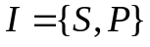 denote an information source, where 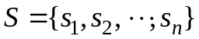 is the set of symbols and 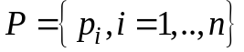 is the associated probability distribution of the symbols. Define the information gain of source 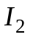 with respect to source 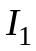.
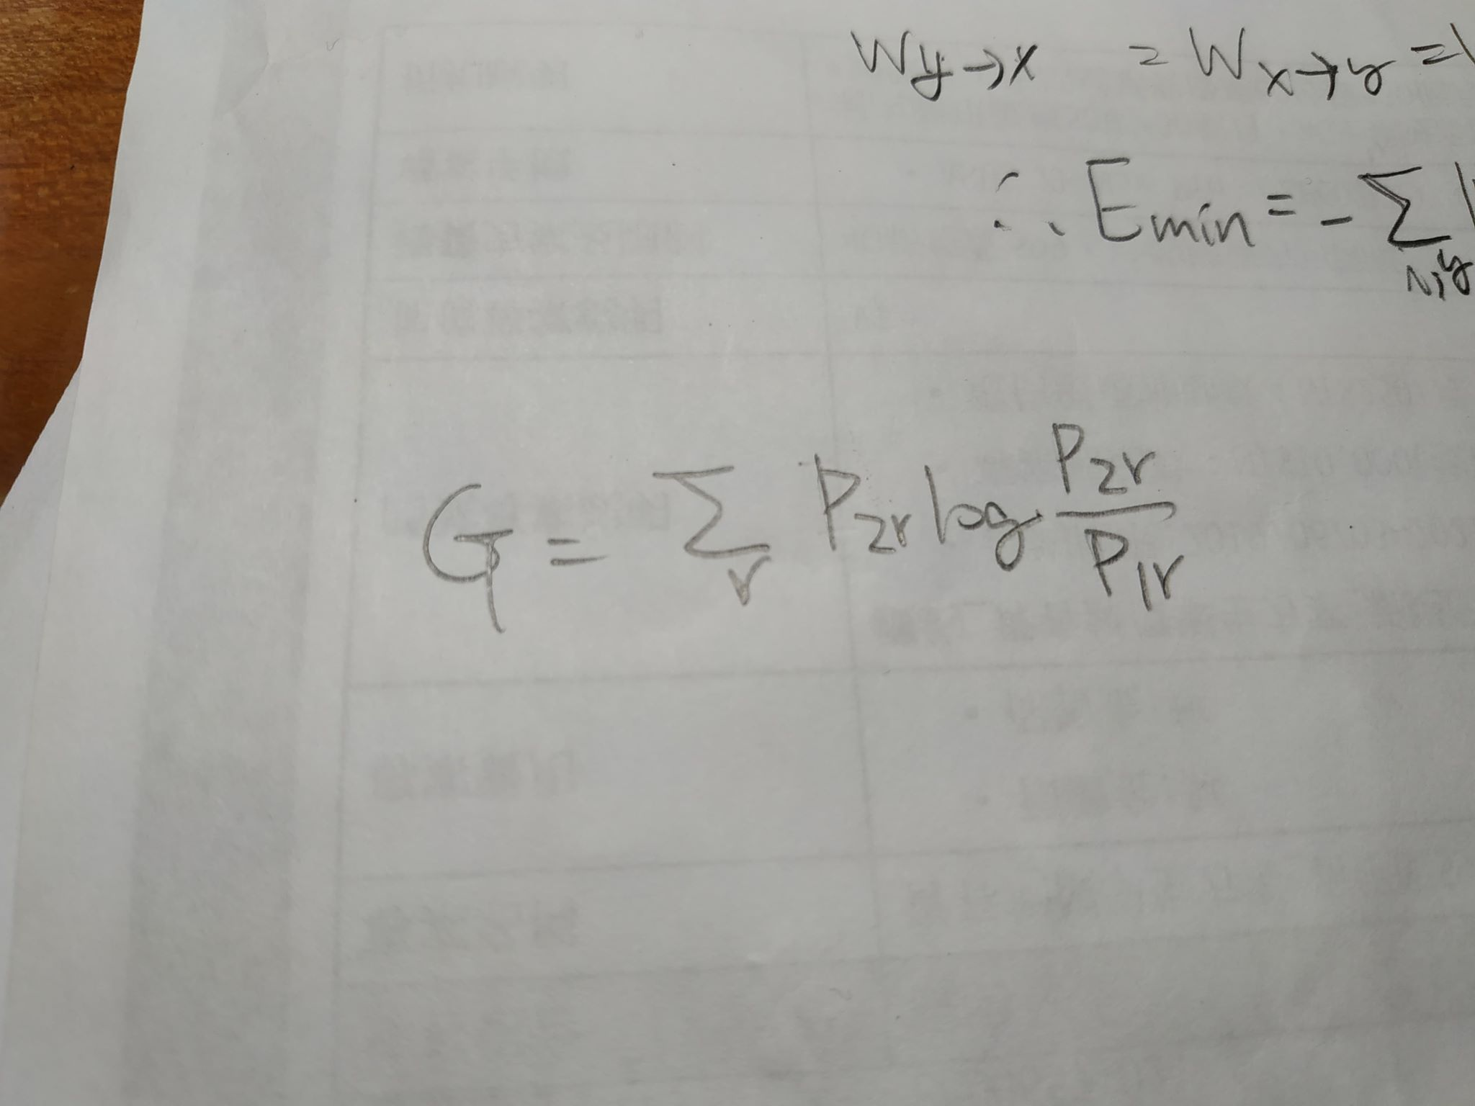

- (3 pts) A function to be an energy function of a neural system has to possess three properties. What are these properties?
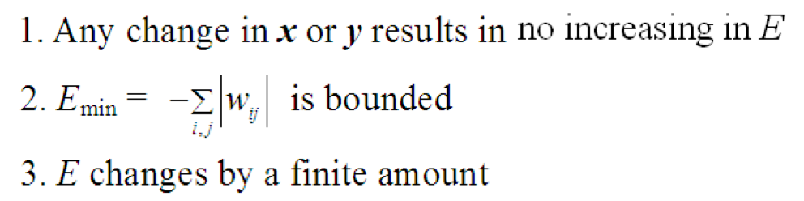
- (9 pts) The objective of the least mean square learning rule has often been used to find a weight vector for an adaline using a set of training input and output pairs. Given training pairs: input vectors 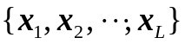 and output values 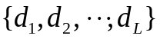, suppose that the actual output values are 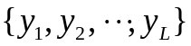. Let 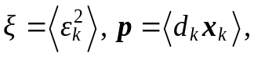 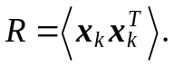 (1) Formulate the mean squared error 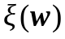. (2) Derive the optimal weight vector  that minimizes . (3) Show that the minimum value of can be written as 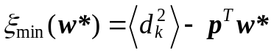.
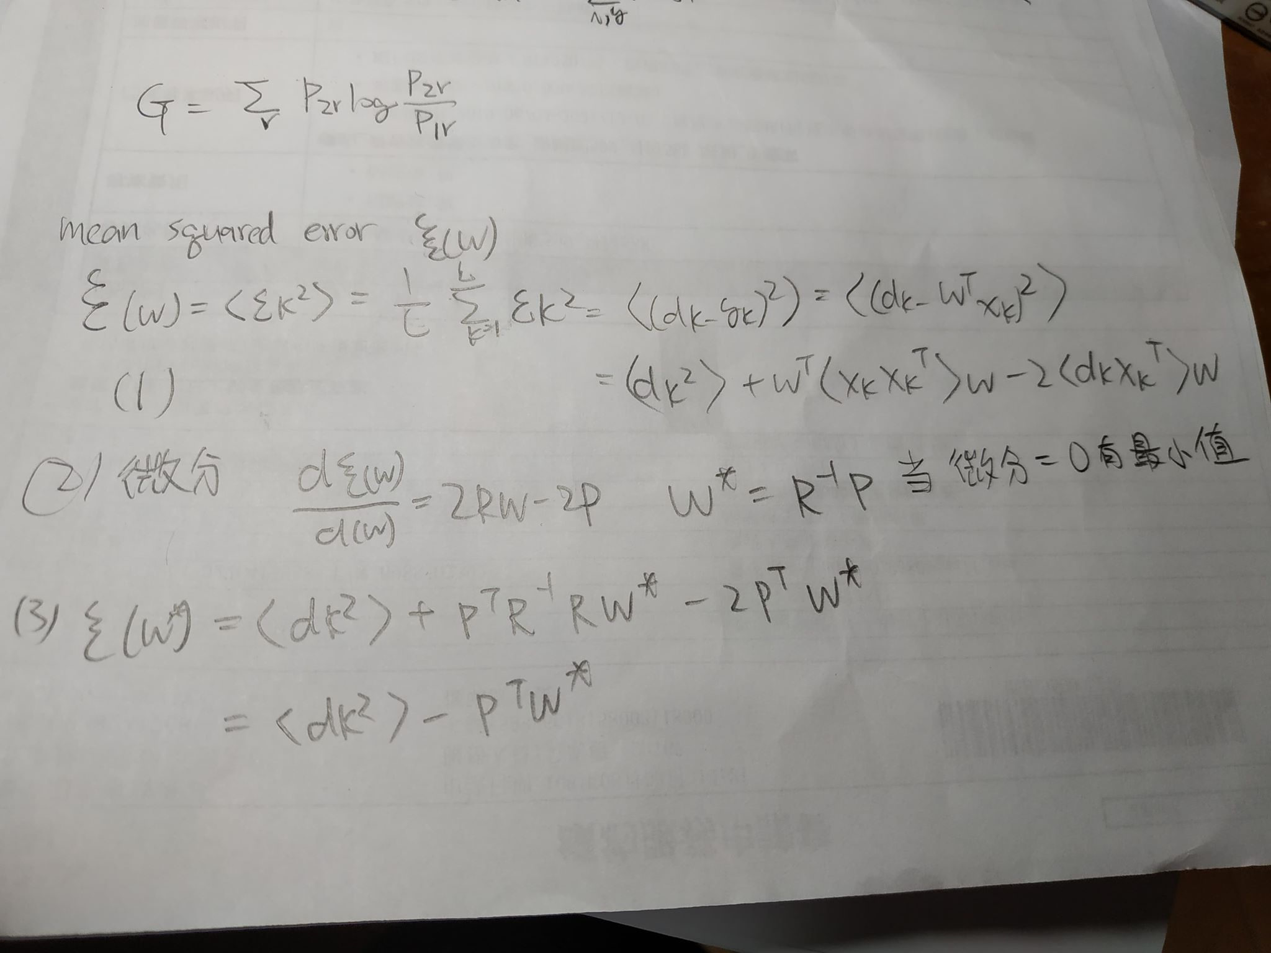

- (9 pts) Let 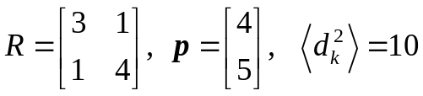 for 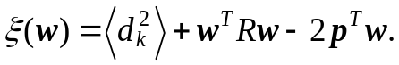 which reveals a paraboloid in the space 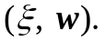 Find i) 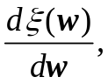 ii) the optimum weight vector 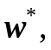 and iii) the minimum squared error 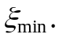
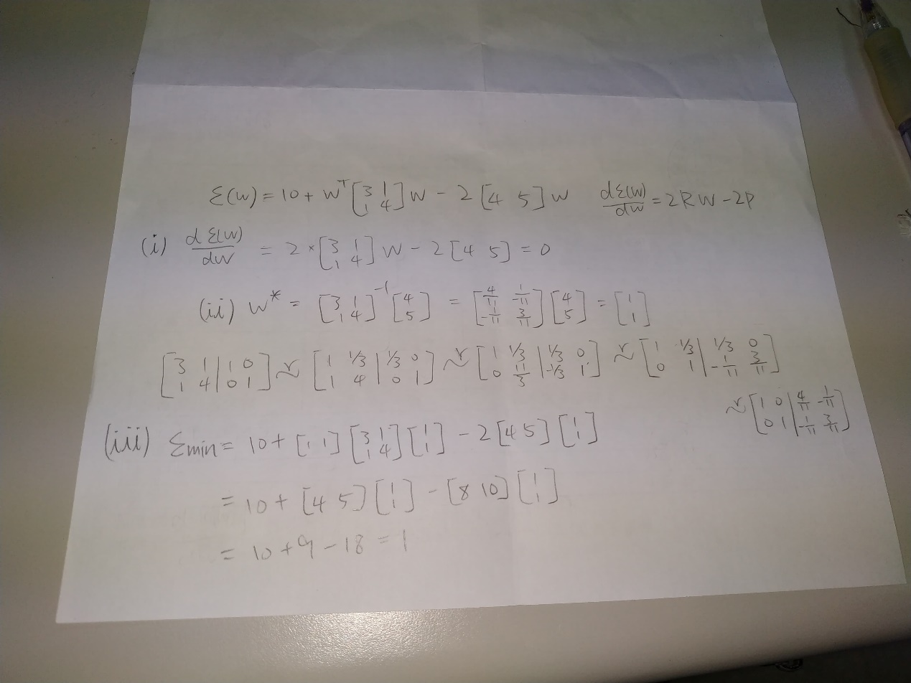

11. (15 pts) A network has quadratic output neurons. The net input to
such a neuron is 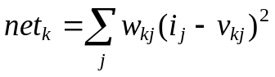, where 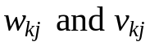 are
weights and are independent and is the jth input value. The
output function is sigmoidal 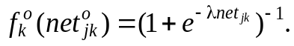 Determine
the weight updating equations of 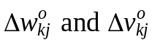 for output-layer
neurons.
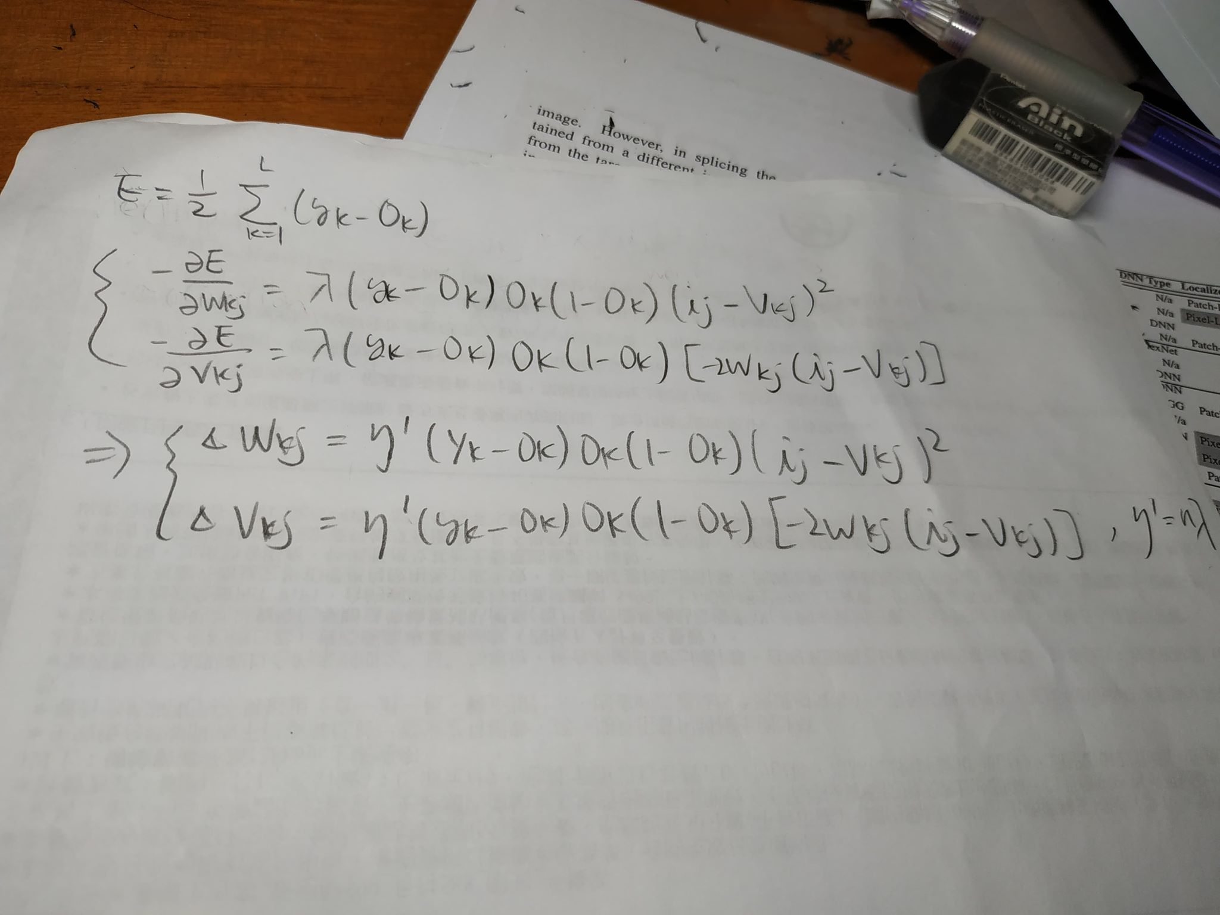

12. (9 pts) Three different types of Boltzmann machines are addressed in
the class. Give their architectures.
- Completion network
i) 2 layers: hidden and visible layers,
ii) Fully interconnected between layers and among
units on each layer,
iii) All connections are bidirectional. 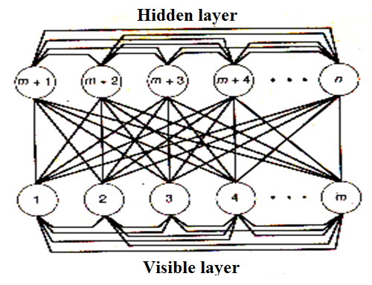

- I/O network
- The visible units are divided into input
and output units
ii) No connections among input units
- Connections from
input to other units
are unidirectional
- All other connections
are bidirectional.
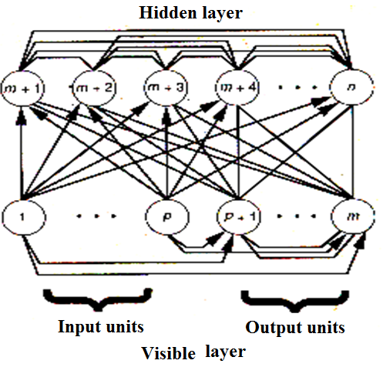

- Restricted Network
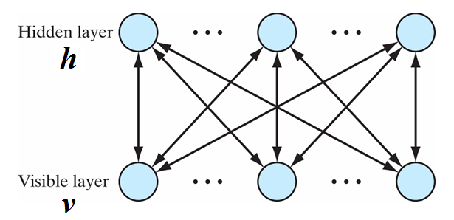
- 2 layers: visible layer v, and hidden layer h.
- There is no connection among the visible or
hidden neurons.

13. (10 pts) Let the energy function of an NN be 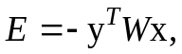 where x
and y are bipolar vectors and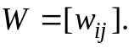 Show 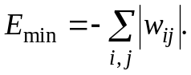
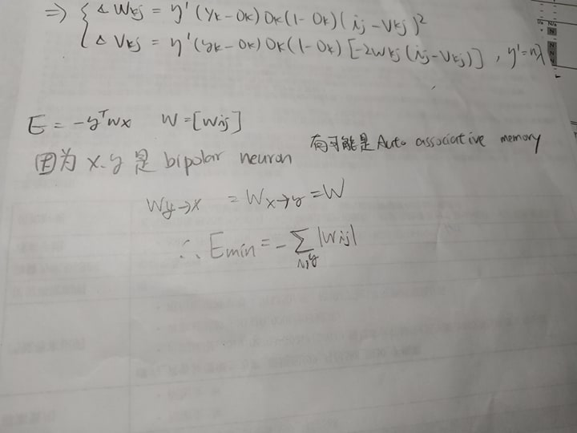

14. (15 pts) Consider a stochastic, two-state neuron j operating at temperature T. This neuron changes from state 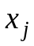 to state 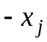 with probability
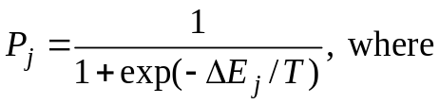 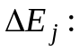 the energy change resulting
from the state change. The total energy of the Boltzmann machine is
defined as 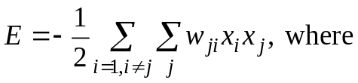 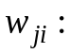 the synaptic
weight from neuron i to neuron j, with 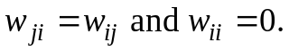
(a) Show that 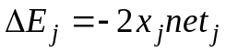.
(b) Suppose that initially state 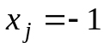, what is the probability that
s changed to state +1.
(c) Suppose that initially state 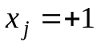, what is the probability that
is changed to state -1.

