高等影像處理
作業六: 影像平滑化與邊緣偵測(Image smoothing and edge detection)
- 請於作業一的程式中加入一個新的功能convolution，可進行image smoothing 以及 edge detection，並將程式執行檔名稱改為“HW6學號.exe”。
- 主視窗請命名為 “AIP學號”。
- 輸入的影像為灰階影像，輸出則為影像平滑化與邊緣偵測之後的影像。範例如附件所示。影像平滑化與邊緣偵測需由使用者輸入不同的convolution masks，大小可為3X3 pixels, 5X5 pixels或其他。
- 本作業convolution的函式需自己撰寫，不可以採用其他人的程式碼。
- 程式語言限C、C++、C#、Python與JAVA系列(若用其他語言需事先告知並酌量扣分)，但作業繳交時必需編譯成EXE檔且在沒有COMPILER的情況下亦能執行。
- 程式需可選擇要輸入的檔案名稱並自動利用附檔名判斷影像格式以及影像大小，界面設計需符合要求。

檔案
…
Convolution

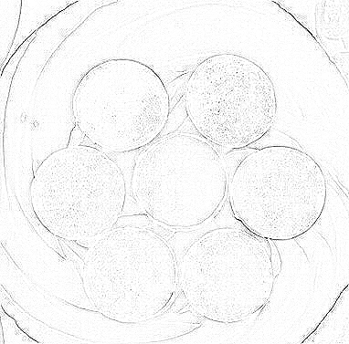

- WORD報告內容需說明程式功能，程式流程或演算法，測試結果以及程式撰寫心得。
- 內容至少為A4二頁，最多為A4三頁。
- 內容文字需為12點字，單行間距，標楷體。
- 測試結果(請附至少四組畫面截圖，並附對應的convolution masks)。
- 程式撰寫心得(至少100字)。
- 輸出與輸入範例儘量與專題名稱相符。
- 本作業請於12月10日晚上10時前上傳至MOODLE中，包括一個程式原始碼檔案“HW6學號.txt”、一個程式執行檔“HW6學號.exe”、 以及一份WORD報告“HW6學號.doc”或“HW6學號.docx”。
Advance Image Processing
Homework 6: Image smoothing and edge detection
- Please add one convolution function in HW1, which can do image smoothing and edge detection respectively using different convolution masks. Compile it to an execution file named “HW6student_number.exe.”
- The program should obtain the input convolution mask by users and be coded by yourself. The size of masks can be 3X3 pixels, 5X5 pixels, or others. These masks should be shown in your report with their corresponding convolution results.
- The inputs of the function are the gray-level image. The output is the convolution result using the selected masks. The following example is one of the edge detection result.
- The inputs of the function are the gray-level image. The outputs should include the results of histogram equalization and their corresponding histograms.
- An example of the user interface:
File
…
Convolution

- The report should include project topic, programming language and compiler, the main functions of the program, the flowchart of the program, testing results, and discussion (learning experience).
  - At least A4 2 pages, no more than 4 pages.
  - 12 point text, single line spacing, times font type.
  - Testing results should be more than 4 examples and their corresponding convolution masks.
  - Learning experience should be more than 100 words.
  - The examples should be consistent with your project topic.
- This homework should be uploaded to https://moodle2.ntnu.edu.tw/ before 10/12/2019 10 PM,, including one source code file, one execution file, and one report word file.

