Nama = Serenity Devina Suryanto

NPM = 2327250009

Kelas = IF3B

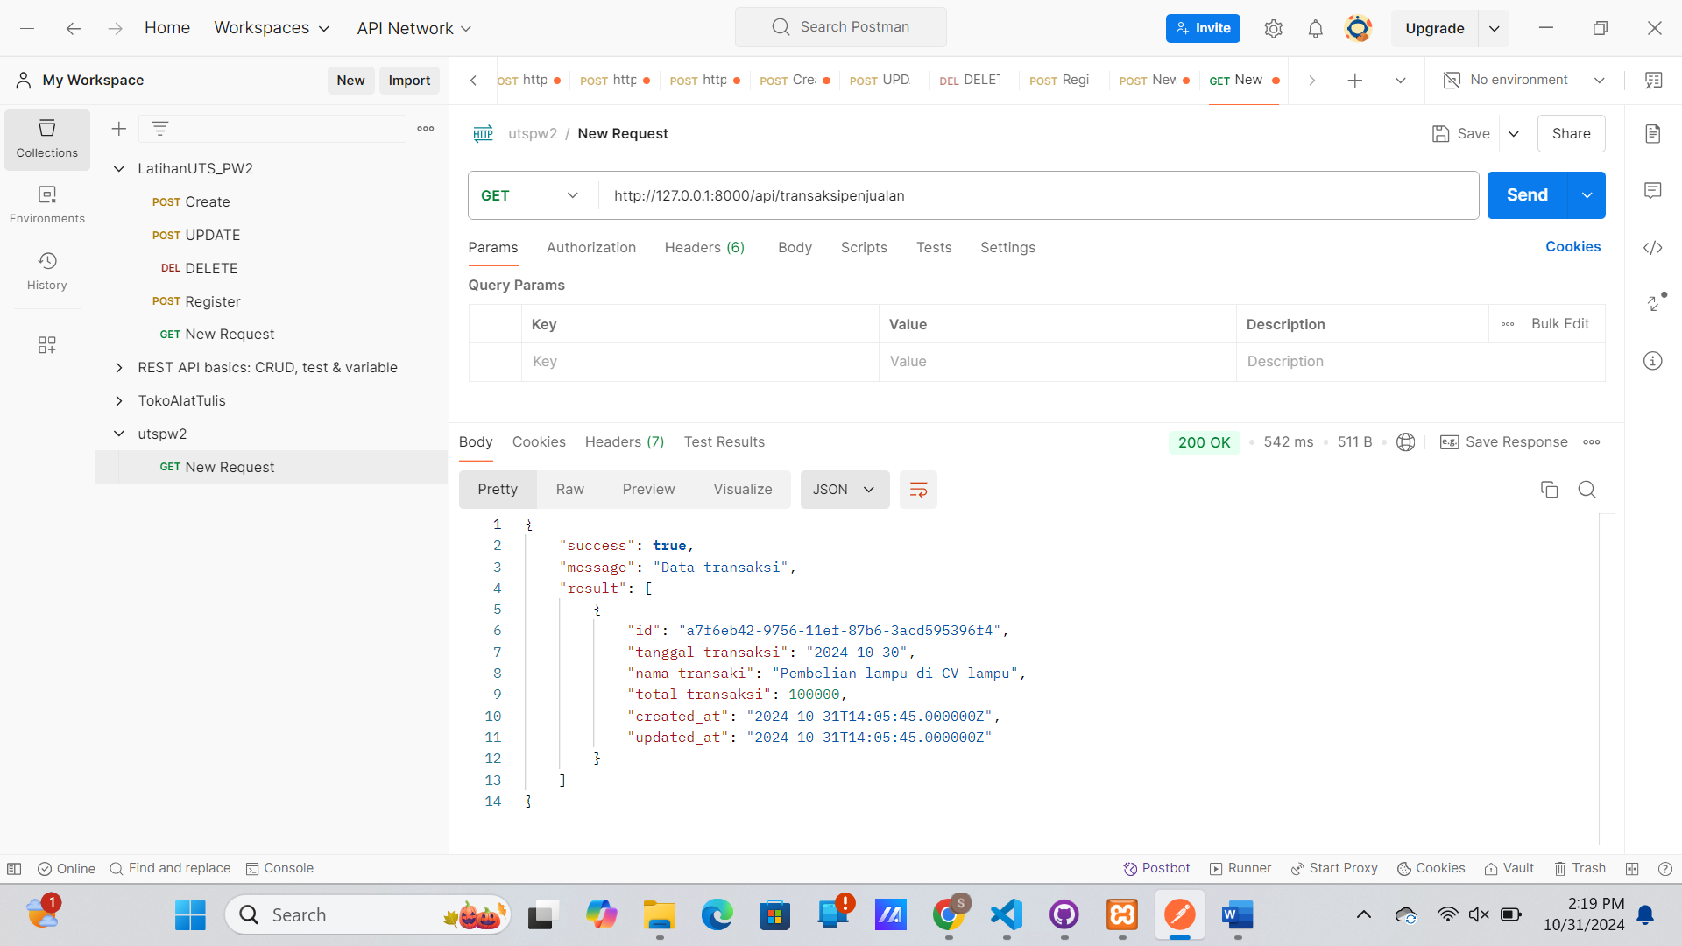

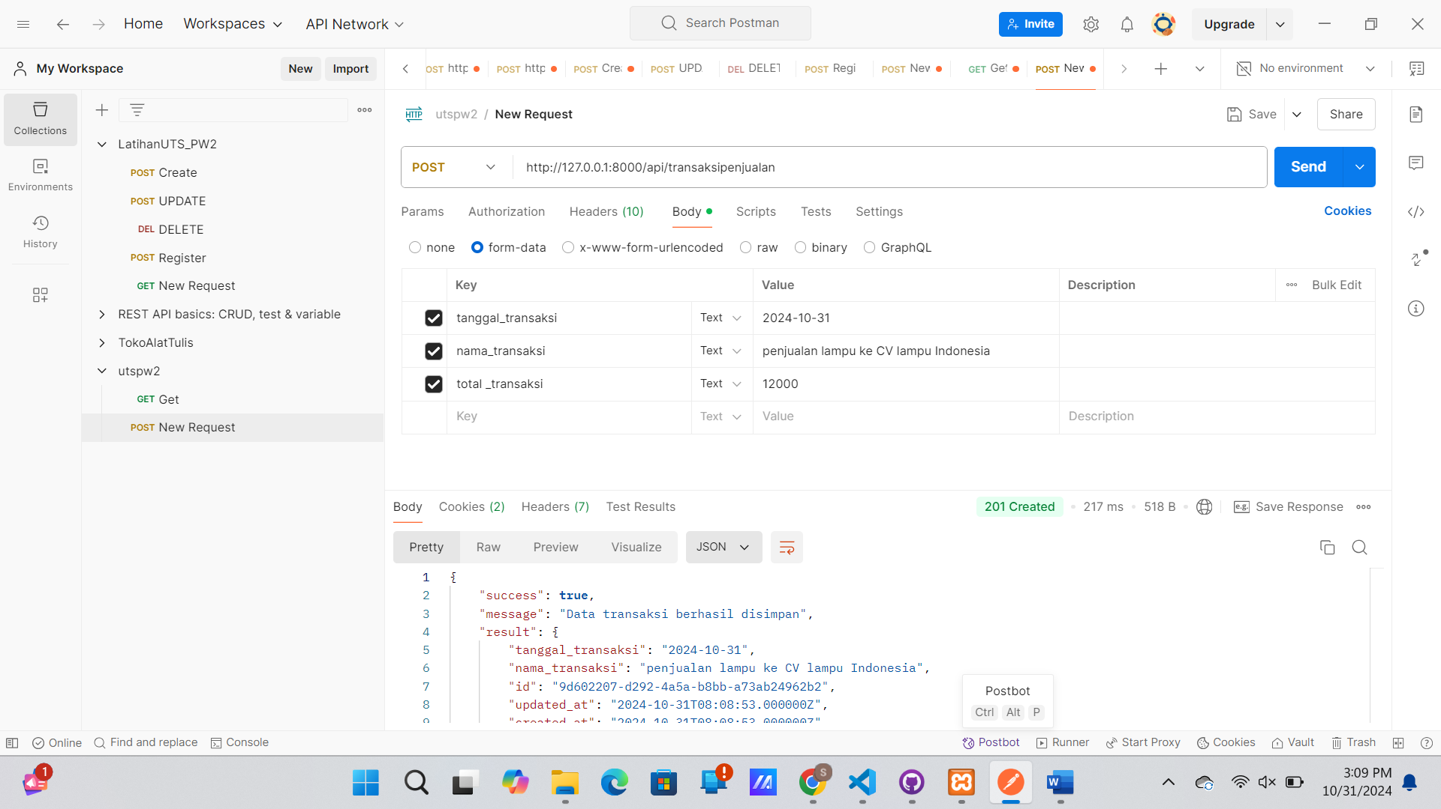

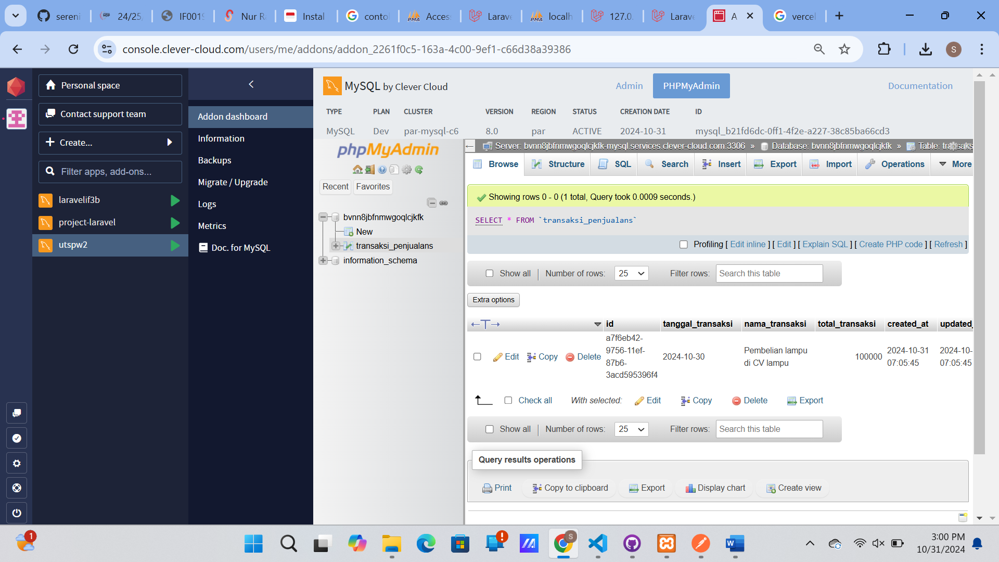

[**https://github.com/serenitydevina/UTS-IF3B-2327250009-API**](https://github.com/serenitydevina/UTS-IF3B-2327250009-API)

[**https://github.com/serenitydevina/UTS-IF3B-2327250009-REACT**](https://github.com/serenitydevina/UTS-IF3B-2327250009-REACT)