Untitled

### ForestFires

날씨가 덥다 -> 그리스 산불 -> 산불을 조심하자(의식의 흐름) 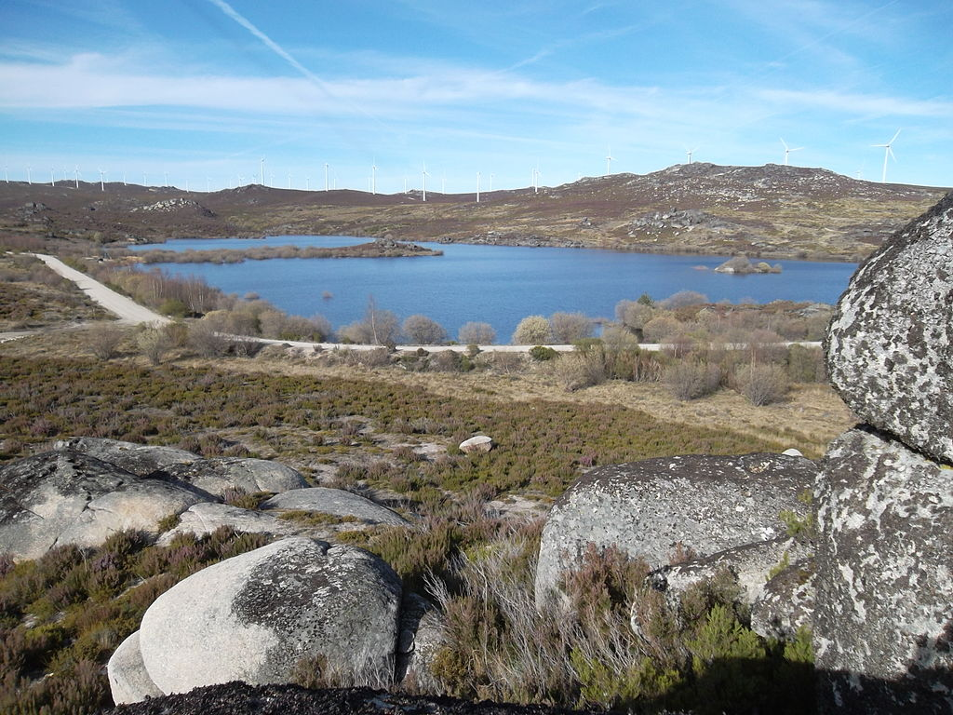 By Hurtuv - Holidays in MontesinhoPreviously published: no, CC BY-SA 3.0, <https://commons.wikimedia.org/w/index.php?curid=39454624> ### 변수 확인 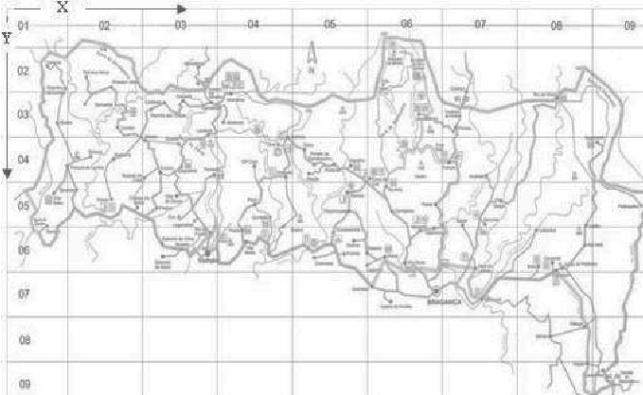

library(data.table)  
forestfire <- fread("~/Downloads/forestfires.csv")  
library(ggplot2)  
library(dplyr)

##   
## Attaching package: 'dplyr'

## The following objects are masked from 'package:data.table':  
##   
## between, first, last

## The following objects are masked from 'package:stats':  
##   
## filter, lag

## The following objects are masked from 'package:base':  
##   
## intersect, setdiff, setequal, union

library(cowplot)

##   
## Attaching package: 'cowplot'

## The following object is masked from 'package:ggplot2':  
##   
## ggsave

library(caret)

## Loading required package: lattice

theme_set(theme_grey())

# 연속형 변수들 히스토그램  
n <- names(forestfire)  
plots <- apply(forestfire[,c(5:13), with=FALSE], 2,function(x){  
 ggplot(forestfire, aes(x))+ geom_freqpoly(binwidth = 5)  
 })  
for(i in 1:9){  
 plots[[i]] <- plots[[i]] + xlab(n[i+4])  
}  
plot_grid(plotlist = plots)

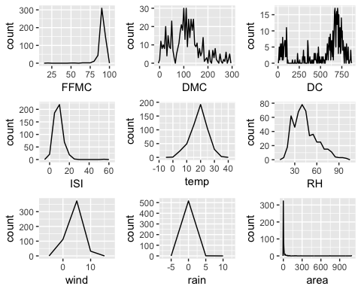

# 지역별 화재 발생 확인 박스 플롯  
plots2 <- lapply(forestfire[,c(1:2), with =FALSE], function(x){  
 ggplot(forestfire, aes(factor(x), log1p(area))) + geom_boxplot() + coord_flip()   
})  
for(i in 1:2){  
 plots2[[i]] <- plots2[[i]] + xlab(n[i])  
}  
plot_grid(plotlist = plots2)

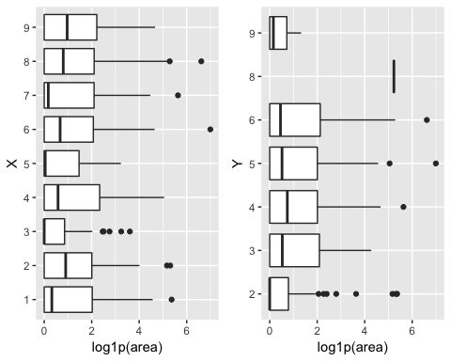

# 일,월 별 화재 발생 확인 박스 플롯  
plots3 <- lapply(forestfire[,c(3,4), with =FALSE], function(x){  
 ggplot(forestfire, aes(x, log1p(area))) + geom_boxplot() + coord_flip()   
})  
for(i in 1:2){  
 plots3[[i]] <- plots3[[i]] + xlab(n[i+2])  
}  
plot_grid(plotlist = plots3)

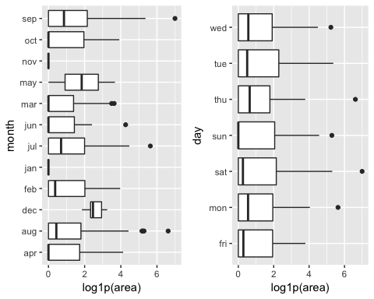

# 변수간 상관 관계랑 모두 볼 수 있음 하지만 시간이 조금 걸림  
#install.packages("GGally")  
#library(GGally)  
#ggpairs(forestfire[,c(-1,-2,-3,-4)])  
  
  
# 지역 별 데이터 빈도수 확인 -> 많을수록 불이 날 확률도 업  
ggplot(forestfire, aes(factor(X),factor(Y))) + geom_count() + scale_size_area()

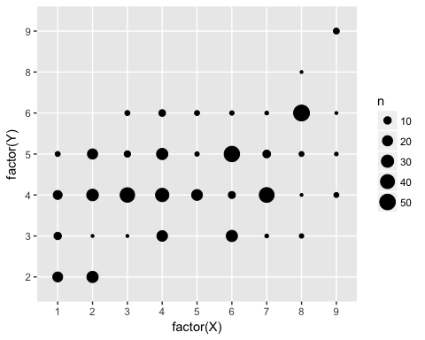

#화재를 6단계로 나누어서 계산 1이 작은 화재 6은 큰 화재  
# 연속형 변수인 area를 카테고리로 잠깐 만들어서 확인  
area_cat1<- cut(log1p(forestfire$area), breaks = quantile(log1p(forestfire$area), probs = c(0,seq(0.5, 1, 0.1))),  
 include.lowest = TRUE, right = FALSE, labels = 1:6)  
data2 <- forestfire %>% mutate(area_cat1 = area_cat1)  
#시각화  
data2 %>% group_by(X, Y, area_cat1) %>% summarise(n())

## # A tibble: 129 x 4  
## # Groups: X, Y [?]  
## X Y area_cat1 `n()`  
## <int> <int> <fct> <int>  
## 1 1 2 1 15  
## 2 1 2 2 2  
## 3 1 2 4 1  
## 4 1 2 6 1  
## 5 1 3 1 4  
## 6 1 3 2 1  
## 7 1 3 4 2  
## 8 1 3 6 3  
## 9 1 4 1 6  
## 10 1 4 3 4  
## # ... with 119 more rows

ggplot(data2, aes(area_cat1)) + geom_bar() + facet_grid(Y~X)

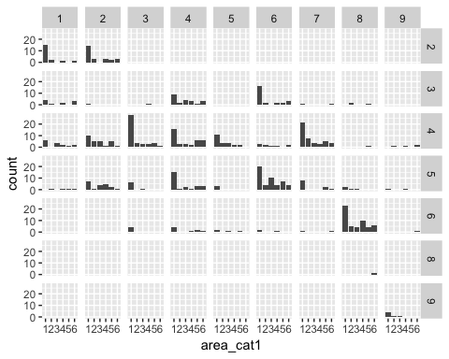

#화재를 2단계로 나누어서 계산, 0은 화재가 0 1은 0보다 큰 경우  
data2 <- data2 %>% mutate(area_cat2 = ifelse(forestfire$area > 0, 1, 0))  
data2 %>% group_by(X,Y, area_cat2) %>% summarise(n())

## # A tibble: 62 x 4  
## # Groups: X, Y [?]  
## X Y area_cat2 `n()`  
## <int> <int> <dbl> <int>  
## 1 1 2 0 15  
## 2 1 2 1 4  
## 3 1 3 0 3  
## 4 1 3 1 7  
## 5 1 4 0 5  
## 6 1 4 1 10  
## 7 1 5 1 4  
## 8 2 2 0 14  
## 9 2 2 1 11  
## 10 2 3 0 1  
## # ... with 52 more rows

ggplot(data2, aes(factor(area_cat2))) + geom_bar() + facet_grid(Y~X)

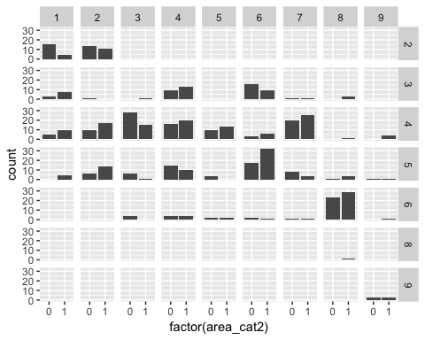

data3 <- forestfire  
data3 <- data3 %>% mutate(weather = ifelse(month %in% c("feb","jan","dec"), "winter",  
 ifelse(month %in% c("oct","nov","sep"), "autoumn",  
 ifelse(month %in% c("aug","jul","jun"), "summer", "spring"))))  
  
data3 <- data3 %>% mutate(weekend = ifelse(day %in% c("mon", "tue", "wed", "thu", "fri"), "week", "weekend"))  
  
data3 <- data3 %>% mutate(area1 = ifelse(area > 0, 1, 0))  
  
data3$weather <- factor(data3$weather, levels = c("spring", "summer", "autoumn", "winter"))  
data3$weekend <- factor(data3$weekend, levels = c("week", "weekend"))  
  
data_model1 <- subset(data3, select = c(-month, - day, - area))  
data_model2 <- data_model1  
data_model2[,c(3:10)] <- scale(data_model1[, c(3:10)])

# 실험 1 scale을 하는게 좋을까? - 안한 친구 부터 확인  
library(caret)  
set.seed(12345)  
index <- createDataPartition(data_model1$area1, p = 0.7, list = FALSE)  
train <- data_model1[index, ]; test <- data_model1[-index, ]  
  
#glm model1 saturated model  
model1 <- glm(area1 ~., data = train, family = binomial(link = "logit"))  
summary(model1)

##   
## Call:  
## glm(formula = area1 ~ ., family = binomial(link = "logit"), data = train)  
##   
## Deviance Residuals:   
## Min 1Q Median 3Q Max   
## -1.672 -1.167 0.702 1.078 1.762   
##   
## Coefficients:  
## Estimate Std. Error z value Pr(>|z|)   
## (Intercept) -6.694735 3.190796 -2.098 0.03589 *   
## X 0.059937 0.055879 1.073 0.28344   
## Y 0.013511 0.108423 0.125 0.90083   
## FFMC 0.043244 0.032879 1.315 0.18843   
## DMC -0.003608 0.002960 -1.219 0.22289   
## DC 0.002158 0.001422 1.518 0.12901   
## ISI -0.001565 0.037217 -0.042 0.96647   
## temp 0.053681 0.038571 1.392 0.16399   
## RH 0.004622 0.010582 0.437 0.66231   
## wind 0.138739 0.066191 2.096 0.03608 *   
## rain -0.857958 1.261966 -0.680 0.49659   
## weathersummer -0.135917 0.792432 -0.172 0.86382   
## weatherautoumn -0.287873 0.938085 -0.307 0.75894   
## weatherwinter 1.800700 0.689111 2.613 0.00897 **  
## weekendweekend -0.033404 0.231528 -0.144 0.88528   
## ---  
## Signif. codes: 0 '***' 0.001 '**' 0.01 '*' 0.05 '.' 0.1 ' ' 1  
##   
## (Dispersion parameter for binomial family taken to be 1)  
##   
## Null deviance: 501.74 on 361 degrees of freedom  
## Residual deviance: 476.96 on 347 degrees of freedom  
## AIC: 506.96  
##   
## Number of Fisher Scoring iterations: 4

pred_model1 <- as.numeric(predict(model1, newdata = test, type = "response") > 0.5)#response면 확률 출력  
result1 <- confusionMatrix(table(pred_model1, test$area1))$overall[1]

#train, test set divide  
library(caret)  
set.seed(12345)  
index <- createDataPartition(data_model2$area1, p = 0.7, list = FALSE)  
train <- data_model2[index, ]; test <- data_model2[-index, ]  
  
#glm model1 saturated model  
model2 <- glm(area1 ~., data = train, family = binomial(link = "logit"))  
summary(model2)

##   
## Call:  
## glm(formula = area1 ~ ., family = binomial(link = "logit"), data = train)  
##   
## Deviance Residuals:   
## Min 1Q Median 3Q Max   
## -1.672 -1.167 0.702 1.078 1.762   
##   
## Coefficients:  
## Estimate Std. Error z value Pr(>|z|)   
## (Intercept) -0.249171 0.810092 -0.308 0.75840   
## X 0.059937 0.055879 1.073 0.28344   
## Y 0.013511 0.108423 0.125 0.90083   
## FFMC 0.238710 0.181495 1.315 0.18843   
## DMC -0.231101 0.189601 -1.219 0.22289   
## DC 0.535323 0.352644 1.518 0.12901   
## ISI -0.007133 0.169692 -0.042 0.96647   
## temp 0.311708 0.223966 1.392 0.16399   
## RH 0.075413 0.172678 0.437 0.66231   
## wind 0.248572 0.118591 2.096 0.03608 *   
## rain -0.253921 0.373490 -0.680 0.49659   
## weathersummer -0.135917 0.792432 -0.172 0.86382   
## weatherautoumn -0.287873 0.938085 -0.307 0.75894   
## weatherwinter 1.800700 0.689111 2.613 0.00897 **  
## weekendweekend -0.033404 0.231528 -0.144 0.88528   
## ---  
## Signif. codes: 0 '***' 0.001 '**' 0.01 '*' 0.05 '.' 0.1 ' ' 1  
##   
## (Dispersion parameter for binomial family taken to be 1)  
##   
## Null deviance: 501.74 on 361 degrees of freedom  
## Residual deviance: 476.96 on 347 degrees of freedom  
## AIC: 506.96  
##   
## Number of Fisher Scoring iterations: 4

pred_model2 <- as.numeric(predict(model2, newdata = test, type = "response") > 0.5)#response면 확률 출력  
result2 <- confusionMatrix(table(pred_model2, test$area1))$overall[1]  
  
cat("sclae x", result1, "scale o", result2) # scale 쪽이 조금 더 나음

## sclae x 0.5225806 scale o 0.5225806

library(caret)  
set.seed(12345)  
index <- createDataPartition(data_model2$area1, p = 0.7, list = FALSE)  
train <- data_model2[index, ]; test <- data_model2[-index, ]  
  
model_full <- glm(area1~., data = train, family = "binomial")  
model_non <- glm(area1~1, data = train, family = "binomial")  
  
model_forward <- step(model_non, list(lower=model_non, upper=model_full), direction = "forward")

## Start: AIC=503.74  
## area1 ~ 1  
##   
## Df Deviance AIC  
## + DC 1 495.58 499.58  
## + weather 3 491.64 499.64  
## + FFMC 1 498.31 502.31  
## + temp 1 498.61 502.61  
## + ISI 1 499.29 503.29  
## + wind 1 499.54 503.54  
## <none> 501.74 503.74  
## + RH 1 500.25 504.25  
## + DMC 1 500.54 504.54  
## + X 1 500.69 504.69  
## + Y 1 501.57 505.57  
## + weekend 1 501.62 505.62  
## + rain 1 501.72 505.72  
##   
## Step: AIC=499.58  
## area1 ~ DC  
##   
## Df Deviance AIC  
## + wind 1 491.16 497.16  
## <none> 495.58 499.58  
## + X 1 494.05 500.05  
## + weather 3 490.27 500.27  
## + FFMC 1 494.31 500.31  
## + RH 1 494.34 500.34  
## + ISI 1 494.61 500.61  
## + Y 1 494.98 500.98  
## + DMC 1 495.04 501.04  
## + temp 1 495.16 501.16  
## + weekend 1 495.52 501.52  
## + rain 1 495.52 501.52  
##   
## Step: AIC=497.16  
## area1 ~ DC + wind  
##   
## Df Deviance AIC  
## <none> 491.16 497.16  
## + RH 1 489.57 497.57  
## + X 1 489.62 497.62  
## + FFMC 1 489.96 497.96  
## + temp 1 490.05 498.05  
## + weather 3 486.39 498.39  
## + Y 1 490.43 498.43  
## + DMC 1 490.51 498.51  
## + ISI 1 490.65 498.65  
## + rain 1 490.90 498.90  
## + weekend 1 491.12 499.12

pred_forward <- as.numeric(predict(model_forward, newdata = test, type = "response") > 0.5)  
result1 <- confusionMatrix(table(pred_forward, test$area1))$overall[1]  
  
model_backward <- step(model_full, list(lower=model_non, upper=model_full), direction = "backward")

## Start: AIC=506.96  
## area1 ~ X + Y + FFMC + DMC + DC + ISI + temp + RH + wind + rain +   
## weather + weekend  
##   
## Df Deviance AIC  
## - ISI 1 476.96 504.96  
## - Y 1 476.97 504.97  
## - weekend 1 476.98 504.98  
## - RH 1 477.15 505.15  
## - rain 1 477.41 505.41  
## - X 1 478.11 506.11  
## - DMC 1 478.45 506.45  
## - temp 1 478.91 506.91  
## <none> 476.96 506.96  
## - FFMC 1 479.19 507.19  
## - DC 1 479.30 507.30  
## - wind 1 481.43 509.43  
## - weather 3 485.83 509.83  
##   
## Step: AIC=504.96  
## area1 ~ X + Y + FFMC + DMC + DC + temp + RH + wind + rain + weather +   
## weekend  
##   
## Df Deviance AIC  
## - Y 1 476.97 502.97  
## - weekend 1 476.98 502.98  
## - RH 1 477.15 503.15  
## - rain 1 477.41 503.41  
## - X 1 478.11 504.11  
## - DMC 1 478.45 504.45  
## - temp 1 478.93 504.93  
## <none> 476.96 504.96  
## - DC 1 479.31 505.31  
## - FFMC 1 479.77 505.77  
## - wind 1 481.62 507.62  
## - weather 3 485.83 507.83  
##   
## Step: AIC=502.97  
## area1 ~ X + FFMC + DMC + DC + temp + RH + wind + rain + weather +   
## weekend  
##   
## Df Deviance AIC  
## - weekend 1 476.99 500.99  
## - RH 1 477.17 501.17  
## - rain 1 477.43 501.43  
## - DMC 1 478.45 502.45  
## - X 1 478.77 502.77  
## <none> 476.97 502.97  
## - temp 1 478.98 502.98  
## - DC 1 479.31 503.31  
## - FFMC 1 479.78 503.78  
## - wind 1 481.62 505.62  
## - weather 3 486.01 506.01  
##   
## Step: AIC=500.99  
## area1 ~ X + FFMC + DMC + DC + temp + RH + wind + rain + weather  
##   
## Df Deviance AIC  
## - RH 1 477.17 499.17  
## - rain 1 477.44 499.44  
## - DMC 1 478.48 500.48  
## - X 1 478.79 500.79  
## - temp 1 478.98 500.98  
## <none> 476.99 500.99  
## - DC 1 479.34 501.34  
## - FFMC 1 479.82 501.82  
## - wind 1 481.64 503.64  
## - weather 3 486.01 504.01  
##   
## Step: AIC=499.17  
## area1 ~ X + FFMC + DMC + DC + temp + wind + rain + weather  
##   
## Df Deviance AIC  
## - rain 1 477.52 497.52  
## - DMC 1 478.49 498.49  
## - X 1 479.03 499.03  
## <none> 477.17 499.17  
## - DC 1 479.39 499.39  
## - temp 1 479.62 499.62  
## - FFMC 1 479.83 499.83  
## - wind 1 481.74 501.74  
## - weather 3 486.07 502.07  
##   
## Step: AIC=497.52  
## area1 ~ X + FFMC + DMC + DC + temp + wind + weather  
##   
## Df Deviance AIC  
## - DMC 1 478.82 496.82  
## - X 1 479.29 497.29  
## <none> 477.52 497.52  
## - DC 1 479.62 497.62  
## - temp 1 479.98 497.98  
## - FFMC 1 480.16 498.16  
## - wind 1 481.86 499.86  
## - weather 3 486.37 500.37  
##   
## Step: AIC=496.82  
## area1 ~ X + FFMC + DC + temp + wind + weather  
##   
## Df Deviance AIC  
## - DC 1 479.74 495.74  
## - X 1 480.53 496.53  
## <none> 478.82 496.82  
## - FFMC 1 481.01 497.01  
## - temp 1 481.18 497.18  
## - wind 1 483.13 499.13  
## - weather 3 487.90 499.90  
##   
## Step: AIC=495.74  
## area1 ~ X + FFMC + temp + wind + weather  
##   
## Df Deviance AIC  
## - X 1 481.25 495.25  
## <none> 479.74 495.74  
## - temp 1 482.01 496.01  
## - FFMC 1 482.37 496.37  
## - wind 1 484.19 498.19  
## - weather 3 492.21 502.21  
##   
## Step: AIC=495.25  
## area1 ~ FFMC + temp + wind + weather  
##   
## Df Deviance AIC  
## <none> 481.25 495.25  
## - temp 1 483.36 495.36  
## - FFMC 1 483.95 495.95  
## - wind 1 485.72 497.72  
## - weather 3 493.46 501.46

pred_backward <- as.numeric(predict(model_backward, newdata = test, type = "response") > 0.5)  
result2 <- confusionMatrix(table(pred_backward, test$area1))$overall[1]  
  
model_step <- step(model_non, list(lower=model_non, upper=model_full), direction = "both")

## Start: AIC=503.74  
## area1 ~ 1  
##   
## Df Deviance AIC  
## + DC 1 495.58 499.58  
## + weather 3 491.64 499.64  
## + FFMC 1 498.31 502.31  
## + temp 1 498.61 502.61  
## + ISI 1 499.29 503.29  
## + wind 1 499.54 503.54  
## <none> 501.74 503.74  
## + RH 1 500.25 504.25  
## + DMC 1 500.54 504.54  
## + X 1 500.69 504.69  
## + Y 1 501.57 505.57  
## + weekend 1 501.62 505.62  
## + rain 1 501.72 505.72  
##   
## Step: AIC=499.58  
## area1 ~ DC  
##   
## Df Deviance AIC  
## + wind 1 491.16 497.16  
## <none> 495.58 499.58  
## + X 1 494.05 500.05  
## + weather 3 490.27 500.27  
## + FFMC 1 494.31 500.31  
## + RH 1 494.34 500.34  
## + ISI 1 494.61 500.61  
## + Y 1 494.98 500.98  
## + DMC 1 495.04 501.04  
## + temp 1 495.16 501.16  
## + weekend 1 495.52 501.52  
## + rain 1 495.52 501.52  
## - DC 1 501.74 503.74  
##   
## Step: AIC=497.16  
## area1 ~ DC + wind  
##   
## Df Deviance AIC  
## <none> 491.16 497.16  
## + RH 1 489.57 497.57  
## + X 1 489.62 497.62  
## + FFMC 1 489.96 497.96  
## + temp 1 490.05 498.05  
## + weather 3 486.39 498.39  
## + Y 1 490.43 498.43  
## + DMC 1 490.51 498.51  
## + ISI 1 490.65 498.65  
## + rain 1 490.90 498.90  
## + weekend 1 491.12 499.12  
## - wind 1 495.58 499.58  
## - DC 1 499.54 503.54

pred_step <- as.numeric(predict(model_step, newdata = test, type = "response") > 0.5)  
result3 <- confusionMatrix(table(pred_step, test$area1))$overall[1]  
  
cat("forward ", result1, "backward ", result2, "step ", result3)

## forward 0.5483871 backward 0.5483871 step 0.5483871

#svm  
library(e1071)  
set.seed(12345)  
index <- createDataPartition(data_model2$area1, p = 0.7, list = FALSE)  
train <- data_model2[index, ]; test <- data_model2[-index, ]  
  
svm.model<-svm(area1~.,data=train, probability=TRUE)  
summary(svm.model)

##   
## Call:  
## svm(formula = area1 ~ ., data = train, probability = TRUE)  
##   
##   
## Parameters:  
## SVM-Type: eps-regression   
## SVM-Kernel: radial   
## cost: 1   
## gamma: 0.06666667   
## epsilon: 0.1   
##   
## Sigma: 0.9143796   
##   
##   
## Number of Support Vectors: 337

predicted.prob<- as.numeric(predict(svm.model,newdata=test) > 0.5)  
confusionMatrix(table(predicted.prob, test$area1))$overall[1]

## Accuracy   
## 0.5741935

#Decision Tree  
library(rpart)  
set.seed(12345)  
index <- createDataPartition(data_model2$area1, p = 0.7, list = FALSE)  
train <- data_model2[index, ]; test <- data_model2[-index, ]  
rpartmodel1 <- rpart(factor(area1)~., data=train)  
rpartmodel1

## n= 362   
##   
## node), split, n, loss, yval, (yprob)  
## * denotes terminal node  
##   
## 1) root 362 178 1 (0.4917127 0.5082873)   
## 2) DC< -1.228463 58 18 0 (0.6896552 0.3103448)   
## 4) X< 4.5 28 4 0 (0.8571429 0.1428571) *  
## 5) X>=4.5 30 14 0 (0.5333333 0.4666667)   
## 10) DMC< -1.158102 21 7 0 (0.6666667 0.3333333)   
## 20) temp>=-1.901133 14 2 0 (0.8571429 0.1428571) *  
## 21) temp< -1.901133 7 2 1 (0.2857143 0.7142857) *  
## 11) DMC>=-1.158102 9 2 1 (0.2222222 0.7777778) *  
## 3) DC>=-1.228463 304 138 1 (0.4539474 0.5460526)   
## 6) Y< 2.5 29 9 0 (0.6896552 0.3103448) *  
## 7) Y>=2.5 275 118 1 (0.4290909 0.5709091)   
## 14) DMC>=-1.304089 267 118 1 (0.4419476 0.5580524)   
## 28) temp< -0.09285398 80 35 0 (0.5625000 0.4375000)   
## 56) DMC< -0.9894742 7 0 0 (1.0000000 0.0000000) *  
## 57) DMC>=-0.9894742 73 35 0 (0.5205479 0.4794521)   
## 114) DMC>=0.4688417 22 6 0 (0.7272727 0.2727273)   
## 228) wind< 0.3808765 12 0 0 (1.0000000 0.0000000) *  
## 229) wind>=0.3808765 10 4 1 (0.4000000 0.6000000) *  
## 115) DMC< 0.4688417 51 22 1 (0.4313725 0.5686275)   
## 230) temp>=-0.3339579 20 7 0 (0.6500000 0.3500000) *  
## 231) temp< -0.3339579 31 9 1 (0.2903226 0.7096774) *  
## 29) temp>=-0.09285398 187 73 1 (0.3903743 0.6096257)   
## 58) DMC>=1.704663 20 8 0 (0.6000000 0.4000000)   
## 116) weekend=week 10 2 0 (0.8000000 0.2000000) *  
## 117) weekend=weekend 10 4 1 (0.4000000 0.6000000) *  
## 59) DMC< 1.704663 167 61 1 (0.3652695 0.6347305)   
## 118) DMC< -0.3313584 29 13 0 (0.5517241 0.4482759)   
## 236) FFMC>=0.1730616 14 3 0 (0.7857143 0.2142857) *  
## 237) FFMC< 0.1730616 15 5 1 (0.3333333 0.6666667) *  
## 119) DMC>=-0.3313584 138 45 1 (0.3260870 0.6739130)   
## 238) weekend=weekend 49 22 1 (0.4489796 0.5510204)   
## 476) DC< 0.04559251 9 2 0 (0.7777778 0.2222222) *  
## 477) DC>=0.04559251 40 15 1 (0.3750000 0.6250000) *  
## 239) weekend=week 89 23 1 (0.2584270 0.7415730) *  
## 15) DMC< -1.304089 8 0 1 (0.0000000 1.0000000) *

library(rpart.plot)  
prp(rpartmodel1, type=2, digits=3) #rpart전용 plot #Class models: Classification rate (ncorrect/nobservations)

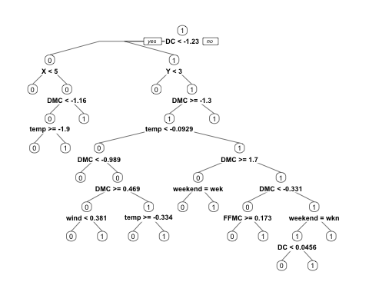

rpart_pred1 <- predict(rpartmodel1, newdata = subset(test, select = c(- area1)), type="class")  
confusionMatrix(rpart_pred1, factor(test$area1))

## Confusion Matrix and Statistics  
##   
## Reference  
## Prediction 0 1  
## 0 35 32  
## 1 34 54  
##   
## Accuracy : 0.5742   
## 95% CI : (0.4923, 0.6532)  
## No Information Rate : 0.5548   
## P-Value [Acc > NIR] : 0.3441   
##   
## Kappa : 0.1355   
## Mcnemar's Test P-Value : 0.9020   
##   
## Sensitivity : 0.5072   
## Specificity : 0.6279   
## Pos Pred Value : 0.5224   
## Neg Pred Value : 0.6136   
## Prevalence : 0.4452   
## Detection Rate : 0.2258   
## Detection Prevalence : 0.4323   
## Balanced Accuracy : 0.5676   
##   
## 'Positive' Class : 0   
##

#minsplit,cp 조정  
set.seed(12345)  
rpartmodel4 <- rpart(factor(area1)~.,data=train,minsplit=6,cp=0.005)  
rpartmodel4

## n= 362   
##   
## node), split, n, loss, yval, (yprob)  
## * denotes terminal node  
##   
## 1) root 362 178 1 (0.49171271 0.50828729)   
## 2) DC< -1.228463 58 18 0 (0.68965517 0.31034483)   
## 4) X< 4.5 28 4 0 (0.85714286 0.14285714) *  
## 5) X>=4.5 30 14 0 (0.53333333 0.46666667)   
## 10) FFMC>=0.154946 5 0 0 (1.00000000 0.00000000) *  
## 11) FFMC< 0.154946 25 11 1 (0.44000000 0.56000000)   
## 22) wind< -0.6237825 5 0 0 (1.00000000 0.00000000) *  
## 23) wind>=-0.6237825 20 6 1 (0.30000000 0.70000000)   
## 46) DMC< -1.218995 13 6 1 (0.46153846 0.53846154)   
## 92) DMC>=-1.365763 3 0 0 (1.00000000 0.00000000) *  
## 93) DMC< -1.365763 10 3 1 (0.30000000 0.70000000)   
## 186) ISI>=-0.4433981 5 2 0 (0.60000000 0.40000000) *  
## 187) ISI< -0.4433981 5 0 1 (0.00000000 1.00000000) *  
## 47) DMC>=-1.218995 7 0 1 (0.00000000 1.00000000) *  
## 3) DC>=-1.228463 304 138 1 (0.45394737 0.54605263)   
## 6) Y< 2.5 29 9 0 (0.68965517 0.31034483)   
## 12) temp>=-0.06702142 22 5 0 (0.77272727 0.22727273)   
## 24) ISI< 1.453749 19 3 0 (0.84210526 0.15789474)   
## 48) wind>=-0.7633185 11 0 0 (1.00000000 0.00000000) *  
## 49) wind< -0.7633185 8 3 0 (0.62500000 0.37500000)   
## 98) RH< -0.5998602 4 0 0 (1.00000000 0.00000000) *  
## 99) RH>=-0.5998602 4 1 1 (0.25000000 0.75000000) *  
## 25) ISI>=1.453749 3 1 1 (0.33333333 0.66666667) *  
## 13) temp< -0.06702142 7 3 1 (0.42857143 0.57142857)   
## 26) X< 1.5 4 1 0 (0.75000000 0.25000000) *  
## 27) X>=1.5 3 0 1 (0.00000000 1.00000000) *  
## 7) Y>=2.5 275 118 1 (0.42909091 0.57090909)   
## 14) DMC>=-1.304089 267 118 1 (0.44194757 0.55805243)   
## 28) temp< -0.09285398 80 35 0 (0.56250000 0.43750000)   
## 56) DMC< -0.9894742 7 0 0 (1.00000000 0.00000000) *  
## 57) DMC>=-0.9894742 73 35 0 (0.52054795 0.47945205)   
## 114) DMC>=0.4688417 22 6 0 (0.72727273 0.27272727)   
## 228) wind< 0.3808765 12 0 0 (1.00000000 0.00000000) *  
## 229) wind>=0.3808765 10 4 1 (0.40000000 0.60000000)   
## 458) DC< 0.326969 3 0 0 (1.00000000 0.00000000) *  
## 459) DC>=0.326969 7 1 1 (0.14285714 0.85714286) *  
## 115) DMC< 0.4688417 51 22 1 (0.43137255 0.56862745)   
## 230) temp>=-0.3339579 20 7 0 (0.65000000 0.35000000)   
## 460) RH>=0.748388 6 0 0 (1.00000000 0.00000000) *  
## 461) RH< 0.748388 14 7 0 (0.50000000 0.50000000)   
## 922) temp>=-0.2392385 11 4 0 (0.63636364 0.36363636)   
## 1844) wind>=-0.8749473 8 1 0 (0.87500000 0.12500000) *  
## 1845) wind< -0.8749473 3 0 1 (0.00000000 1.00000000) *  
## 923) temp< -0.2392385 3 0 1 (0.00000000 1.00000000) *  
## 231) temp< -0.3339579 31 9 1 (0.29032258 0.70967742)   
## 462) RH>=0.8096721 16 7 1 (0.43750000 0.56250000)   
## 924) Y>=4.5 3 0 0 (1.00000000 0.00000000) *  
## 925) Y< 4.5 13 4 1 (0.30769231 0.69230769)   
## 1850) RH>=1.790216 5 2 0 (0.60000000 0.40000000) *  
## 1851) RH< 1.790216 8 1 1 (0.12500000 0.87500000) *  
## 463) RH< 0.8096721 15 2 1 (0.13333333 0.86666667) *  
## 29) temp>=-0.09285398 187 73 1 (0.39037433 0.60962567)   
## 58) DMC>=1.704663 20 8 0 (0.60000000 0.40000000)   
## 116) temp< 1.336548 17 5 0 (0.70588235 0.29411765)   
## 232) RH< -0.07894614 6 0 0 (1.00000000 0.00000000) *  
## 233) RH>=-0.07894614 11 5 0 (0.54545455 0.45454545)   
## 466) ISI< -0.4214657 3 0 0 (1.00000000 0.00000000) *  
## 467) ISI>=-0.4214657 8 3 1 (0.37500000 0.62500000)   
## 934) temp< 0.08797394 3 1 0 (0.66666667 0.33333333) *  
## 935) temp>=0.08797394 5 1 1 (0.20000000 0.80000000) *  
## 117) temp>=1.336548 3 0 1 (0.00000000 1.00000000) *  
## 59) DMC< 1.704663 167 61 1 (0.36526946 0.63473054)   
## 118) DMC< -0.3313584 29 13 0 (0.55172414 0.44827586)   
## 236) FFMC>=0.1730616 14 3 0 (0.78571429 0.21428571)   
## 472) FFMC< 0.5172576 7 0 0 (1.00000000 0.00000000) *  
## 473) FFMC>=0.5172576 7 3 0 (0.57142857 0.42857143)   
## 946) wind< 0.1297118 3 0 0 (1.00000000 0.00000000) *  
## 947) wind>=0.1297118 4 1 1 (0.25000000 0.75000000) *  
## 237) FFMC< 0.1730616 15 5 1 (0.33333333 0.66666667)   
## 474) Y< 3.5 2 0 0 (1.00000000 0.00000000) *  
## 475) Y>=3.5 13 3 1 (0.23076923 0.76923077) *  
## 119) DMC>=-0.3313584 138 45 1 (0.32608696 0.67391304)   
## 238) weekend=weekend 49 22 1 (0.44897959 0.55102041)   
## 476) DC< 0.04559251 9 2 0 (0.77777778 0.22222222)   
## 952) temp< 1.017946 7 0 0 (1.00000000 0.00000000) *  
## 953) temp>=1.017946 2 0 1 (0.00000000 1.00000000) *  
## 477) DC>=0.04559251 40 15 1 (0.37500000 0.62500000)   
## 954) DMC< 0.9700402 33 15 1 (0.45454545 0.54545455)   
## 1908) RH< -0.2934402 21 9 0 (0.57142857 0.42857143)   
## 3816) temp< 0.6821228 7 1 0 (0.85714286 0.14285714) *  
## 3817) temp>=0.6821228 14 6 1 (0.42857143 0.57142857)   
## 7634) X>=6.5 2 0 0 (1.00000000 0.00000000) *  
## 7635) X< 6.5 12 4 1 (0.33333333 0.66666667)   
## 15270) Y< 4.5 9 4 1 (0.44444444 0.55555556)   
## 30540) temp>=0.8801725 6 2 0 (0.66666667 0.33333333) *  
## 30541) temp< 0.8801725 3 0 1 (0.00000000 1.00000000) *  
## 15271) Y>=4.5 3 0 1 (0.00000000 1.00000000) *  
## 1909) RH>=-0.2934402 12 3 1 (0.25000000 0.75000000)   
## 3818) DMC>=0.1526651 6 3 0 (0.50000000 0.50000000)   
## 7636) RH>=-0.1708722 3 0 0 (1.00000000 0.00000000) *  
## 7637) RH< -0.1708722 3 0 1 (0.00000000 1.00000000) *  
## 3819) DMC< 0.1526651 6 0 1 (0.00000000 1.00000000) *  
## 955) DMC>=0.9700402 7 0 1 (0.00000000 1.00000000) *  
## 239) weekend=week 89 23 1 (0.25842697 0.74157303)   
## 478) RH< -1.028848 15 7 1 (0.46666667 0.53333333)   
## 956) ISI< -0.0047513 6 1 0 (0.83333333 0.16666667) *  
## 957) ISI>=-0.0047513 9 2 1 (0.22222222 0.77777778) *  
## 479) RH>=-1.028848 74 16 1 (0.21621622 0.78378378)   
## 958) FFMC>=0.970147 2 0 0 (1.00000000 0.00000000) *  
## 959) FFMC< 0.970147 72 14 1 (0.19444444 0.80555556)   
## 1918) RH< 0.2581159 61 14 1 (0.22950820 0.77049180)   
## 3836) ISI>=0.6532189 20 8 1 (0.40000000 0.60000000)   
## 7672) FFMC< 0.5081998 9 3 0 (0.66666667 0.33333333)   
## 15344) temp>=0.5874034 4 0 0 (1.00000000 0.00000000) *  
## 15345) temp< 0.5874034 5 2 1 (0.40000000 0.60000000) *  
## 7673) FFMC>=0.5081998 11 2 1 (0.18181818 0.81818182) *  
## 3837) ISI< 0.6532189 41 6 1 (0.14634146 0.85365854)   
## 7674) FFMC< 0.05531033 3 1 0 (0.66666667 0.33333333) *  
## 7675) FFMC>=0.05531033 38 4 1 (0.10526316 0.89473684)   
## 15350) DC>=0.8103078 12 3 1 (0.25000000 0.75000000)   
## 30700) FFMC< 0.1640038 2 0 0 (1.00000000 0.00000000) *  
## 30701) FFMC>=0.1640038 10 1 1 (0.10000000 0.90000000) *  
## 15351) DC< 0.8103078 26 1 1 (0.03846154 0.96153846) *  
## 1919) RH>=0.2581159 11 0 1 (0.00000000 1.00000000) *  
## 15) DMC< -1.304089 8 0 1 (0.00000000 1.00000000) *

prp(rpartmodel4 , type=2, digits=3) #cp값을 낮추니 복잡해짐

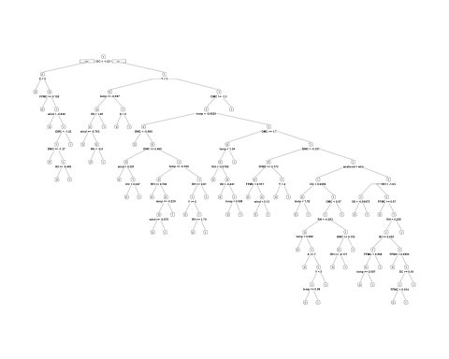

rpart_pred4 <- predict(rpartmodel4,subset(test,select=-area1),type="class")  
confusionMatrix(rpart_pred4,factor(test$area1))

## Confusion Matrix and Statistics  
##   
## Reference  
## Prediction 0 1  
## 0 46 42  
## 1 23 44  
##   
## Accuracy : 0.5806   
## 95% CI : (0.4988, 0.6593)  
## No Information Rate : 0.5548   
## P-Value [Acc > NIR] : 0.28657   
##   
## Kappa : 0.1736   
## Mcnemar's Test P-Value : 0.02557   
##   
## Sensitivity : 0.6667   
## Specificity : 0.5116   
## Pos Pred Value : 0.5227   
## Neg Pred Value : 0.6567   
## Prevalence : 0.4452   
## Detection Rate : 0.2968   
## Detection Prevalence : 0.5677   
## Balanced Accuracy : 0.5891   
##   
## 'Positive' Class : 0   
##

rpart_pred4_train <- predict(rpartmodel4,subset(train,select=-area1),type="class")  
confusionMatrix(rpart_pred4_train,factor(train$area1))

## Confusion Matrix and Statistics  
##   
## Reference  
## Prediction 0 1  
## 0 159 16  
## 1 19 168  
##   
## Accuracy : 0.9033   
## 95% CI : (0.8681, 0.9317)  
## No Information Rate : 0.5083   
## P-Value [Acc > NIR] : <2e-16   
##   
## Kappa : 0.8065   
## Mcnemar's Test P-Value : 0.7353   
##   
## Sensitivity : 0.8933   
## Specificity : 0.9130   
## Pos Pred Value : 0.9086   
## Neg Pred Value : 0.8984   
## Prevalence : 0.4917   
## Detection Rate : 0.4392   
## Detection Prevalence : 0.4834   
## Balanced Accuracy : 0.9032   
##   
## 'Positive' Class : 0   
##

# overfit이 생긴다!  
  
########################################## pruning ##################################################  
  
printcp(rpartmodel4) # == rpartmodel4$cptable

##   
## Classification tree:  
## rpart(formula = factor(area1) ~ ., data = train, minsplit = 6,   
## cp = 0.005)  
##   
## Variables actually used in tree construction:  
## [1] DC DMC FFMC ISI RH temp weekend wind   
## [9] X Y   
##   
## Root node error: 178/362 = 0.49171  
##   
## n= 362   
##   
## CP nsplit rel error xerror xstd  
## 1 0.123596 0 1.00000 1.15730 0.052932  
## 2 0.061798 1 0.87640 1.01685 0.053445  
## 3 0.028090 2 0.81461 0.94944 0.053327  
## 4 0.022472 4 0.75843 0.94382 0.053307  
## 5 0.019663 7 0.69101 0.96067 0.053363  
## 6 0.016854 10 0.61798 0.91573 0.053180  
## 7 0.014981 11 0.60112 0.92697 0.053235  
## 8 0.014045 14 0.55618 0.94382 0.053307  
## 9 0.011236 18 0.50000 0.97753 0.053405  
## 10 0.008427 26 0.41011 1.01685 0.053445  
## 11 0.005618 38 0.30337 0.97191 0.053392  
## 12 0.005000 57 0.19663 0.98876 0.053424

plotcp(rpartmodel4)

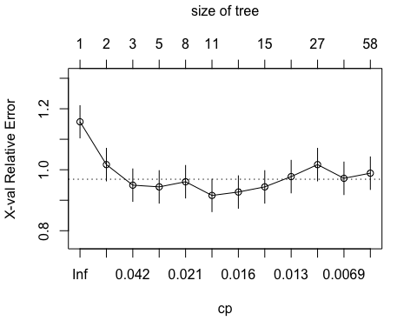

rpartmodel4_prune <- prune(rpartmodel4,  
 cp=rpartmodel4$cptable[which.min(rpartmodel4$cptable[,"xerror"])],"CP")  
prp(rpartmodel4_prune, type=2, digits=3)

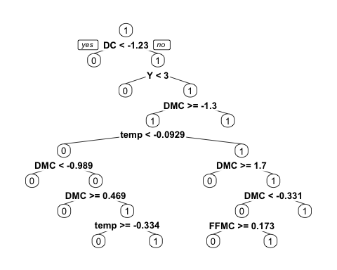

rpart_pred4_prune <- predict(rpartmodel4_prune,subset(test,select=-area1),type="class") #test accuracy  
confusionMatrix(rpart_pred4_prune,factor(test$area1))

## Confusion Matrix and Statistics  
##   
## Reference  
## Prediction 0 1  
## 0 39 42  
## 1 30 44  
##   
## Accuracy : 0.5355   
## 95% CI : (0.4537, 0.6159)  
## No Information Rate : 0.5548   
## P-Value [Acc > NIR] : 0.7148   
##   
## Kappa : 0.0755   
## Mcnemar's Test P-Value : 0.1949   
##   
## Sensitivity : 0.5652   
## Specificity : 0.5116   
## Pos Pred Value : 0.4815   
## Neg Pred Value : 0.5946   
## Prevalence : 0.4452   
## Detection Rate : 0.2516   
## Detection Prevalence : 0.5226   
## Balanced Accuracy : 0.5384   
##   
## 'Positive' Class : 0   
##

#accuracy : 0.5677 tree가 간단해졌는데 acc는 올랐다.  
rpart_pred4_prune_train <- predict(rpartmodel4_prune,subset(train,select=-area1),type="class") #train accuracy  
confusionMatrix(rpart_pred4_prune_train, factor(train$area1))

## Confusion Matrix and Statistics  
##   
## Reference  
## Prediction 0 1  
## 0 119 51  
## 1 59 133  
##   
## Accuracy : 0.6961   
## 95% CI : (0.6459, 0.7431)  
## No Information Rate : 0.5083   
## P-Value [Acc > NIR] : 3.078e-13   
##   
## Kappa : 0.3917   
## Mcnemar's Test P-Value : 0.5045   
##   
## Sensitivity : 0.6685   
## Specificity : 0.7228   
## Pos Pred Value : 0.7000   
## Neg Pred Value : 0.6927   
## Prevalence : 0.4917   
## Detection Rate : 0.3287   
## Detection Prevalence : 0.4696   
## Balanced Accuracy : 0.6957   
##   
## 'Positive' Class : 0   
##

#xgboost  
set.seed(12345)  
index <- createDataPartition(data_model2$area1, p = 0.7, list = FALSE)  
train <- data_model2[index, ]; test <- data_model2[-index, ]  
  
library(xgboost)

##   
## Attaching package: 'xgboost'

## The following object is masked from 'package:dplyr':  
##   
## slice

model.xg <- xgboost(data = data.matrix(train[,-13]), label = train[,13], max_depth = 4, nrounds = 30, objective = "binary:logistic" )

## [1] train-error:0.328729   
## [2] train-error:0.290055   
## [3] train-error:0.281768   
## [4] train-error:0.243094   
## [5] train-error:0.209945   
## [6] train-error:0.209945   
## [7] train-error:0.196133   
## [8] train-error:0.190608   
## [9] train-error:0.182320   
## [10] train-error:0.174033   
## [11] train-error:0.157459   
## [12] train-error:0.143646   
## [13] train-error:0.132597   
## [14] train-error:0.127072   
## [15] train-error:0.116022   
## [16] train-error:0.116022   
## [17] train-error:0.110497   
## [18] train-error:0.096685   
## [19] train-error:0.096685   
## [20] train-error:0.096685   
## [21] train-error:0.091160   
## [22] train-error:0.088398   
## [23] train-error:0.077348   
## [24] train-error:0.069061   
## [25] train-error:0.069061   
## [26] train-error:0.069061   
## [27] train-error:0.060773   
## [28] train-error:0.060773   
## [29] train-error:0.058011   
## [30] train-error:0.058011

pred <- as.numeric(predict(model.xg, data.matrix(test[,-13])) > 0.5)  
confusionMatrix(table(pred, test$area1))

## Confusion Matrix and Statistics  
##   
##   
## pred 0 1  
## 0 37 33  
## 1 32 53  
##   
## Accuracy : 0.5806   
## 95% CI : (0.4988, 0.6593)  
## No Information Rate : 0.5548   
## P-Value [Acc > NIR] : 0.2866   
##   
## Kappa : 0.1523   
## Mcnemar's Test P-Value : 1.0000   
##   
## Sensitivity : 0.5362   
## Specificity : 0.6163   
## Pos Pred Value : 0.5286   
## Neg Pred Value : 0.6235   
## Prevalence : 0.4452   
## Detection Rate : 0.2387   
## Detection Prevalence : 0.4516   
## Balanced Accuracy : 0.5763   
##   
## 'Positive' Class : 0   
##

#Random Forest  
set.seed(12345)  
index <- createDataPartition(data_model2$area1, p = 0.7, list = FALSE)  
train <- data_model2[index, ]; test <- data_model2[-index, ]  
  
library(randomForest)

## randomForest 4.6-14

## Type rfNews() to see new features/changes/bug fixes.

##   
## Attaching package: 'randomForest'

## The following object is masked from 'package:dplyr':  
##   
## combine

## The following object is masked from 'package:ggplot2':  
##   
## margin

model.rf <- randomForest(factor(area1) ~., data = train, proximity = T)  
round(importance(model.rf))

## MeanDecreaseGini  
## X 15  
## Y 11  
## FFMC 17  
## DMC 22  
## DC 20  
## ISI 18  
## temp 27  
## RH 22  
## wind 18  
## rain 1  
## weather 4  
## weekend 3

pred.rf <- predict(model.rf, test[,-13])  
confusionMatrix(table(pred.rf, test$area1))

## Confusion Matrix and Statistics  
##   
##   
## pred.rf 0 1  
## 0 40 28  
## 1 29 58  
##   
## Accuracy : 0.6323   
## 95% CI : (0.5512, 0.7082)  
## No Information Rate : 0.5548   
## P-Value [Acc > NIR] : 0.03084   
##   
## Kappa : 0.2545   
## Mcnemar's Test P-Value : 1.00000   
##   
## Sensitivity : 0.5797   
## Specificity : 0.6744   
## Pos Pred Value : 0.5882   
## Neg Pred Value : 0.6667   
## Prevalence : 0.4452   
## Detection Rate : 0.2581   
## Detection Prevalence : 0.4387   
## Balanced Accuracy : 0.6271   
##   
## 'Positive' Class : 0   
##