HW5_write_up

Seré Williams

11/11/2019

knitr::opts_chunk$set(echo = TRUE, message = FALSE, warning = FALSE, error = FALSE)

## Load Libraries

library(readr)  
library(dplyr)  
library(tidyr)  
library(ggplot2)  
library(sf)  
library(tigris)  
options(tigris_class = "sf")  
library(scales)  
library(forcats)

## Load and clean the homicide data. Filter for Chicago and modify victim_race and disposition vectors.

homicide <- read_csv("../data/homicide-data.csv")  
chicago <- homicide %>%   
 filter(city == "Chicago") %>%   
 mutate(victim_race = fct_lump(victim_race, n = 3)) %>%   
 mutate(disposition = as_factor(x = disposition),  
 disposition = fct_recode(.f = disposition,  
 Solved = "Closed by arrest",  
 Unsolved = "Closed without arrest",  
 Unsolved = "Open/No arrest"))

## Practice with counties using sf and tigris.

il_counties <- counties(state = "IL", cb = TRUE, class = "sf")

##   
 |   
 | | 0%  
 |   
 | | 1%  
 |   
 |= | 1%  
 |   
 |= | 2%  
 |   
 |== | 2%  
 |   
 |== | 3%  
 |   
 |== | 4%  
 |   
 |=== | 4%  
 |   
 |=== | 5%  
 |   
 |==== | 5%  
 |   
 |==== | 6%  
 |   
 |==== | 7%  
 |   
 |===== | 7%  
 |   
 |===== | 8%  
 |   
 |====== | 9%  
 |   
 |====== | 10%  
 |   
 |======= | 10%  
 |   
 |======= | 11%  
 |   
 |======== | 12%  
 |   
 |======== | 13%  
 |   
 |========= | 13%  
 |   
 |========= | 14%  
 |   
 |========= | 15%  
 |   
 |========== | 15%  
 |   
 |========== | 16%  
 |   
 |=========== | 16%  
 |   
 |=========== | 17%  
 |   
 |=========== | 18%  
 |   
 |============ | 18%  
 |   
 |============ | 19%  
 |   
 |============= | 19%  
 |   
 |============= | 20%  
 |   
 |============= | 21%  
 |   
 |============== | 21%  
 |   
 |============== | 22%  
 |   
 |=============== | 22%  
 |   
 |=============== | 23%  
 |   
 |=============== | 24%  
 |   
 |================ | 24%  
 |   
 |================ | 25%  
 |   
 |================= | 25%  
 |   
 |================= | 26%  
 |   
 |================= | 27%  
 |   
 |================== | 27%  
 |   
 |================== | 28%  
 |   
 |=================== | 29%  
 |   
 |=================== | 30%  
 |   
 |==================== | 30%  
 |   
 |==================== | 31%  
 |   
 |==================== | 32%  
 |   
 |===================== | 32%  
 |   
 |===================== | 33%  
 |   
 |====================== | 33%  
 |   
 |====================== | 34%  
 |   
 |====================== | 35%  
 |   
 |======================= | 35%  
 |   
 |======================= | 36%  
 |   
 |======================== | 36%  
 |   
 |======================== | 37%  
 |   
 |======================== | 38%  
 |   
 |========================= | 38%  
 |   
 |========================= | 39%  
 |   
 |========================== | 39%  
 |   
 |========================== | 40%  
 |   
 |========================== | 41%  
 |   
 |=========================== | 41%  
 |   
 |=========================== | 42%  
 |   
 |============================ | 42%  
 |   
 |============================ | 43%  
 |   
 |============================ | 44%  
 |   
 |============================= | 44%  
 |   
 |============================= | 45%  
 |   
 |============================== | 45%  
 |   
 |============================== | 46%  
 |   
 |============================== | 47%  
 |   
 |=============================== | 47%  
 |   
 |=============================== | 48%  
 |   
 |================================ | 49%  
 |   
 |================================ | 50%  
 |   
 |================================= | 50%  
 |   
 |================================= | 51%  
 |   
 |================================== | 52%  
 |   
 |================================== | 53%  
 |   
 |=================================== | 53%  
 |   
 |=================================== | 54%  
 |   
 |=================================== | 55%  
 |   
 |==================================== | 55%  
 |   
 |==================================== | 56%  
 |   
 |===================================== | 56%  
 |   
 |===================================== | 57%  
 |   
 |===================================== | 58%  
 |   
 |====================================== | 58%  
 |   
 |====================================== | 59%  
 |   
 |======================================= | 59%  
 |   
 |======================================= | 60%  
 |   
 |======================================= | 61%  
 |   
 |======================================== | 61%  
 |   
 |======================================== | 62%  
 |   
 |========================================= | 62%  
 |   
 |========================================= | 63%  
 |   
 |========================================= | 64%  
 |   
 |========================================== | 64%  
 |   
 |========================================== | 65%  
 |   
 |=========================================== | 65%  
 |   
 |=========================================== | 66%  
 |   
 |=========================================== | 67%  
 |   
 |============================================ | 67%  
 |   
 |============================================ | 68%  
 |   
 |============================================= | 68%  
 |   
 |============================================= | 69%  
 |   
 |============================================= | 70%  
 |   
 |============================================== | 70%  
 |   
 |============================================== | 71%  
 |   
 |============================================== | 72%  
 |   
 |=============================================== | 72%  
 |   
 |=============================================== | 73%  
 |   
 |================================================ | 73%  
 |   
 |================================================ | 74%  
 |   
 |================================================ | 75%  
 |   
 |================================================= | 75%  
 |   
 |================================================= | 76%  
 |   
 |================================================== | 76%  
 |   
 |================================================== | 77%  
 |   
 |================================================== | 78%  
 |   
 |=================================================== | 78%  
 |   
 |=================================================== | 79%  
 |   
 |==================================================== | 79%  
 |   
 |==================================================== | 80%  
 |   
 |==================================================== | 81%  
 |   
 |===================================================== | 81%  
 |   
 |===================================================== | 82%  
 |   
 |====================================================== | 82%  
 |   
 |====================================================== | 83%  
 |   
 |====================================================== | 84%  
 |   
 |======================================================= | 84%  
 |   
 |======================================================= | 85%  
 |   
 |======================================================== | 86%  
 |   
 |======================================================== | 87%  
 |   
 |========================================================= | 87%  
 |   
 |========================================================= | 88%  
 |   
 |========================================================== | 89%  
 |   
 |========================================================== | 90%  
 |   
 |=========================================================== | 90%  
 |   
 |=========================================================== | 91%  
 |   
 |============================================================ | 92%  
 |   
 |============================================================ | 93%  
 |   
 |============================================================= | 93%  
 |   
 |============================================================= | 94%  
 |   
 |============================================================== | 95%  
 |   
 |============================================================== | 96%  
 |   
 |=============================================================== | 96%  
 |   
 |=============================================================== | 97%  
 |   
 |=============================================================== | 98%  
 |   
 |================================================================ | 98%  
 |   
 |================================================================ | 99%  
 |   
 |=================================================================| 99%  
 |   
 |=================================================================| 100%

class(il_counties)

## [1] "sf" "data.frame"

il_counties %>%   
 slice(1:3)

## Simple feature collection with 3 features and 9 fields  
## geometry type: MULTIPOLYGON  
## dimension: XY  
## bbox: xmin: -89.60386 ymin: 39.91692 xmax: -87.52535 ymax: 42.49622  
## epsg (SRID): 4269  
## proj4string: +proj=longlat +ellps=GRS80 +towgs84=0,0,0,0,0,0,0 +no_defs  
## STATEFP COUNTYFP COUNTYNS AFFGEOID GEOID NAME LSAD ALAND  
## 1 17 097 01784796 0500000US17097 17097 Lake 06 1149926934  
## 2 17 107 00424255 0500000US17107 17107 Logan 06 1600758859  
## 3 17 197 01785190 0500000US17197 17197 Will 06 2166099738  
## AWATER geometry  
## 1 2394188156 MULTIPOLYGON (((-88.19955 4...  
## 2 2252736 MULTIPOLYGON (((-89.60385 4...  
## 3 33374154 MULTIPOLYGON (((-88.26127 4...

class(il_counties$geometry)

## [1] "sfc_MULTIPOLYGON" "sfc"

ggplot() +  
 geom_sf(data = il_counties)

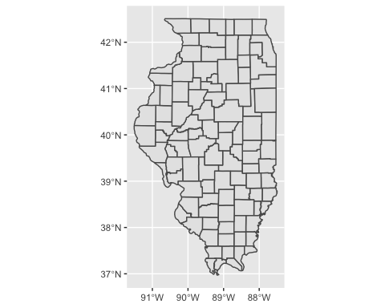

## Narrow in on Chicago (Cook County).

cook <- il_counties %>%   
 filter(NAME == "Cook")  
cook

## Simple feature collection with 1 feature and 9 fields  
## geometry type: MULTIPOLYGON  
## dimension: XY  
## bbox: xmin: -88.26357 ymin: 41.46971 xmax: -87.52404 ymax: 42.15426  
## epsg (SRID): 4269  
## proj4string: +proj=longlat +ellps=GRS80 +towgs84=0,0,0,0,0,0,0 +no_defs  
## STATEFP COUNTYFP COUNTYNS AFFGEOID GEOID NAME LSAD ALAND  
## 1 17 031 01784766 0500000US17031 17031 Cook 06 2447469694  
## AWATER geometry  
## 1 1786452809 MULTIPOLYGON (((-88.26329 4...

ggplot() +  
 geom_sf(data = il_counties, color = "lightgray") +  
 geom_sf(data = cook, fill = "darkcyan") +  
 geom_sf_text(data = cook, aes(label = NAME),  
 color = "white",  
 nudge_y = .26) +  
 theme_dark() +  
 labs(x = "", y = "")

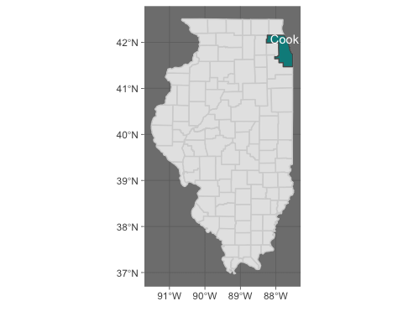

## Consider tracts.

cook_tracts <- tracts("IL", county = "cook", cb = TRUE)

##   
 |   
 | | 0%  
 |   
 |= | 1%  
 |   
 |= | 2%  
 |   
 |== | 3%  
 |   
 |== | 4%  
 |   
 |=== | 5%  
 |   
 |==== | 5%  
 |   
 |==== | 7%  
 |   
 |===== | 8%  
 |   
 |====== | 9%  
 |   
 |======= | 10%  
 |   
 |======= | 11%  
 |   
 |======== | 12%  
 |   
 |======== | 13%  
 |   
 |========= | 14%  
 |   
 |========== | 15%  
 |   
 |========== | 16%  
 |   
 |=========== | 17%  
 |   
 |============ | 18%  
 |   
 |============ | 19%  
 |   
 |============= | 19%  
 |   
 |============= | 20%  
 |   
 |============== | 21%  
 |   
 |============== | 22%  
 |   
 |=============== | 23%  
 |   
 |================ | 25%  
 |   
 |================= | 26%  
 |   
 |================== | 27%  
 |   
 |================== | 28%  
 |   
 |=================== | 29%  
 |   
 |=================== | 30%  
 |   
 |==================== | 31%  
 |   
 |===================== | 32%  
 |   
 |===================== | 33%  
 |   
 |====================== | 34%  
 |   
 |======================= | 35%  
 |   
 |======================= | 36%  
 |   
 |======================== | 37%  
 |   
 |======================== | 38%  
 |   
 |========================= | 38%  
 |   
 |========================= | 39%  
 |   
 |========================== | 40%  
 |   
 |=========================== | 42%  
 |   
 |============================ | 43%  
 |   
 |============================= | 44%  
 |   
 |============================= | 45%  
 |   
 |============================== | 46%  
 |   
 |=============================== | 47%  
 |   
 |=============================== | 48%  
 |   
 |================================ | 49%  
 |   
 |================================= | 51%  
 |   
 |================================== | 52%  
 |   
 |================================== | 53%  
 |   
 |=================================== | 54%  
 |   
 |==================================== | 55%  
 |   
 |==================================== | 56%  
 |   
 |===================================== | 56%  
 |   
 |===================================== | 57%  
 |   
 |===================================== | 58%  
 |   
 |====================================== | 59%  
 |   
 |======================================= | 59%  
 |   
 |======================================= | 60%  
 |   
 |======================================== | 61%  
 |   
 |======================================== | 62%  
 |   
 |========================================= | 63%  
 |   
 |========================================== | 64%  
 |   
 |========================================== | 65%  
 |   
 |=========================================== | 66%  
 |   
 |============================================ | 68%  
 |   
 |============================================= | 69%  
 |   
 |============================================= | 70%  
 |   
 |============================================== | 71%  
 |   
 |=============================================== | 72%  
 |   
 |=============================================== | 73%  
 |   
 |================================================ | 73%  
 |   
 |================================================= | 75%  
 |   
 |================================================= | 76%  
 |   
 |================================================== | 76%  
 |   
 |================================================== | 78%  
 |   
 |=================================================== | 79%  
 |   
 |==================================================== | 80%  
 |   
 |===================================================== | 81%  
 |   
 |===================================================== | 82%  
 |   
 |====================================================== | 83%  
 |   
 |======================================================= | 84%  
 |   
 |======================================================= | 85%  
 |   
 |======================================================== | 86%  
 |   
 |========================================================= | 87%  
 |   
 |========================================================= | 88%  
 |   
 |========================================================== | 89%  
 |   
 |=========================================================== | 90%  
 |   
 |============================================================ | 92%  
 |   
 |============================================================= | 93%  
 |   
 |============================================================= | 94%  
 |   
 |============================================================= | 95%  
 |   
 |============================================================== | 95%  
 |   
 |=============================================================== | 96%  
 |   
 |=============================================================== | 97%  
 |   
 |================================================================ | 98%  
 |   
 |================================================================ | 99%  
 |   
 |=================================================================| 100%

ggplot() +  
 geom_sf(data = cook_tracts, color = "darkblue") +  
 theme_dark() +  
 labs(x = "", y = "")

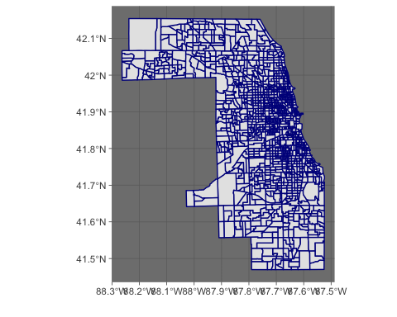

## Making sf object of lat and lon in homicide dataset and create plot.

il_point <- st_as_sf(chicago, coords=c("lon", "lat")) %>%  
 st_set_crs(4269)  
  
ggplot() +  
 geom_sf(data = cook_tracts, color = "goldenrod2") +  
 geom_sf(data = il_point, aes(color = victim_race, fill = victim_race)) +  
 theme_dark() +  
 labs(x = "", y = "") +  
 facet_wrap(~ disposition) +  
 theme(axis.text.x = element_text(angle = 45, hjust = 1)) +  
 ggtitle("Homicides in Chicago, IL")

