**Vission**

SYAID is proud of its working team who work on supporting the rights of the people to help them on staying in their land and face all the difficulties.

**Save 50% of Costs**

We reach more than 17.9 million readers every month. With channels in English, Spanish, Portuguese and Chinese, and more than 40 new projects published daily, no other architecture network has the global scope we have. Our editorial team works with thousands of practices around the world to deliver the best architecture, as soon as possible.

**INTERIOR DESIGN**



Everyone has a lifetime goal, which is constructing your dream home. But many people make mistakes after constructing their home. They fail to choose perfect interior designers. Designing your interiors is not an easy task, from layout to action plan each and every step should be taken very precisely.

**ARCHITECH**

Whether you gaze at the Rajasthan 'baolis' that create a cooler microclimate around the monument, Kathiawadi jali lattice work that replaces window frames or most famously, the Hawa Mahal in Jaipur.

**GARDEN VIEW**

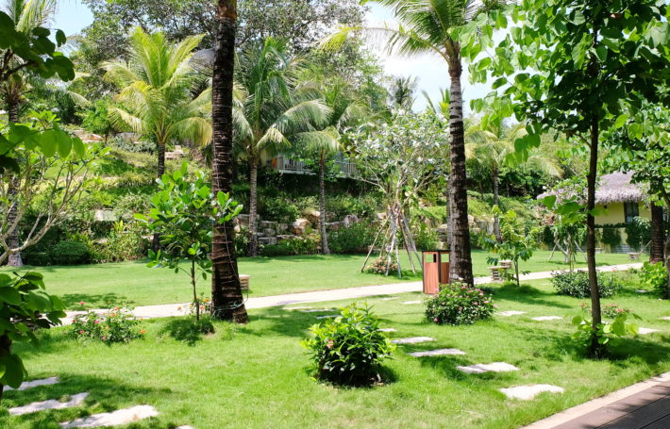

Deluxe Twin Garden View Room has a view of the garden which offers the most relaxing space with the most sound and colors but has a larger capacity with 2 twin beds. This room is the most suitable for some friends.

**WELCOME TO OUR PROFILE**



**Welcome to Our Company**

 08-Aug-2023  Writen by Vorleak

Tour a Luxury Lake House Inspired by Minecraft A love of Danish design and modern architecture infused this lake house, which sprang from the imagination of a video game executive with sophisticated style.Architect Ryan Stephenson has had clients come to him with plenty of dream-house visual aids. They’ve arrived with sketches, tear sheets from magazines, or Pinterest pages. But the Minecraft model that his clients Michael and Siobhán Persson presented him, with a dream house designed in the game’s blocky 3-D style, was a first.

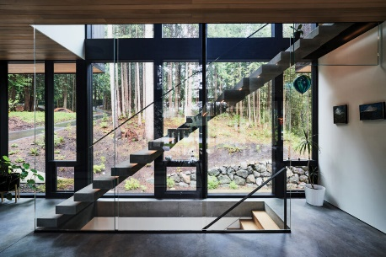

**Architect for Future**

 08-Aug-2023  Writen by Vorleak

MIP Architecture is an architectural firm founded by Michalis Patsalosavis, an architect who gained his early professional experience in the UK. Michalis obtained his BA (Honours) Degree at the University of Greenwich (RIBA Part 1) and consequently his Diploma at the Architectural Association (RIBA Part 2). He is currently a registered member of ETEK ARB and RIBA.



**Project Management**

 08-Aug-2023  Writen by Vorleak

We offer management services that can handle the heavy lifting for each stage of a project. Our comprehensive local knowledge, built over years of operating in Cambodia, and stand-out technical expertise ensure smooth delivery from inception to completion. At the early stage this process involves reviewing and revising building plans to meet design standards as well as appropriate regulations, preparing contracts with contractors and assisting with cost and time estimates. We perform regular site visits to establish quality control and expectations and to monitor overall progress and deadlines.

**MAIN MENU**

* HOME
* TYPOGRAPHY
* NAVIGATION
* COLOR
* LAYOUTS
* JOOMLA OVER VIEW
* THE NEWS

**LOGIN FORM**

User Name:



Password:



Remember me 

* Forget your Username?
* Forget your Password?
* Create New User Account

**Contact US**

Tel / Fax 023 880 612

Mobile 010 880 612, 011 600 619

012 395 190, 016 229 514

Facebook www.facebook.com/setecedu

Website www.setecu.com

**Company News**

**Social Media**

**Connect With AD**

* Team
* Careers
* Contact Us
* Terms & Conditions

**Information**

* Pricing
* About us
* Press room
* API
* Jobs
* Sell your content

**@SETEC**