# [Serhii](https://serg-yalosovetsky.github.io/CV/) [Yalosovetskyi](https://serg-yalosovetsky.github.io/CV/)

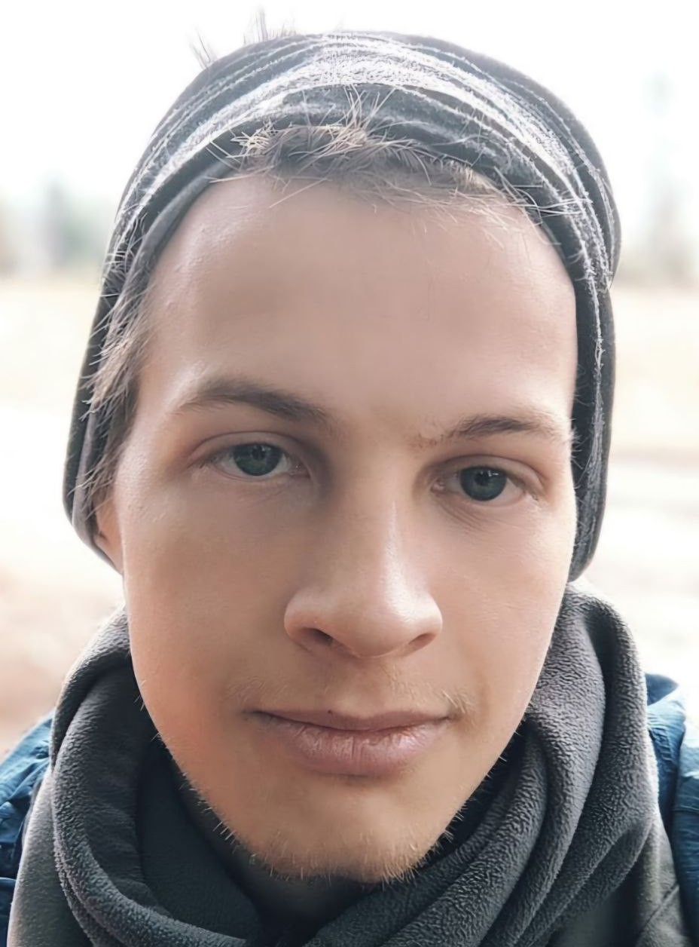

Full Stack Software Engineer - crafting

seamless digital experiences where code meets creativity.

[View the Project on GitHub](https://github.com/serg-yalosovetsky/CV)

[serg-yalosovetsky/CV](https://github.com/serg-yalosovetsky/CV)

# Full Stack Software Engineer

📧 Email: [serg.yalosovetsky@gmail.com](mailto:serg.yalosovetsky@gmail.com)

📱 Telegram: [@ozzzimandiya](https://t.me/ozzzimandiya)

🌐 GitHub: [https://github.com/serg-yalosovetsky](https://github.com/syalosovetskyi)

🔗 LinkedIn: <https://www.linkedin.com/in/serhii-yalosovetskyi/>

## Summa[ry](https://raw.githubusercontent.com/serg-yalosovetsky/CV/refs/heads/main/CV.pdf)

Full Stack Software Engineer specializing in Python, Flutter, and Svelte. Skilled in backend and mobile app development, DevOps, and cybersecurity, with a strong interest in machine learning and web technologies. Currently seeking full remote opportunities.

## Technical Skills

 Back-End

|  |  |  |  |  |  |  |
| --- | --- | --- | --- | --- | --- | --- |
| **P Y T H O N** | | **F A S T A P I** | | **P O S T G R E S Q L** | | **R E D I S** |
| **P L / S Q L** | **P I C C O L O** | | **D J A N G O** | | **D J A N G O R E S T A P I** | |

Mobile Development



**D A R T**

**F L U T T E R**

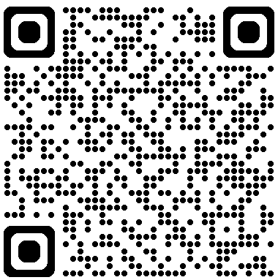Front-End

**H T M L 5**

**T A I L W I N D C S S**

**S V E L T E K I T**

**S V E L T E**

Tools & Platforms



**U B U N T U**

**B A S H**

**N G I N X**

**A N S I B L E**

**T E R R A F O R M**

**A W S**

**K U B E R N E T E S**

**D O C K E R**

**G I T**

Testing & Frameworks



**P Y T E S T**

Machine Learning

Experience with fast.ai and pytorch for image classification tasks.

## Education

Bachelor’s Degree in Informatics and Computer Engineering National Technical University of Ukraine “Igor Sikorsky Kyiv Polytechnic Institute”

*2014 – 2018*

Developed a CNN project to diagnose liver diseases.

## Research & Work Experience

### Software Developer

Techwhirl Infotech

*October 2024 – January 23, 2025*

 Built a backend for a Telegram-based crypto exchange using FastAPI

and Piccolo.

 Contributed to business requirement creation for the project.

 The project was discontinued after Telegram restricted blockchain exchanges except TON.

### Software Developer

Zeus Electronics

*2021 – October 2024*

Supported and developed Fyuzd, a synchronous audio streaming app.

Designed and implemented new architectures for the Fyuzd app.

Developed and maintained Zeem, a new streaming audio app based on microservices.

 Tested REST APIs and websites for performance and reliability.  Configured Kubernetes environments for Allgram CI/CD.

 Collaborated on defining business requirements for various projects.

### Cybersecurity Specialist

Vodafone Ukraine

*2018 – 2021*

 Developed REST APIs for API security testing.

 Created security standards aligned with OWASP Mobile Security Guide and OWASP Web App Security Guide.

 Enhanced infrastructure security using McAfee Endpoint Security and VMware ONE UEM.

 Conducted penetration testing for websites and mobile apps.  Created captcha to preventing DDOS attacks.

 Automated daily tasks with Bash and VBA scripting.

 Collaborated on creating business requirements for multiple projects.

### Software Developer

United Help Ukraine

*2022 – 2023*

 Developed backend views and models for the [UnitedHelp Project](https://github.com/serg-yalosovetsky/united_help).  Built a Flutter-based mobile app for volunteers.

 Defined business requirements for UnitedHelp systems.

## Projects

### [Captcha Project](https://github.com/serg-yalosovetsky/captcha)

 A Python-based tool for generating and verifying captchas to enhance security for web applications.

### [2048 Game](https://github.com/serg-yalosovetsky/2048)

 Implementation of the classic 2048 game on python, used TUI.

### [UnitedHelp Project (Inactive)](https://github.com/serg-yalosovetsky/united_help)

 A backend and mobile solution for volunteer operations, featuring task management and reporting capabilities.

### [SongLyrics App](https://github.com/serg-yalosovetsky/songs)

 A Flutter-based mobile app to search for song lyrics offline.

### [Portfolio Website](https://arbolev.pro/)

 A SvelteKit project with a landing page, portfolio, about page, request forms (Telegram integration), and a blog.

## Language Skills

 Ukrainian: Native.

 English: B2 (Upper-intermediate).

## Contact

📧 [serg.yalosovetsky@gmail.com](mailto:serg.yalosovetsky@gmail.com)

📱 [@ozzzimandiya](https://t.me/ozzzimandiya)

🌐 [GitHub Profile](https://github.com/serg-yalosovetsky/)