# [Serhii](https://serg-yalosovetsky.github.io/CV/) [Yalosovetskyi](https://serg-yalosovetsky.github.io/CV/)

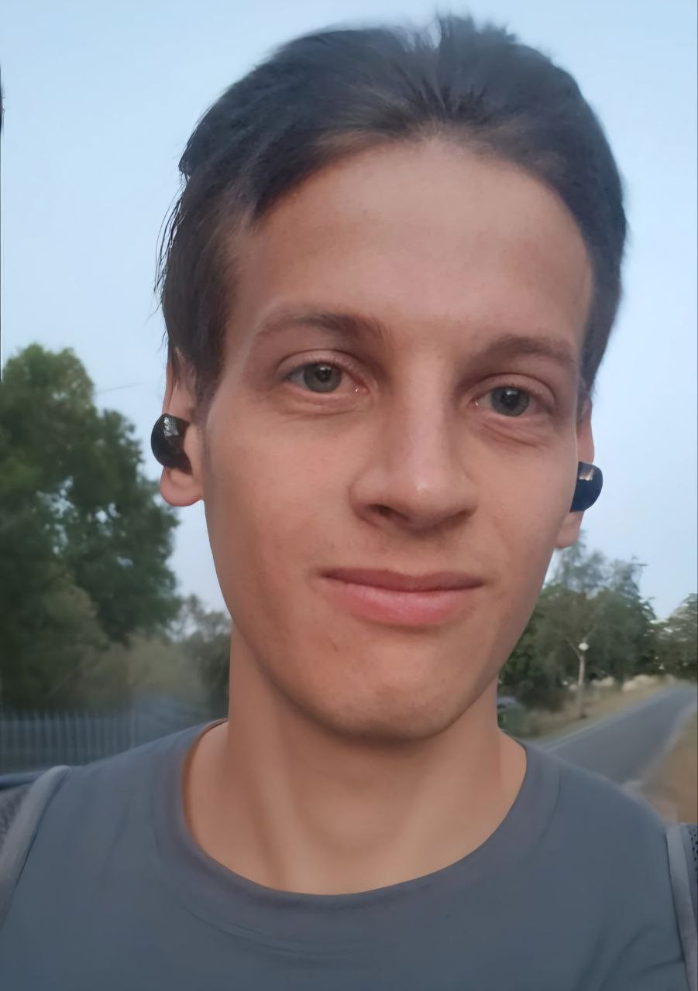

Full Stack Software Engineer - crafting

seamless digital experiences where code meets creativity.

[View the Project on GitHub](https://github.com/serg-yalosovetsky/CV)

[serg-yalosovetsky/CV](https://github.com/serg-yalosovetsky/CV)

# Full Stack Software Engineer

📧 Email: [serg.yalosovetsky@gmail.com](mailto:serg.yalosovetsky@gmail.com)

📱 Telegram: [@ozzzimandiya](https://t.me/ozzzimandiya)

🌐 GitHub: [https://github.com/serg-yalosovetsky](https://github.com/syalosovetskyi)

🔗 LinkedIn: <https://www.linkedin.com/in/serhii-yalosovetskyi/>

## CV: [pdf](https://raw.githubusercontent.com/serg-yalosovetsky/CV/refs/heads/main/Serhii_Yalosovetskyi_Resume.pdf) Summary

Full Stack Software Engineer specializing in Python, Flutter, and Svelte. Developed scalable backend systems and mobile applications, leveraging DevOps practices that improved deployment speed by 40%, leading to

quicker product iterations based on user feedback in agile environments.



Overall Industry 7 yrs Python & BackEnd 5+ yrs Software Development 7 yrs

Mobile (Flutter) 2-3 yrs

## Technical Skills

 Back-End



**F A S T A P I**

**P O S T G R E S Q L**

**P I C C O L O**

**D J A N G O**

**A S Y N C I O**

**P Y T H O N**

**R E D I S**

**P L / S Q L**

**D J A N G O R E S T A P I**

Mobile Development



**D A R T**

**F L U T T E R**

Front-End

**H T M L 5**

**T A I L W I N D C S S**

**S V E L T E K I T**

**S V E L T E**

Tools & Platforms



**U B U N T U**

**B A S H**

**N G I N X**

**A N S I B L E**

**T E R R A F O R M**

**A W S**

**K U B E R N E T E S**

**D O C K E R**

**G I T**

Testing & Frameworks



**P Y T E S T**

Machine Learning

**P Y T O R C H**

**F A S T . A I**

## Research & Work Experience

Software Developer

Techwhirl Infotech

*October 2024 – January 23, 2025*

 Engineered a robust backend for a Telegram-based crypto exchange using FastAPI and Piccolo, reducing transaction times to under 2

seconds while maintaining adherence to evolving blockchain regulations.

 Collaborated with cross-functional teams to define precise business requirements, enabling the rapid achievement of key milestones in just two months despite evolving project parameters.

Software Developer

Zeus Electronics

*2021 – October 2024*

This project is maintained by [serg-](https://github.com/serg-yalosovetsky) [yalosovetsky](https://github.com/serg-yalosovetsky)

Hosted on GitHub Pages — Theme by [orderedlist](https://github.com/orderedlist)

Redesigned architectural frameworks within Fyuzd, reducing monthly downtime incidents from six to one and ensuring smooth integration with existing workflows.

Transformed legacy systems into scalable, cloud-native architectures while aligning with industry standards, directly supporting the

company’s strategic objectives.

Executed comprehensive performance and reliability tests on REST APIs, pinpointing bottlenecks and driving a 50% acceleration in

response times across endpoints.

 Configured Kubernetes environments to streamline Allgram CI/CD pipelines.

 Analyzed requirements across three applications and collaborated with stakeholders to refine specifications, achieving a 25% reduction in initial development time.

Cybersecurity Specialist

Vodafone Ukraine

*2018 – 2021*

 Performed in-depth API security assessments by performing over 30 simulated attacks to evaluate system robustness and inform new

guidelines aligned with OWASP standards.

 Established security protocols based on OWASP Mobile Security and Web App Security Guides, reducing critical incident response times by 40%.

 Fortified the organization’s cyber defense strategy by implementing tools such as McAfee Endpoint Security and VMware ONE UEM,

protecting sensitive data for over 5,000 daily users.

 Implemented advanced scanning methods to identify structural flaws, resolving key issues that impacted service delivery for thousands of

daily interactions.

 Created a custom captcha system to neutralize DDOS attacks,

ensuring uninterrupted service for more than 50,000 daily mobile interactions.

 Automated daily workflows with Bash and VBA scripting, saving over 60 work hours monthly.

 Spearheaded the formulation of business requirements for five major cybersecurity projects, ensuring alignment with strategic goals and

enhancing cross-department collaboration.

## Projects

United Help Ukraine

[UnitedHelp](https://github.com/serg-yalosovetsky/united_help)

 Established the infrastructure for both web and mobile applications designed to enhance volunteer coordination, with real-time tracking that accelerated task completion.

 Crafted innovative backend features to address key challenges at UnitedHelp, prioritizing tasks to resolve three critical issues affecting user satisfaction.

 Designed and launched a user-friendly Flutter mobile platform,

streamlining assignment tracking and reducing coordination time by one-third.

[Captcha Project](https://github.com/serg-yalosovetsky/captcha)

 Developed a Python tool for generating and verifying captchas, bolstering web application security.

[SongLyrics App](https://github.com/serg-yalosovetsky/songs)

 Engineered features in a Flutter app that allow users to search and store song lyrics offline, resolving three major performance

challenges based on user feedback.

[Portfolio Website](https://arbolev.pro/)

 Built a SvelteKit-powered site featuring a landing page, portfolio, about section, request forms (with Telegram integration), and a blog.

## Education

Bachelor’s Degree in Informatics and Computer Engineering National Technical University of Ukraine “Igor Sikorsky Kyiv Polytechnic Institute”

*2014 – 2018*

## Language Skills

 English: B2 (Upper-intermediate).

 Ukrainian: Native.

## Contact

📧 [serg.yalosovetsky@gmail.com](mailto:serg.yalosovetsky@gmail.com)

📱 [@ozzzimandiya](https://t.me/ozzzimandiya)

🌐 [GitHub Profile](https://github.com/serg-yalosovetsky/)