


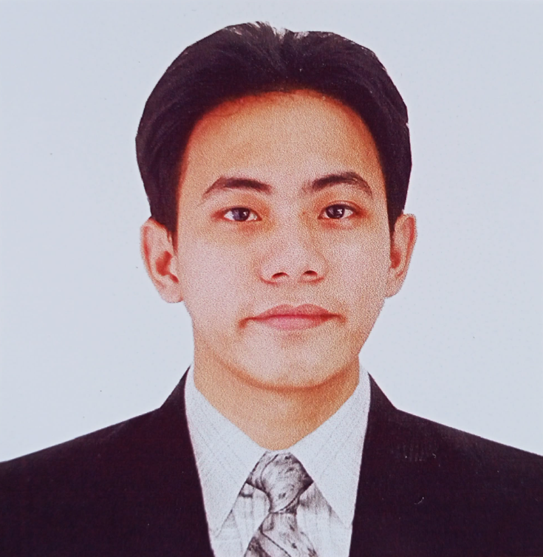

Graduated in Bayanan Elementary school
Special recognition for becoming a volleyball
Varsity player.

Addition hills Integrated School
High School Diploma, Class of 2022
An overall average of 93%
Grd.8 2nd placer in poster making.
A leader of a research/thesis project.
College
College of mary Immaculate

Intern at Elisachem Industries OPApril 28 - June 13, 2025
VOTTO Control - Dockerized election dashboard with socket-based live events.
Personal Summary

Education
Personal Skills
Job experience
- Good communication skills
- Charcoal art
- Digital art
- Leadership
- Problem-solving skills

Personal Information
Serg Michael N.Aparri
Bdate: April/15/2000
I'm an goal oriented, ambitious person who has develop a mature and responsible approach to any task
I undertake or situation that I pesented with.As a person with an ambition I take things seriously that gives me benefits
Email: sergaparri@gmail.com
Phom: 09760948694
Address: Blk.24 Lot30 Willobend Ph1,Brg Pinagkuartelan, Pandi Bulacan

