Capstone - Final

Sergey Mouzykin

December 23, 2017

### Introduction

The great beer shortage has driven people to madness. No. That is obviously not true. On the contrary, the abundance of beer variety has left us with little imagination as to what the next micro brew will be found on the shelves of your local beer distributor. Perhaps there is hope in narrowing down your next selection before the next meal by using some type of recommendation system based on previous reviews. The decision for your next beer experience doesn't have to be a tedious one. Technology exists to make our lives easier and this surely applies in aiding decision making in regards to the next purchase of a perfect brew.

Sifting through a diverse selection of beers can be quite overwhelming. However, there is a methodical approach that we can take in order to solve this problem. Instinctively, we can come to realize that there is some type of pattern in our decision making, whether it is selecting your next meal or a beer to go along with it. Through experience of taking in massive amounts of data, our minds have learned how to recognize everyday objects and separate (cluster) them into similar groups. This same technique can be applied specifically for aiding us in selecting a beer that will match anyone's personal preference. In particular, we can use an unsupervised learning technique to classify similarities and cluster them into groups.

### Client

The client can be an application developer or a website/blog comprised of beer enthusiasts who are looking for a way to recommend beer based on previous reviews in order to invite people to discover new brews from around the world without bias. A well built recommendation system can be a powerful tool which can drive traffic to the client's website or application.

Another possible client can a brewery or distributor. A brewery will most certainly want to know which beers are in high demand so they could optimize their production to focus on demand in order to maximize their profit and increase efficiency of production. The distributor also needs to know which beers are in high demand in order to maintain optimal inventory and sales by communicating their needs to the brewer.

### Beer Reviews Data Set

The data set is a collection of about 1.5 million beer reviews from a period of about 10 years up to 2011. Reviewers were tasked with rating a beer's five aspects such as appearance, aroma, palate, taste and overall impression based on a (1-5) scale. This data set was acquired from data.world [link](https://data.world/socialmediadata/beeradvocate).

### Data Set Preview

|  |  |
| --- | --- |
| Variable | Description |
| review time | Number of times the beer was reviewed |
| review overall | Overall rating of the beer |
| review aroma | Aroma rating |
| review appearance | Appearance rating |
| review profilename | Reviewer's profile name |
| review palate | Palate rating |
| review taste | Taste rating |
| brewery name | Name of the brewery |
| brewery ID | Brewery's identification number |
| beer style | Style of the beer |
| beer name | Name of the beer |
| beer ABV | Alcohol content of beer |
| beer ID | Identification number of beer |

### Approach

To begin with, the goal is to focus on a select number of questions to answer in order to create an appropriate recommendation system. These questions will be based on the perspective of the customers and will encompass personal preferences.

1. Find the overall rating for each beer style and the most popular beer style.
2. Which breweries produce the highest rated beers?
3. How does each aspect, including alcohol content and beer style, affect the overall rating?
4. Create groups for alcohol level (low, medium, high)
5. Recommend five beers based on preferred aspects and style (Ex.: Hefeweizen, taste, aroma, ABV).

In order answer these questions, the following techniques will be applied, summary statistics, bar charts, and histograms. Machine learning application will be necessary for providing a recommendation. In general, a variety of clustering methods will be applied to find similarities between various beers and their characteristics.

Things to consider: - Outliers. Some beers may have a low amount of reviews which may skew results adversely and therefore should be discounted. The cutoff needs to be determined. - Missing values. Why are they missing? Can they teach us anything? Will they have a great impact on the overall ratings?

### Data Wrangling Overview

This raw data will be cleaned and wrangled into a form which then can be analyzed. The following will be performed:

* Column names will be renamed to be short, simple and descriptive
* All columns with characters will be changed to lower case. This includes brewery name, beer name, beer style, and profile name
* Any missing values found will be replaced accordingly
* The amount of beer styles will be reduced from 104 to a more manageable size

Lower Case - Change all columns with characters to lower case. This includes four columns, brewery name, beer name, profile name, and beer style.

Rename Columns - Some columns need to be renamed in order to be more concise. The changes are summarized in the table below.

|  |  |
| --- | --- |
| Old Name | New Name |
| review_overall | overall |
| review_aroma | aroma |
| review_appearance | appearance |
| review_palate | palate |
| review_taste | taste |
| review_profilename | profile_name |
| brewery_name | *no change* |
| brewery_id | *no change* |
| beer_style | *no change* |
| beer_name | *no change* |
| beer_abv | *no change* |
| beer_id | *no change* |
| review_time | *no change* |

### Missing Values

Approach:

1. Create a function for finding missing values
2. Iterate this function over every column
3. Create a matrix of missing values for easier visualization

## beer id brewery name brewery id beer ABV profile name taste  
## missing values 0 15 0 67785 348 0   
## palate beer style appearance aroma overall review time  
## missing values 0 0 0 0 0 0   
## beer name  
## missing values 0

Missing values are found in the following columns:

|  |  |
| --- | --- |
| Column | Amount of missing values |
| brewery name | 15 |
| beer ABV | 67,785 |
| profile name | 348 |

The alcohol content is not always written on the container and relatively low ABV is not required to be printed on containers. This may explain the large amount of missing values in the *beer_abv* column.

### Missing Values: beer ABV (alcohol by volume)

To deal with these missing values, the mean of the *beer_abv* will be computed and used to replace the missing values. After replacing the missing values, the column will be checked again for any missing values in order to confirm the result.

mean_abv = mean(beer_reviews$beer_abv, na.rm = TRUE) # = 7.04  
median_abv = median(beer_reviews$beer_abv, na.rm = TRUE) # 6.6  
  
# replace the missing values in ABV with the mean  
beer_reviews =   
 beer_reviews %>%  
 replace_na(list(beer_abv = mean_abv))  
# check for missing values again  
find_NA(beer_reviews$beer_abv)

## # A tibble: 1 x 1  
## missing_values  
## <int>  
## 1 0

### Missing Values: Brewery Name

At the moment, we can't make any accurate guesses as to what the names are of the breweries. Therefore, their missing values will be replaced with the string '*unknown*'. After replacing the missing values, the column will be checked again for any missing values in order to confirm the result.

# view the matrix with missing values  
missing_matrix

## beer id brewery name brewery id beer ABV profile name taste  
## missing values 0 15 0 67785 348 0   
## palate beer style appearance aroma overall review time  
## missing values 0 0 0 0 0 0   
## beer name  
## missing values 0

# replace the missing names with 'unknown'  
beer_reviews =   
 beer_reviews %>%  
 replace_na(list(brewery_name = 'unknown'))  
# check for missing values again  
find_NA(beer_reviews$brewery_name)

## # A tibble: 1 x 1  
## missing_values  
## <int>  
## 1 0

### Missing Values: Profile Name

Profile names will be replaced with the string '*unknown*' since we can't make any accurate guesses of somebody's name in this instance.

# view the matrix with missing values  
missing_matrix

## beer id brewery name brewery id beer ABV profile name taste  
## missing values 0 15 0 67785 348 0   
## palate beer style appearance aroma overall review time  
## missing values 0 0 0 0 0 0   
## beer name  
## missing values 0

# glance over the missing values  
beer_reviews %>%  
 select(profile_name) %>%  
 filter(is.na(profile_name))

## # A tibble: 348 x 1  
## profile_name  
## <chr>  
## 1 <NA>  
## 2 <NA>  
## 3 <NA>  
## 4 <NA>  
## 5 <NA>  
## 6 <NA>  
## 7 <NA>  
## 8 <NA>  
## 9 <NA>  
## 10 <NA>  
## # ... with 338 more rows

# replace the missing profile names with 'Unknown'  
beer_reviews =   
 beer_reviews %>%  
 replace_na(list(profile_name = 'unknown'))  
  
# check for missing values again  
find_NA(beer_reviews$profile_name)

## # A tibble: 1 x 1  
## missing_values  
## <int>  
## 1 0

### Beer Styles

Currently, there are 104 unique beer styles included in this data set. However, some of these styles are highly specific due to their brewing process, ingredient ratios, yeast type, or a combination of other factors; but they can be grouped together since they are a variation of an ale or a lager. The goal is to classify them into more general terms, but without over simplifying, in order to produce plots that are easy to read and translate. A new column will be created to represent these styles. The approach will involve doing some research on the current beer styles included and deciding how to categorize them to yield a reduced list. The *gsub* function will be used to iterate over beer styles and categorize them accordingly.

New Beer-Style column will consist of the following styles:

|  |  |  |  |  |
| --- | --- | --- | --- | --- |
| Beer Style |  |  |  |  |
| ale | lager | stout | lambic | spiced |
| pilsner | porter | smoked | barleywine | ipa |
| wheat | bock | bitter | rye | trappist |

A new column for beer styles is created using the mutate() function.

# create new column with the new styles using mutate()  
beer_reviews =   
 beer_reviews %>%  
 mutate(general_beer_style = style_list_mod)  
  
glimpse(beer_reviews)

## Observations: 1,586,614  
## Variables: 14  
## $ brewery_name <chr> "vecchio birraio", "vecchio birraio", "vecc...  
## $ beer_name <chr> "sausa weizen", "red moon", "black horse bl...  
## $ profile_name <chr> "stcules", "stcules", "stcules", "stcules",...  
## $ beer_style <chr> "hefeweizen", "english strong ale", "foreig...  
## $ taste <dbl> 1.5, 3.0, 3.0, 3.0, 4.5, 3.5, 4.0, 3.5, 4.0...  
## $ palate <dbl> 1.5, 3.0, 3.0, 2.5, 4.0, 3.0, 4.0, 2.0, 3.5...  
## $ appearance <dbl> 2.5, 3.0, 3.0, 3.5, 4.0, 3.5, 3.5, 3.5, 3.5...  
## $ aroma <dbl> 2.0, 2.5, 2.5, 3.0, 4.5, 3.5, 3.5, 2.5, 3.0...  
## $ overall <dbl> 1.5, 3.0, 3.0, 3.0, 4.0, 3.0, 3.5, 3.0, 4.0...  
## $ brewery_id <int> 10325, 10325, 10325, 10325, 1075, 1075, 107...  
## $ beer_id <int> 47986, 48213, 48215, 47969, 64883, 52159, 5...  
## $ review_time <int> 1234817823, 1235915097, 1235916604, 1234725...  
## $ beer_abv <dbl> 5.0, 6.2, 6.5, 5.0, 7.7, 4.7, 4.7, 4.7, 4.7...  
## $ general_beer_style <chr> "wheat", "ale", "stout", "pilsner", "ipa", ...

# summarize the new beer styles by calling distinct()  
beer_reviews %>%  
 group_by(general_beer_style) %>%  
 summarise(style_count = n()) %>%  
 arrange(desc(style_count))

## # A tibble: 24 x 2  
## general_beer_style style_count  
## <chr> <int>  
## 1 ale 577361  
## 2 ipa 216034  
## 3 stout 182268  
## 4 lager 132481  
## 5 wheat 80947  
## 6 porter 73249  
## 7 trappist 68397  
## 8 bock 46501  
## 9 barleywine 40459  
## 10 pilsner 40330  
## # ... with 14 more rows

### Plot: Beer ABV

Plotting the beer's ABV as a histogram will reveal it's distribution and help us spot any outliers that may be present before diving into deeper analysis.

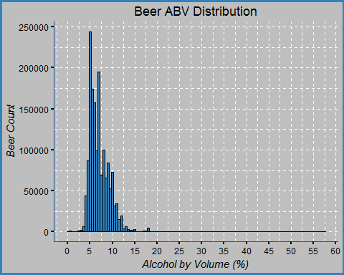

This plot shows us that the ABV is actually a right-skewed distribution due to some beers having a a very high alcohol by volume content. The minimum and maximum of ABV content are 0.01% and 57.7%, respectively. The mean lies at 7.04, the median at 6.6, and the standard deviation is 2.27. We can also infer that the distribution is right-skewed due to the median being lower than the mean as the outliers have a greater effect on the mean than the median. Although the values range from 0.01 to 57.7, in theory, about 95% of these values should lie within two standard deviations from the mean.

|  |  |
| --- | --- |
| Stat | Value |
| Standard Deviation | 2.27 |
| Variance | 5.16 |
| Mean | 7.04 |
| Median | 6.6 |
| Max | 57.7 |
| Min | 0.01 |

# find max and min for beer ABV  
# replace the missing values before finding MAX and MIN  
max(beer_reviews$beer_abv) # 57.7 %

## [1] 57.7

min(beer_reviews$beer_abv) # 0.01 %

## [1] 0.01

### Interval: Beer ABV

In order to better visualize the alcohol level content, the ABV can be distributed into five factored levels using the calculated mean and standard deviation. These five levels will be labeled as, '*low*', '*below normal*', '*normal*', *'above normal*', and '*high*'. The computed standard deviation will be used to create the breaks for the labels.

## [1] 2.272372

## [1] 5.163673

## [1] 1586614

## interval_abv  
## low below normal normal above normal high   
## 1630 140735 1193157 200598 50494

Sum the amounts within two standard deviations and divide by total amount of rows. This will contain about 95% of all the data points in the beer's abv column.

## [1] 96.71476

# NEW COLUMN: beer_abv_factor  
beer_reviews =   
 beer_reviews %>%  
 mutate(beer_abv_factor = interval_abv)  
  
glimpse(beer_reviews)

## Observations: 1,586,614  
## Variables: 15  
## $ brewery_name <chr> "vecchio birraio", "vecchio birraio", "vecc...  
## $ beer_name <chr> "sausa weizen", "red moon", "black horse bl...  
## $ profile_name <chr> "stcules", "stcules", "stcules", "stcules",...  
## $ beer_style <chr> "hefeweizen", "english strong ale", "foreig...  
## $ taste <dbl> 1.5, 3.0, 3.0, 3.0, 4.5, 3.5, 4.0, 3.5, 4.0...  
## $ palate <dbl> 1.5, 3.0, 3.0, 2.5, 4.0, 3.0, 4.0, 2.0, 3.5...  
## $ appearance <dbl> 2.5, 3.0, 3.0, 3.5, 4.0, 3.5, 3.5, 3.5, 3.5...  
## $ aroma <dbl> 2.0, 2.5, 2.5, 3.0, 4.5, 3.5, 3.5, 2.5, 3.0...  
## $ overall <dbl> 1.5, 3.0, 3.0, 3.0, 4.0, 3.0, 3.5, 3.0, 4.0...  
## $ brewery_id <int> 10325, 10325, 10325, 10325, 1075, 1075, 107...  
## $ beer_id <int> 47986, 48213, 48215, 47969, 64883, 52159, 5...  
## $ review_time <int> 1234817823, 1235915097, 1235916604, 1234725...  
## $ beer_abv <dbl> 5.0, 6.2, 6.5, 5.0, 7.7, 4.7, 4.7, 4.7, 4.7...  
## $ general_beer_style <chr> "wheat", "ale", "stout", "pilsner", "ipa", ...  
## $ beer_abv_factor <fctr> normal, normal, normal, normal, normal, be...

### Write the cleaned data to a new file

The clean file is now ready to be written.

beer_reviews_clean = beer_reviews  
glimpse(beer_reviews_clean)

## Observations: 1,586,614  
## Variables: 15  
## $ brewery_name <chr> "vecchio birraio", "vecchio birraio", "vecc...  
## $ beer_name <chr> "sausa weizen", "red moon", "black horse bl...  
## $ profile_name <chr> "stcules", "stcules", "stcules", "stcules",...  
## $ beer_style <chr> "hefeweizen", "english strong ale", "foreig...  
## $ taste <dbl> 1.5, 3.0, 3.0, 3.0, 4.5, 3.5, 4.0, 3.5, 4.0...  
## $ palate <dbl> 1.5, 3.0, 3.0, 2.5, 4.0, 3.0, 4.0, 2.0, 3.5...  
## $ appearance <dbl> 2.5, 3.0, 3.0, 3.5, 4.0, 3.5, 3.5, 3.5, 3.5...  
## $ aroma <dbl> 2.0, 2.5, 2.5, 3.0, 4.5, 3.5, 3.5, 2.5, 3.0...  
## $ overall <dbl> 1.5, 3.0, 3.0, 3.0, 4.0, 3.0, 3.5, 3.0, 4.0...  
## $ brewery_id <int> 10325, 10325, 10325, 10325, 1075, 1075, 107...  
## $ beer_id <int> 47986, 48213, 48215, 47969, 64883, 52159, 5...  
## $ review_time <int> 1234817823, 1235915097, 1235916604, 1234725...  
## $ beer_abv <dbl> 5.0, 6.2, 6.5, 5.0, 7.7, 4.7, 4.7, 4.7, 4.7...  
## $ general_beer_style <chr> "wheat", "ale", "stout", "pilsner", "ipa", ...  
## $ beer_abv_factor <fctr> normal, normal, normal, normal, normal, be...

# write the clean file   
write_csv(beer_reviews_clean, 'beer_reviews_clean.csv')

### Summary Statistics

This will be a good and simple starting point for finding more complex answers later on. Summary statistics will give us a glimpse into the characteristics of this data set and will guide us toward the next steps.

### Beer Name

Here we will summarize the standard deviation, variance, mean, median, max, and min for every beer name. Also, it will be useful to summarize each rated characteristic such as the *overall*, *taste*, *appearace*, *aroma*, and *palate.*

## Overall Rating Summary  
## standard deviation 0.7206219   
## variance 0.5192959   
## mean 3.815581   
## median 4   
## max 5   
## min 0

## Taste Rating Summary  
## standard deviation 0.7319696   
## variance 0.5357795   
## mean 3.79286   
## median 4   
## max 5   
## min 1

## Aroma Rating Summary  
## standard deviation 0.6976167   
## variance 0.4866691   
## mean 3.735636   
## median 4   
## max 5   
## min 1

## Appearance Rating Summary  
## standard deviation 0.6160928   
## variance 0.3795703   
## mean 3.841642   
## median 4   
## max 5   
## min 0

## Palate Rating Summary  
## standard deviation 0.6822184   
## variance 0.4654219   
## mean 3.743701   
## median 4   
## max 5   
## min 1

The min and max for two columns, overall and appearance, are 0 and 5 respectively. It's worth taking a closer look at those ratings since the other aspects range from 1 to 5.

Looking at the mean and standard deviation (SD) of overall stat summary column where the overall rating is given a zero, it is interesting to find that in some of the more extreme scenarios, the ratings between different aspects vary greatly. In particular, for the beer, *Latter Days Stout*, we can find that a rating of zero for the overall was given out while at the same time its aroma was rated a four. It seems contradictory to rate the overall as a zero while enjoying at least one aspect of the beer, in particular, its aroma.

## # A tibble: 7 x 8  
## # Groups: beer_name, overall, taste, aroma, appearance [7]  
## beer_name overall taste aroma appearance palate  
## <chr> <dbl> <dbl> <dbl> <dbl> <dbl>  
## 1 latter days stout 0 2.0 4 0 2.0  
## 2 pub pils 0 2.0 2 0 3.0  
## 3 red rock amber ale 0 3.5 3 0 2.5  
## 4 red rock bavarian weiss 0 2.0 2 0 2.5  
## 5 red rock dunkel weizen 0 2.0 2 0 2.5  
## 6 red rock pilsner 0 1.5 2 0 3.0  
## 7 utah pale ale 0 2.0 3 0 2.0  
## # ... with 2 more variables: beer_name_count <int>, overall_sd <dbl>

## # A tibble: 38,364 x 8  
## # Groups: beer_name [37,852]  
## beer_name general_beer_style  
## <chr> <chr>  
## 1 '99 wee heavy scotch ale ale  
## 2 't hommelhof cuvée spéciale ale  
## 3 "\"100\"" ale  
## 4 "\"12\" belgian golden strong ale" ale  
## 5 "\"33\" export" lager  
## 6 "\"4\" horse oatmeal stout" stout  
## 7 "\"76\" anniversary ale" ale  
## 8 "\"alt\"ered state" ale  
## 9 "\"naughty scot\" scotch ale" ale  
## 10 "\"old school\" craft cream ale" ale  
## 11 "\"the camp\" barleywine" barleywine  
## 12 #1 saison ale  
## 13 #1073 prairie stout stout  
## 14 ¿por que no? ale  
## 15 10 bbl pale ale ale  
## 16 1000.0 ale  
## 17 10th anniversary ale wheat  
## 18 10th anniversary oak aged rye barleywine barleywine  
## 19 111 pilsener pilsner  
## 20 1133 biere d'abbaye ale  
## # ... with 3.834e+04 more rows, and 6 more variables:  
## # beer_name_count <int>, overall_sd <dbl>, taste_sd <dbl>,  
## # aroma_sd <dbl>, appearance_sd <dbl>, palate_sd <dbl>

## Beer Review Count  
## standard deviation 146.3773   
## variance 21426.3   
## mean 40.85022   
## median 5   
## max 3290   
## min 2

### Plot: Standard Deviation Distribution

These plots illustrate the distribution of the standard deviations.

In support to the histogram, we can also calculate the mean, median, standard deviation, maximum rating, and minimum rating. Essentially, the deviation can tell us how divisive people are among the ratings. Generally, it appears that people will agree on a rating value to within about 3/4 of a point. However, the deviation will vary depending on the beer.

# PLOT  
# overall_sd histogram  
ggplot(beer_reviews_SD, aes(x = overall_sd)) +   
 geom_histogram(binwidth = 0.1, fill = '#3182BD', col = 'black') +   
 scale_x_continuous('Overall Deviation', breaks = seq(0, 3.0, by = 0.2)) +  
 theme_blue

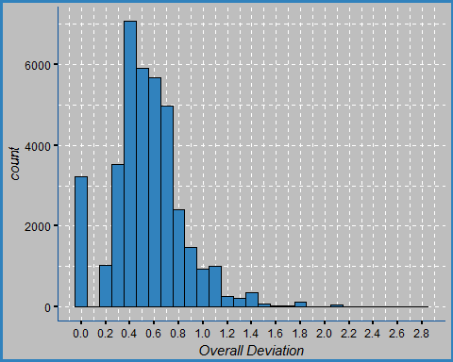

stats_function_2(beer_reviews_SD$overall_sd, 'Overall SD Summary')

## Overall SD Summary  
## standard deviation 0.2995806   
## variance 0.08974856   
## mean 0.5390207   
## median 0.5188745   
## max 2.828427   
## min 0

ggplot(beer_reviews_SD, aes(x = taste_sd)) +   
 geom_histogram(binwidth = 0.1, fill = '#3182BD', col = 'black') +   
 scale_x_continuous('Taste Deviation', breaks = seq(0, 3.0, by = 0.2)) +  
 theme_blue

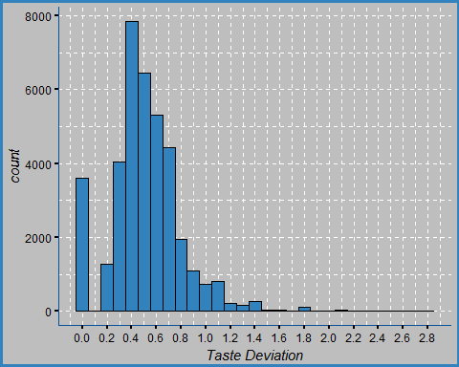

stats_function_2(beer_reviews_SD$taste_sd, 'Taste SD Summary')

## Taste SD Summary  
## standard deviation 0.2844422   
## variance 0.08090736   
## mean 0.5029366   
## median 0.4936502   
## max 2.828427   
## min 0

ggplot(beer_reviews_SD, aes(x = aroma_sd)) +   
 geom_histogram(binwidth = 0.1, fill = '#3182BD', col = 'black') +   
 scale_x_continuous('Aroma Deviation', breaks = seq(0, 3.0, by = 0.2)) +  
 theme_blue

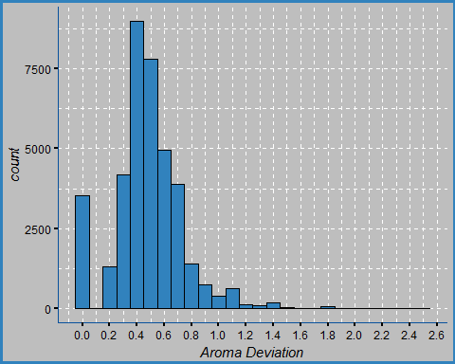

stats_function_2(beer_reviews_SD$aroma_sd, 'Aroma SD Summary')

## Aroma SD Summary  
## standard deviation 0.2541058   
## variance 0.06456977   
## mean 0.4724818   
## median 0.4714045   
## max 2.474874   
## min 0

ggplot(beer_reviews_SD, aes(x = appearance_sd)) +   
 geom_histogram(binwidth = 0.1, fill = '#3182BD', col = 'black') +   
 scale_x_continuous('Appearance Deviation', breaks = seq(0, 3.0, by = 0.2)) +  
 theme_blue

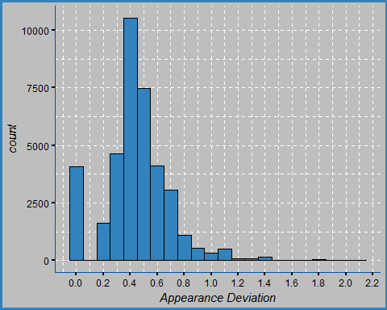

stats_function_2(beer_reviews_SD$appearance_sd, 'Appearance SD Summary')

## Appearance SD Summary  
## standard deviation 0.2418059   
## variance 0.05847009   
## mean 0.4395605   
## median 0.4291975   
## max 2.12132   
## min 0

ggplot(beer_reviews_SD, aes(x = palate_sd)) +   
 geom_histogram(binwidth = 0.1, fill = '#3182BD', col = 'black') +   
 scale_x_continuous('Palate Deviation', breaks = seq(0, 3.0, by = 0.2)) +  
 theme_blue

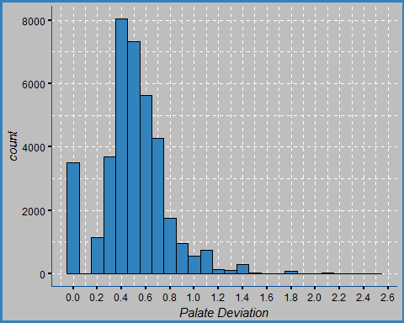

stats_function_2(beer_reviews_SD$palate_sd, 'Palate SD Summary')

## Palate SD Summary  
## standard deviation 0.2693696   
## variance 0.07255996   
## mean 0.4966859   
## median 0.4929625   
## max 2.474874   
## min 0

Additionally, a filter can be created to find beers with the smallest deviation. This will return a list of beers which reviewers are more likely to agree upon with their ratings.

# NOTE:   
# with only 1 or 2 reviews, disagreements vary greatly among the 5 observations  
# 1. lower deviation implies agreement between different reviews  
# 2. higher deviation implies disagreement between reviewers  
  
# GRAPH NOTE:  
# The outliers contained in the graph are due to low amount of reviews and the disagreements between reviewers  
  
# FIND the least amount of disagreements by filtering the SD for each observation. Smaller deviation = less disagreement  
# filter(sd between(0, 0.25), name_count >=5)  
beer_reviews_sd_filter =   
 beer_reviews %>%  
 group_by(beer_name, general_beer_style) %>%  
 summarise(beer_name_count = n(),   
 overall_sd = sd(overall),   
 taste_sd = sd(taste),   
 aroma_sd = sd(aroma),   
 appearance_sd = sd(appearance),   
 palate_sd = sd(palate)) %>%  
 filter(beer_name_count >= 5,   
 between(overall_sd, 0, 0.30),   
 between(taste_sd, 0, 0.30),   
 between(aroma_sd, 0, 0.30),   
 between(appearance_sd, 0, 0.30),   
 between(palate_sd, 0, 0.30)) %>%  
 arrange(overall_sd, taste_sd, aroma_sd, appearance_sd, palate_sd) %>%  
 print(n = 20)

## # A tibble: 75 x 8  
## # Groups: beer_name [75]  
## beer_name  
## <chr>  
## 1 founders dirty darkness  
## 2 kelso industrial pale ale  
## 3 red scare  
## 4 starobrno cerne (black)  
## 5 super wit  
## 6 oak-aged cherry stout  
## 7 spooky  
## 8 rye not?  
## 9 limited edition 2004  
## 10 st. denis pilzenn imperialni (deni pilsner imperial)  
## 11 old bad cat barleywine 2008  
## 12 andechser dunkel naturtrüb jubiläumsbier  
## 13 pale tail  
## 14 sandy paws (2010)  
## 15 pilot series passionfruit and dragonfruit berliner weiss  
## 16 chaos chaos imperial stout  
## 17 sfo  
## 18 live oak ipa  
## 19 maduro oatmeal brown ale - blueberry  
## 20 hotter than helles  
## # ... with 55 more rows, and 7 more variables: general_beer_style <chr>,  
## # beer_name_count <int>, overall_sd <dbl>, taste_sd <dbl>,  
## # aroma_sd <dbl>, appearance_sd <dbl>, palate_sd <dbl>

### General Beer Style

## # A tibble: 24 x 8  
## general_beer_style style_count overall_mean overall_sd  
## <chr> <int> <dbl> <dbl>  
## 1 low alcohol beer 1201 2.578268 1.0073243  
## 2 american malt liquor 3925 2.678854 1.0338246  
## 3 happoshu 241 2.914938 0.9863785  
## 4 fruit / vegetable beer 33861 3.415124 0.8917166  
## 5 spiced/herbed 13663 3.424907 0.8712269  
## 6 lager 132481 3.438693 0.9056884  
## 7 black & tan 2358 3.486853 0.7200659  
## 8 bière de champagne / bière brut 1046 3.648184 0.8661809  
## 9 sahti 1061 3.700283 0.7065662  
## 10 pilsner 40330 3.768634 0.7304550  
## 11 smoked 6948 3.778929 0.6740619  
## 12 ale 577361 3.795629 0.6902948  
## 13 bock 46501 3.813047 0.6678802  
## 14 wheatwine 3714 3.815563 0.6502937  
## 15 bitter 25999 3.825743 0.6536035  
## 16 wheat 80947 3.868840 0.6865366  
## 17 barleywine 40459 3.881089 0.6392141  
## 18 flanders oud bruin 4995 3.902503 0.6840799  
## 19 porter 73249 3.908558 0.6347968  
## 20 lambic 18682 3.954502 0.7081593  
## 21 trappist 68397 3.958068 0.6326675  
## 22 stout 182268 3.960232 0.6612623  
## 23 rye 10893 3.963233 0.6122244  
## 24 ipa 216034 3.977897 0.6193515  
## # ... with 4 more variables: taste_sd <dbl>, aroma_sd <dbl>,  
## # appearance_sd <dbl>, palate_sd <dbl>

## Style Count  
## standard deviation 123448.7   
## variance 15239576394  
## mean 66108.92   
## median 22340.5   
## max 577361   
## min 241

## Overall SD  
## standard deviation 0.1329949   
## variance 0.01768764  
## mean 0.7472439   
## median 0.6884157   
## max 1.033825   
## min 0.6122244

## Overall Mean  
## standard deviation 0.399404   
## variance 0.1595236   
## mean 3.644107   
## median 3.804338   
## max 3.977897   
## min 2.578268

## Aroma SD   
## standard deviation 0.09766952   
## variance 0.009539336  
## mean 0.6561789   
## median 0.6188605   
## max 0.8507946   
## min 0.5366802

## Taste SD   
## standard deviation 0.1132976   
## variance 0.01283634  
## mean 0.717111   
## median 0.6716393   
## max 0.9552426   
## min 0.6070527

## Appearance SD  
## standard deviation 0.1131763   
## variance 0.01280887   
## mean 0.5966167   
## median 0.5577862   
## max 0.8427827   
## min 0.4783073

## Palate SD   
## standard deviation 0.1034379   
## variance 0.01069939  
## mean 0.6709814   
## median 0.6295702   
## max 0.8835709   
## min 0.5470604

Looking at the general beer style, we can find the least disliked beer style by looking at the mean of the overall (shown above). However, the standard deviation (1.00) is quite high in this case which implies disagreement and the ratings can vary by one point. Therefore, we cannot absolutely conclude that the low alcohol beer is rated the worst. Although, we can say that it is one the least appreciated beer styles among a few others.

### Beer Style

We can find the beer styles which are relatively best rated (shown below).

## # A tibble: 104 x 8  
## beer_style style_count overall_sd overall_mean  
## <chr> <int> <dbl> <dbl>  
## 1 american wild ale 17794 0.6542419 4.093262  
## 2 gueuze 6009 0.6413163 4.086287  
## 3 quadrupel (quad) 18086 0.6296276 4.071630  
## 4 lambic - unblended 1114 0.6567664 4.048923  
## 5 american double / imperial stout 50705 0.6664566 4.029820  
## 6 russian imperial stout 54129 0.6354456 4.023084  
## 7 weizenbock 9412 0.5983101 4.007969  
## 8 american double / imperial ipa 85977 0.6367582 3.998017  
## 9 flanders red ale 6664 0.6752854 3.992722  
## 10 rye beer 10130 0.5930640 3.981737  
## 11 keller bier / zwickel bier 2591 0.6257269 3.981088  
## 12 eisbock 2663 0.6250778 3.977094  
## 13 american ipa 117586 0.6107604 3.965221  
## 14 gose 686 0.6221699 3.965015  
## 15 saison / farmhouse ale 31480 0.6183095 3.962564  
## 16 belgian ipa 12471 0.5726129 3.958704  
## 17 baltic porter 11572 0.5905583 3.955410  
## 18 roggenbier 466 0.5313079 3.948498  
## 19 oatmeal stout 18145 0.6314181 3.941692  
## 20 american black ale 11446 0.5622348 3.934475  
## 21 hefeweizen 27908 0.6767538 3.929626  
## 22 dubbel 19983 0.6270035 3.921733  
## 23 english porter 11200 0.6361153 3.917946  
## 24 tripel 30328 0.6299255 3.914287  
## 25 belgian strong dark ale 37743 0.6353371 3.913322  
## 26 flanders oud bruin 4995 0.6840799 3.902503  
## 27 berliner weissbier 3475 0.7678588 3.901151  
## 28 old ale 14703 0.6402962 3.899000  
## 29 american barleywine 26728 0.6206632 3.896756  
## 30 american porter 50477 0.6437006 3.895735  
## 31 belgian strong pale ale 31490 0.6514504 3.895602  
## 32 milk / sweet stout 13166 0.6554527 3.892526  
## 33 lambic - fruit 10950 0.7297482 3.892283  
## 34 bière de garde 6729 0.6160419 3.880294  
## 35 foreign / export stout 5972 0.6308640 3.877679  
## 36 scotch ale / wee heavy 17441 0.6065514 3.874262  
## 37 american strong ale 31945 0.6956994 3.873501  
## 38 doppelbock 21699 0.6604465 3.872805  
## 39 munich helles lager 7870 0.6924057 3.869441  
## 40 american stout 24538 0.6710999 3.865311  
## 41 american double / imperial pilsner 5435 0.6335278 3.858694  
## 42 american brown ale 25297 0.6226342 3.857434  
## 43 dunkelweizen 7122 0.6448806 3.856782  
## 44 american pale ale (apa) 63469 0.6604517 3.852306  
## 45 english barleywine 13731 0.6728391 3.850594  
## 46 california common / steam beer 4038 0.6472510 3.847821  
## 47 extra special / strong bitter (esb) 17212 0.6195223 3.847025  
## 48 english dark mild ale 2314 0.7312741 3.837511  
## 49 schwarzbier 9826 0.6367924 3.835030  
## 50 dortmunder / export lager 4440 0.7259446 3.833108  
## # ... with 54 more rows, and 4 more variables: taste_sd <dbl>,  
## # aroma_sd <dbl>, appearance_sd <dbl>, palate_sd <dbl>

## Overall Stats  
## standard deviation 0.1080415   
## variance 0.01167296   
## mean 0.7007821   
## median 0.6698763   
## max 1.12708   
## min 0.5313079

## Overall Mean Stats  
## standard deviation 0.3019827   
## variance 0.09119353   
## mean 3.732231   
## median 3.821994   
## max 4.093262   
## min 2.578268

## Taste Stats  
## standard deviation 0.09168585   
## variance 0.008406294  
## mean 0.6661918   
## median 0.6370729   
## max 1.096588   
## min 0.4824496

## Aroma Stats  
## standard deviation 0.07634401   
## variance 0.005828408  
## mean 0.6078849   
## median 0.584121   
## max 0.9147802   
## min 0.4632211

## Appearance Stats  
## standard deviation 0.08295096   
## variance 0.006880862   
## mean 0.5579751   
## median 0.5283527   
## max 0.8498464   
## min 0.4154222

## Palate Stats  
## standard deviation 0.08356234   
## variance 0.006982665   
## mean 0.6312968   
## median 0.6119725   
## max 1.009596   
## min 0.498748

### Plot: Beer ABV (alcohol by volume)

This plot shows us that the ABV is actually a right-skewed distribution due to some beers having a a very high alcohol by volume content. The minimum and maximum of ABV content are 0.01% and 57.7%, respectively. The mean lies at 7.04, the median at 6.6, and the standard deviation is 2.27. We can also infer that the distribution is right-skewed due to the median being lower than the mean since the mean can easily be affected by outliers. Although the values range from 0.01 to 57.7, in theory, about 95% of these values should lie within two standard deviations from the mean.

# reduce the amount of data points with the sample_n()  
# this will produce the plots much faster than plotting all 1.5 million reviews  
beer_reviews_10k = sample_n(beer_reviews, size = 10000)  
  
# PLOT: Beer ABV distribution  
ggplot(beer_reviews_10k, aes(x = beer_abv)) +   
 geom_histogram(binwidth = 0.5, position = 'dodge', fill = '#3182BD', col = 'black') +   
 scale_x_continuous('Alcohol by Volume (%)', breaks = seq(0, 60, by = 2)) +  
 scale_y_continuous('Beer Count') +  
 ggtitle('Beer ABV Distribution') +  
 theme_blue

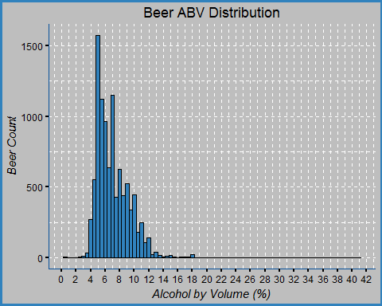

stats_function_2(beer_reviews$beer_abv, 'Beer ABV Summary')

## Beer ABV Summary  
## standard deviation 2.272372   
## variance 5.163673   
## mean 7.042387   
## median 6.6   
## max 57.7   
## min 0.01

# HISTOGRAM  
ggplot(beer_reviews_10k, aes(x = as.factor(overall), fill = general_beer_style)) +  
 geom_histogram(binwidth = 15, stat = 'count') +  
 #scale_x_continuous(limits = c(1,20)) +   
 theme_blue

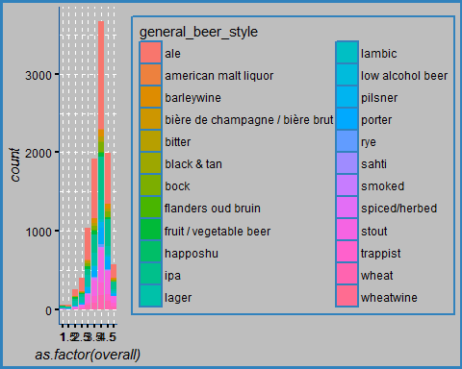

# ABV factor and beer style  
ggplot(beer_reviews_10k, aes(x = beer_abv_factor, fill = general_beer_style)) +   
 geom_histogram(stat = 'count', position = 'dodge') +  
 scale_x_discrete('Beer ABV') +   
 theme_blue

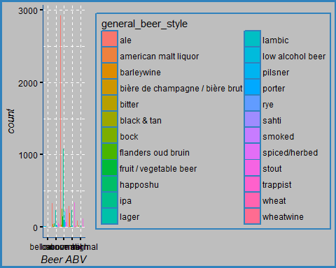

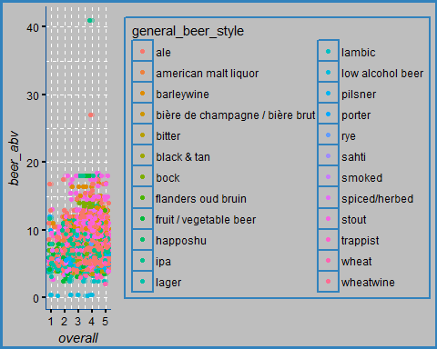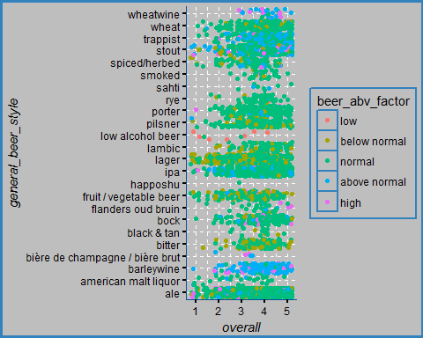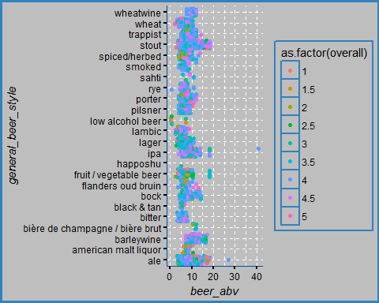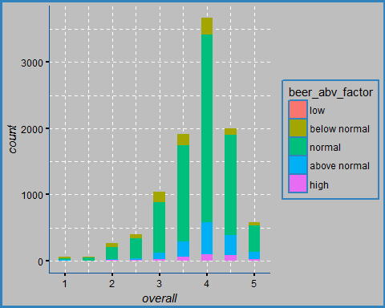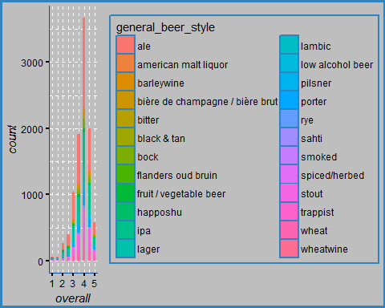

The graphs above helps visualize the overall rating distribution among the beer styles and their respective alcohol content.

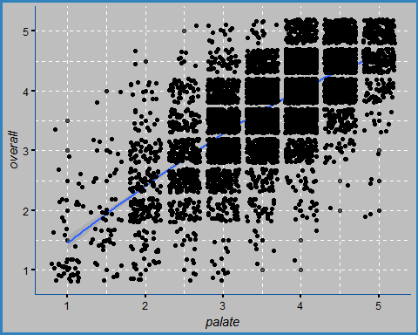

##   
## Pearson's product-moment correlation  
##   
## data: beer_reviews$palate and beer_reviews$overall  
## t = 1241.3, df = 1586600, p-value < 2.2e-16  
## alternative hypothesis: true correlation is not equal to 0  
## 95 percent confidence interval:  
## 0.7011237 0.7027025  
## sample estimates:  
## cor   
## 0.7019139

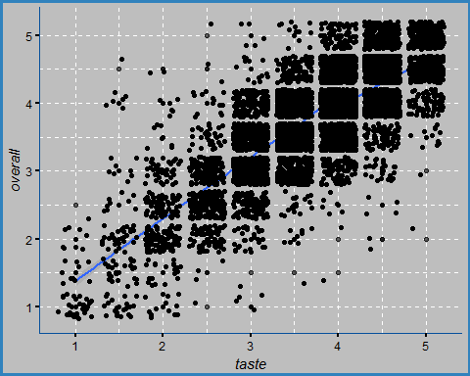

##   
## Pearson's product-moment correlation  
##   
## data: beer_reviews$taste and beer_reviews$overall  
## t = 1622, df = 1586600, p-value < 2.2e-16  
## alternative hypothesis: true correlation is not equal to 0  
## 95 percent confidence interval:  
## 0.7892296 0.7904003  
## sample estimates:  
## cor   
## 0.7898156

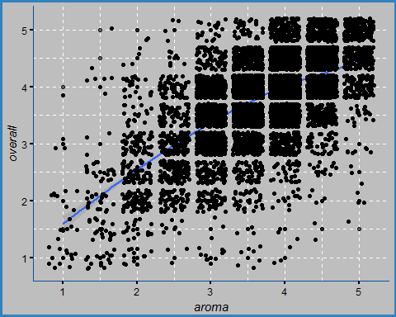

##   
## Pearson's product-moment correlation  
##   
## data: beer_reviews$aroma and beer_reviews$overall  
## t = 985.02, df = 1586600, p-value < 2.2e-16  
## alternative hypothesis: true correlation is not equal to 0  
## 95 percent confidence interval:  
## 0.6150466 0.6169777  
## sample estimates:  
## cor   
## 0.6160131

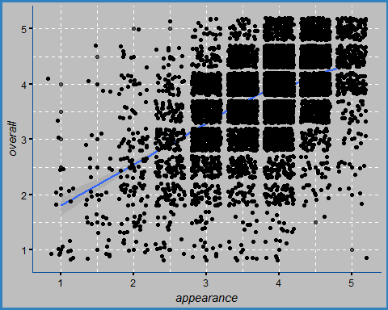

##   
## Pearson's product-moment correlation  
##   
## data: beer_reviews$appearance and beer_reviews$overall  
## t = 730.6, df = 1586600, p-value < 2.2e-16  
## alternative hypothesis: true correlation is not equal to 0  
## 95 percent confidence interval:  
## 0.5005672 0.5028958  
## sample estimates:  
## cor   
## 0.5017324

Plotting overall against other aspects, we can observe a linear correlation emerging. Testing for correlation, we can observe that the strongest positive linear correlation occurs between Taste and Overall ratings with a value of 0.7915. Similarly, a strong positive linear correlation occurs between Palate and Overall with a value of 0.7029.

### Plot: Distribution of Ratings

These plots below help visualize the rating distribution of the five aspects, overall, taste, aroma, appearance, and palate.

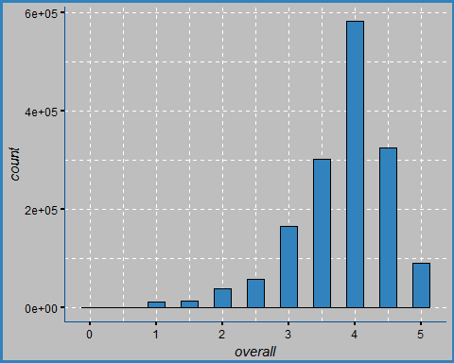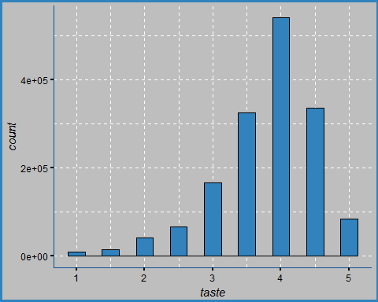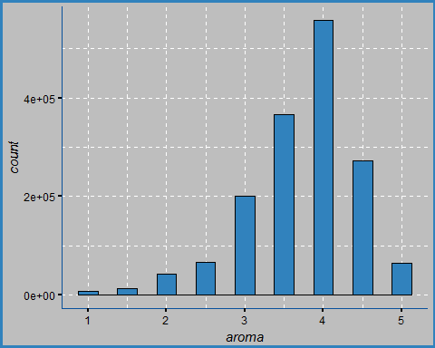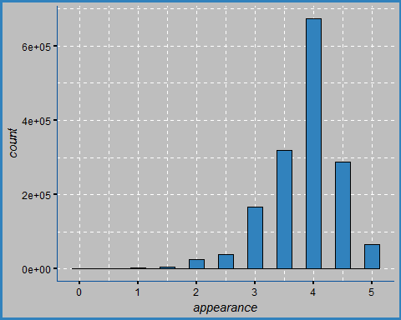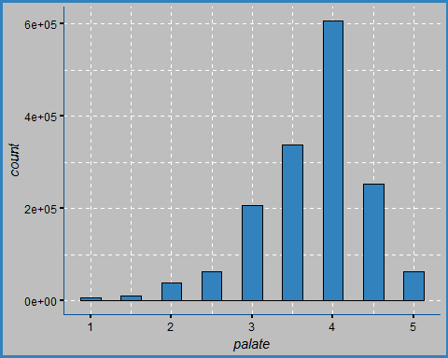

### Brewery Names: Rate the breweries

Let's rate the breweries based on the amount of times a beer from that brewery was reviewed. In total, there are 5,740 distinct breweries included in this data set.

# distinct amount of breweries  
beer_reviews %>%  
 select(brewery_name) %>%  
 n_distinct()

## [1] 5740

# Rating the Breweries  
brewery_rating =  
 beer_reviews %>%  
 group_by(brewery_name) %>%  
 summarise(review_count = n(),  
 overall_mean = mean(overall),  
 overall_sd = sd(overall)) %>%  
 arrange(desc(overall_mean)) %>%  
 filter(review_count >= 2) %>%  
 print(n = 20)

## # A tibble: 5,068 x 4  
## brewery_name review_count  
## <chr> <int>  
## 1 edsten brewing company 2  
## 2 hosokawa sake brewing co., ltd. 2  
## 3 restaurant flieger bräu 2  
## 4 barum brewery limited 2  
## 5 brimstage brewing co ltd 2  
## 6 helios distillery co., ltd. 2  
## 7 scone bierbrouwerij 2  
## 8 von scheidt brewing company 2  
## 9 sherlock's home 5  
## 10 cheriton brewery 3  
## 11 brauerei zehendner gmbh 28  
## 12 brass monkey brewing co. 10  
## 13 the alchemist 527  
## 14 brouwerij westvleteren (sint-sixtusabdij van westvleteren) 2378  
## 15 augustiner bräu kloster mülln ohg 13  
## 16 u fleku pivovaru a restauraci 30  
## 17 peg's cantina & brewpub / cycle brewing 79  
## 18 4 hands brewing co. 4  
## 19 amber ales limited 2  
## 20 bad bear brewing company 2  
## # ... with 5,048 more rows, and 2 more variables: overall_mean <dbl>,  
## # overall_sd <dbl>

stats_function_2(brewery_rating$overall_mean, 'Overall Mean stats')

## Overall Mean stats  
## standard deviation 0.4845017   
## variance 0.2347419   
## mean 3.547968   
## median 3.642857   
## max 5   
## min 1

stats_function_2(brewery_rating$review_count, 'brewery review stats')

## brewery review stats  
## standard deviation 1593.546   
## variance 2539388   
## mean 312.9325   
## median 20   
## max 39444   
## min 2

# the median for reviewed amount is 20, so we can use filter() to narrow the search by looking at breweries with at least 20 ratings  
   
# Looking at breweries with at least 20 ratings, we can rate them by calculating the mean of the overall ratings  
# Before deciding on the best breweries, we should calculate the mean and SD for all overall ratings. Better breweries should be at least   
# two SD's away from the mean

Having only one review is not enough information to make a decision, so filtering the count of reviews being greater than two is a better start. Now the median for reviewed amount is 20, so we can use filter() to narrow the search by looking at breweries with at least 20 ratings.

# change review count to 20  
brewery_rating =  
 beer_reviews %>%  
 group_by(brewery_name) %>%  
 summarise(review_count = n(),  
 overall_mean = mean(overall),  
 overall_sd = sd(overall)) %>%  
 arrange(desc(overall_mean)) %>%  
 filter(review_count >= 20) %>%  
 print(n = 20)

## # A tibble: 2,548 x 4  
## brewery_name review_count  
## <chr> <int>  
## 1 brauerei zehendner gmbh 28  
## 2 the alchemist 527  
## 3 brouwerij westvleteren (sint-sixtusabdij van westvleteren) 2378  
## 4 u fleku pivovaru a restauraci 30  
## 5 peg's cantina & brewpub / cycle brewing 79  
## 6 russian river brewing company 11311  
## 7 närke kulturbryggeri ab 212  
## 8 badische staatsbrauerei rothaus ag 126  
## 9 brauerei im füchschen 27  
## 10 brauerei zur malzmühle schwartz kg 20  
## 11 founders restaurant & brewing co. 22  
## 12 de cam geuzestekerij 159  
## 13 thoroughbreds grill & brewing 22  
## 14 live oak brewing company 584  
## 15 hill farmstead brewery 1531  
## 16 brouwerij drie fonteinen 1668  
## 17 kern river brewing company 929  
## 18 oakham ales / the brewery tap 88  
## 19 bayerische staatsbrauerei weihenstephan 6269  
## 20 timothy taylor & co. limited 144  
## # ... with 2,528 more rows, and 2 more variables: overall_mean <dbl>,  
## # overall_sd <dbl>

stats_function_2(brewery_rating$review_count, 'brewery review stats')

## brewery review stats  
## standard deviation 2206.299   
## variance 4867755   
## mean 615.4133   
## median 91   
## max 39444   
## min 20

Looking at breweries with at least 20 ratings, we can rate them by calculating the mean of the overall ratings. Before deciding on the best breweries, we should calculate the mean and SD for all overall ratings. Better breweries should be at least two SD's above the mean which would put them in the top 5%.

## [1] 3.99523

## [1] 4.375959

## # A tibble: 5 x 12  
## brewery_name review_count  
## <chr> <int>  
## 1 brauerei zehendner gmbh 28  
## 2 the alchemist 527  
## 3 brouwerij westvleteren (sint-sixtusabdij van westvleteren) 2378  
## 4 u fleku pivovaru a restauraci 30  
## 5 peg's cantina & brewpub / cycle brewing 79  
## # ... with 10 more variables: overall_mean <dbl>, taste_mean <dbl>,  
## # aroma_mean <dbl>, appearance_mean <dbl>, palate_mean <dbl>,  
## # overall_sd <dbl>, taste_sd <dbl>, aroma_sd <dbl>, appearance_sd <dbl>,  
## # palate_sd <dbl>

Now, out of 5,740 breweries contained in this data set we have found five which meet or exceed this specific criteria.

### Profile Names

Here we can find the summary statistics for the profile names columns. In total, there are 33,388 people who submitted reviews.

# number of profile names  
beer_reviews %>%   
 select(profile_name) %>%   
 distinct()

## # A tibble: 33,388 x 1  
## profile_name  
## <chr>  
## 1 stcules  
## 2 johnmichaelsen  
## 3 oline73  
## 4 reidrover  
## 5 alpinebryant  
## 6 lordadmnelson  
## 7 augustgarage  
## 8 fodeeoz  
## 9 madeinoregon  
## 10 rawthar  
## # ... with 33,378 more rows

# amount of reviews by each person  
beer_reviews %>%   
 group_by(profile_name) %>%   
 tally(sort = TRUE)

## # A tibble: 33,388 x 2  
## profile_name n  
## <chr> <int>  
## 1 northyorksammy 5817  
## 2 buckeyenation 4661  
## 3 mikesgroove 4617  
## 4 thorpe429 3518  
## 5 womencantsail 3497  
## 6 nerofiddled 3488  
## 7 chaingangguy 3471  
## 8 brentk56 3357  
## 9 phyl21ca 3179  
## 10 weswes 3168  
## # ... with 33,378 more rows

# find total amount of profile names  
profile_names =   
 beer_reviews %>%   
 group_by(profile_name) %>%  
 summarise(reviewed_amount = n(),  
   
 overall_mean = mean(overall),  
 overall_sd = sd(overall)) %>%  
   
 arrange(desc(reviewed_amount)) %>%  
 #filter(reviewed_amount >= 13) %>%  
 print(n = 20)

## # A tibble: 33,388 x 4  
## profile_name reviewed_amount overall_mean overall_sd  
## <chr> <int> <dbl> <dbl>  
## 1 northyorksammy 5817 3.629362 0.6295269  
## 2 buckeyenation 4661 3.734714 0.7412904  
## 3 mikesgroove 4617 4.086203 0.6362618  
## 4 thorpe429 3518 3.735645 0.7271591  
## 5 womencantsail 3497 3.546754 0.8250244  
## 6 nerofiddled 3488 4.107081 0.5032886  
## 7 chaingangguy 3471 3.547249 0.6857443  
## 8 brentk56 3357 3.822163 0.6294877  
## 9 phyl21ca 3179 3.355615 0.7594024  
## 10 weswes 3168 3.856376 0.5034304  
## 11 oberon 3128 3.892743 0.4799349  
## 12 feloniousmonk 3081 3.904901 0.6460761  
## 13 akorsak 3010 3.842193 0.4757466  
## 14 beerchitect 2946 3.784623 0.5779166  
## 15 gueuzedude 2938 3.609598 0.5860451  
## 16 jwc215 2735 3.653382 0.6179189  
## 17 russpowell 2696 4.029859 0.5971007  
## 18 themaniacalone 2659 3.781309 0.7548641  
## 19 gavage 2630 3.878327 0.6378348  
## 20 zeff80 2622 3.835431 0.6275618  
## # ... with 3.337e+04 more rows

profile_names # 33,388 total profile names

## # A tibble: 33,388 x 4  
## profile_name reviewed_amount overall_mean overall_sd  
## <chr> <int> <dbl> <dbl>  
## 1 northyorksammy 5817 3.629362 0.6295269  
## 2 buckeyenation 4661 3.734714 0.7412904  
## 3 mikesgroove 4617 4.086203 0.6362618  
## 4 thorpe429 3518 3.735645 0.7271591  
## 5 womencantsail 3497 3.546754 0.8250244  
## 6 nerofiddled 3488 4.107081 0.5032886  
## 7 chaingangguy 3471 3.547249 0.6857443  
## 8 brentk56 3357 3.822163 0.6294877  
## 9 phyl21ca 3179 3.355615 0.7594024  
## 10 weswes 3168 3.856376 0.5034304  
## # ... with 33,378 more rows

glimpse(profile_names)

## Observations: 33,388  
## Variables: 4  
## $ profile_name <chr> "northyorksammy", "buckeyenation", "mikesgroov...  
## $ reviewed_amount <int> 5817, 4661, 4617, 3518, 3497, 3488, 3471, 3357...  
## $ overall_mean <dbl> 3.629362, 3.734714, 4.086203, 3.735645, 3.5467...  
## $ overall_sd <dbl> 0.6295269, 0.7412904, 0.6362618, 0.7271591, 0....

# find lowest activity by filtering review amount   
beer_reviews %>%   
 group_by(profile_name) %>%  
 summarise(review_amount = n()) %>%  
 arrange(desc(review_amount)) %>%  
 filter(review_amount < 2)

## # A tibble: 10,443 x 2  
## profile_name review_amount  
## <chr> <int>  
## 1 01ryan10 1  
## 2 0naught0 1  
## 3 0to15 1  
## 4 0xff 1  
## 5 100proof 1  
## 6 103stiga 1  
## 7 10shb 1  
## 8 1100.0 1  
## 9 11soccer11 1  
## 10 12647summerfield 1  
## # ... with 10,433 more rows

# 10,443 names submitted only 1 review

For each profile name, we can summarize the overall ratings that were given out as well as the amount of reviews by each person.

## Review Amount  
## standard deviation 182.6044   
## variance 33344.38   
## mean 47.52049   
## median 3   
## max 5817   
## min 1

## Profile Name  
## standard deviation 0.6617195   
## variance 0.4378726   
## mean 3.942309   
## median 4   
## max 5   
## min 1

From the *Review Amount* column, we can conclude that most people provided three ratings, as we can see from the median, but the average review per person is about 48 which is demonstrated by the mean, 47.52. Since there is a great disparity between the mean and the median, we can infer that the distribution of reviews per person will be right-skewed. This is due to having a small amount of people providing a large amount of reviews and thus skewing the distribution. It would be a safe assumption to say that they are proud beer drinkers.

From the *Profile Name* column, we can conclude that most people rated a beer with a four, which was seen earlier with a histogram.

### Machine Learning

Since the goal is to cluster according to similarities, all necessary information must be included. This includes the independent variables (provided) such as the five rated aspects are aroma, palate, taste, appearance, and overall. In addition, the alcohol content and beer styles will play an important role in classifying similar beers. To add more information, we can calculate the overall grade, count the amount of reviews per beer and per brewery.

Goals: - Create clusters based on similarities among beers - Find optimal amount of clusters with the least amount of error

Approach: - Create multiple data sets with varying information for applying clustering - For each data set, select columns for clustering - Iterate multiple times in order to find the least amount of error - Start with *k-means* technique, then *kcca*, *cclust*, *pam*, and *clara* - Test for error using Rrand() to find optimal amount of clusters - Plot Rrand() on the y-axis and the number of clusters on y-axis - Repeat until the least amount of error and optimal amount of clusters are found

After multiple iterations, this data set proved to have the least amount of error based on the adjusted rand index (ARI).

Since k-means is very susceptible to outliers, it is best to try and reduce them by setting some specific filters but without completely eliminating them. The effect of outliers can be seen by calculating the mean and median. Outliers will create disparity between the two by skewing the distribution towards the mean. Adding filters through trial and error, observe the mean and median converge. This convergence is due to outliers having less effect on the mean.

# using filter, attempt to remove some of the outliers  
stats_function_2(beer_reviews_1$beer_name_cnt, 'beer')

## beer   
## standard deviation 649.2142  
## variance 421479.1  
## mean 1099.817  
## median 899   
## max 3290   
## min 352

stats_function_2(beer_reviews_1$brewery_name_cnt, 'brewery')

## brewery   
## standard deviation 9298.954  
## variance 86470549  
## mean 20708.72  
## median 16107   
## max 39444   
## min 10062

stats_function_2(beer_reviews_1$profile_name_cnt, 'profile name')

## profile name  
## standard deviation 754.0335   
## variance 568566.5   
## mean 1203.368   
## median 931   
## max 5817   
## min 501

stats_function_2(beer_reviews_1$beer_abv, 'abv')

## abv   
## standard deviation 2.615641  
## variance 6.841579  
## mean 7.704224  
## median 7   
## max 27   
## min 4

# look for median and mean converging, reduce the outliers' effect on mean

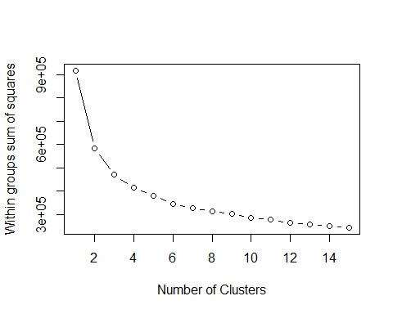

Run k-means clustering on the data frame after scaling it and use adjusted rand index (ARI) for finding the accuracy. The plot will show the optimal amount of clusters with the greatest accuracy. The *taste* is chosen here because it would be time consuming to plot each observation individually.

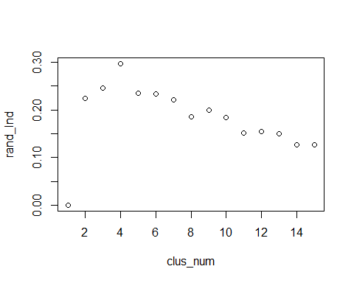

The accuracy levels appear to be relatively low, ranging from 0.1260 to 0.3013, depending on the chosen aspect to compute with *taste* having highest and *appearance* having lowest accuracy. This may be due to a number things. For one, outliers can have adverse effects on the clusters' centroids and thus affecting the clusters' composition. Also, having a data set populated with human opinions will naturally created some disagreement around the ratings. This may create additional overlap in clusters and, in turn, result in lower accuracy.

According to the plot, the optimal amount of clusters to use is four which produces an accuracy of 0.3013 for the *taste* using k-means.

Since k-means is very susceptible to outliers, it is appropriate to try other methods of clustering and distance calculations in order to improve the accuracy. Other methods such as *kcca*, *cclust*, *pam*, and *clara* will be applied and compared to each other to find one with least error.

## ARI   
## 0.3811966

## ARI   
## 0.2422985

## ARI   
## 0.2138243

## ARI   
## 0.3676151

## ARI   
## 0.2361065

## ARI   
## 0.2115559

## ARI   
## 0.3782873

## ARI   
## 0.2406867

## ARI   
## 0.2039574

## ARI   
## 0.3070905

## ARI   
## 0.2293398

## ARI   
## 0.1914316

After testing others methods, *cclust* appears to produce the best results. Although, *pam* produced very similar accuracy, *cclust* works much faster and therefore will be used for final clustering.

# ---- CONCLUSION ----  
# CCLUST produces least error and works relatively quickly   
# PAM also results in a lower error but works much slower  
  
# ---- CCLUST ----  
# now use the full data set  
beer_ccl = cclust(beer_reviews_df, k = 4, method = 'hardcl', dist = 'manhattan')   
randIndex(table(beer_reviews_1$taste, beer_ccl@cluster))# hardcl + manhattan -> 0.3658

## ARI   
## 0.3655686

randIndex(table(beer_reviews_1$overall, beer_ccl@cluster))# hardcl + manhattan -> 0.3033

## ARI   
## 0.3020813

randIndex(table(beer_reviews_1$ovr_grade, beer_ccl@cluster))# hardcl + manhattan -> 0.2074

## ARI   
## 0.2062773

## size av_dist max_dist separation  
## 1 30977 3.182824 14.64938 2.956696  
## 2 6674 6.180827 20.24765 5.087299  
## 3 64244 2.771070 12.96633 2.695881  
## 4 29038 3.671791 16.88626 3.168534

We'll choose cluster four because it has the highest mean ratings for the five aspects. Also, it also has the highest mean rating for alcohol content and most reviews per beer.

Now, to make a recommendation, we can search for specific criteria using the *filter()* function and then store it in a new data frame. This new data frame will then be analysed in order to further narrow down the results. Lastly, using sample_n() function, five beers will be selected randomly to create the final recommendation.

In the end, out of thousands of choices, this set of five beers will provide a more reasonable selection for the customer.

# ---- RECOMMENDATION ----  
# list of criteria:  
# taste, overall, aroma, palate, appearance, overall grade, beer ABV, beer style, general beer style  
  
# search for specific criteria  
beer_rec_df =   
 beer_reviews_1_ordered %>%  
 filter(general_beer_style == 'lager', beer_abv_factor == 'normal')  
  
# analyse the criteria df further before recommendation   
beer_reviews_1_sub =   
 beer_rec_df %>%   
 group_by(beer_name) %>%  
 summarise(  
 review_count = n(),  
 overall_mean = mean(overall),   
 taste_mean = mean(taste),  
 aroma_mean = mean(aroma),   
 appearance_mean = mean(appearance),   
 palate_mean = mean(palate),  
 rev_cnt_ovr = review_count/overall_mean,  
 mean_consistency = (overall_mean + taste_mean + aroma_mean + appearance_mean + palate_mean)/5,  
   
 overall_sd = sd(overall),   
 taste_sd = sd(taste),  
 aroma_sd = sd(aroma),   
 appearance_sd = sd(appearance),   
 palate_sd = sd(palate),  
 sd_consistency = (overall_sd + taste_sd + aroma_sd + appearance_sd + palate_sd)/5) %>%  
 filter(review_count >= 10) %>%  
 arrange(desc(overall_mean), desc(taste_mean), desc(aroma_mean), desc(appearance_mean), desc(palate_mean))  
  
# select random beer from list  
# using sample_n(), generate 5 recommendations  
rec_func = function(df){  
 if (length(df$beer_name) <= 5){  
 head(df)  
 }  
 else if(length(df$beer_name) > 5){  
 head(sample_n(df, 5))  
 }  
 else if (length(df$beer_name) == 0){  
 print('None found')  
 }  
}  
rec_func(beer_reviews_1_sub)

## # A tibble: 5 x 15  
## beer_name review_count overall_mean taste_mean  
## <chr> <int> <dbl> <dbl>  
## 1 brooklyn oktoberfest beer 225 3.871111 3.742222  
## 2 oktoberfest 75 3.906667 3.740000  
## 3 festbier 284 3.968310 3.778169  
## 4 brooklyn lager 358 4.033520 3.842179  
## 5 great lakes eliot ness 304 4.220395 4.083882  
## # ... with 11 more variables: aroma_mean <dbl>, appearance_mean <dbl>,  
## # palate_mean <dbl>, rev_cnt_ovr <dbl>, mean_consistency <dbl>,  
## # overall_sd <dbl>, taste_sd <dbl>, aroma_sd <dbl>, appearance_sd <dbl>,  
## # palate_sd <dbl>, sd_consistency <dbl>

### Further Research

This recommendation system is far from perfect and can greatly benefit from further research. Current accuracy levels are relatively low and could use improvement. Other machine learning techniques such as decision trees or k-nearest neighbors can be applied with the same goal of classification. Optionally, multiple methods can be combined together to further improve accuracy in classifying this data set.

Another way that a recommendation system can be created is based on the profile names. Since people tend to have personal preferences, it is quite likely that the profile names share similar tastes. By finding and comparing patterns for preferences across all profile names we can find similarities and create recommendations based on those similarities.

Logistic regression can also be applied in predicting whether someone will *like* or *dislike* (a binary outcome) a recommended beer. However, a *like* and *dislike* would have to be defined clearly. For example, we can try to predict whether the customer will rate the recommended beer higher or lower than the mean. The results can then be used to modify the model and improve performance.

### Applying Results

1. This recommendation system can aid in decision making when it comes to beer; however, it would be helpful to know where the recommended beers can be purchased within the local area. With more data, it would be possible to provide the customer with the exact store locations with their recommended beers. As a result, this may drive traffic to undiscovered places with great selection of beer and improve the sales within the establishment. Also, knowing the most popular beers will help the establishment maintain their stock of those particular beers in high demand.
2. From the perspective of the beer distributors and manufacturers these results may also be used to improve sales. Although people have diverse preferences, these results give us a glimpse as to which beers are the most popular among people and this can certainly be advantageous to distributors and manufacturers. Essentially, by finding the most popular beers we can see which beers have the greatest demand. Also, since this data set includes many seasonal beers, it would be useful to predict each beer's demand for each season. From here, the supply can be adjusted to maximize profits.
3. An application developer or a website/blog comprised of beer enthusiasts with a successful recommendation system may benefit from increased traffic to their domain. From the perspective of a customer, anyone with a desire in finding a great beer to try with their next meal will certainly be attracted to a website/blog or an application with a solid recommendation system. Additionally, these findings can be used in other areas that involve classification. With some modifications, this recommendation system can be used for classifying restaurant reviews and recommending different places to eat. Further, the two recommendations can be combined together into a single easy-to-use application. Altogether, it will become much easier to find the perfect place for dining with a perfect beer for pairing.